Payroll Tax Ruling PTA003

Fringe Benefits
Version | Issued | Dates of Effect
1 | 1 July 2009 | From: 1 July 2009 | To: 30 June 2016
2 | 1 July 2016 | From: 1 July 2016 | Current

PREAMBLE

The Payroll Tax Act (the Act), which commenced on 1 July 2009, rewrites the Pay-roll Tax Act to largely harmonise it with the legislation of other states. One of the areas that have been harmonised is the value of fringe benefits to be declared for payroll tax purposes.

This Payroll Tax Ruling addresses the following points:
- Calculating the value of fringe benefits for payroll tax purposes.
- Clarifying the treatment of fringe benefits with a nil taxable value and exempt benefits where such benefits also fall within another part of the definition of wages.
- Explaining the requirements of the alternative method of declaring fringe benefits.
- Explaining the method of calculating the Territory component of fringe benefits when they are not readily identifiable.
- The adoption of Australian Taxation Office (ATO) fringe benefits tax rulings.

RULING

Value of fringe benefits for payroll tax purposes

The definition of wages in Part 3 of the Act includes fringe benefits as defined in the
Fringe Benefits Tax Assessment Act 1986 (FBT Act), but does not include tax exempt body entertainment fringe benefits.

Under the FBT Act, fringe benefits are categorised into two types depending on the GST implications. The Type 1 fringe benefits for which the employer can claim a GST input tax credit are grossed up by a higher Type 1 factor and Type 2 fringe benefits for which the employer cannot claim a GST input tax credit are grossed up by a lower Type 2 factor.

Section 15 of the Act requires employers to gross up all fringe benefits by using only the lower Type 2 factor. The Type 2 factor may be calculated as follows:
$$\frac{\text{1}}{\text{1-FBT rate}}$$

Fringe benefits with a nil taxable value

Where a benefit has a nil taxable value under the FBT Act, some uncertainty may exist as to whether or not such benefits will be subject to payroll tax where the benefit also falls within another part of the definition of wages under the Act.

Fringe benefits which have a nil taxable value under the FBT Act will also have a nil taxable value for payroll tax purposes.

Exempt benefits

The FBT Act provides specific exemptions for certain types of benefits. Such exempt benefits are not fringe benefits for the purposes of the FBT Act. Some uncertainty may exist as to whether or not such benefits will be subject to payroll tax where the benefit also falls within another part of the definition of wages under the Act.

Section 14(2) of the Act ensures that exempt benefits are not fringe benefits for payroll tax purposes even where the exempt benefit would also fit within another part of the definition of wages under the Act. Deposits to a Superannuation Holding Account Special Account within the meaning of the Small Superannuation Accounts Act 1995 (Cth) are an exception to this rule, as specified in section 14(2) of the Act.

Election for alternative method to declare fringe benefits

Employers are required to declare in their monthly returns the actual value of total fringe benefits (grossed up by the Type 2 factor) provided in each month.

For administrative ease, section 16 of the Act allows employers to make a formal election to adopt an alternative method, whereby the amounts declared are based on the FBT returns.

Where such an election is made, employers must include in each monthly payroll tax return from July to May, one-twelfth of the total taxable value of fringe benefits in the FBT return for the year ending 31 March immediately preceding the start of each financial year, grossed up by the Type 2 factor. The Annual Adjustment return for each financial year should include the total taxable value of fringe benefits declared in the FBT return ending 31 March immediately before the Annual Adjustment return, grossed up by the Type 2 factor.

Example:

ABC Pty Ltd made the election to adopt the alternative method of declaring fringe benefits for payroll tax purposes. In the FBT year ended 31 March 2015, the total taxable value of the fringe benefits grossed-up by the Type 2 factor is $100 000. Accordingly, ABC Pty Ltd would declare $8333 of fringe benefits in each payroll tax return for July 2015 to May 2016
(i.e. 1/12 x $100 000 = $8333).

In its FBT return for the year ended 31 March 2016, the total taxable value of the fringe benefits grossed-up by the Type 2 factor is $105 000, which is the amount that would be declared as the fringe benefits amount in the 2015-16 Annual Adjustment return.

Under the Act, an employer may only take advantage of the formal election where the employer was liable to pay FBT for a period of not less than 15 months prior to the commencement of the relevant tax year and the Commissioner of Territory Revenue (the Commissioner) is notified of the election in the approved form.

An employer who does not meet these requirements must return the actual value of the fringe benefits paid during the relevant return period or make a written request for another method for declaring the fringe benefits.

Once an election is made, an employer will not be permitted to revert to declaring the actual value of fringe benefits in monthly payroll tax returns, unless approval is given in writing by the Commissioner. (Note: an employer must not use a combination of methods.)

Employers seeking such approval must lodge an application in writing which explains why termination of the election is sought (i.e. the employer provides fewer benefits during the current financial year compared with the previous FBT year).

Where an employer ceases to be liable for payroll tax, regardless of whether or not the election has been made, the amount of fringe benefits declared in the employer’s final payroll tax return is to be as follows:
- the actual value of the Territory component of fringe benefits paid or payable by the employer for the period from the preceding 1 July to the cease date, grossed up by the Type 2 factor; less
- the value of the Territory component of fringe benefits declared in payroll tax returns during that period.

Determination of the Territory component of fringe benefits

In relation to employers who employ in more than one State and/or Territory, it is recognised that existing FBT record-keeping systems may not allow an employer to identify the Territory component of the fringe benefits.

In such circumstances, the Territory component of the fringe benefit amount may be declared on an apportionment basis, calculated in accordance with the approved method.

The approved method of estimating the Territory component of the total value of fringe benefits is only available where:
- existing records do not allow the identification of the actual fringe benefits which relate to the Territory; and
- the employer has formally elected to declare fringe benefits based on the alternative method.

The approved method of calculating the Territory component of total fringe benefits involves two steps.

Step one — July to May monthly returns

The amount to be declared in each of the monthly returns July to May, is one-twelfth of the total value of the fringe benefits declared in the FBT return for the year ending 31 March (immediately preceding the current financial year) grossed up by the Type 2 factor, adjusted by the ratio of total Territory taxable wages to total Australian taxable wages, for the full financial year (immediately preceding the current financial year).

Step two — Annual Adjustment return

The amount to be declared in the Annual Adjustment return is the total value of fringe benefits declared in the FBT return for the year ending 31 March, immediately preceding the Annual Adjustment return grossed up by the Type 2 factor, adjusted by the ratio of Territory taxable wages to Australian taxable wages, for the current financial year.
The Territory taxable wages and the Australian taxable wages in the above two steps should not include fringe benefits.

Example:
The value of fringe benefits of XYZ Pty Ltd in its 31 March 2015 FBT return after grossing up by the Type 2 factor is $120 000. XYZ Pty Ltd paid a total of $600 000 (excluding fringe benefits) in taxable wages for the 2014-15 financial year, of which $300 000 (excluding fringe benefits) were Territory wages.

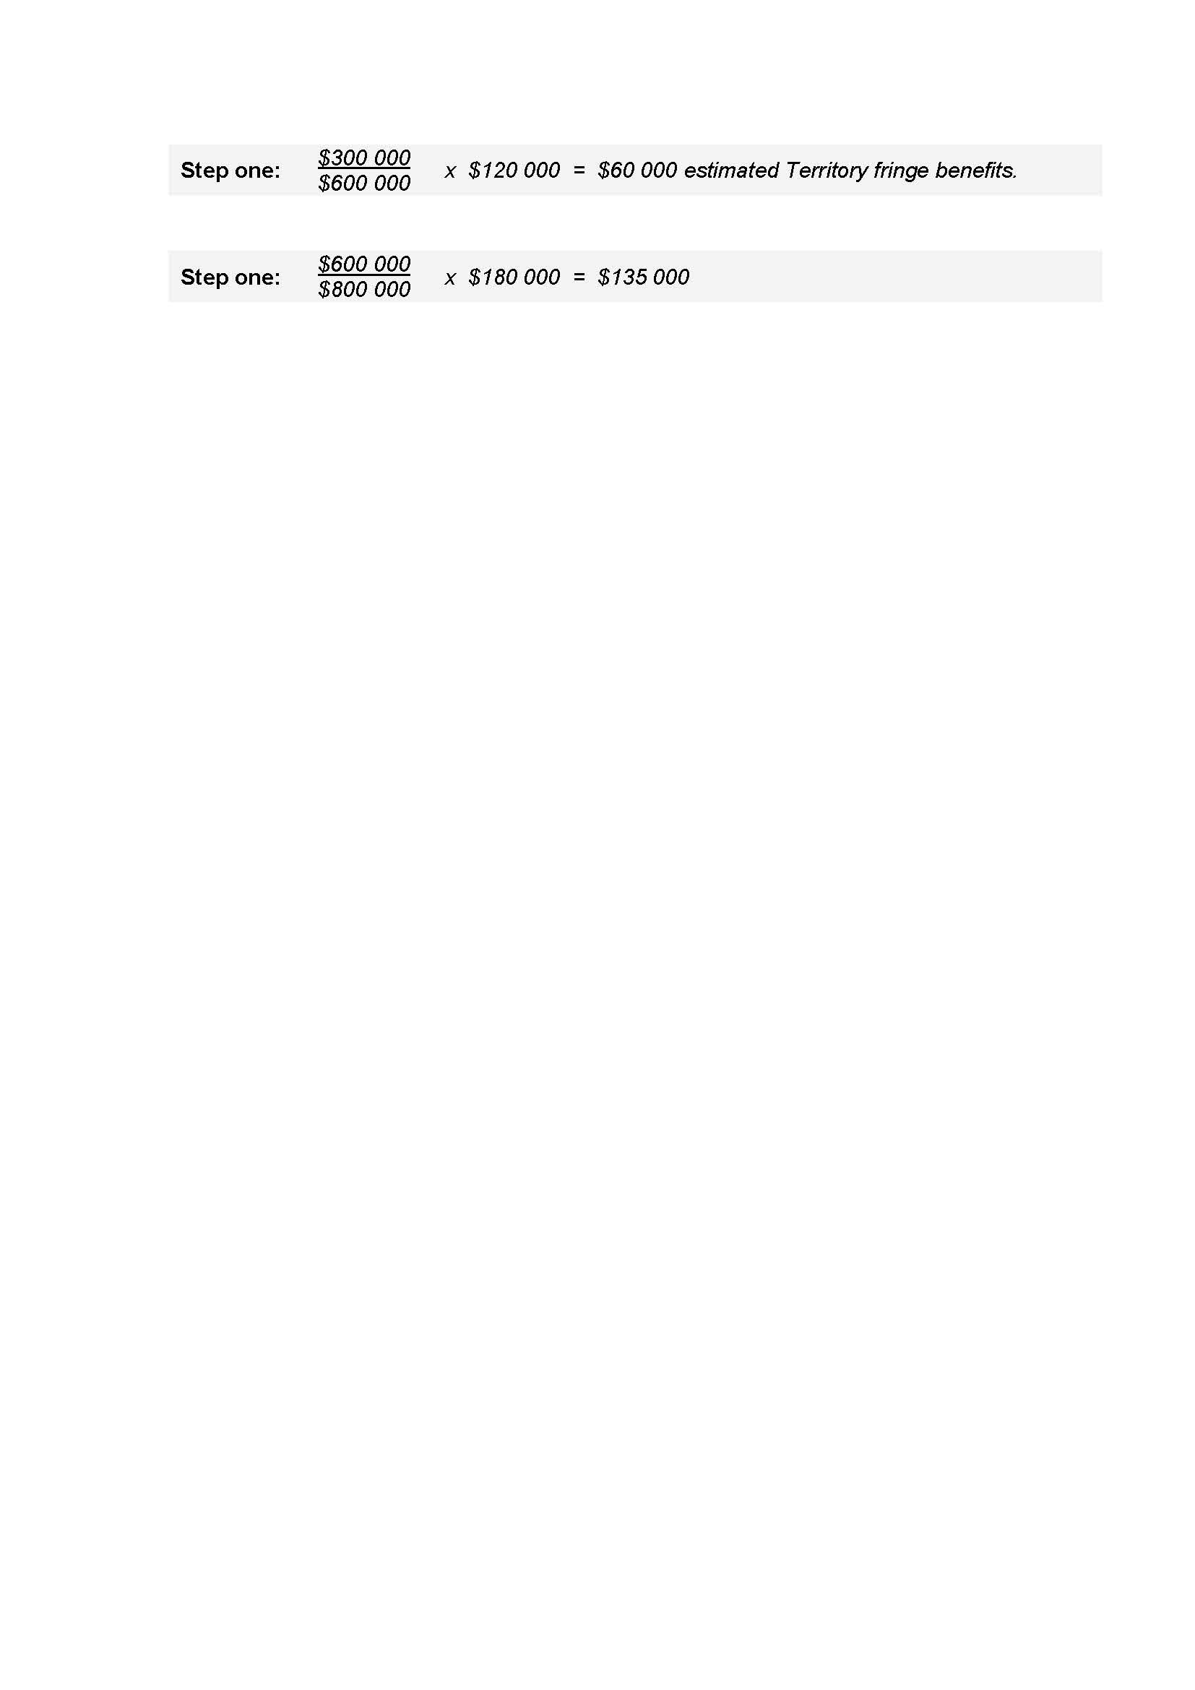

Therefore, $60 000 ÷ 12 = $5 000 of fringe benefits is to be declared in each monthly Territory payroll tax return from July 2015 to May 2016.

The value of fringe benefits of XYZ Pty Ltd in its 31 March 2016 FBT return after grossing up by the Type 2 factor is $180 000. The total Australian taxable wages for the 2015-16 financial year were $800 000 (excluding fringe benefits), of which $600 000 (excluding fringe benefits) were Territory taxable wages.

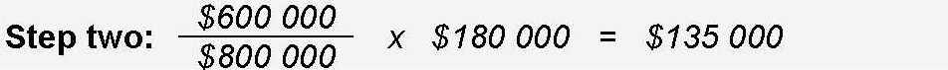

The Territory component of fringe benefits to be declared in the 2015-16 Annual Adjustment return is $135 000.

Employers who are unable to calculate the actual Territory component of fringe benefits and are unable to adopt the approved method or believe they would be disadvantaged by adopting the approved method, should make a written submission to the Commissioner of Territory Revenue (the Commissioner) detailing another method.

Adoption of ATO fringe benefits tax rulings

In order to follow as closely as possible the effect of the FBT Act, the Commissioner will adopt all rulings issued by the ATO which relate to fringe benefits tax (with the exception of rulings relating to employee share schemes).

Please note that rulings do not have the force of law. Each decision made by the Territory Revenue Office is made on the merits of each individual case, having regard to any relevant ruling. Commissioner’s Guideline CG-GEN-001, which sets out information on the revenue publication system, is incorporated into and is to be read as one with this Ruling. All Circulars, Guidelines and Rulings are available from www.revenue.nt.gov.au.

Mick Butler
DEPUTY COMMISSIONER OF TERRITORY REVENUE

For further information contact the Territory Revenue Office:
GPO Box 1974  DARWIN NT 0801 | Tel: 1300 305 353 | Email: ntrevenue@nt.gov.au  Website: www.revenue.nt.gov.au

