Northern Territory Population Projections
(2019 Release)

Contents
Executive summary 3
1 Introduction 5
2 NTPOP model 5
Method 5
Outputs 5
Assumptions 5
3 Overview of Territory projection results 7
Projected population change 7
Age structure 8
4 Regional projections 10
5 Comparison of projections 13
DTF projections – 2019 release compared to 2017 release 13
DTF projections compared to ABS projections 13
6 Sensitivity analysis 14
Effects of change in migration assumption 14
Effects of change in fertility assumption 15
Appendix 1: Summary of input variables and parameters for the Territory population projections 17
Appendix 2A: Northern Territory regions 19
Appendix 2B: Greater Darwin regions 20

Executive summary
Population projections are estimates of the future size and characteristics of the population and, consequently, are an important resource used by decision-makers across government, non-government organisations and business in planning service delivery across the Territory.
The Department of Treasury and Finance have developed projections for the whole of the Territory’s resident population out to the year 2046 and the Territory’s regional populations out to the year 2036, disaggregated by age, sex and Aboriginal identity. The projections are based on Australian Bureau of Statistics (ABS) 2016 Census final estimated resident population numbers at 30 June 2016. These projections update the earlier release from December 2017, which were based on preliminary 2016 Census data.
Key results:
- The Territory’s total population is projected to grow from 245 678 in 2016 to 351 607 in 2046 (Table 1), which equates to an annual average growth rate of 1.2 per cent (Table 2). Over 2016-21 population is projected to grow annually at a rate of 0.5 per cent, reflecting the Territory’s current below-trend population growth. The annual growth rate is then projected to increase over time, reaching 1.4 per cent by 2026-31, which represents a return to the Territory’s long-term growth rate (the 20-year annual average growth rate).
- The Territory’s Aboriginal population is projected to grow from 74 546 in 2016 to 104 387 in 2046 (Table 1), representing an annual average growth rate of 1.1 per cent (Table 2). The Territory’s non-Aboriginal population is projected to grow from 171 132 in 2016 to 247 220 in 2046, which equates to an annual average growth rate of 1.2 per cent.
- Aboriginal population growth is relatively constant at an annual rate of about 1.1 per cent over each five-year projection period, whereas the growth profile of the non-Aboriginal population is similar to the total population, starting from an annual growth rate of 0.1 per cent over 2016-21 and stabilising at an annual growth rate of between 1.5 and 1.6 per cent from 2026-31 (Table 2).
- The projections of both the Aboriginal and non-Aboriginal populations show steady population ageing, with the proportion of persons aged 65 and over projected to increase (Table 5). However the Aboriginal population is ageing faster, with the proportion of Aboriginal persons aged 65 and over increasing by two and a half times from 2016 to 2046 (from 3.6 per cent to 9.1 per cent, Table 5). Over the same time period the proportion of non-Aboriginal persons aged 65 and over is projected to increase from 8.3 per cent to 11.4 per cent.
- Greater Darwin (consisting of Darwin city, Darwin suburbs, Litchfield and Palmerston) is projected to grow from 147 102 in 2016 to 195 663 in 2036, equating to an annual average growth rate of 1.4 per cent (Table 6). The rest of the Territory (consisting of Alice Springs, Barkly, Daly–Tiwi–West Arnhem, East Arnhem and Katherine) is projected to grow from 98 576 in 2016 to 109 201 in 2036, equating to an annual average growth rate of 0.5 per cent.
- Across all Territory regions, Palmerston is projected to grow fastest at 2.4 per cent annually over 2016-36 (Table 6). Barkly is the only region projected to decline (annual decline of -0.2 per cent) over the same period.
Population projections should be used with a clear understanding of the underlying assumptions and limitations as they are developed by applying mathematical models and assumptions of likely population trends (current and historical) to the base population. The value of population projections is they provide information about how a population may change over the long term, subject to assumed parameters.
Projections are not accurate short-term forecasts, which may incorporate substantial volatility, or predictions of the future. Projections are also not targets, nor do they reflect the effects of current or future policies. Similarly, projections do not incorporate the effects of future developments such as land releases or major projects.
Table 1: Territory resident population, actual results and projections, 2016 to 2046 (at 30 June)
 | 2016 | 2021 | 2026 | 2031 | 2036 | 2041 | 2046
 | no. | no. | no. | no. | no. | no. | no.
Total population | 245 678 | 251 727 | 265 168 | 283 775 | 304 864 | 327 440 | 351 607
Aboriginal | 74 546 | 79 318 | 84 080 | 88 924 | 93 834 | 98 986 | 104 387
Non-Aboriginal | 171 132 | 172 408 | 181 088 | 194 850 | 211 031 | 228 454 | 247 220

Introduction
This brief, released in April 2019, provides an overview of the official Northern Territory Government projections of the Territory’s total population from 2016 to 2046 (30 years) and the Territory’s regional populations from 2016 to 2036 (20 years).This release provides projections for Territory residents in five-year intervals at 30 June, disaggregated by five-year age groups, sex and Aboriginal identity.
The projections are based on final Australian Bureau of Statistics (ABS) 2016 Census estimated resident population (ERP) numbers at 30 June 2016. The current projections update the previous whole of Territory projections presented in the Northern Territory Population Projections Preliminary Update (2017 Release), which were based on preliminary ABS 2016 Census data. The current regional projections update those presented in the Northern Territory Population Projections Main Update (2014 Release) based on ABS 2011 Census data.
The projections have been developed in collaboration with the Demography and Growth Planning team at the Northern Institute of Charles Darwin University.
A summary of the projections is included in this brief. For the complete set of projected population numbers, users should refer to the electronic Excel spreadsheets available through the Department of Treasury and Finance (DTF) website at:
https://treasury.nt.gov.au/dtf/economic-group/population-projections

NTPOP model

Method
The NTPOP model is a cohort-component model, a commonly used method for developing demographic projections. The method adjusts a base population for births, deaths, migration and changes to Aboriginal identity (the components of population change) to arrive at a population five years into the future. The sum of regional component population flows are constrained by whole of Territory population flows. The process continues for the extent of the projection horizon.

Outputs
A single set of whole of Territory and regional projections (the main projection) has been produced for this release. However, to demonstrate the sensitivity of the model to changes in the magnitude of population components, several Territory-level scenarios have been developed by systematically varying select components.

Assumptions
The population projections use input parameters based on averages and trends from past data as follows:
- The annual population growth rate was set at 0.5 per cent over 2016-21 (Table 2), which is the actual five-year annual average growth rate to June 2018 as published by the ABS, and therefore it models current population growth. The annual growth rate is then adjusted upwards to reach 1.4 per cent from 2026-31, which reflects a return to the long-term growth rate (the 20-year annual average growth rate to June 2016).
- The growth profile of the Territory’s non-Aboriginal population is similar to the total Territory population, with growth dropping from 2011-16 to 2016-21 and then increasing to reach a relatively stable growth rate from 2026-31 (Table 2). In contrast, Aboriginal population growth is relatively constant over all projection periods.
- In the regions, the growth profile of greater Darwin (including Darwin city, Darwin suburbs, Litchfield and Palmerston) is similar to the total Territory population (Chart 3). Growth rates for these regions were assumed to fall from 2011-16 to 2016-21 and then rise. In contrast, the growth profile for regions within the rest of the Territory (Alice Springs, Barkly, Daly–Tiwi–West Arnhem, East Arnhem and Katherine) start from low values in 2011-16 and were assumed to rise over the projection period.
- Territory and regional growth profiles reflect the recent and short-term impact of weak labour force conditions on total migration (sum of net interstate migration and net overseas migration) of the non-Aboriginal population. The model assumes a high net out-migration of non-Aboriginal persons from the greater Darwin region over 2016-21, coinciding with the completion of construction on the Inpex Ichthys liquefied natural gas (LNG) project. In addition, general weakness in the broader resources sector resulted in population declines in the rest of the Territory over 2011-16 (Chart 3). Subsequently, net total migration of the non-Aboriginal population was assumed to recover from 2021-26 in greater Darwin and from 2016-21 in the rest of the Territory.
- The projections assume that net total migration of Aboriginal persons is unaffected by the temporary weakness in the resources sector, remaining negative (that is net out-migration from the Territory) over the projection period in line with the long-term migration trend for this population. Territory-level Aboriginal population interstate migration flows were held constant over the projection period given the uncertainty associated with projecting future interstate migration flows for this population. Net overseas migration for the Aboriginal population was assumed to be zero.
- Migration rates were derived from published and unpublished (regional interstate migration estimates) ABS data.
- Territory and individual regional fertility rates were computed using published and unpublished ABS data from the past five years (2011-16), and held constant over the projection period because of the uncertainty associated with modelling change in the variable.
- Mortality rates were derived from published ABS data and other sources. These rates assume life expectancy improves over the projection period. Individual regional mortality rates were assumed to equal whole of Territory rates.
- Proportions of births to Aboriginal and non-Aboriginal mothers ascribed Aboriginal and non-Aboriginal identities were computed using the method in Wilson (2009) from unpublished ABS census data. As no clear trend was evident in past data the proportions were held constant over the projection period. Whole of Territory proportions were applied to the regions.
- Aboriginal identity as reported in ABS Census data (the Australian Census Longitudinal Dataset) were used to derive the rate at which people changed their reported Aboriginal identity from Census 2011 to Census 2016. The increase over time in self-identification as Aboriginal observed nationally has not been reported in the Territory and is therefore held constant over the projection period. It was assumed greater Darwin residents could change their identity from non-Aboriginal to Aboriginal and Aboriginal to non-Aboriginal, whereas in the rest of the Territory the rate of change of identity from Aboriginal to non-Aboriginal was zero.
Appendix 1 provides a numerical summary of the assumptions described above.

Overview of Territory projection results

Projected population change
All population projections are at 30 June. As Chart 1 shows, the Territory’s total population and its component Aboriginal and non-Aboriginal populations are projected to grow from 2016 to 2046.
Chart 1: Territory resident population, actual results and projections, 1996 to 2046 (at 30 June)
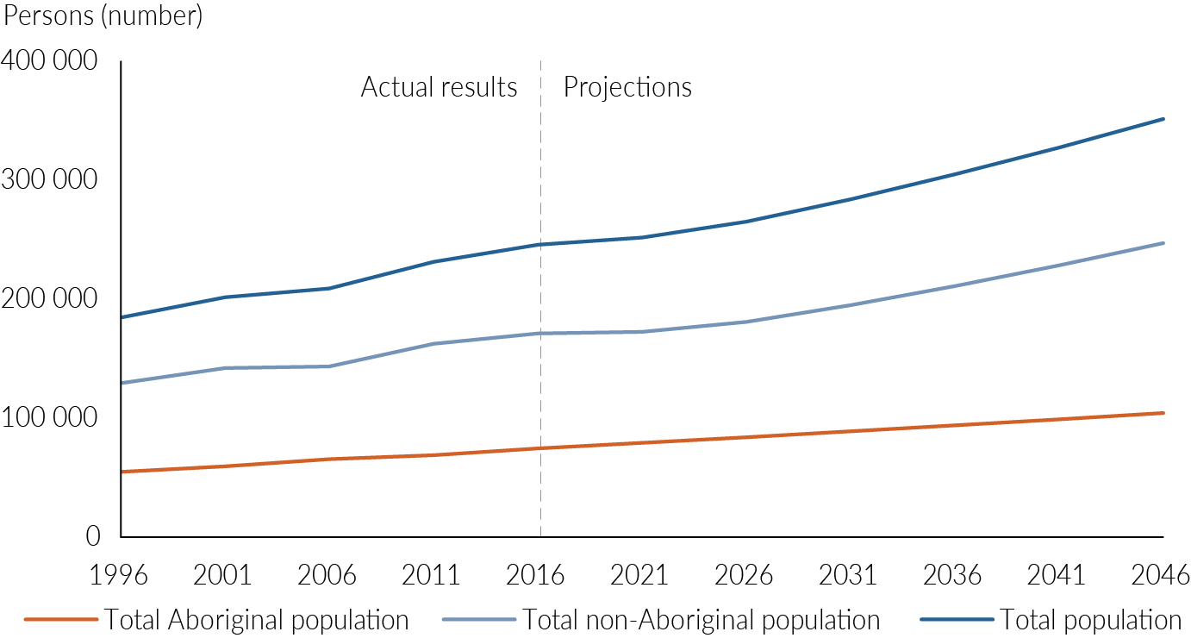
Table 1 presents Territory population projections at five-year intervals from 2016 to 2046, and Table 2 reports the annual average population growth rates for each five-year projection period.
Table 1: Territory resident population, actual results and projections, 2016 to 2046 (at 30 June)
 | 2016¹ | 2021 | 2026 | 2031 | 2036 | 2041 | 2046
Total population | 245 678 | 251 727 | 265 168 | 283 775 | 304 864 | 327 440 | 351 607
Aboriginal | 74 546 | 79 318 | 84 080 | 88 924 | 93 834 | 98 986 | 104 387
Non-Aboriginal | 171 132 | 172 408 | 181 088 | 194 850 | 211 031 | 228 454 | 247 220
1 Actual results
Table 2: Territory resident population, annual average population growth rates, 2006 to 2046
 | Actual results |  | Projections
 | 2006-11 | 2011-16 | 2016-21 | 2021-26 | 2026-31 | 2031-36 | 2036-41 | 2041-46 | 2016-46
 | % | % | % | % | % | % | % | % | %
Total population | 2.0 | 1.2 | 0.5 | 1.0 | 1.4 | 1.4 | 1.4 | 1.4 | 1.2
Aboriginal | 1.0 | 1.6 | 1.2 | 1.2 | 1.1 | 1.1 | 1.1 | 1.1 | 1.1
Non-Aboriginal | 2.5 | 1.0 | 0.1 | 1.0 | 1.5 | 1.6 | 1.6 | 1.6 | 1.2

While the growth rates over the total projection period (2016-46) are almost equal for Aboriginal and non-Aboriginal populations, growth over individual five-year projection intervals are markedly different (Table 2). Aboriginal growth rates are relatively steady over each five-year interval from 2016 to 2046 (approximately 1.1 per cent), however non-Aboriginal growth rates begin lower than Aboriginal growth rates over 2016-21 and 2021-26, rising to rates higher than Aboriginal growth rates over subsequent projection intervals from 2026 to 2046. Projection growth rates are driven by model input assumptions, in particular the recent and short-term impact of weak labour force conditions on the total migration (the sum of net interstate migration and net overseas migration) of the Territory’s non-Aboriginal population (see Section 2).

Age structure
All Aboriginal and non-Aboriginal population broad age groups – under 15 years (children), 15-64 years (working age), and 65 years and over (retirees) – in the Territory are projected to steadily grow in number from 2016 to 2046 (Table 3). Both the Aboriginal and non-Aboriginal populations show steady population ageing, with the median ages (Table 4) and proportion of persons aged 65 and over projected to increase (Table 5 and Chart 2). However, the Aboriginal population is ageing faster, with the median age of the Aboriginal population increasing by 22.5 per cent from 2016 to 2046 (Table 4) in comparison to the 4.8 per cent increase in the median age of the non-Aboriginal population over the same period.
This follows from a greater increase in the proportion of Aboriginal persons aged 65 and over (increasing 5.5 percentage points from 3.6 per cent in 2016 to 9.1 per cent in 2046, Table 5) relative to the increase in proportion of non-Aboriginal persons aged 65 and over (increasing 3.1 percentage points from 8.3 per cent in 2016 to 11.4 per cent in 2046, Table 5).
This is a result of the model assumptions of greater increase in life expectancy of Aboriginal persons relative to non-Aboriginal persons (see Appendix 1), and greater out-migration of non-Aboriginal persons aged 65 and over.
Table 3: Territory resident population, actual results and projections by broad age groups, 2016 to 2046 (at 30 June)
 | 2016 | 2021 | 2026 | 2031 | 2036 | 2041 | 2046 | Annual average growth rate  2016-46
 | no. | no. | no. | no. | no. | no. | no. | %
Aged under 15
Aboriginal | 22 127 | 22 103 | 22 276 | 22 989 | 23 834 | 24 743 | 25 723 | 0.5
Non-Aboriginal | 31 471 | 31 957 | 32 996 | 35 098 | 37 664 | 40 511 | 43 711 | 1.1
Total | 53 598 | 54 061 | 55 272 | 58 086 | 61 498 | 65 253 | 69 434 | 0.9
Aged 15-64
Aboriginal | 49 725 | 53 530 | 57 033 | 59 930 | 62 623 | 65 710 | 69 206 | 1.1
Non-Aboriginal | 125 399 | 123 477 | 128 510 | 137 831 | 149 265 | 161 816 | 175 259 | 1.1
Total | 175 124 | 177 006 | 185 543 | 197 762 | 211 888 | 227 526 | 244 464 | 1.1
Aged 65 and over
Aboriginal | 2 694 | 3 685 | 4 771 | 6 005 | 7 377 | 8 533 | 9 458 | 4.3
Non-Aboriginal | 14 262 | 16 975 | 19 582 | 21 922 | 24 101 | 26 128 | 28 250 | 2.3
Total Population | 16 956 | 20 660 | 24 353 | 27 927 | 31 478 | 34 661 | 37 708 | 2.7

Table 4: Territory resident population, median age (in years) by Aboriginal identity, 2016 to 2046 (at 30 June)
 | 2016 | 2021 | 2026 | 2031 | 2036 | 2041 | 2046 | Change 2016-46
 | no. | no. | no. | no. | no. | no. | no. | %
Aboriginal | 25.5 | 27.0 | 28.3 | 29.2 | 30.0 | 30.8 | 31.3 | 22.5
Non-Aboriginal | 34.4 | 35.3 | 35.7 | 35.9 | 35.9 | 35.9 | 36.1 | 4.8
All persons | 32.0 | 32.9 | 33.6 | 34.0 | 34.3 | 34.5 | 34.8 | 9.0

The ageing of the Aboriginal and non-Aboriginal populations is accompanied by a proportional decline in the other age groups (Table 5). The faster ageing of the Aboriginal population is reflected in the greater decline in the proportion of Aboriginal persons aged under 15 years. The proportion of Aboriginal persons aged 15 years and under is projected to decline from 29.7 per cent in 2016 to 24.6 per cent in 2046, a decline of 17.0 per cent. In contrast, the proportion of non-Aboriginal persons aged 15 years and under is projected to decline from 18.4 per cent in 2016 to 17.7 per cent in 2046, a decline of only 3.9 per cent. This reflects a greater decrease in the proportion of Aboriginal women of child-bearing age relative to non-Aboriginal women of the same age.
Table 5: Proportion of Territory population by broad age groups, 2016 to 2046
 | 2016 | 2021 | 2026 | 2031 | 2036 | 2041 | 2046 | Trend 2016-46
 | % | % | % | % | % | % | %
Aged under 15
Aboriginal | 29.7¹ | 27.9 | 26.5 | 25.9 | 25.4 | 25.0 | 24.6
Non-Aboriginal | 18.4 | 18.5 | 18.2 | 18.0 | 17.8 | 17.7 | 17.7
Total | 21.8 | 21.5 | 20.8 | 20.5 | 20.2 | 19.9 | 19.7
Aged 15-64
Aboriginal | 66.7 | 67.5 | 67.8 | 67.4 | 66.7 | 66.4 | 66.3
Non-Aboriginal | 73.3 | 71.6 | 71.0 | 70.7 | 70.7 | 70.8 | 70.9
Total | 71.3 | 70.3 | 70.0 | 69.7 | 69.5 | 69.5 | 69.5
Aged 65 and over
Aboriginal | 3.6 | 4.6 | 5.7 | 6.8 | 7.9 | 8.6 | 9.1
Non-Aboriginal | 8.3 | 9.8 | 10.8 | 11.3 | 11.4 | 11.4 | 11.4
Total | 6.9 | 8.2 | 9.2 | 9.8 | 10.3 | 10.6 | 10.7
¹ Computed as number of Aboriginal persons aged under 15 years divided by total number of Aboriginal persons
The proportional decrease in Aboriginal women of child-bearing age (15-49 years) is part of a proportional decline in all Aboriginal persons in this age group (Chart 2), a consequence of age-specific out-migration within this population. In comparison, the age structure of the non-Aboriginal population shows less relative change between 2016 and 2046, which is a result of the churn (high in-migration and high out-migration) within this population, periodically refreshing the population and maintaining a relatively constant age profile.
Chart 2: Age pyramid, Territory Aboriginal and non-Aboriginal populations, 2016 and 2046
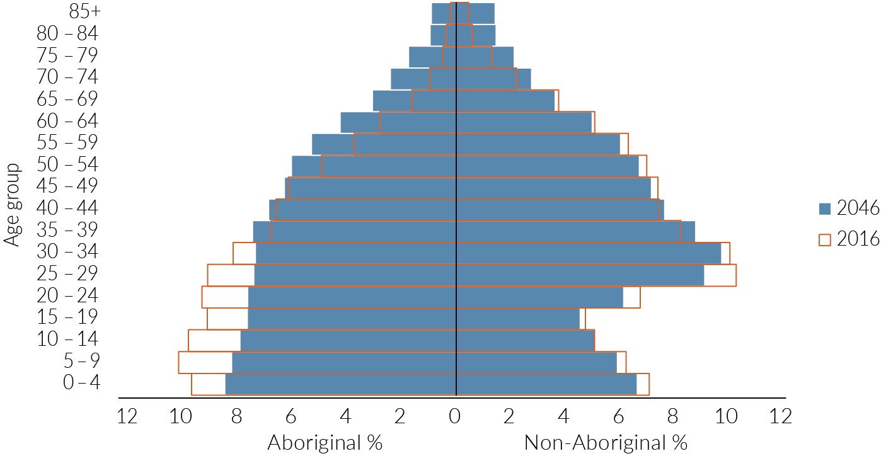

Regional projections
Projections are produced for nine regions, which align with the Statistical Area 3 (SA3) boundaries of the ABS Australian Statistical Geography Standard, 2016 (ASGS 2016). The nine regions are: Darwin city, Darwin suburbs, Litchfield, Palmerston, Alice Springs, Barkly, Daly–Tiwi–West Arnhem, East Arnhem and Katherine (see maps in Appendix 2). Darwin city, Darwin suburbs, Litchfield and Palmerston together comprise greater Darwin, and the remaining five SA3 regions together comprise the rest of the Territory.
Regional projections are produced from 2016 to 2036 (20 years), in comparison to Territory projections which are produced from 2016 to 2046 (30 years). This reflects the greater volatility associated with projecting smaller populations over time, making regional projections less reliable.
Chart 3: Regional annual population change
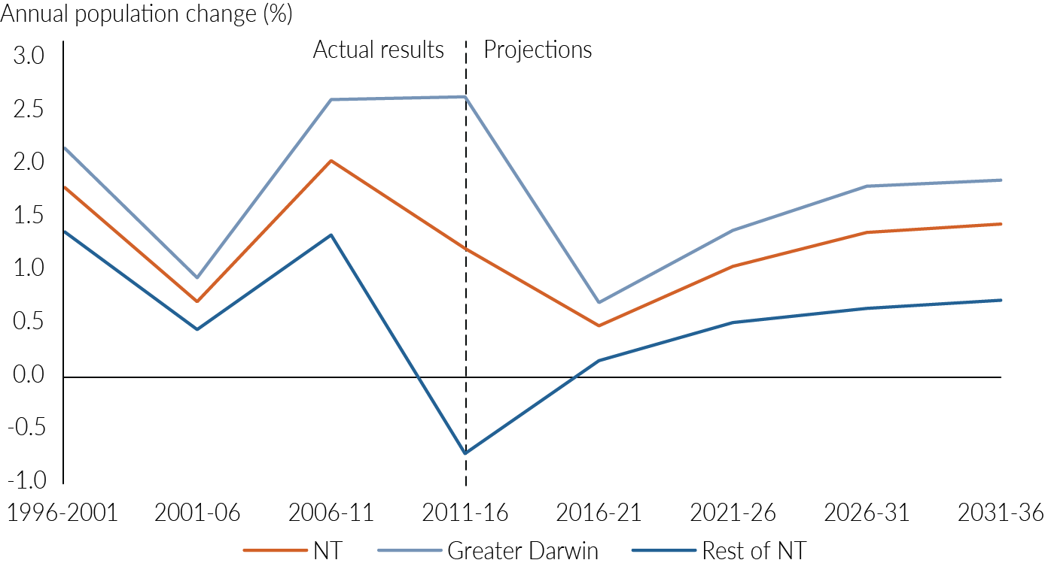
Regional projections are driven by model input assumptions. Growth rates for greater Darwin regions were assumed to drop from 2011-16 to 2016-21 (Chart 3), in contrast to the growth profile for the rest of the Territory regions, where growth rates were assumed to increase from 2011-16 to 2016-21. Greater Darwin and the rest of the Territory growth profiles are similar to the growth profiles of its non-Aboriginal population (Chart 4). In particular they reflect the recent and short-term impact of weak labour force conditions on total migration (the sum of net interstate migration and net overseas migration) of this population. The model assumes a high net out-migration of non-Aboriginal persons from the greater Darwin region over 2016-21. In addition, general weakness in the broader resources sector resulted in non-Aboriginal population declines in the rest of the Territory over 2011-16 (Chart 4). Subsequently, net total migration of the non-Aboriginal population was assumed to recover from 2021-26 in greater Darwin and from 2016-21 in the rest of the Territory.
Chart 4: Regional annual population change by Aboriginal identity
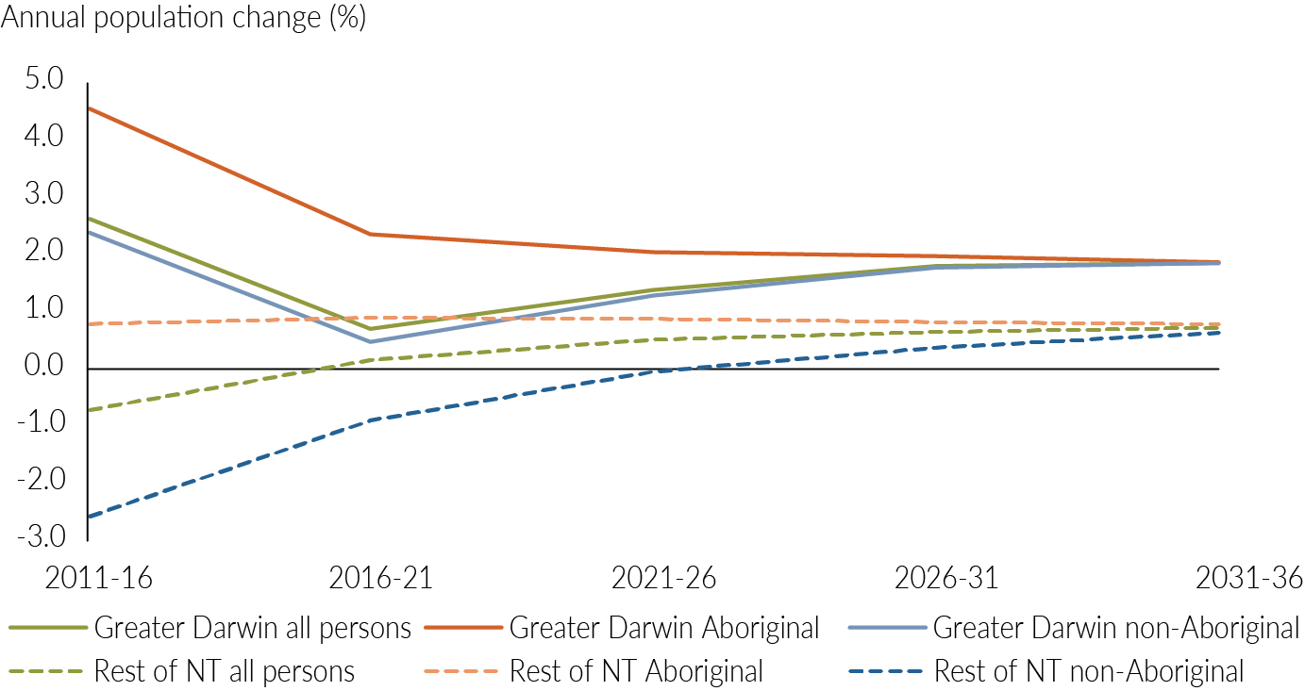
Greater Darwin is projected to grow 1.4 per cent annually over 2016-36, greater than the 0.5 per cent annual average growth projected for Rest of NT (Table 6). At this rate, greater Darwin’s share of the Territory’s population is projected to increase from 59.9 per cent in 2016 to 64.2 per cent in 2036.
Across greater Darwin, Palmerston is projected to grow fastest at 2.4 percent annually over 2016-36 (Table 6). This would make Palmerston the fastest growing region in the Territory. Darwin suburbs is expected to be the slowest growing region (0.4 per cent annually over 2016-36) in greater Darwin. Katherine is projected to grow fastest in the rest of the Territory, growing 0.8 per cent annually over 2016-36, followed by Alice Springs and Daly–Tiwi–West Arnhem (annual growth of 0.5 per cent). Barkly is the only region in the Territory projected to decline (-0.2 per cent annually) over 2016-36.

Table 6: Regional population projections and annual average population change rates by Aboriginal identity, 2016 to 2036 (at 30 June)
 | Population |  |  |  |  | Annual average population change
 | 2016 | 2021 | 2026 | 2031 | 2036 | 2016-21 | 2021-26 | 2026-31 | 2031-36 | 2016-36
 | no. | no. | no. | no. | no. | % | % | % | % | %
Aboriginal
Darwin City | 1 883 | 2 050 | 2 222 | 2 398 | 2 599 | 1.7 | 1.6 | 1.5 | 1.6 | 1.6
Darwin Suburbs | 6 620 | 6 645 | 6 859 | 7 112 | 7 465 | 0.1 | 0.6 | 0.7 | 1.0 | 0.6
Litchfield | 3 732 | 4 764 | 5 587 | 6 567 | 7 478 | 5.0 | 3.2 | 3.3 | 2.6 | 3.5
Palmerston | 5 219 | 6 154 | 7 034 | 7 856 | 8 712 | 3.4 | 2.7 | 2.2 | 2.1 | 2.6
Greater Darwin | 17 454 | 19 613 | 21 702 | 23 933 | 26 253 | 2.4 | 2.0 | 2.0 | 1.9 | 2.1
Alice Springs | 17 001 | 17 911 | 18 831 | 19 726 | 20 613 | 1.0 | 1.0 | 0.9 | 0.9 | 1.0
Barkly | 4 375 | 4 303 | 4 232 | 4 205 | 4 221 | - 0.3 | - 0.3 | - 0.1 | 0.1 | - 0.2
Daly–Tiwi– West Arnhem | 13 272 | 13 807 | 14 347 | 14 834 | 15 299 | 0.8 | 0.8 | 0.7 | 0.6 | 0.7
East Arnhem | 10 582 | 11 008 | 11 415 | 11 790 | 12 115 | 0.8 | 0.7 | 0.6 | 0.5 | 0.7
Katherine | 11 862 | 12 676 | 13 553 | 14 437 | 15 332 | 1.3 | 1.3 | 1.3 | 1.2 | 1.3
Rest of NT | 57 092 | 59 706 | 62 378 | 64 991 | 67 581 | 0.9 | 0.9 | 0.8 | 0.8 | 0.8
Total NT | 74 546 | 79 318 | 84 080 | 88 924 | 93 834 | 1.2 | 1.2 | 1.1 | 1.1 | 1.2
Non-Aboriginal
Darwin City | 26 691 | 27 040 | 29 165 | 32 859 | 36 833 | 0.3 | 1.5 | 2.4 | 2.3 | 1.6
Darwin Suburbs | 51 025 | 50 779 | 51 713 | 53 396 | 55 395 | - 0.1 | 0.4 | 0.6 | 0.7 | 0.4
Litchfield | 21 271 | 22 164 | 23 565 | 25 625 | 28 121 | 0.8 | 1.2 | 1.7 | 1.9 | 1.4
Palmerston | 30 661 | 32 774 | 37 074 | 42 652 | 49 061 | 1.3 | 2.5 | 2.8 | 2.8 | 2.4
Greater Darwin | 129 648 | 132 757 | 141 517 | 154 531 | 169 410 | 0.5 | 1.3 | 1.8 | 1.9 | 1.3
Alice Springs | 22 242 | 21 865 | 22 065 | 22 377 | 22 884 | - 0.3 | 0.2 | 0.3 | 0.4 | 0.1
Barkly | 1 778 | 1 589 | 1 546 | 1 604 | 1 663 | - 2.2 | - 0.6 | 0.7 | 0.7 | - 0.3
Daly–Tiwi– West Arnhem | 4 677 | 4 157 | 4 141 | 4 315 | 4 581 | - 2.3 | - 0.1 | 0.8 | 1.2 | - 0.1
East Arnhem | 3 975 | 3 493 | 3 440 | 3 604 | 3 714 | - 2.6 | - 0.3 | 0.9 | 0.6 | - 0.3
Katherine | 8 812 | 8 547 | 8 379 | 8 420 | 8 780 | - 0.6 | - 0.4 | 0.1 | 0.8 | 0.0
Rest of NT | 41 484 | 39 651 | 39 571 | 40 320 | 41 620 | - 0.9 | 0.0 | 0.4 | 0.6 | 0.0
Total NT | 171 132 | 172 408 | 181 088 | 194 850 | 211 031 | 0.1 | 1.0 | 1.5 | 1.6 | 1.1
Total persons
Darwin City | 28 574 | 29 089 | 31 387 | 35 257 | 39 433 | 0.4 | 1.5 | 2.4 | 2.3 | 1.6
Darwin Suburbs | 57 645 | 57 424 | 58 571 | 60 507 | 62 860 | - 0.1 | 0.4 | 0.7 | 0.8 | 0.4
Litchfield | 25 003 | 26 928 | 29 153 | 32 192 | 35 598 | 1.5 | 1.6 | 2.0 | 2.0 | 1.8
Palmerston | 35 880 | 38 928 | 44 108 | 50 508 | 57 772 | 1.6 | 2.5 | 2.7 | 2.7 | 2.4
Greater Darwin | 147 102 | 152 370 | 163 219 | 178 464 | 195 663 | 0.7 | 1.4 | 1.8 | 1.9 | 1.4
Alice Springs | 39 243 | 39 776 | 40 896 | 42 103 | 43 496 | 0.3 | 0.6 | 0.6 | 0.7 | 0.5
Barkly | 6 153 | 5 892 | 5 778 | 5 809 | 5 884 | - 0.9 | - 0.4 | 0.1 | 0.3 | - 0.2
Daly–Tiwi–West Arnhem | 17 949 | 17 964 | 18 489 | 19 148 | 19 880 | 0.0 | 0.6 | 0.7 | 0.8 | 0.5
East Arnhem | 14 557 | 14 501 | 14 855 | 15 393 | 15 829 | - 0.1 | 0.5 | 0.7 | 0.6 | 0.4
Katherine | 20 674 | 21 223 | 21 932 | 22 857 | 24 112 | 0.5 | 0.7 | 0.8 | 1.1 | 0.8
Rest of NT | 98 576 | 99 357 | 101 949 | 105 310 | 109 201 | 0.2 | 0.5 | 0.7 | 0.7 | 0.5
Total NT | 245 678 | 251 727 | 265 168 | 283 775 | 304 864 | 0.5 | 1.0 | 1.4 | 1.4 | 1.1

Comparison of projections

DTF projections – 2019 release compared to 2017 release
The releases differ in two aspects (Table 7):
- Growth profile of the total population – total population is modelled to grow at a constant annual rate of 1.4 percent in the 2017 release, where in the 2019 release annual population growth is 0.5 per cent over 2016-21, transitioning to 1.4 percent from 2026-31. The change in growth rate over 2016-21 between the two population projection releases is attributable to the availability of two years of additional ABS data, for 2016-17 and 2017-18, showing a drop in population growth in the Territory over these years (0.7 per cent in 2016-17 and -0.1 per cent in 2017-18). These data are reflected in the assumption of lower growth over 2016-21 for the total population and the non-Aboriginal population in the 2019 release.
- Growth rate of the Aboriginal population – projections in the 2017 release were based on preliminary ABS Census 2016 data, where projections in the 2019 release utilise final data from the 2016 Census. Revisions to ABS data resulted in the annual average growth rate for the Aboriginal population increasing from 0.9 per cent over 2016-46 in the 2017 release to 1.1 per cent in the 2019 release, attributable to a small decrease in the net outward interstate migration of this population and a slight increase in the propensity of Territory residents to self-identify as Aboriginal.
Table 7: Annual average population change – 2019 release and 2017 release
 | 2016-21 | 2021-26 | 2026-31 | 2031-36 | 2036-41 | 2041-46 | 2016-46
 | % | % | % | % | % | % | %
2019 Release
Total population | 0.5 | 1.0 | 1.4 | 1.4 | 1.4 | 1.4 | 1.2
Aboriginal | 1.2 | 1.2 | 1.1 | 1.1 | 1.1 | 1.1 | 1.1
Non-Aboriginal | 0.1 | 1.0 | 1.5 | 1.6 | 1.6 | 1.6 | 1.2
2017 Release
Total population | 1.4 | 1.4 | 1.4 | 1.4 | 1.4 | 1.4 | 1.4
Aboriginal | 1.0 | 0.9 | 0.9 | 0.8 | 0.9 | 0.9 | 0.9
Non-Aboriginal | 1.6 | 1.6 | 1.6 | 1.6 | 1.6 | 1.6 | 1.6

DTF projections compared to ABS projections
ABS released its Territory projections in November 2018 (ABS 3222.0 Population Projections, Australia). These projections are available for greater Darwin and the rest of the Territory, but do not include projections for the SA3 regional geography. The growth rates presented in Table 8 correspond to the ABS Series B projections. ABS Aboriginal projections updated for the 2016 Census are scheduled to be released in July 2019, and as such comparison of ABS and DTF projections by Aboriginal identity is not possible at this stage.
Both DTF and ABS project the Territory’s population to grow at an annual average rate of 1.2 per cent from 2016 to 2046 (Table 8). Given equal growth rates, total population at 2046 as projected by DTF and ABS are similar, with DTF projecting a total of 351 607 persons in comparison to ABS’ estimate of 351 872 persons. However the growth profiles of the two projections differ, with DTF projections starting at a lower growth rate over 2016-21 (0.5 per cent annually) relative to the ABS projections (0.9 per cent annually) and subsequently settling at a higher growth rate.
At the regional level DTF projects greater Darwin to grow slower over 2016-36 (1.4 per cent annually) than ABS (1.7 per cent annually). The reverse is true for the rest of the Territory, with DTF assuming the region will grow by 0.5 per cent annually over 2016-36 in comparison to the 0.3 per cent annual growth modelled by ABS over the same period.
Table 8: Annual average population change – DTF and ABS projections
 | 2016-21 | 2021-26 | 2026-31 | 2031-36 | 2036-41 | 2041-46 | 2016-36 | 2016-46
 | % | % | % | % | % | % | % | %
DTF (2019)
Total population | 0.5 | 1.0 | 1.4 | 1.4 | 1.4 | 1.4 | 1.1 | 1.2
Greater Darwin | 0.7 | 1.4 | 1.8 | 1.9 |  |  | 1.4
Rest of NT | 0.2 | 0.5 | 0.7 | 0.7 |  |  | 0.5
ABS
Total population | 0.9 | 1.3 | 1.4 | 1.3 | 1.2 | 1.2 | 1.2 | 1.2
Greater Darwin | 1.4 | 1.8 | 1.9 | 1.8 |  |  | 1.7
Rest of NT | 0.2 | 0.4 | 0.3 | 0.2 |  |  | 0.3

Sensitivity analysis

Effects of change in migration assumption
The principal driver of volatility in the Territory’s population growth is migration of the non-Aboriginal population. The following three scenarios (Table 9) explore the effects of alternative non-Aboriginal migration assumptions on the Territory’s projected population. In these scenarios (Table 9) Aboriginal population migration remains unchanged from the main projection, as do all other parameters for the Aboriginal and non-Aboriginal populations.
Table 9: Territory population projection scenario assumptions – migration
Scenario | Migration assumption | Total migration value over 5 years
Main projection | Total migration flow adjusted to give annual population growth of 0.5% over 2016-21, increasing to 1.4% over 2026-31 and remaining steady to 2046 | -8 507 over 2016-21, increasing to 7 436 over 2041-46
Current (2013-18 growth) scenario | Total migration flow adjusted to give annual population growth of 0.5% over 2016-46. This growth corresponds to actual annual compounded growth over 2013-18. | -8 435 over 2016-21, increasing to  -5 976 over 2041-46
90th percentile¹ scenario | Total migration approximates the 90th percentile of the moving annual total migration flows over the 20 years to June 2018 | 14 549 over 2016-21, held approximately constant over all five-year projection periods
10th percentile¹ scenario | Total migration approximates the 10th percentile of the moving annual total migration flows over the 20 years to June 2018 | -8 871 over 2016-21, held approximately constant over all five-year projection periods
¹ A percentile is a measure at which that percentage of all values are below that value. For example, 90% of all total migration values lie below the 90th percentile, whereas 10% of all total migration values lie below the 10th percentile. An example in recent history of the 90th percentile total migration value occurred in 2008-09, and the 10th percentile total migration value occurred in 2001-02 and 2016-17.
Chart 5 and Table 10 display the consequences of the alternative migration scenarios on the Territory’s projected population. The model assumes the migration patterns are maintained over the 30-year projection timeframe.
The nature of population projections is such that certain assumptions around changes to population components are held constant over the projection horizon, making them quite distinct from short-run forecasts. The migration scenarios in this section are all based on observed population trends and outcomes at a particular point in time. These point-in-time outcomes are then assumed to hold over the 30-year projection horizon. In this way the scenarios provide a confidence interval in which actual population outcomes are likely to fall.
Chart 5: Territory resident population projections, migration scenarios, 1996 to 2046 (at 30 June)
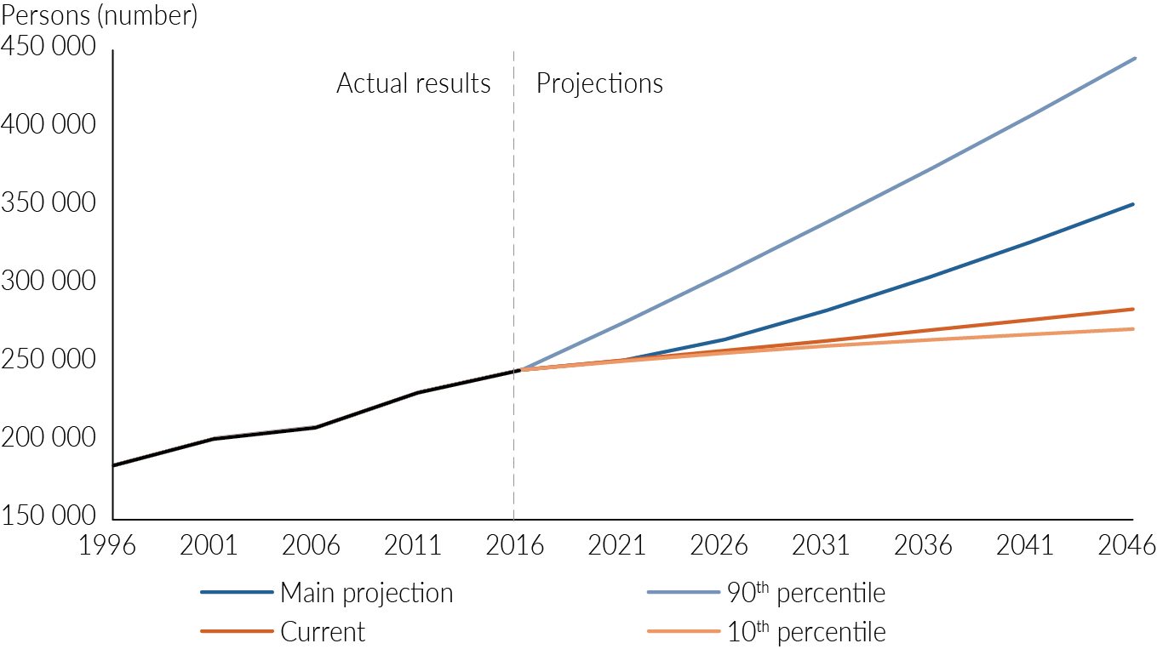
Table 10: Territory population projections and annual average growth rates, alternative migration scenarios
Scenario | Total population at 30 June 2046 | Annual average growth rate 2016-46
 | no. | %
Main projection | 351 607 | 1.2
Current (2013-18 growth) scenario | 284 527 | 0.5
90th percentile scenario | 444 552 | 2.0
10th percentile scenario | 271 741 | 0.3

Effects of change in fertility assumption
While fertility within a population can exhibit long-term change, it does not fluctuate sharply over short periods. Over a 30-year period, however, it is possible that the average total fertility rate for women (TFR) could be 10 percent higher or lower than the figure assumed in the main projection (Table 11).

Table 11: Territory population projection scenario assumptions – fertility
Scenario | Aboriginal TFR | Non-Aboriginal TFR
Main projection | 2.148 | 1.860
Fertility level +10% | 2.362 | 2.046
Fertility level -10% | 1.933 | 1.674

Table 12 demonstrates the effect of assuming fertility to be consistently 10 per cent higher or 10 per cent lower than the assumptions for the main projection. While the effect of changes in fertility is significant, it is less significant than the impacts of variation in total migration.
Table 12: Territory population projections and annual average growth rates, alternative fertility scenarios
Scenario | Total population at 30 June 2046 | Annual average growth rate 2016-46
 | no. | %
Main projection | 351 607 | 1.2
Fertility level +10% | 363 956 | 1.3
Fertility level -10% | 339 475 | 1.1

Appendix 1: Summary of input variables and parameters for the Territory population projections¹
Growth component | Parameter
Fertility  Northern Territory (NT) | Total fertility rate (TFR)  (five-year average, held constant over projection period)
- Aboriginal mothers | - 2.148
- Non-Aboriginal mothers | - 1.860
Darwin city
- Aboriginal mothers | - 1.750
- Non-Aboriginal mothers | - 1.350
Darwin suburbs
- Aboriginal mothers | - 2.313
- Non-Aboriginal mothers | - 1.973
Litchfield
- Aboriginal mothers | - 1.930
- Non-Aboriginal mothers | - 2.382
Palmerston
- Aboriginal mothers | - 2.982
- Non-Aboriginal mothers | - 2.352
Alice Springs
- Aboriginal mothers | - 2.118
- Non-Aboriginal mothers | - 1.843
Barkly
- Aboriginal mothers | - 2.441
- Non-Aboriginal mothers | - 1.981
Daly–Tiwi–West Arnhem
- Aboriginal mothers | - 2.122
- Non-Aboriginal mothers | - 1.968
East Arnhem
- Aboriginal mothers | - 1.642
- Non-Aboriginal mothers | - 2.249
Katherine
- Aboriginal mothers | - 2.386
- Non-Aboriginal mothers | - 2.288
Mortality (NT & Regions) | Life expectancy
- Aboriginal males | - 64.51 years over 2016-21 increasing to 69.12 years over 2041-46
- Aboriginal females | - 70.43 years over 2016-21 increasing to 75.68 years over 2041-46
- Non-Aboriginal males | - 81.31 years over 2016-21 increasing to 83.92 years over 2041-46
- Non-Aboriginal females | - 85.40 years over 2016-21 increasing to 87.32 years over 2041-46
Infant Aboriginal identity (NT & Regions) | Probabilities for allocating infant Aboriginal identity
- Aboriginal infant to Aboriginal mother | - 0.991, held constant over projection period
- Non-Aboriginal infant to Aboriginal mother | - 0.009, held constant over projection period
- Aboriginal infant to non-Aboriginal mother | - 0.044, held constant over projection period
- Non-Aboriginal infant to non-Aboriginal mother | - 0.956, held constant over projection period
Aboriginal identity change | Gross identification change rate (GICR)
NT & Greater Darwin regions
- Non-Aboriginal to Aboriginal females | - 0.323, held constant over projection period
- Non-Aboriginal to Aboriginal males | - 0.204, held constant over projection period
- Aboriginal to non-Aboriginal females | - 0.359, held constant over projection period
- Aboriginal to non-Aboriginal males | - 0.300, held constant over projection period
Rest of NT regions
- Non-Aboriginal to Aboriginal females | - 0.323, held constant over projection period
- Non-Aboriginal to Aboriginal males | - 0.204, held constant over projection period
- Aboriginal to non-Aboriginal females | - Zero
- Aboriginal to non-Aboriginal males | - Zero
Interstate migration (NT) | Net interstate migration
- Total persons | - -14 817 persons over 2016-21 (adjusted to give growth of 0.5%) to -3 512 persons over 2041-46 (adjusted to give growth of 1.4%)
- Aboriginal persons | - Approximately -1 200/5 years over 2016-46
- Non-Aboriginal persons | - -13 553 persons over 2016-21 to -2 334 over 2041-46
Overseas migration (NT) | Net overseas migration
- Aboriginal persons | - Zero
- Non-Aboriginal persons | - 6 310 persons over 2016-21 to 10 948 over 2041-46
At the regional level the high negative net interstate migration over 2016-21 at the Territory level is mirrored in the interstate migration rates of non-Aboriginal persons in the greater Darwin region.
¹ Most input data sourced from published and unpublished ABS data

Appendix 2A: Northern Territory regions
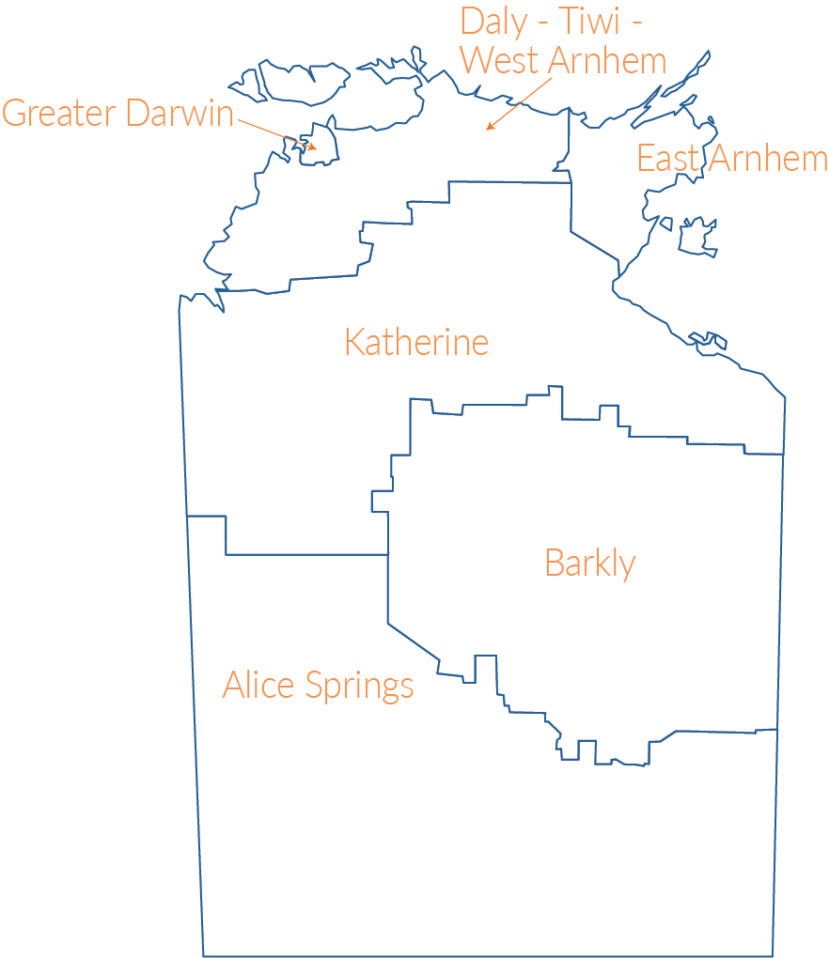
Source: Adapted from ABS Australian Statistical Geography Standard (ASGS) Volume 1 – Northern Territory Maps

Appendix 2B: Greater Darwin regions
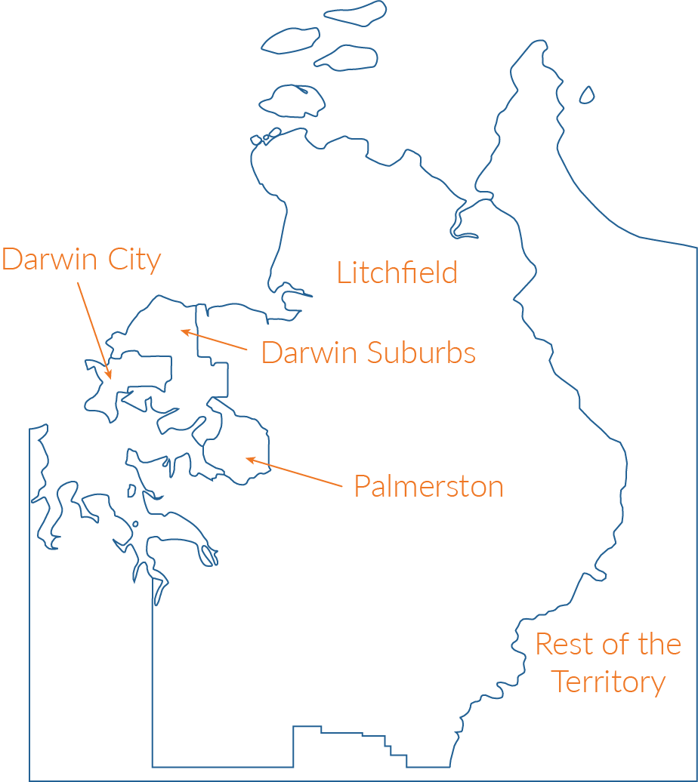
Source: Adapted from ABS Australian Statistical Geography Standard (ASGS) Volume 1 – Northern Territory Maps

The NTG has adopted the term Aboriginal instead of Indigenous, and Aboriginal includes Torres Strait Islanders.
Wilson T, 2009, “A multistate model for projecting regional populations by Indigenous status: an application to the Northern Territory, Australia”, Environment and Planning A 41 230-249.
Wilson T, Brokensha H, Rowe F and Simpson L, 2018, “Insights from the evaluation of past local area population forecasts”, Population Research and Policy Review 37 137-155.

