Budget Overview

Budget at a Glance
The 2014-15 Budget has a focus on eliminating the Territory’s fiscal deficit by 2017-18, through increased own-source revenue and service delivery improvements, while ensuring the Government’s priorities are achieved.
The 2014-15 Budget provides resources to develop Northern Australia by building on the Government’s key priorities of attracting investment in mineral resources, increasing tourist visitation, expanding the Territory’s primary industries, investing in infrastructure and increasing the supply of affordable housing.
Fiscal Position
The Government has continued its targeted elimination of the fiscal deficit in order to stabilise the Territory’s debt burden by 2017-18. The fiscal deficit has improved significantly since the May 2013 Budget, with a small deficit of $39 million projected by 2017-18. The significant improvement is a result of additional own-source revenue due to the current economic conditions, efficiency measures across general government agencies and the improving financial position of the Power and Water Corporation.
Key Economic Indicators
Economic growth in the Territory is estimated to be 5.0 per cent in 2013-14, strengthening to 6.0 per cent in 2014-15. Growth is expected to be underpinned by an acceleration of onshore construction activity related to the INPEX Ichthys liquefied natural gas project.
In the forward years, the Territory economy is expected to undergo a significant transition. From 2015-16, private investment is expected to moderate and net exports are expected to emerge as the primary driver of economic growth as the Ichthys project transitions from the construction to the production phase.
Territory employment growth is expected to strengthen over the next two years to 3.8 per cent in 2014-15, supported by elevated levels of construction activity that is expected to flow through to other industries in the Territory.
Consistent with economic activity, Territory population growth is estimated to increase by 1.6 per cent in 2014 before strengthening to 2.6 per cent in 2015.
In the forward years, Territory employment and population growth are expected to moderate as the Ichthys project transitions from the construction phase to the less labour-intensive production phase.
Key Economic Indicators
 | 2012-13 | 2013-14e | 2014-15f | 2015-16f | 2016-17f | 2017-18f
 | % | % | % | % | % | %
Gross state product¹ | 5.6 | 5.0 | 6.0 | 3.0 | 4.0 | 3.5
Population² | 2.3 | 2.0 | 1.6 | 2.6 | 1.0 | 1.0
Employment³ | 2.6 | 3.7 | 3.8 | 2.1 | 0.7 | 0.7
Consumer price index⁴ | 2.0 | 3.9 | 3.0 | 2.8 | 2.5 | 2.5
e: estimate; f: forecast
1 Year ended June, year-on-year percentage change, inflation adjusted.
2 As at December, annual percentage change.
3 Year-on-year percentage change.
4 As at December, year-on-year percentage change.
Source: ABS; Department of Treasury and Finance

Economic Development
The 2014-15 Budget focuses on developing Northern Australia and advancing the Territory’s economy through the creation of jobs and business opportunities including:
- $5.88 million over two years, including an additional $5.1 million to establish the Northern Australia Development Office and to support the Northern Territory Government Commissioner to Indonesia and the Association of Southeast Asian Nations (ASEAN) region;
- $23.8 million over four years to the Department of Mines and Energy to continue the Creating Opportunities for Resource Exploration initiative; and
- an additional $7.5 million for Tourism NT, providing a total of $13.6 million to extend the Territory’s international marketing activities.
Affordable Housing and Land Release
The 2014-15 Budget provides support to ensure housing supply will keep pace with the Territory’s growing population and make home ownership affordable and accessible for Territorians.
The 2014-15 Budget supports a significant residential land release program including $36.9 million to continue the staged development at Zuccoli, $17 million for projects in the Greater Darwin area, $15.7 million for projects in the northern region and $7.3 million for land release projects in Alice Springs including Kilgariff stage 1a and Larapinta Valley redevelopment.
The 2014-15 Budget also invests in public housing assets with $20.6 million for repairs and maintenance, $12.4 million for upgrades and $4 million to continue redevelopment of public housing unit complexes.
The Territory Government continues to support home loan products and services to increase the supply of new housing and alleviate demand pressures in the rental market.
Infrastructure
The 2014-15 infrastructure program underpins the Territory Government’s priority of developing Northern Australia to create economic opportunities for Territorians. Total infrastructure payments will be $1.14 billion in 2014-15, with 71 per cent of this Territory funded.
The 2014-15 infrastructure program focuses on improving transport networks across the Territory by investing $408 million to build new and upgrade existing roads and transport assets, and $135.5 million for projects to accelerate the release of residential, commercial and industrial land.
In partnership with the Commonwealth, the 2014-15 infrastructure program continues the strong investment in remote Indigenous housing and infrastructure, with $122.8 million to build new, and upgrade existing, houses in remote communities. The 2014-15 infrastructure program also provides $421.7 million for new and upgraded infrastructure in remote communities to deliver better housing, transport, health, education and police facilities.
Infrastructure investment in the Power and Water Corporation is estimated at $276 million in 2014-15.
Operating Expenses
Funding to key service delivery agencies in 2014-15 includes:
- $1.35 billion for Health;
- $871 million for Education;
- $382 million for Police, Fire and Emergency Services;
- $310 million for Housing;
- $161 million for Children and Families;
- $223 million for Correctional Services; and
- $153 million for Community Services.

Regional Development
The 2014-15 Budget initiatives include:
- $17.5 million to upgrade essential services infrastructure in remote communities;
- $10 million for strategic regional economic infrastructure;
- $49.2 million to support the local economies of regional areas including funding for vocational education and training, tourism marketing and livestock and mining industry support; and
- $184.2 million in 2014-15 under the ten-year Stronger Futures in the Northern Territory National Partnership Agreement to improve Indigenous outcomes.

Significant Territory Government 2014-15 Projects
Project | $M
Palmerston East headworks | 37
Alice Springs Hospital upgrades | 35
Royal Darwin Hospital upgrades | 35
Strategic economic development roads | 30
Greater Darwin area land release | 17
Northern region land release | 16
Southern region land release | 11
Hidden Valley Motor Sports Complex upgrades | 9
Outback Way roads | 7

Major Capital Works Projects by Functional Category
 | $M
Roads and transport | 326
Housing and related works | 181
Health | 160
Economic and community infrastructure | 139
Education | 49
Community safety | 46
Lifestyle and environment | 28
Total Budget sector | 929

Other Key 2014-15 Initiatives
The 2014-15 Budget includes:
- $5 million to expand the Sports Voucher scheme from $75 to $200 and to include more activities;
- $5.9 million to increase and expand the Northern Territory Early Childhood Services Subsidy; and
- $6.6 million to continue providing the Back to School Voucher of $150 per student across all Territory schools.

Fiscal Outlook
Fiscal Outlook
The 2014-15 Budget demonstrates the Government’s continued focus on returning the Budget to a balanced position by 2017-18. It presents a significantly improved fiscal position from that projected in the 2013-14 Budget. This improved fiscal outlook has been achieved through a combination of the following factors:
- increased Territory revenue;
- additional efficiency measures through improved service delivery; and
- an improving financial performance of the Power and Water Corporation.
These factors have resulted in the general government net operating balance now projected to be in surplus by 2014-15, two years ahead of the fiscal strategy target. In addition, the non financial public sector fiscal balance has improved on average by $170 million per annum when compared to the 2013 May Budget. A small fiscal deficit of $39 million is projected in 2017-18, the target year to return the budget to surplus. Improvements in net debt and the net debt to revenue ratio are also projected over the forward estimate period.
For 2014-15 the fiscal deficit is projected to be $723 million, $372 million higher than expected in the 2013-14 Budget due to the delay in the completion of the Darwin Correctional Precinct. This increase has been offset by higher revenues.
Key Fiscal Indicators
 | 2013-14 | 2014-15 | 2015-16 | 2016-17 | 2017-18
 | Estimate | Budget | Forward Estimates
 | $M | $M | $M | $M | $M
Net operating balance – GGS | - 31 | 63 | 99 | 69 | 1
Fiscal balance – NFPS | - 395 | - 723 | - 92 | - 53 | - 39
Net debt – NFPS | 3 406 | 4 066 | 4 117 | 4 139 | 4 159
Net debt to revenue – NFPS (%) | 58 | 67 | 66 | 65 | 65
GGS: general government sector; NFPS: non financial public sector
Source: Department of Treasury and Finance
Non Financial Public Sector – Fiscal Balance
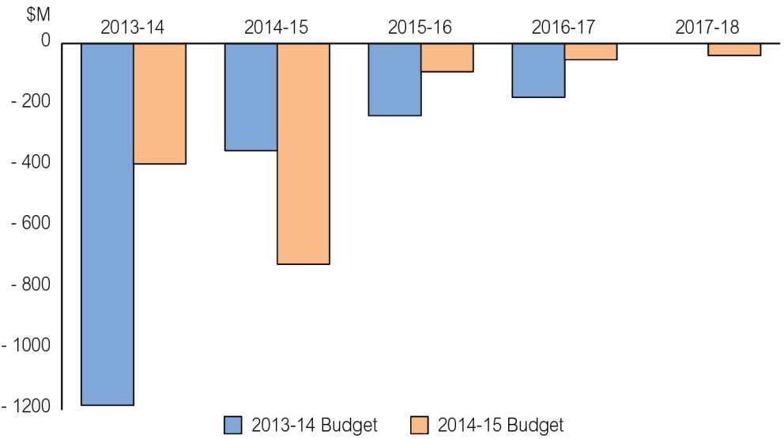
Source: Department of Treasury and Finance

Infrastructure
Total infrastructure payments in 2014-15 are estimated to be $1.14 billion, including $799 million for capital projects and $335 million for repairs and maintenance.
Total infrastructure payments remain steady in 2014-15, compared to 2013-14 in recognition of continued strong private sector investment associated with major projects.
The Budget sector capital works program in 2014-15 is $929 million, with 72 per cent dedicated to housing, roads and transport, and health.
Revenue
Territory revenue is expected to be $5.4 billion in the general government sector in 2014-15. This comprises around 58 per cent GST revenue, 19 per cent tied Commonwealth funding and 23 per cent Territory own-source revenue.
The projected revenue for 2014-15 from Territory own-source revenue totals $1.2 billion with Commonwealth revenue totalling $4.17 billion as shown below.
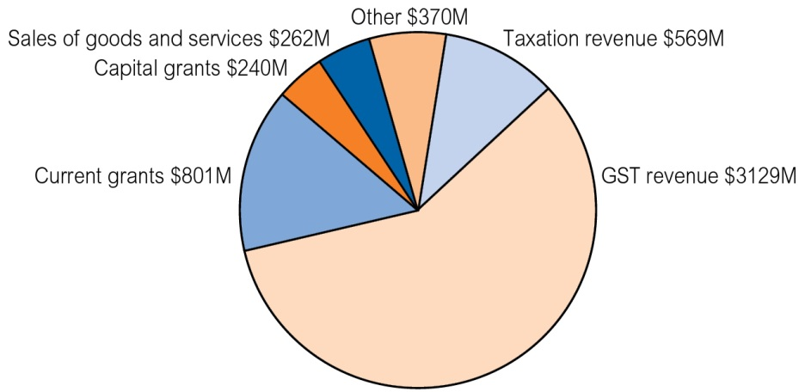
Source: Department of Treasury and Finance
Expenses
In 2014-15, Territory expenses for the general government sector are estimated to be $5.3 billion. The key functions of health, education, and public order and safety comprise 58 per cent of total expenses.
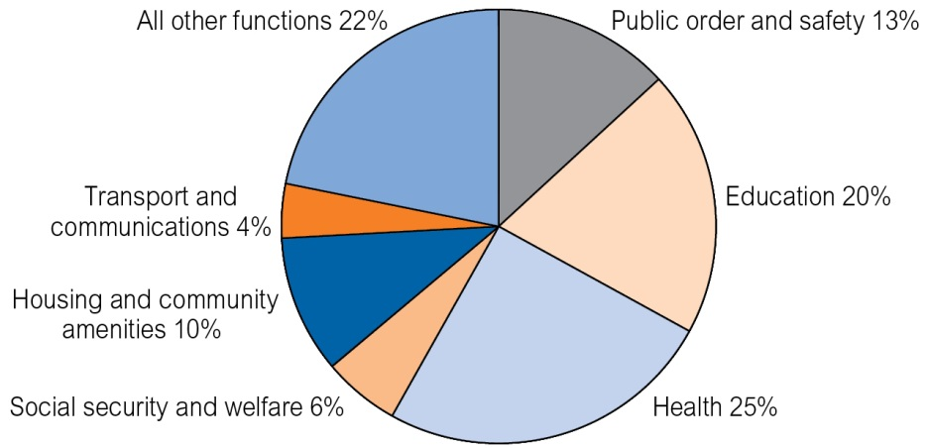
Source: Department of Treasury and Finance

Intergovernmental Financial Arrangements
Intergovernmental financial arrangements continue to be of critical importance to the Northern Territory Budget.
The major source of revenue to the Territory remains the GST, representing about 58 per cent of the Territory’s total revenue. GST revenue to the Territory in 2014-15 is now expected to be higher than in 2013-14.
Total Revenue 2014-15
 | $M
Commonwealth revenue | 4 171
GST | 3 129
Specific Purpose Payments | 297
National Partnership payments | 444
Other Commonwealth revenue | 301
Own-source revenue | 1 200
Total revenue | 5 370
Tied Commonwealth revenue is 19 per cent of the Territory’s total revenue, with the Territory’s own-source revenue contributing 23 per cent.
Growth in own-source revenue reflects current economic conditions and results in the following increases in 2014-15:
- stamp duties of $18.4 million;
- payroll tax of $34.8 million; and
- mining royalties of $50.8 million.
Government’s Fiscal Strategy
Key fiscal target: by 2017-18 the fiscal imbalance in the Territory’s non financial public sector is to be eliminated.
Assessment: fiscal balance trending to improvement with a deficit of $39 million projected in 2017-18.
Associated fiscal outcome: by 2016-17 the Territory’s general government sector to achieve a net operating surplus.
Assessment: the operating balance in 2014-15 is a surplus, two years ahead of the fiscal strategy target.
Associated fiscal outcome: by 2016-17, taxation effort in the Territory’s general government sector is more on par with the average effort of the states.
Assessment: the Territory’s revenue-raising effort in 2012-13 is 84 per cent, from 78 per cent in 2011-12.
Associated fiscal outcome: by 2016-17, the Territory’s government owned corporation is moving towards commercial rates of return on capital employed.
Assessment: the 2016-17 estimate of 5.4 per cent is trending towards the target measure.
Associated fiscal outcome: by 2020, the Territory’s non financial public sector net debt as a percentage of revenue is approaching 60 per cent.
Assessment: net debt to revenue is projected to decrease to 65 per cent in 2017-18.

Infrastructure
Investing in the Territory’s Future
The 2014-15 Budget continues to deliver high levels of infrastructure investment in the Territory, providing a total infrastructure budget of $1.14 billion.
Major highlights of the 2014-15 infrastructure program include:
- $224 million for housing in the Territory including:
- $122.8 million for remote Indigenous housing capital works and $19.5 million for repairs and maintenance grants;
- $32 million for government employee housing for more nurses, teachers and police officers in remote towns; and
- $4 million to redevelop existing public housing complexes across the Territory.
- $84 million for education infrastructure including:
- $11.6 million for the Northern Territory Open Education Centre;
- $5 million to commence construction of boarding facilities to provide bush students improved access to secondary education;
- $1.2 million to extend Rosebery Preschool to provide additional places; and
- $34.9 million to maintain Territory schools.
- $191 million for health infrastructure including:
- $43.6 million for remote health centres in Canteen Creek, Elliott, Galiwin’ku, Kaltukatjara, Maningrida, Ngukurr, Ntaria, Numbulwar, Papunya, Robinson River and Titjikala;
- $35 million for upgrades at Royal Darwin Hospital;
- $5.2 million for a multidisciplinary teaching and training facility at Alice Springs Hospital; and
- $1.9 million to upgrade airconditioning at Katherine Hospital.
- $40 million for new and improved police, fire and emergency services infrastructure, including $14.2 million to continue works to deliver multipurpose police stations at Arlparra and Yuendumu.
Residential Land Release
The 2014-15 Budget provides $84.4 million to progress the release of residential land including:
- $44.9 million to support accelerated land release in Palmerston East and bring forward new releases in Berrimah Farm and Palmerston North, and to continue the staged development of land at Zuccoli; and
- $39.5 million to progress land release projects across the Territory, including Humpty Doo, stage 2 of the Darwin Waterfront Development, Katherine East, Kalkarindji, Mataranka, Timber Creek, Pine Creek, Tennant Creek, Ti Tree, Kilgariff land development and Larapinta Valley redevelopment.
Investment in Roads
The 2014-15 Budget provides $378 million towards Territory roads and national highways, including $81 million for repairs and maintenance. Investment by the Territory and Commonwealth governments includes:
- $30 million for strategic economic development roads projects across the Territory;
- $5 million for improved local roads traffic management initiatives;
- $4 million to upgrade the Leviathan Creek crossing on Fog Bay Road to improve flood immunity, including constructing a new bridge and associated approaches and drainage works;
- $7.3 million to commence improvement of the Outback Way, including upgrading and sealing various sections of the Plenty Highway and Tjukururu Road;
- $2.75 million to upgrade rural roads in the Katherine region, including roads in the Edith Farms, Emungalan and Florina areas and bridging at Leight Creek;
- $2.5 million to seal sections of the Lajamanu access road between Kalkarindji and Lajamanu;
- $3 million to upgrade the Larapinta Drive/Lovegrove Drive intersection in Alice Springs;
- $4.75 million to continue upgrading and sealing Litchfield Park Road;
- $45 million to commence works on six priority projects on the regional road network as part of the Regional Roads Productivity Package;
- $5.5 million to duplicate Roystonea Avenue from Temple Terrace to Gurd Street, including intersection upgrades;
- $17 million to upgrade, strengthen and widen urban arterial, rural arterial and local roads;
- $3 million for road safety and traffic management improvements on urban arterials; and
- $6 million to continue the Roads to Recovery Program on targeted local roads.
The 2014-15 Budget also commits $83 million to continue the duplication of Tiger Brennan Drive from the Darwin CBD to Berrimah as part of the Territory’s $103 million Territory and Commonwealth governments’ project.
Essential Infrastructure
The Territory Government is investing $276 million to upgrade, deliver and maintain power, water and sewerage infrastructure.
The 2014-15 Budget also provides $17.5 million to upgrade essential services infrastructure in remote communities to support additional housing and expanded government services, as well as $32.5 million in capital and repairs and maintenance investment for the Indigenous Essential Services program.
Total Infrastructure Payments
 |  | 2014-15
 |  | Program | Cash
 |  | $M | $M
BUDGET SECTOR
Capital works |  | 929 | 566
Grants
Capital grants |  |  | 38
Repairs and maintenance grants |  |  | 35
Total grants |  |  | 73
Repairs and maintenance |  |  | 219
Infrastructure-related
Asset planning and delivery |  |  | 6
Total infrastructure-related payments |  |  | 6
TOTAL BUDGET SECTOR |  |  | 864
GOVERNMENT OWNED CORPORATIONS
Power and Water Corporation
Capital works |  |  | 195
Repairs and maintenance |  |  | 81
TOTAL GOVERNMENT OWNED CORPORATIONS |  |  | 276
TOTAL INFRASTRUCTURE PAYMENTS |  |  | 1 140

Industrial Land Release
The 2014-15 Budget provides $51.1 million to progress the release of commercial and industrial land including:
- $5.1 million for subdivision works and associated services to create 11 strategically located industrial blocks at Darwin Business Park North;
- $6 million at Darwin Business Park to service further subdivisions;
- $6.3 million to construct 7 hectares of land to create five industrial lots adjoining Muramats Road in East Arm;
- $3 million for industrial land release on Udall Road, Tennant Creek;
- $0.8 million to construct new and upgrade existing assets and infrastructure to support agriculture, aquaculture, industrial and tourism industries on the Tiwi Islands; and
- $5.9 million to continue works, including the release of 14 lots for transport services under stage 1 of the Wishart Road Industrial Precinct development.

Developing the Economy
The 2014-15 Budget focuses on developing Northern Australia and advancing the Territory’s economy through the creation of jobs and business opportunities including $157 million for business, $45 million for tourism, $36 million for mines and energy and $54 million for primary industry and fisheries.
Regional Investment
The 2014-15 Budget promotes economic development in the Territory’s regions through investment in roads, infrastructure and services, including:
Tiwi Islands
- $0.8 million to continue the Tiwi Islands ferry services; and
- $0.26 million for economic development in the Tiwi Islands.
East Arnhem
- $2 million to match Rio Tinto’s $2 million contribution to establish a regional economic development fund for the transitional support package for the East Arnhem region;
- $0.5 million for a medium to large vessel pontoon at Melville Bay in Nhulunbuy; and
- $2.6 million to replace water storage facilities at Numbulwar and Yirrkala.
Central Australia
- $5.2 million for a multidisciplinary teaching and training facility at Alice Springs Hospital;
- $2.5 million to construct a tourism boardwalk in Alice Springs;
- $7.3 million to improve Outback Way roads;
- $3 million to upgrade the Larapinta and Lovegrove drives intersection; and
- $3 million for a new Supreme Court in Alice Springs.
Across the Territory
- $30 million for strategic economic development roads projects;
- $45 million in partnership with the Commonwealth for a Regional Roads Productivity Package to upgrade the Roper Highway, Port Keats Road, Arnhem Link Road, Buntine Highway, Central Arnhem Road and Santa Teresa Road; and
- $14.85 million to upgrade sewerage at Maningrida, Angurugu and Galiwin’ku.
Primary Industry and Fisheries
The 2014-15 Budget positions the Territory’s primary industry and fisheries sectors to benefit from trade and investment opportunities by investing:
- $1 million over two years to establish a Food Industry Development Group to drive agricultural development activities;
- $1.24 million, including Commonwealth funding of $0.35 million, to improve export access to overseas markets and lengthen the mango production season;
- $0.4 million to lead Ord stage 3 development work;
- $0.4 million to support the Indigenous Pastoral Program; and
- $0.7 million to continue to develop Indigenous commercial fishing capacity.
Tourism
The 2014-15 Budget includes $17.5 million for domestic marketing activity, $13.6 million (including an additional $7.5 million) to market the Territory internationally, and an additional $0.5 million for a tourism product development grant program focused on regional and remote areas. Tourism funding includes:

International Marketing
- $2.8 million for eastern markets to support marketing by Territory operators and promote travel to Darwin and the Top End;
- $7.6 million for western markets with a continued focus on regional dispersal to the Territory as part of broader Tourism Australia campaigns;
- $0.5 million for marketing on the east coast of Australia to encourage travellers already in Australia to include the Territory as part of their travel plans; and
- $0.8 million for cooperative marketing campaigns with airlines to build inbound demand for existing aviation services.
Domestic Marketing
- $3 million for branding and regional awareness promotions including corporate sponsorships;
- $8.2 million in cooperative activity to drive sales and trade training; and
- $0.65 million to capture and update tourism imagery across the regions.
Other Initiatives
- $1.9 million for the provision of regional marketing and visitor information services across the Territory; and
- $2.5 million to promote the Territory as a business event destination.
Northern Australia Development Office
The 2014-15 Budget includes $5.88 million over the next two years to support the Northern Australia Development Office to harness and coordinate the Territory Government’s economic development strategies locally, nationally and internationally. Additional funding includes:
- $3.6 million to work with the Commonwealth and industry groups to capitalise on economic development opportunities in the Territory; and
- $1.5 million to support the Northern Territory Government Commissioner to Indonesia and the ASEAN region.
Mines and Energy
The 2014-15 Budget includes $23.8 million over four years to continue the Creating Opportunities for Resource Exploration initiative, including:
- $15.8 million to create opportunities for resource exploration, including acquiring pre-competitive geoscience information, providing industry grants for high-risk exploration, and promoting the Territory as an exploration investment destination;
- $8 million to assess the Territory’s shale gas potential and resources;
- $1.5 million to support mineral and petroleum exploration; and
- $1.1 million to improve mining approval timeframes and water monitoring assessment.
Business
The 2014-15 Budget supports local businesses to take advantage of opportunities in the growing Territory economy, including:
- $5.4 million for a suite of industry development programs, which aim to increase the capacity and capability of local businesses;
- $1.85 million to continue to support Territory Business Centres;
- $1 million to continue the Indigenous Workforce Participation Program, to support Indigenous employment opportunities;
- $0.95 million for a Red Tape Abolition Squad and to progress procurement reforms;
- $0.5 million over two years to implement the Business Innovation Support Initiatives program to provide funding to small and medium-sized businesses to pursue innovation and undertake research and development projects; and
- $0.2 million to provide business management upskill workshops to enhance business performance and employment.

Regional Highlights
Darwin
- $891.4M for better health
- $318.2M for better schooling
- $293.4M for safer communities
- $83M to duplicate Tiger Brennan Drive – CBD to Berrimah
- $42.6M to support the local economy
- $22.8M to upgrade Royal Darwin Hospital
- $11.6M for the new Northern Territory Open Education Centre
- $5M for the foreshore boardwalk along the base of Darwin City Esplanade from Darwin Waterfront
- $4.3M to upgrade the Hidden Valley Motor Sports Complex
- $4M to facilitate the release of land at Berrimah Farm
- $3M for the refurbishment of Darwin Plaza
- $2.4M for Leanyer Recreation Park

Palmerston and Litchfield
- $182.1M for safer communities
- $153.4M for better schooling
- $23.9M for headworks infrastructure to continue release of land in Palmerston East
- $12.8M for the Channel Island power station
- $8.8M to help support the local economy
- $6.5M for land release projects in Humpty Doo and Palmerston North
- $6.3M to provide public bus transport
- $6.1M for the Territory Wildlife Park
- $5.5M to duplicate Roystonea Avenue
- $5M for preliminary works and planning of the Palmerston Regional Hospital
- $3.5M for non-acute health and community services in the region
- $2.2M to extend Rosebery and Durack preschools

Top End Rural
- $62.3M under National Partnership Agreements for new housing, upgrades and property and tenancy management
- $54M for better schooling
- $49.2M for better health
- $19.7M to help support the local economy
- $17.9M for safer communities
- $5.9M to strengthen and widen sections of the Arnhem Highway
- $9M for new and continued works to upgrade and seal Fog Bay Road, including the Leviathan Creek crossing
- $2.5M for Mary River floodplain
protection
- $2M to upgrade the hardstand at Wurrumiyanga
- $1.7M for Maningrida Health Clinic upgrades
- $0.43M for feral cat management

Katherine
- $90.8M for better schooling
- $59.2M for better health
- $59.1M for safer communities
- $32.4M under National Partnership Agreements for new housing, upgrades and property and tenancy management
- $11.1M to help support the local economy
- $2.8M to upgrade Katherine rural roads
- $2.5M to seal the Yarralin airstrip
- $2.5M to seal selected sections of the Lajamanu Access Road
- $2.2M for the Ngukurr Trade Training Centre
- $1.5M to support new regional councils

Central Australia
- $344.9M for better health
- $159.9M for safer communities
- $32.7M under National Partnership Agreements for new housing, upgrades and property and tenancy management
- $20.8M to help support the local economy
- $10.2M to continue and expand the Territory and Commonwealth governments’ Alice Springs Transformation Plan
- $7.3M to upgrade Outback Way roads
- $6.9M to develop and subdivide the Ilpeye Ilpeye town camp
- $6.3M to progress land release in Kilgariff
- $5.8M for the Alice Springs Desert Park
- $2.5M for tourism boardwalks
- $1.27M to stage the Alice Springs Masters Games and support the Imparja Cup
- $0.47M for the assessment of mining impacts on surface and groundwater

East Arnhem
- $88.9M for better schooling
- $48.1M for better health
- $28.2M for safer communities
- $12.3M to continue works in remote health clinics in Galiwin’ku and Numbulwar
- $12.9M under National Partnership Agreements for new housing, upgrades and property and tenancy management
- $10.6M for continued upgrades to the Central Arnhem Highway
- $11.5M to help support the local economy
- $6.2M to continue works on trade training centres across the East Arnhem region
- $2.82M to enhance a 50-bed prisoner work camp in Nhulunbuy
- $0.25M for the Marine Ranger Program

Barkly
- $32.2M for better schooling
- $26.1M for safer communities
- $26.3M for better health
- $10.4M under National Partnership Agreements for new housing, upgrades and property and tenancy management
- $8.2M to upgrade the gas engines at Tennant Creek power station
- $5.8M to help support the local economy
- $5.18M to oversee the Commonwealth-funded Remote Indigenous Housing Community Benefits Package and youth accommodation initiatives
- $10.1M to continue works on the new remote health centres at Elliott and Canteen Creek
- $2.5M to upgrade and seal the existing airstrip at Canteen Creek

Territory Wide
- $45M for the Regional Roads Productivity Package
- $32.2M to support homelands
- $30.8M for aeromedical retrieval services including patient-assisted travel
- $30M for strategic economic roads
- $28.3M for mandatory treatment alcohol reform programs
- $27.9M to subsidise pensioners, carers and seniors in the Territory
- $30.5M for grants to councils
- $24.6M to market and promote the Territory as a leisure tourism destination
- $24.4M for public housing, including refurbishing existing unit complexes
- $14.7M to assist the thoroughbred racing industry
- $8.6M to undertake asbestos removal from non-government buildings in 34 remote communities
- $7.12M for the newly independent Museum and Art Gallery of the Northern Territory
- $6.7M to manage and deliver geoscience and exploration data to the minerals and petroleum exploration industry
- $5.65M to support sporting peak bodies and active recreation organisations
- $5.5M to deliver sustainable municipal and essential services in rural and remote Indigenous communities
- $5M to expand the Sports Voucher scheme to include recreational and cultural activities

Community Safety
The 2014-15 Budget commits $709 million to reducing crime and increasing community safety for all Territorians. The Territory Government continues to focus on all areas of law and order, including reducing alcohol-related crime, as well as property offences, house break-ins, theft and property damage.
Community Safety
Northern Territory Domestic and Family Violence Reduction Strategy
The Northern Territory Domestic and Family Violence Reduction Strategy will be implemented in 2014, addressing domestic violence by focusing on prevention, early intervention, protection, rebuilding the lives of victims and their children, as well as accountability and positive change for perpetrators.
Mandatory Rehabilitation
The Territory Government continues to provide support for mandatory rehabilitation for problem drinkers. Since inception, more than 300 people have been assessed and provided with medical withdrawal and rehabilitation services.
The 2014-15 Budget provides for the establishment of custom-designed mandatory rehabilitation facilities, including:
- the Darwin services transferring to a facility in Berrimah, following its refurbishment into a therapeutic environment;
- a secure treatment facility in Katherine to complement expanded assessment capacity at Katherine Hospital;
- assessment and treatment facilities being developed in Tennant Creek; and
- increased capacity in Alice Springs.
Strengthening Police Services
The 2014-15 Budget also continues to support frontline policing through technology and facility upgrades including:
- installation of five new CCTV cameras at the Elizabeth River boat ramp, which will also be monitored by the CCTV Unit in Darwin;
- $4.34 million to continue to operate 24/7 front counter services at the Alice Springs Police Station, as well as upgrade and support the Northern Territory Joint Emergency Services Communication Centre (JESCC) to build on significant improvements in answer times over the past year. The funding includes $1.5 million to continue refurbishment of facilities at JESCC and additional technological resources to allow police to be dispatched to incidents electronically via new tablets; and
- $3.96 million for continued upgrades for information, communication and technology systems, including $0.91 million to upgrade the NT Fire Alarm System Transmission.
A further $0.466 million is provided in 2014-15 for a Water Police program to provide marine ranger training.
Upgraded and New Police Facilities
The 2014-15 Budget provides $39.7 million for police infrastructure, including:
- $9 million to redevelop the Alice Springs Police Station;
- $15.6 million to construct police facilities in Arlparra, Yuendumu and Pirlangimpi;
- $1.8 million for overnight police facilities in Mount Leibig, Areyonga and Robinson River; and
- $8.4 million for repairs and maintenance for police, fire and emergency services facilities.
Supporting the Justice System
The 2014-15 Budget provides new facilities and additional support for the justice system through:
- $3 million for a new Supreme Court in Alice Springs;
- $3.36 million to establish and operate the Northern Territory Civil and Administrative Tribunal. The tribunal is being established to provide a single, easy to find, easy to use, non-judicial body, for fair and independent resolution of disputes relating to administrative decisions; and
- $0.3 million to the Office of the Commissioner for Information and Public Interest Disclosures to strengthen capacity to investigate claims of serious improper conduct and corruption within public sector organisations.
Enhanced Correctional Services
The 2014-15 Budget also provides:
- $2.45 million to establish a 50-bed regional work camp at Nhulunbuy;
- $1 million to provide enhanced electronic monitoring and surveillance of offenders in the community; and
- $2.3 million to establish and operate a mental health facility at the Darwin Correctional Precinct.
Youth Support
The 2014-15 Budget focuses on improving youth justice facilities and services to help reduce the number of young people at risk of offending and re-offending with the development of the Youth Justice Framework and includes:
- $9.75 million for youth detention across the Territory to provide a safe, structured, secure and supportive environment for young offenders; and
- $5.65 million for early intervention targeted youth programs including boot camps and community-based diversion programs for young people at risk of entering, or in, the youth justice system.
Darwin Correctional Precinct
The 2014-15 Budget provides $70.7 million for costs associated with the commencement and operation of the new Darwin Correctional Precinct at Holtze.
The facility is designed to maximise education, training and employment opportunities for inmates in line with the Government’s focus on reducing re-offending across the Territory.
The precinct will see the establishment of Northern Territory Correctional Industries, providing more opportunities for inmates to receive valuable training to assist reintegration into the community and reduce the risk of recidivism.
The Budget also includes $1.85 million to support ‘Sentenced to a Job’ and the continued enhancement of prison industries at Alice Springs Correctional Centre.

Education and Training
Education Reform
The 2014-15 Budget includes $17 million over three years to support implementation of a suite of reforms, such as the independent public schools initiative and global school budgeting. The reforms will increase school autonomy by facilitating greater local decision making to improve school performance, school leadership and teaching quality.
The reforms are being supported by a review of the Education Act, which presents an opportunity to introduce the best elements of successful initiatives and reforms in other jurisdictions and internationally that have shown evidence of improving education outcomes.
The 2014-15 Budget supports Territory students and families to maximise educational outcomes, reduce cost of living pressures on families and support post-school education.
Improving Educational Facilities
The 2014-15 Budget provides new, and upgrades existing, school infrastructure across the Territory. New infrastructure projects include providing additional classrooms and educational facilities and new services to support special needs students.
The 2014-15 Budget provides $83.9 million for new education-related infrastructure priorities, including:
- $5 million to construct boarding facilities to provide bush students improved access to secondary education, being the first year of a four-year, $40.5 million program;
- $1.2 million to extend Rosebery Preschool to provide additional enrolment places;
- $11.6 million for construction of the Northern Territory Open Education Centre, including a $3 million contribution from INPEX;
- $5.2 million for extra classroom space and related works at Maningrida, Galiwin’ku, Borroloola, Ntaria and Alekarenge schools to meet higher student attendance needs;
- $1.2 million for the redevelopment of the Batchelor Outdoor Education Centre;
- $1 million to extend the preschool at Durack Primary School; and
- $1.5 million to provide two permanent classrooms and a flexible learning space at Larrakeyah Primary School.
In addition to infrastructure funding in the 2014-15 Budget, the government has committed to new facilities over the next four years, including:
- $37 million over two stages for a new preschool and primary school in Zuccoli;
- $20 million for a new special school in Bellamack; and
- $10 million for special school infrastructure in the northern suburbs.
The 2014-15 Budget includes $9.2 million for minor new works in 44 schools across the Territory, including:
- $1.2 million to install and upgrade playground equipment and outdoor learning areas in schools across the Territory;
- $1.63 million to resolve flooding and drainage issues and upgrade ablutions at schools across the Territory;
- $0.45 million to install and upgrade basketball and netball courts at Centralian Senior College, Darwin Middle School, Wagaman Primary School and Woolianna School;
- $0.3 million for disabled and special needs access modifications in schools across the Territory;
- $0.45 million to improve parking, security and access at Sanderson Middle School;
- $0.2 million to upgrade facilities at Pularumpi School;
- $0.4 million to upgrade the administration area at Wulagi Primary School as part of modernising the school;
- $0.4 million to relocate and refurbish the English/humanities faculty room at Darwin High School;
- $0.3 million to construct a new boundary fence at Ntaria School; and
- $0.5 million to install additional gutters and covered walkways at Dripstone Middle School, Jingili Primary School and Rosebery Primary School.
The 2014-15 Budget also includes $34.9 million for repairs and maintenance of schools across the Territory, to repair ageing assets needing major mechanical, plumbing and roofing works, conduct regular tree inspections, improve energy efficiency of older buildings and fund retrospective building certification and compliance issues. The funding includes $4 million for remote schools in Central Australia.
Training Opportunities
The 2014-15 Budget creates opportunities for skills development throughout the Territory to deliver lifelong learning for all Territorians, including:
- $42 million in Territory and Commonwealth funding for Charles Darwin University and the Batchelor Institute of Indigenous Tertiary Education to deliver qualifications to Territorians to develop new skills or build on existing skills for employment opportunities;
- $4.66 million in Territory and Commonwealth funding for the Apprenticeship and Traineeship Support package for training of apprentices and trainees, and supporting their employers;
- $5 million to provide vocational education, training and employment pathways in schools, including through trade training centres and pre-employment programs across the Territory in partnership with industry;
- $5.7 million in partnership with the Commonwealth to assist Territorians to achieve their first qualification at Certificate III or above through private training providers;
- $2.45 million for continued support for Indigenous Territorians to access training that links to community projects with employment outcomes, improved employability skills or enterprise development; and
- $1 million in partnership with the Commonwealth to continue implementing the Stronger Futures Local Jobs Program to deliver up to 100 additional traineeships for Indigenous Territorians in remote communities by June 2016.
Reducing the Cost of Living
The 2014-15 Budget provides additional funding to help reduce day-to-day costs faced by Territory families.
Northern Territory Early Childhood Services Subsidy
The 2014-15 Budget provides $5.9 million for the Northern Territory Early Childhood Services Subsidy, including additional funding of $1.3 million to expand the scheme to include family day care and $0.4 million to increase the subsidy by 10 per cent.
The subsidy of $30 per week contributes around $1445 per year towards the cost of day care for children under the age of two, and $22 per week (around $1067 per year) for children aged between two and five.
Sports Voucher
The 2014-15 Budget provides a $5 million increase to the Government’s Sports Voucher scheme, increasing the annual voucher from $75 to $200. The voucher will be available twice a year ($100 in July and $100 in January) and has been expanded to include other recreation and cultural activities. The expanded scheme also allows vouchers to be used for learn-to-swim lessons for children up to five years of age.
Back to School Payment
The 2014-15 Budget includes $6.6 million to continue providing the Back to School Payment Scheme of $150 per student across all Territory schools. The scheme assists parents with expenses such as school uniforms and textbooks.

Health and Wellbeing
The 2014-15 Budget supports the health and wellbeing of all Territorians by investing in health infrastructure and services with $1.35 billion in total health-related expenditure.
Palmerston Regional Hospital
The 2014-15 Budget confirms the $150 million Commonwealth and Territory government-funded Palmerston Regional Hospital development.
The hospital will deliver an emergency department and also provide medical and surgical services including cardiology, renal medicine, cancer services, paediatric, antenatal and postnatal obstetric services.
Palmerston Regional Hospital headworks are planned to commence in 2014 and major construction works are anticipated to be underway in 2016. The hospital is projected to be completed in 2018.
Health Services
The 2014-15 Budget provides funding to maintain the expanded range and quality of vital services to Territorians including:
- $6.5 million in continued funding for enhanced cardiac outreach and rehabilitation services and low-risk angioplasty services;
- $7.5 million in continued funding for the implementation of review recommendations to improve the Patient Assistance Travel Scheme, a subsidy scheme to provide financial assistance to Territorians who are referred by an approved practitioner to the nearest approved specialist medical service;
- $4.46 million in continued funding to provide 400 elective surgery procedures per year to reduce elective surgery waiting times; and
- $5.67 million, including an additional $0.16 million in 2014-15, to meet the increased operational costs of the new Alice Springs Hospital emergency department.
Budget 2014-15 also provides additional funding of:
- $0.39 million to support palliative respite care services in Alice Springs;
- $0.725 million for mobile breast screening across remote communities and for a Palmerston-based service; and
- $1.32 million for primary health services at the Darwin Correctional Precinct.
Mental Health
The 2014-15 Budget includes $52.2 million to provide mental health services across the Territory. In 2013-14, the delivery of frontline mental health services transferred from the Department of Health to the Top End and Central Australia Health Services. The department retains responsibility for reporting, policy and procedure development, legal and forensic services, while the Health Services provide specialist mental health services including assessment, case management and treatment.
Northern Territory Pensioner and Carer Concession Scheme
The 2014-15 Budget provides $27.9 million to support seniors, carers, pensioners and veterans through a range of concessions for services including utilities, rates, spectacles, drivers licences, motor vehicle registration and travel.
To ensure that the Northern Territory Pensioner and Carer Concession Scheme (NTPCCS) remains an equitable and sustainable source of support for those most in need, membership requirements for new members entering the NTPCCS have been revised. New senior members will be required to meet Commonwealth eligibility criteria to receive concessions by being in receipt of a Centrelink concession such as the Commonwealth Seniors Health Care Card, bringing seniors into line with membership requirements for existing non-senior scheme members. The revised membership arrangements will only apply to new members, existing members will be unaffected by this change.
Health Infrastructure
The 2014-15 Budget continues to invest in the health and wellbeing of Territorians by upgrading health facilities including:
- $22.8 million for upgrades at Royal Darwin Hospital, including:
- $11.9 million Commonwealth funding to refurbish paediatric wards;
- $6.7 million to upgrade negative pressure rooms; and
- $4.2 million to upgrade fire control measures;
- $8 million in Commonwealth funding for remote health clinics:
- $5.3 million for Robinson River; and
- $2.7 million for Titjikala;
- $35.6 million in Commonwealth funding for remote health centres in Canteen Creek, Elliott, Galiwin’ku, Kaltukatjara, Maningrida, Ngukurr, Ntaria, Numbulwar and Papunya;
- $5.2 million in Commonwealth funding for a multidisciplinary teaching and training facility at the Alice Springs Hospital; and
- $1.9 million for emergency department airconditioning at Katherine Hospital.
New Health Services Framework
From 1 July 2014, primary health care services will be integrated into the Top End Health Service and the Central Australia Health Service through the transfer of urban and remote primary health care services and prison health from the Department of Health.
The three separate entities (the department and the two Health Services) will continue to operate as a single Territory-wide system with consistent standards and protocols to ensure that service accessibility, safety and quality are not compromised by the structural changes.
Supporting Children
Budget 2014-15 provides $161 million to the Department of Children and Families for a range of services to protect children in the Northern Territory from harm, including:
- $79.4 million to provide out-of-home care services including:
- $0.8 million for additional recruitment, retention and support for foster and kinship carers, improving long-term care options for children;
- $2.1 million to improve management and accountability of out-of-home care services, providing better outcomes for children; and
- $0.5 million for a new residential care facility in Tennant Creek for children under ten years
of age;
- $33.9 million to provide child protection services including $40 000 for upgrades to the Katherine Service Centre to provide sensitive and secure premises for staff and clients; and
- $38.3 million for family and parent support services including $1.4 million for new youth services in Katherine, Darwin and Alice Springs.
Budget 2014-15 also provides $0.94 million to continue funding for the BushMob Youth Residential Rehabilitation Service in Alice Springs.

Housing
The 2014-15 Budget provides strong support for home ownership through the continued release of residential land, a range of Home Build Access loans and a First Home Owner Grant scheme that focuses on increasing the Territory’s new dwelling stock.
Increasing Land Supply
The 2014-15 Budget commits $84.4 million to progress residential land development to meet the needs of the Territory’s growing population, including:
Darwin
- $36.9 million to continue the staged development at Zuccoli;
- $4 million to facilitate the release of land at Berrimah Farm for residential, commercial and mixed-use development;
- $4 million to support headworks for a staged release of a mixed-use urban and residential development at Palmerston North to support and complement the development of the Palmerston Regional Hospital; and
- $4.5 million for headworks for stage 2 of the Darwin Waterfront Development.
Greater Darwin Area
- $4.5 million for drainage works in the rural area and to upgrade headworks infrastructure to support development of private land in Humpty Doo.
Northern Region
- $15.7 million for projects to facilitate land release in Katherine East, Kalkarindji, Pine Creek, Mataranka and Timber Creek.
Southern Region
- $4 million for infrastructure to facilitate land release in Tennant Creek and Ti Tree.
Alice Springs
- $6.3 million for land release projects, including Kilgariff stage 1a and headworks for future stages at Kilgariff.
Indicative dwellings from land release
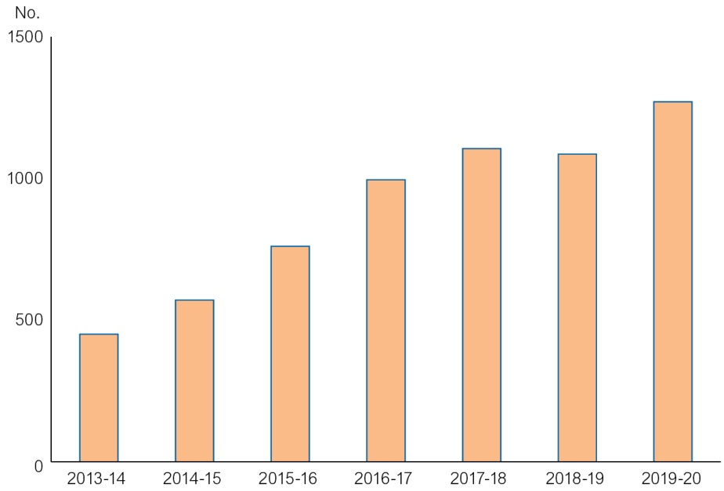
Source: Department of Lands, Planning and Environment

Real Housing for Growth
The Territory Government’s Real Housing for Growth plan provides more housing choices for Territorians, with $6.7 million in 2014-15 to:
- increase the supply of affordable housing for families and key workers to ease cost of living pressures;
- support rental initiatives of the Real Housing for Growth Plan; and
- support a head lease scheme where subsidised rents are provided to eligible key workers at 30 per cent below market rates.
Government Employee Housing
The 2014-15 Budget invests $33.1 million to construct and upgrade government employee housing to support more nurses, teachers and police officers in remote communities including $3.6 million to continue repairs and maintenance of existing government employee assets across the Territory.
Remote Housing
The 2014-15 Budget continues to support the Territory Government’s Framing the Future strategy to improve housing stock for Territorians living in remote areas.
Under National Partnership Agreements between the Territory and Commonwealth governments, the 2014-15 Budget includes:
- $122.8 million to construct new and upgrade existing housing in remote Indigenous communities; and
- $30.2 million to provide property and tenancy management for remote Indigenous public housing.
The 2014-15 Budget also includes $4.5 million over three years from 2014-15, to develop a Remote Indigenous Home Purchase Strategy to increase home ownership opportunities for remote Territorians living in remote communities.
Home Loan Support
The 2014-15 Budget provides a number of home ownership loan products and services to Territorians who would otherwise be unable to access private sector finance. The Territory Government’s home loan products focus on increasing the supply of new housing to alleviate demand pressures in the rental market.
The 2014-15 Budget provides Home Build Access loans for home buyers across the Territory, including:
- the HomeBuild Access Low Deposit Loan, which provides a Territory Government loan of up to 17.5 per cent, with an 80 per cent loan provided by the Territory Insurance Office. This allows home buyers to borrow up to 97.5 per cent of the purchase price, with a deposit of 2.5 per cent;
- the HomeBuild Access Off The Plan Deposit Loan to help fund the deposit for off-the-plan purchases;
- the HomeBuild Access Subsidised Interest Rate Loan, which reduces the interest rate for the first five years of the loan term; and
- a Fee Assistance Loan, for eligible Subsidised Interest Rate Loan applicants, to enable borrowing of up to $10 000 interest-free to help with costs associated with buying a home such as conveyancing, white goods and stamp duty.
First Home Owner Grant
The Territory Government’s First Home Owner Grant provides targeted assistance for people looking to purchase their first property, with the following changes taking effect from 13 May 2014:
- increasing the grant from $25 000 to $26 000 for first home buyers building a new home; and
- removing the $600 000 value cap, meaning buyers can consider a wider range of properties.
To encourage an increase in the construction of new dwellings, the scheme will be available for new homes only from 1 January 2015. The current grant for the purchase of existing homes will cease from this date. This is consistent with most other jurisdictions and encourages an increase in housing supply.
Improving Public Housing
The 2014-15 Budget will support the development of public housing to suit the needs of Territorians and increase the number of smaller one to two-bedroom public housing dwellings suitable for smaller households, senior tenants or tenants with disabilities.
The 2014-15 Budget provides $4 million to continue the redevelopment of public housing unit complexes, with an aim to improve housing affordability and reduce concentrations of social disadvantage.
The 2014-15 Budget also includes $20.6 million for repairs and maintenance for public housing across the Territory and $12.4 million for upgrades.

Lifestyle
The 2014-15 Budget supports Territorians to lead a healthy and balanced lifestyle, with $82 million provided for greater resources for sport, recreation and cultural activities.
Keeping Kids Active
The 2014-15 Budget supports Territory children to get into organised sport and recreation activities to help them lead healthier lives, with additional funding of $5 million for the Sports Voucher scheme, increasing the annual voucher from $75 to $200.
The scheme is being expanded to include more activities such as dance, music lessons and other arts and cultural pursuits and can also be used for learn-to-swim lessons for children up to five years.
The 2014-15 Budget also supports growth of sport at the grassroots level and keeps children and adults active, with $19.67 million in grants to sport and recreation organisations and programs, including:
- $5.6 million for grants to peak sporting bodies and recreation bodies; and
- $2.3 million to support sporting programs in remote communities.
Sports and Major Events
The 2014-15 Budget delivers major sporting and entertainment events for Territorians, with $5.84 million for major events including:
- $2.19 million for the V8 Supercars Championship, including the Race and Rock Concert;
- $1 million to Parramatta Eels to hold an NRL premiership game in Darwin and pre-season game in Alice Springs;
- $1 million to bring the AFL’s Melbourne Demons to the Territory with matches to be played at both TIO Traeger Park in Alice Springs and TIO Stadium in Darwin;
- $0.15 million to support Adelaide United in hosting pre-season A-League games in Alice Springs; and
- $58 000 for the Tattersall’s Finke Desert Race.
Recreation and Fishing
The 2014-15 Budget allows Territorians to continue to enjoy a range of recreational facilities and events, including $14.7 million to assist the thoroughbred racing industry for race meetings.
The 2014-15 Budget provides $11.7 million for fishing industry management and development, including:
- $2.5 million for the sustainable management of the Territory aquatic resource;
- $2.5 million additional funding to upgrade two barrages upstream of Shady Camp on the Mary River to prevent salt water intrusion and protect upstream ecosystems and habitats; and
- $0.56 million for the sustainable management of the Territory’s recreational fishing sector.
Arts and Culture
The 2014-15 Budget helps support arts and cultural institutions so that they can continue to be enjoyed by Territorians and visitors each year.
A total of $44.9 million will help support our arts and cultural institutions including:
- $7.12 million to support the Museum and Art Gallery of the Northern Territory under its new governance arrangement as an independent, stronger statutory authority; and
- $2.85 million for ongoing repairs and maintenance of our cultural institutions across the Territory.
Sporting Facilities
The 2014-15 Budget continues investment in sports and recreation facilities, including:
- $4.27 million for stage 2 upgrades to the Hidden Valley Motor Sports Complex, which includes upgrades of drainage, sewerage and toilets and the redesign of the track’s turn 1;
- $2.38 million for repairs and maintenance to sporting facilities across the Territory; and
- $0.3 million to continue upgrades to the Alice Springs drag strip, and construct light towers to allow night racing and the ability to host regional and national events.
The 2014-15 Budget also includes $0.78 million for minor new works to improve sporting facilities.

