Guidance document: Classification of the functions of government – Australia (COFOG-A)
21 July 2023
Version 1.2

Document details
Document title | Guidance document: Classification of the functions of government – Australia (COFOG-A)
Contact details | Financial Management Group  Department of Treasury and Finance  dtf.financialpolicy@nt.gov.au
Date and version | 21 July 2023  Version 1.2
Approved by | Tarrant Moore  A/Executive Director (Finance)
Date approved | 21 July 2023
Document review | Annually

Change history
Version | Date | Author | Change details
1.0 | 22 February 2018 | DTF Financial Policy | Initial version
1.1 | 29 May 2018 | DTF Financial Policy | Minor amendments, introduce FTE reporting
1.2 | 21 July 2023 | DTF Financial Policy | Minor amendments, update agency names and references

Acronyms
The following acronyms are used in this document
Acronyms | Full form
ABS | Australian Bureau of Statistics
AGFS15 | The Australian System of Government Finance Statistics: Concepts, Sources and Methods – 2015
CGC | Commonwealth Grants Commission
COFOG-A | Classification of the functions of government – Australia
DCDD | Department of Corporate and Digital Development
DIPL | Department of Infrastructure, Planning and Logistics
DTF | Department of Treasury and Finance
FTE | Full-time equivalent
GFS | Government finance statistics
GST | Goods and services tax
SDC | Source destination code
TAFR | Treasurer’s Annual Financial Report
UPF | Uniform Presentation Framework

Contents
1 Introduction 4
1.1 Purpose 4
1.2 Statement 4
1.3 Legislative basis and related documents 4
2 Classification of the functions of government – Australia 5
2.1 Government finance statistics framework 5
2.2 Why is COFOG-A and GFS important to the Territory? 5
2.3 Coding COFOG-A 6
2.3.1 COFOG-A structure 6
2.3.2 COFOG-A coding example 7
3 Reporting 8
3.1 Uniform Presentation Framework 8
3.2 Australian Bureau of Statistics 8
3.3 Agency reporting requirements 8
3.3.1 Reporting process for agencies 8
3.3.2 Reporting corporate and governance expenditure 9
3.3.3 Reporting timeline 9

Introduction

Purpose
To provide best practice guidance to assist accountable officers and agencies to meet their obligations under the Treasurer’s Direction on COFOG-A and the Territory’s whole of government reporting obligations, in accordance with the Australian System of Government Finance Statistics: Concepts, Sources and Methods – 2015 (AGFS15) manual.
Guidance material in this document is not mandatory. If a conflict arises between this guidance document and the Treasurer’s Directions or other legislative requirements, the legislation takes precedence, followed by the Treasurer’s Directions.
The Treasurer’s Direction designates responsibility to the accountable officer. Unless specifically excluded by the Financial Management Act 1995 or Treasurer’s Directions, accountable officers may choose to delegate certain responsibilities and functions to agency employees. This can be done through a number of mechanisms, such as accountable officer approved policies, procedures, and agency delegations.

Statement
The objectives of the Treasurer’s Direction on COFOG-A and this guide are to:
- assist agencies in preparing COFOG-A returns in order to meet Australian Government reporting obligations
- emphasise the importance of data integrity when preparing COFOG-A returns
- explain how the results from COFOG-A returns can impact the Northern Territory Government’s future revenue streams.

Legislative basis and related documents
- Financial Management Act 1995
- Treasurer’s Direction – Classification of the functions of government – Australia (COFOG-A)
- AASB 1049 – Whole of government and general government sector financial reporting
- Australian System of Government Finance Statistics: Concepts, Sources and Methods – 2015 (AGFS15) manual

Classification of the functions of government – Australia
The classification of the functions of government – Australia (COFOG-A) forms part of the Australian Government finance statistics framework, which measures the financial activity of Australian, state, territory and local governments.
COFOG-A classifies and groups government expenditure according to type of government function or purpose, and is an important input in determining funding flows from the Australian Government to state, territory and local governments.

Government finance statistics framework
The Government finance statistics (GFS) framework measures the financial activities of governments. It is used by policy makers and analysts to understand how government affects the economic and social wellbeing of Australians.
GFS data is derived from government accounting systems and is collected by the Australian Bureau of Statistics (ABS) from all levels of government, including public corporations.

Why is COFOG-A and GFS important to the Territory?
The Australian, state and territory governments use the statistics collected by the ABS to compare data nationally for policy development and informed decision-making.
How agencies classify their expenditure using COFOG-A can affect the Northern Territory Government’s future revenue streams. For example:
- Commonwealth Grants Commission (CGC) – uses GFS as one of its main data sources when providing advice on the distribution of goods and services tax (GST)
- Indigenous Expenditure Report – COFOG-A data is the starting point for determining the level of expenditure for Aboriginal and Torres Strait Islander people
- Australian Institute of Health and Welfare – uses GFS data in its reports on expenditure in the health, social security, and welfare sectors
- Productivity Commission – uses GFS data in its reports on government services, for example expenditure on education.
A high-level overview of how government finance statistics contribute to state and territory funding and the importance of agencies role in providing quality financial data, is illustrated in Figure 1.
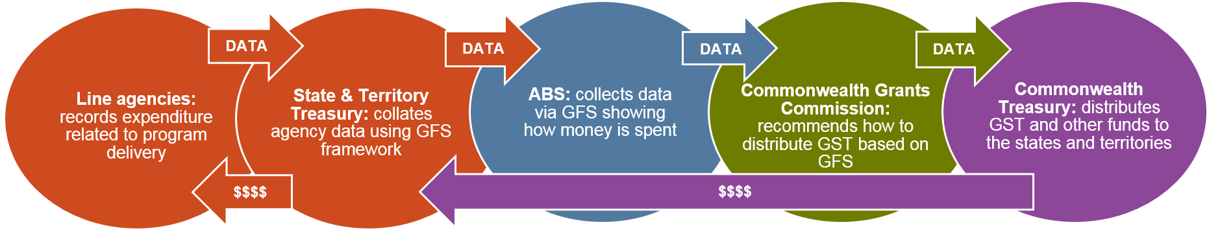
Figure 1. Impact of GFS data on government funding flows
- Line agencies – record expenditure related to program delivery and classify it using COFOG-A
- State and territory treasuries – collate line agencies expenditure and submit the data to the ABS
- ABS – converts the data to the GFS framework
- CGC – analyses the converted GFS data and makes recommendations to the Australian Government on distribution of GST revenue
- Commonwealth Treasury – taking into consideration CGC recommendations, distributes GST and other funds to the states and territories
- Funding flows from the Commonwealth Treasury to the states and territories, through to line agencies.

Coding COFOG-A
The Australian System of Government Finance Statistics: Concepts, Sources and Methods – 2015 (AGFS15) manual is produced by the ABS. It outlines the GFS framework, including the structure and definitions for COFOG-A.
Recommendation
To comply with COFOG-A reporting requirements, Appendix 1 Part C of the AGFS15 manual should be referred to when classifying agency expenditure.

COFOG-A structure
The COFOG-A structure outlined in Table 1 is hierarchical and consists of a two-digit level (division), a three-digit level (group) and a four-digit level (class). The divisions reflect the broad objectives of government, and the groups and classes detail the means by which these broad objectives are achieved.
Table 1. COFOG-A structure
Descriptor | COFOG-A (division) | COFOG-A (group) | COFOG-A (class)
General public services | 01 | 011-019 | 0111-0199
Defence | 02 | 021-029 | 0211-0299
Public order and safety | 03 | 031-039 | 0311-0399
Economic affairs | 04 | 041-049 | 0411-0499
Environmental protection | 05 | 051-059 | 0511-0599
Housing and community amenities | 06 | 061-069 | 0611-0699
Health | 07 | 071-079 | 0711-0799
Recreation, culture and religion | 08 | 081-089 | 0811-0899
Education | 09 | 091-099 | 0911-0999
Social protection | 10 | 100-109 | 1001-1099
Transport | 11 | 111-119 | 1111-1199

Recommendation
Agencies are required to code their expenditure at the four-digit class level. To facilitate the coding process, it is recommended agencies’ internal systems support assigning COFOG-A codes to cost centres.
It is also recommended that agencies review their COFOG-A code allocations on a regular basis to ensure outputs are appropriately captured.

COFOG-A coding example
Expenditure is to be classified based on the primary purpose of the outlay. Agencies must consider the main objective of the government work unit before determining the primary purpose of the expenditure.
Where there is more than one function, the government work unit must determine which function is the most dominant.
Figure 2 demonstrates how to determine the correct COFOG-A code.
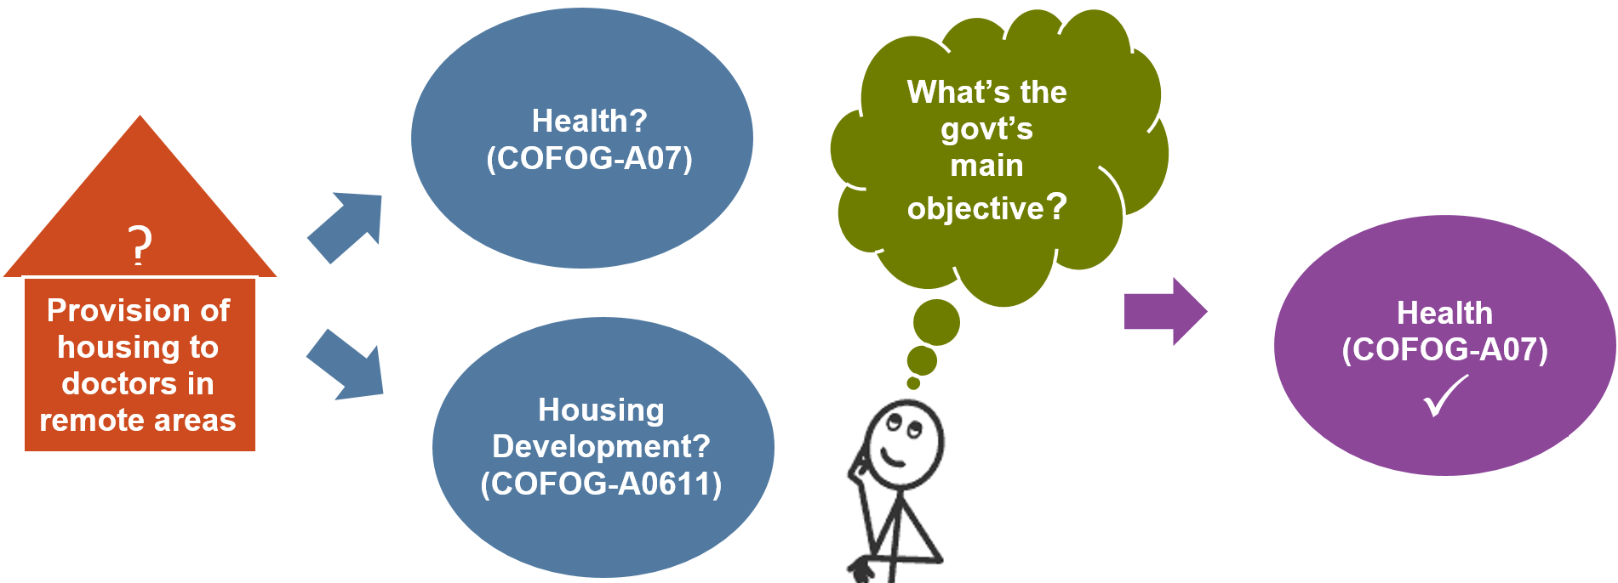
Figure 2. COFOG-A coding example
An agency has recorded expenditure related to the construction of houses for doctors in remote areas. Should the expenditure be coded to health (COFOG-A 07) or housing development (COFOG-A 0611)?
In order to classify correctly, the agency must consider if the government’s primary purpose is to:
- make housing available for doctors in remote communities
- or enable doctors to deliver health services in remote communities.
Answer – the primary purpose is the delivery of health services to remote communities. Making housing available for doctors (as an incentive to work in remote locations) is considered a secondary purpose. The expenditure should be coded to Health (COFOG-A 07).

Reporting

Uniform Presentation Framework
Reporting of government expenditure by COFOG-A is a requirement under the Uniform Presentation Framework (UPF). UPF is the standard format agreed by the Australian Government, states and territories for publishing financial information in budget papers and financial reports.

Australian Bureau of Statistics
The Australian Bureau of Statistics (ABS) requires all jurisdictions to submit actual expenditure data categorised using COFOG-A, both quarterly and annually. The Department of Treasury and Finance (DTF) coordinates and manages this function on behalf of the Northern Territory Government.

Agency reporting requirements
Agencies must submit annual COFOG-A returns (both budget and actual) to enable DTF to collate COFOG-A expenditure data at the whole of government level. This data is then used to prepare:
- annual expenditure reports for the ABS, in accordance with the GFS framework
- quarterly expenditure reports for the ABS, in accordance with the GFS framework, using agencies’ annual returns as a basis for apportioning actual expenditure, and
- high level reports on government expenditure by function, for publishing in the Treasurer’s Annual Financial Report (TAFR) and Budget Paper No. 2, in accordance with the UPF.

Reporting process for agencies
Actual return
To prepare a COFOG-A actual return, agencies should:
- use the prescribed template provided by DTF
- note that each output and or program may have multiple COFOG-A codes
- identify and explain significant changes between:
- COFOG-A code allocations from previous returns
- actual variations between years
- current year actuals and revised budget.
The level of information should be sufficient to enable agencies to answer queries from DTF about changes in COFOG-A code allocations, budget versus actuals analysis, or both.
Budget return
To prepare a COFOG-A budget return, agencies should:
- use the prescribed template provided by DTF
- note that each output and or program may have multiple COFOG-A codes
- identify and explain significant changes between:
- COFOG-A code allocations from previous returns
- actuals and revised budget
- revised budget and budget.
The level of information should be sufficient to enable agencies to answer queries from DTF about changes in COFOG-A code allocations, budget versus actuals analysis, or both.

Reporting corporate and governance expenditure
Shared services received output
The Shared Services Received output consolidates Department of Corporate and Digital Development (DCDD) and Department of Infrastructure, Planning and Logistics (DIPL) services free of charge into the one output.
Agencies do not need to allocate expenditure in this output by COFOG-A. This function will be performed by DTF on agencies’ behalf.
Corporate and governance output (excluding shared services received)
Agencies do not need to allocate expenditure in this output by COFOG-A. This function will be performed by DTF on agencies’ behalf using the methodology: corporate and governance expenditure allocated to COFOG-A codes in proportion to total COFOG-A expenditure in the other outputs, based on the assumption the greater the expenditure by COFOG-A, the greater the level of corporate expenditure is required to support that function.
If an agency has a more appropriate methodology to allocate their corporate and governance expenditure, the agency should contact DTF to discuss further.

Reporting timeline
An example of the COFOG-A reporting timeline, including requests and data submissions, is outlined in Figure 3. These times are indicative only and may be subject to change.
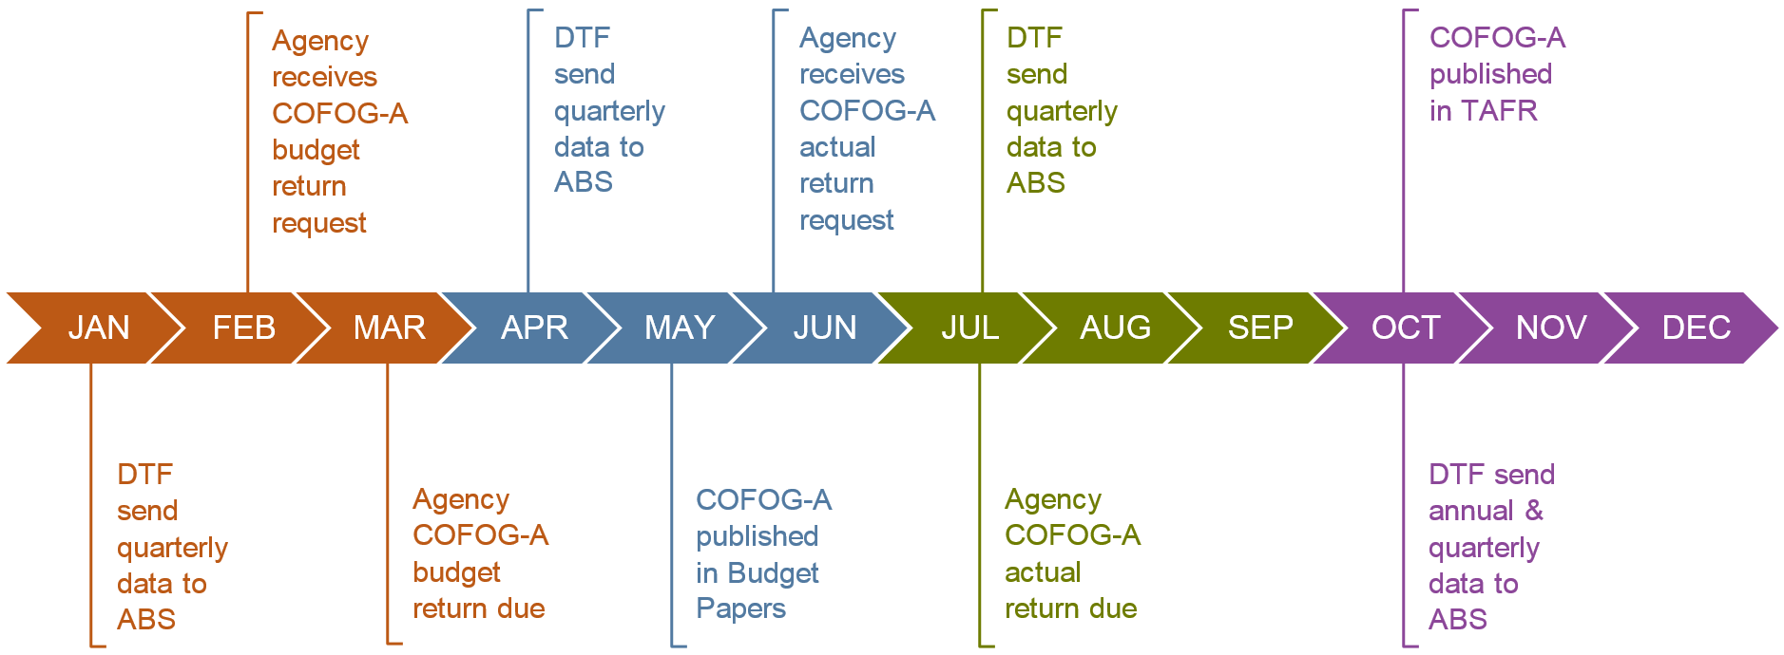
Figure 3. COFOG-A reporting timeline
In February each year, agencies are requested to submit a COFOG-A budget return, due around March or April. The outcome will be published in the Budget Papers (handed down around May).
In June, agencies receive a further request for a COFOG-A actual return, due around July or August. The result is published in the TAFR in October or November.
DTF will send quarterly data (based on actual expenditure) to the ABS in January, April, July, and October.

