Northern Territory Population Projections (2017 Release)
Preliminary Update
(2017 Release)

Contents
Executive summary 3
1 Introduction 5
2 NTPOP model 5
Method 5
Outputs 5
Assumptions 6
3 Overview of main projection results 7
Projected population change 7
Age structure 8
4 Sensitivity analysis – the effects of change in migration assumption 10
Conclusion 11
Appendix 1: Summary of input variables and parameters for the Territory population projections 12

Executive summary
Population projections are estimates of the future size and characteristics of the population, and consequently are an important resource used by decision makers across government, non-government organisations and business in planning service delivery across the Territory. Population projections should be used with a clear understanding of the underlying assumptions and limitations as they are developed by applying mathematical models and assumptions of likely population trends (current and historical) to the base population. Projections provide information about how a population may change over the long term subject to assumed parameters. They are not accurate short-term forecasts, which may incorporate substantial volatility, or predictions of the future. Projections are also not targets, nor do they reflect the effects of current or future policies.
The Department of Treasury and Finance have developed preliminary projections for the whole of Territory’s resident population up to the year 2046, disaggregated by age, sex and Aboriginal status. The projections are based on Australian Bureau of Statistics (ABS) 2016 Census preliminary estimated resident population numbers at 30 June 2016.
Key characteristics of the Territory’s projected population include:
- The Territory’s total population is projected to grow from 245 740 in 2016 to 375 067 in 2046 (Chart 1), assuming an annual growth rate of 1.4 per cent. The growth rate reflects the 20-year average annual population growth rate, and is comprised mostly (86 per cent or 1.2 percentage points) of natural increase and to a lesser extent migration (14 per cent or 0.2 percentage points).
- The Territory’s Aboriginal population is projected to grow from 74 509 in 2016 to 97 363 in 2046 (Chart 1), an annual growth rate of 0.9 per cent. The Territory’s non-Aboriginal population is projected to grow from 171 231 in 2016 to 277 704 in 2046 (Chart 1), an annual growth rate of 1.6 per cent.
- All Aboriginal and non-Aboriginal population broad age groups – under 15 years (children), 15-64 years (working age), and 65 years and over (retirees) – in the Territory are projected to steadily grow in number from 2016 to 2046 (Table 3).
- Both the Aboriginal population and the non-Aboriginal population show steady ageing, with the proportion of persons aged 65 and over projected to increase (Table 4). However, the Aboriginal population is ageing faster, with the proportion of Aboriginal persons aged 65 and over more than doubling from 2016 to 2046 (from 3.6 per cent to 9.0 per cent, Table 4). Over the same time period the proportion of non-Aboriginal persons aged 65 and over is projected to increase from 8.3 per cent to 11.5 per cent.
Chart 1: Territory resident population, actual results and projections, 1996 to 2046
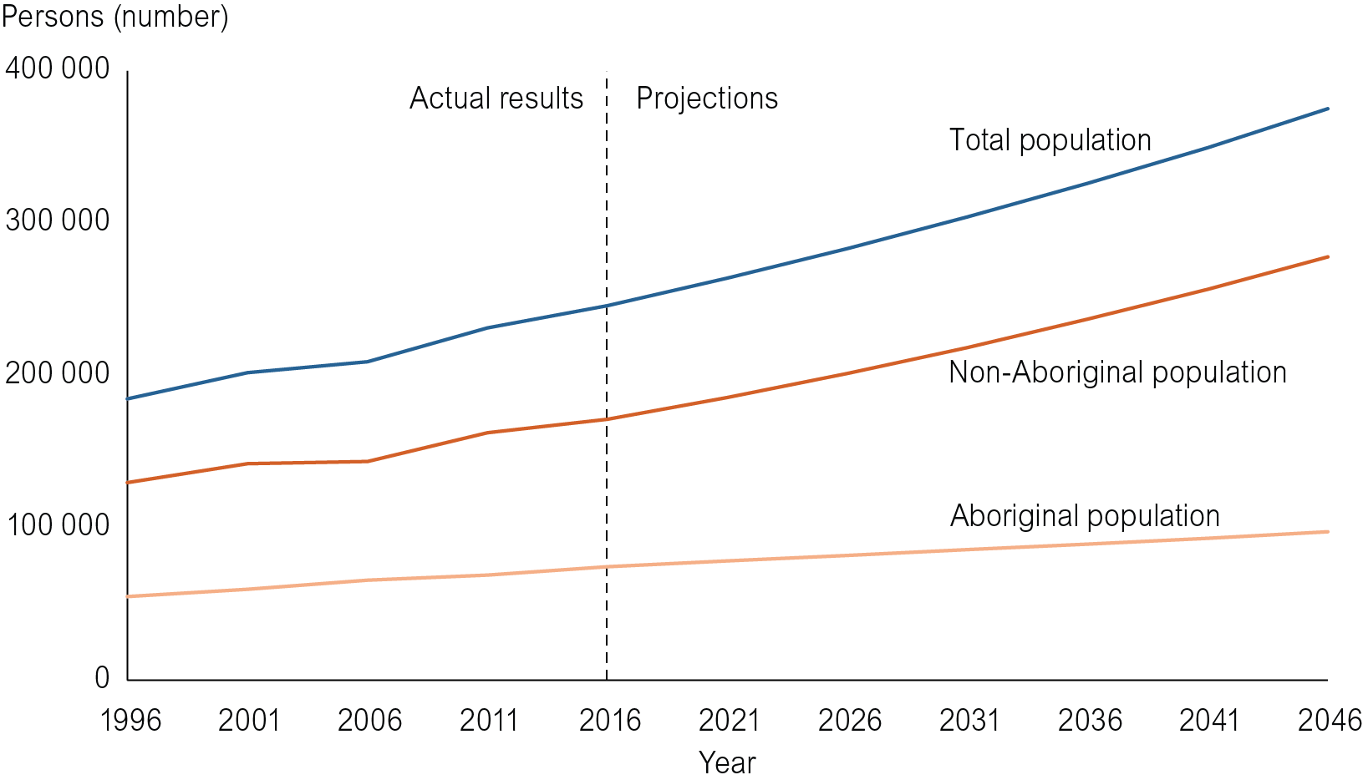
Final ABS data based on the 2016 Census will be released mid-2018, following which updated Territory population projections will be released. This release will also include more detailed regional population projections for the Territory.

Introduction
This brief provides an overview of the official Northern Territory Government projections of the Territory’s total population for the 30-year period from 2016 to 2046, released in December 2017. The projections are based on preliminary Australian Bureau of Statistics (ABS) 2016 Census estimated resident population (ERP) numbers at 30 June 2016 and therefore are preliminary projections. Updated projections will be released in 2018 (see below).
A summary of the projections are included in this brief. For the complete set of projected population numbers, users should refer to the electronic Excel spreadsheets available through the Department of Treasury and Finance (DTF) website at:
http://www.treasury.nt.gov.au/Economy/populationprojections/Pages/default.aspx
This release provides projections for residents of the whole of the Territory from 2016 to 2046 in five-year intervals, disaggregated by five-year age groups, sex and Aboriginal status.
The current projections update the previous projections presented in the Northern Territory Population Projections Main Update (2014 Release) and were obtained using a redeveloped Northern Territory population projection (NTPOP) model. Redevelopment of the model, necessitated by a requirement to change the model software, is ongoing. The Territory regional population projection module is scheduled to be completed in 2018, when updated population projections for the Territory and its regions will be released. These will also incorporate final ERP data based on the 2016 Census as produced by ABS.
Population projections are estimates of the future size and characteristics of the population and should be used with a clear understanding of the underlying assumptions and limitations. They are developed by applying mathematical models and assumptions of likely population trends (current and historical) to the base population. Projections provide information about how a population may change over time subject to assumed parameters. They are not accurate short-term forecasts, which may incorporate substantial volatility, or predictions of the future. Projections are also not targets, nor do they reflect the effects of current or future policies. Given this, and because population trends in the Territory can be quite volatile, DTF have produced some scenario-based projections in addition to those shown in Chart 1 (See section 4).

NTPOP model

Method
The NTPOP model is a cohort-component model, a commonly used method for developing demographic projections. The method adjusts a base population for births, deaths, migration and Aboriginal status changes to arrive at a population five years into the future. The process continues for the extent of the projection horizon.

Outputs
A single set of projections (the main projection) has been produced for this release. However, to demonstrate the sensitivity of the model to changes in migration levels, scenarios have been developed by assuming different levels of constant net migration (the most volatile component of the Territory’s population) and holding all other parameters fixed.
The NTPOP model also has the capacity to run other user-defined scenarios if users need to explore other population futures that incorporate different parameter values for population change components. Users wishing to explore different scenarios should discuss their needs with DTF.

Assumptions
These population projections use input parameters based on averages and trends from past data as follows:
- The annual population growth rate was held constant at 1.4 per cent over the entire projection period, which is the 20-year average annual population growth rate.
- Fertility rates were computed using data from the past five years (2011-16) and held constant over the projection period.
- Projected mortality rates were obtained directly from data published by ABS and other sources. These rates assume that life expectancy improves over the projection period.
- Probabilities of infants being Aboriginal given the Aboriginal status of the mother were obtained from Wilson (2009) and held constant over the projection period.
- The rate at which people report a different Aboriginal status from one Census to the next were derived from 2006 and 2011 Census data, being the latest available data. The increase over time in self-identification as Aboriginal observed nationally has not been reported in the Territory, and is therefore held constant over the projection period.
- Migration rates reflect 20-year average net overseas migration flow and net interstate migration flow, both flows adjusted proportionately to obtain annual population growth of 1.4 per cent. Aboriginal interstate migration flow were derived from 2011 Census data.
Appendix 1 provides a summary of the assumptions in the components described above.

Overview of main projection results

Projected population change
All population projections are at 30 June. As Chart 1 shows, the Territory’s total population and its component Aboriginal and non-Aboriginal populations are projected to steadily grow from 2016 to 2046.
Chart 1: Territory resident population, actual results and projections, 1996 to 2046
Table 1 presents Territory population projections at 5-year intervals from 2016 to 2046, and Table 2 notes the annual population growth rates for each 5-year projection period.
Table 1: Territory resident population, actual results and projections, 2016 to 2046
 | 2016 | 2021 | 2026 | 2031 | 2036 | 2041 | 2046
 | no. | no. | no. | no. | no. | no. | no.
Total population | 245 740 | 263 899 | 283 252 | 304 004 | 326 168 | 349 567 | 375 067
Aboriginal | 74 509 | 78 237 | 81 937 | 85 585 | 89 253 | 93 120 | 97 363
Non-Aboriginal | 171 231 | 185 662 | 201 315 | 218 419 | 236 915 | 256 447 | 277 704

Table 2: Territory resident population, annual population growth rates, 2016 to 2046
 | 2016-21 | 2021-26 | 2026-31 | 2031-36 | 2036-41 | 2041-46 | 2016-2046
 | % | % | % | % | % | % | %
Total population | 1.4 | 1.4 | 1.4 | 1.4 | 1.4 | 1.4 | 1.4
Aboriginal | 1.0 | 0.9 | 0.9 | 0.8 | 0.9 | 0.9 | 0.9
Non-Aboriginal | 1.6 | 1.6 | 1.6 | 1.6 | 1.6 | 1.6 | 1.6

The projected growth rates are driven by model input assumptions. The difference between non-Aboriginal annual population growth rate (1.6 per cent) and Aboriginal annual population growth rate (0.9 per cent) is largely attributable to the difference in the migration characteristics of the two populations. Total migration (the sum of interstate migration and overseas migration) detracts from Aboriginal population growth, whereas it contributes to the growth of the non-Aboriginal population. Notwithstanding the slightly higher fertility of the Aboriginal population, the natural increase rates for the Aboriginal and non-Aboriginal populations are approximately equal given the higher mortality of the Aboriginal population (Appendix 1).

Age structure
All Aboriginal and non-Aboriginal population broad age groups – under 15 years (children), 15-64 years (working age), and 65 years and over (retirees) – in the Territory are projected to steadily grow in number from 2016 to 2046 (Table 3). Both the Aboriginal population and the non-Aboriginal population show steady ageing, with the proportion of persons aged 65 and over projected to increase (Table 4 and Chart 2). However, the Aboriginal population is ageing faster, with the proportion of Aboriginal persons aged 65 and over more than doubling from 2016 to 2046 (from 3.6 per cent to 9.0 per cent, Table 4). This is a result of the model assumptions of greater increase in life expectancy of Aboriginal persons relative to non-Aboriginal persons, and greater out-migration of non-Aboriginal persons aged 65 and over.
The ageing of the Aboriginal and non-Aboriginal populations is accompanied by a proportional decline in the other age groups (Table 4). The proportionately faster ageing of the Aboriginal population is reflected in the greater decline in the proportion of Aboriginal persons aged under 15 years. The proportion of Aboriginal persons aged 15 years and under is projected to decline from 29.7 per cent in 2016 to 27.4 per cent in 2046, a decline of 7.7 per cent. In contrast, the proportion of non-Aboriginal persons aged 15 years and under is projected to decline from 18.4 per cent in 2016 to 18.1 per cent in 2046, a decline of only 1.6 per cent. This reflects a greater decrease in the proportion of Aboriginal women of child-bearing age relative to non-Aboriginal women of the same age.
Table 3: Territory resident population, actual results and projections by broad age groups, 2016 to 2046
 | 2016 | 2021 | 2026 | 2031 | 2036 | 2041 | 2046 | Annual growth rate  2016-46
 | no. | no. | no. | no. | no. | no. | no. | %
Aged under 15
Aboriginal | 22 120 | 22 613 | 23 291 | 24 564 | 24 981 | 25 638 | 26 673 | 0.6
Non-Aboriginal | 31 487 | 34 909 | 37 654 | 40 521 | 43 270 | 46 411 | 50 169 | 1.6
Total | 53 607 | 57 522 | 60 945 | 65 085 | 68 251 | 72 048 | 76 842 | 1.2
Aged 15-64
Aboriginal | 49 731 | 52 015 | 54 041 | 55 288 | 57 303 | 59 510 | 61 928 | 0.7
Non-Aboriginal | 125 520 | 133 196 | 142 861 | 154 125 | 167 083 | 180 892 | 195 711 | 1.5
Total | 175 251 | 185 211 | 196 902 | 209 413 | 224 386 | 240 402 | 257 640 | 1.3
Aged 65 and over
Aboriginal | 2 658 | 3 608 | 4 605 | 5 733 | 6 969 | 7 972 | 8 762 | 4.1
Non-Aboriginal | 14 224 | 17 557 | 20 800 | 23 773 | 26 563 | 29 145 | 31 824 | 2.7
Total Population | 16 882 | 21 165 | 25 405 | 29 506 | 33 532 | 37 117 | 40 586 | 3.0

Table 4: Proportion of Territory population by broad age groups, 2016 to 2046
 | 2016 | 2021 | 2026 | 2031 | 2036 | 2041 | 2046 | Trend 2016-46
 | % | % | % | % | % | % | %
Aged under 15
Aboriginal | 29.7 | 28.9 | 28.4 | 28.7 | 28.0 | 27.5 | 27.4
Non-Aboriginal | 18.4 | 18.8 | 18.7 | 18.6 | 18.3 | 18.1 | 18.1
Total | 21.8 | 21.8 | 21.5 | 21.4 | 20.9 | 20.6 | 20.5
Aged 15-64
Aboriginal | 66.7 | 66.5 | 66.0 | 64.6 | 64.2 | 63.9 | 63.6
Non-Aboriginal | 73.3 | 71.7 | 71.0 | 70.6 | 70.5 | 70.5 | 70.5
Total | 71.3 | 70.2 | 69.5 | 68.9 | 68.8 | 68.8 | 68.7
Aged 65 and over
Aboriginal | 3.6 | 4.6 | 5.6 | 6.7 | 7.8 | 8.6 | 9.0
Non-Aboriginal | 8.3 | 9.5 | 10.3 | 10.9 | 11.2 | 11.4 | 11.5
Total | 6.9 | 8.0 | 9.0 | 9.7 | 10.3 | 10.6 | 10.8
The proportional decrease in Aboriginal women of child-bearing age (15-49 years) is part of a proportional decline in all Aboriginal persons in this age group (Chart 2). In comparison, the age structure of the non-Aboriginal population shows less relative change between 2016 and 2046, a consequence of this population being strongly influenced by migration.
Chart 2: Age pyramid, Territory Aboriginal and non-Aboriginal populations, 2016 and 2046
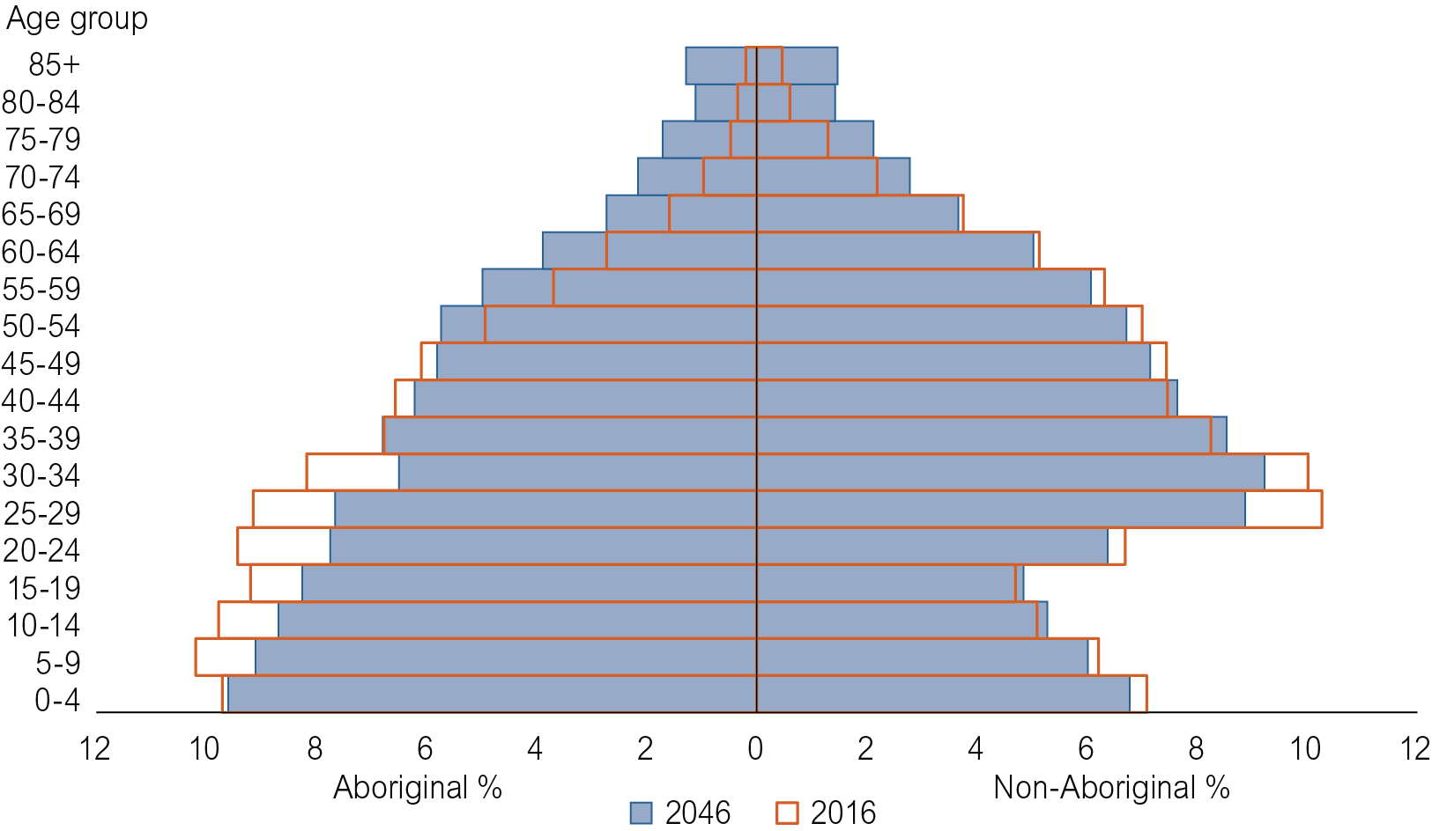

Sensitivity analysis – the effects of change in migration assumption
The principal driver of volatility in the Territory’s population growth is migration of the non-Aboriginal population. The following three scenarios (Table 5) explore the effects of alternative non-Aboriginal migration assumptions on the Territory’s projected population. In these scenarios (Table 5) Aboriginal population migration remains unchanged from the main projection, as do all other parameters for the Aboriginal and non-Aboriginal populations.
Table 5: Territory population projection scenario assumptions
Scenario | Migration assumption | Total migration value over 5 years
Main projection | Total migration flow approximates 20-year average adjusted to give annual population growth of 1.4% | 1 994 over 2016-21, increasing to 6 471 over 2041-46
Current scenario | Total migration approximates migration flows from 2011 to 2016 | -6 104 over 2016-21, held constant over all five-year projection periods
90th percentile¹ scenario (High) | Total migration approximates the 90th percentile of the moving annual total migration flows over the past 20 years | 13 667 over 2016-21, held constant over all five-year projection periods
10th percentile¹ scenario (Low) | Total migration approximates the 10th percentile of the moving annual total migration flows over the past 20 years | -10 303 over 2016-21, held constant over all five-year projection periods
¹ A percentile is a measure at which that percentage of all values are below that value. For example, 90% of all total migration values lie below the 90th percentile, whereas 10% of all total migration values lie below the 10th percentile. An example in recent history of the 90th percentile (high) total migration value occurred in 2008-09 and the 10th percentile (low) total migration values occurred in 2002 and 2015-16.
Chart 3 and Table 6 display the consequences of the alternative migration scenarios on the Territory’s projected population. The model assumes the migration patterns are maintained over the 30-year projection timeframe.

Chart 3: Territory resident population, alternative projection scenarios, 1996 to 2046
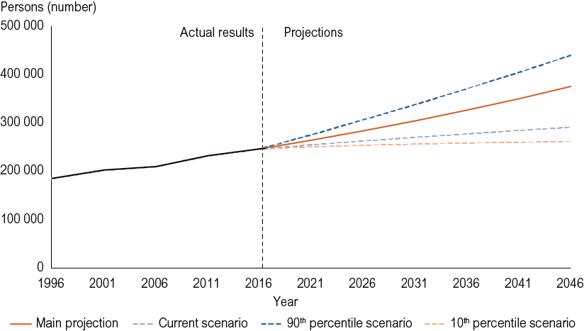
Table 6: Territory population projections and annual growth rates, alternative scenarios
Scenario | Total population in 2046 (no.) | Annual growth rate 2016-46 (%)
Main projection | 375 067 | 1.4
Current scenario | 291 042 | 0.6
90th percentile (high) scenario | 439 272 | 2.0
10th percentile (low) scenario | 261 508 | 0.2

Conclusion
The nature of population projections is such that certain assumptions around changes to population components are held constant over the projection horizon, making them quite distinct from short-run forecasts. The current, low and high scenarios are all based on observed population trends and outcomes at a particular point in time. These point in time outcomes (particularly around migration) are then assumed to hold over the 30-year projection horizon. In this way the scenarios provide a confidence interval in which actual population outcomes are likely to fall.

Appendix 1: Summary of input variables and parameters for the Territory population projections
Growth component | Parameter
Fertility | Total fertility rate (TFR)
- Aboriginal mothers | - TFR 2.110 (five-year average), held constant over projection period
- Non-Aboriginal mothers | - TFR 1.934 (five-year average), held constant over projection period
Mortality | Life expectancy
- Aboriginal males | - 62.85 years over 2016-21 increasing to 66.63 years over 2041-46
- Aboriginal females | - 69.95 years over 2016-21 increasing to 75.42 years over 2041-46
- Non-Aboriginal males | - 81.31 years over 2016-21 increasing to 83.92 years over 2041-46
- Non-Aboriginal females | - 85.40 years over 2016-21 increasing to 87.32 years over 2041-46
Infant Aboriginal status | Probabilities for allocating infant Aboriginal status
- Aboriginal infant to Aboriginal mother | - 0.993, held constant over projection period
- Non-Aboriginal infant to Aboriginal mother | - 0.007, held constant over projection period
- Aboriginal infant to non-Aboriginal mother | - 0.038, held constant over projection period
- Non-Aboriginal infant to non-Aboriginal mother | - 0.962, held constant over projection period
Aboriginal status change | Gross identification change rate (GICR)
- Non-Aboriginal to Aboriginal females | - 0.185, held constant over projection period
- Non-Aboriginal to Aboriginal males | - 0.178, held constant over projection period
- Aboriginal to non-Aboriginal females | - 0.243, held constant over projection period
- Aboriginal to non-Aboriginal males | - 0.368, held constant over projection period
Interstate migration | Net interstate migration
- Total persons | - -5 317 persons over 2016-21 (approx. 20-year average), adjusted over projection period to give annual population growth of 1.4%
- Aboriginal persons | - -1 792 persons over 2016-21, held constant over all 5-yr projection periods
- Non-Aboriginal persons | - -3 525 persons over 2016-21, adjusted proportionately to overseas migration over projection period to give annual population growth of 1.4%
Overseas migration | Net overseas migration
- Aboriginal persons | - Zero
- Non-Aboriginal persons | - 7 311 persons over 2016-21 (approx. 20-year average), adjusted proportionately to interstate migration over projection period to give annual population growth of 1.4%

The NTG has adopted the term Aboriginal instead of Indigenous, and Aboriginal includes Torres Strait Islanders.
Wilson T, 2009, “A multistate model for projecting regional populations by Indigenous status: an application to the Northern Territory, Australia”, Environment and Planning A 41 230-249.

