Northern Territory Economy Overview
This overview is a summarised assessment of the Northern Territory economy, including a brief description of recent performance and growth prospects, the external economic environment, population, labour market, and prices and wages. It represents a summary of the more detailed document, Northern Territory Economy.
(For more information, visit www.budget.nt.gov.au)

Contents
Structure of the Economy 2
Economic Growth 3
External Economic Environment 5
Population 7
Labour Market 9
Prices and Wages 11
Industry Analysis 13
Mining 13
Construction 13
Agriculture, Forestry and Fishing 14
Tourism 15
Defence 16
Retail and Wholesale Trade 16
Manufacturing 17
Government and Community Services 18
Other Services 18

Structure of the Economy
The structure of the Territory’s economy is markedly different to other Australian jurisdictions. This reflects the Territory’s population characteristics and its large land mass, with an abundance of natural endowments. In addition, the Territory has a small open economy that is heavily influenced by international trade and major projects.
Key industries in the Territory, in terms of contribution to gross state product (GSP), are construction, mining, and government and community services (which comprises industries with outputs predominantly supplied by the public sector, including defence). These industries account for half the Territory’s GSP compared with about one third of Australia’s gross domestic product (GDP) (Chart 1).
Chart 1: Industry Proportion of GSP and GDP, 2012-13¹
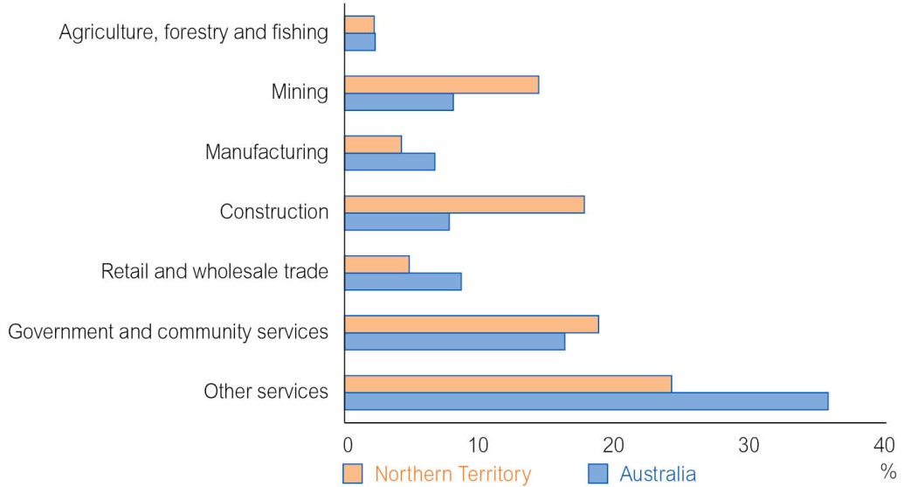
1 Current prices.
Source: ABS, Australian National Accounts: State Accounts, Cat. No. 5220.0
Table 1 shows each industry’s contribution to the Territory’s GSP and total employment.
Table 1: Territory Industry Contribution to GSP and Employment
 | GSP¹ |  |  |  | Employment²
 | 2011-12 | 2012-13 | 10-Year Average |  | 2011-12 | 2012-13 | 10-Year Average
 | % | % | %
Mining | 18.0 | 14.3 | 16.7 |  | 4 300 | 4 800 | 3 300
Construction | 13.7 | 17.7 | 13.6 |  | 12 200 | 13 500 | 10 100
Agriculture, forestry and fishing | 2.0 | 2.2 | 2.9 |  | 5 000 | 3 100 | 3 000
Tourism³ | 4.6 | 4.5 | n.a. |  | 8 000 | 8 000 | n.a.
Defence³ | 7.6 | 7.0 | 8.5 |  | 6 659 | 6 512 | 6 612
Retail and wholesale trade | 4.7 | 4.8 | 4.8 |  | 13 600 | 13 600 | 13 400
Manufacturing | 5.4 | 4.2 | 5.9 |  | 3 400 | 3 900 | 3 700
Government and community services | 18.7 | 18.8 | 19.4 |  | 42 600 | 44 400 | 39 700
Other services | 23.7 | 24.1 | 23.4 |  | 41 200 | 42 100 | 38 000

GSP: gross state product; n.a.: not available
1 Current prices.
2 Year average.
3 Standard ABS measures of production in national accounts are not available for tourism and defence.
Sources: ABS, Australian National Accounts: State Accounts, Cat. No. 5220.0; ABS, Labour Force, Australia,
Cat. No. 6291.0.55.003; ABS unpublished data; TRA, State Tourism Satellite Accounts; Department of Defence

Economic Growth
In 2012-13, the Territory economy expanded by 5.6 per cent. This was the highest growth rate of all jurisdictions and over twice the level of national growth of 2.6 per cent (Chart 2).
Chart 2: Change in GSP and GDP¹
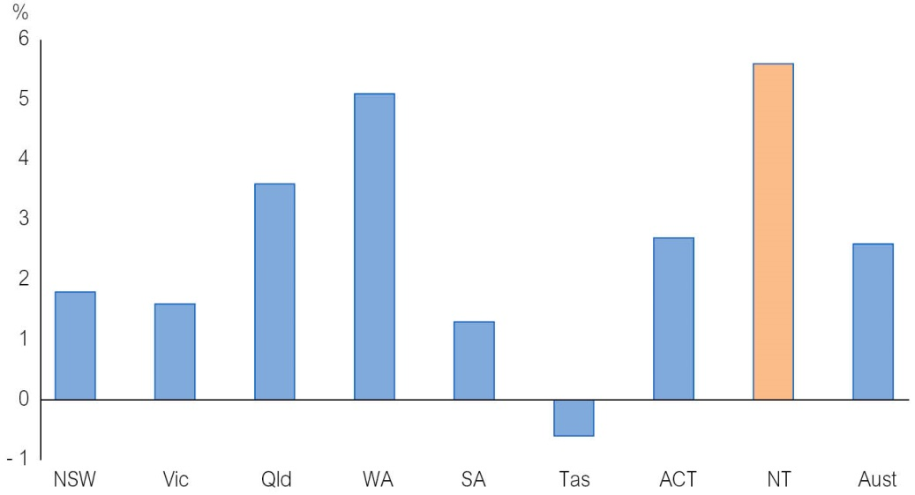
1 Inflation adjusted.
Source: ABS, Australian National Accounts: State Accounts, Cat. No. 5220.0
Economic growth in the Territory in 2012-13 was primarily driven by a 62.2 per cent increase in private investment, coinciding with record levels of engineering construction associated with several major projects, predominantly in the resource sector.
Growth was also supported by a 6.2 per cent increase in household consumption and a 14.1 per cent increase in net exports. Detracting from growth was a 5.6 per cent decline in public final demand, comprising decreases of 23.5 per cent in public investment and 0.7 per cent in public consumption (Table 2).
Table 2: Components of Territory GSP¹
 | 2011-12 | 2012-13 | Contribution to GSP Growth
 | $M | $M | ppt
Household consumption | 8 403 | 8 925 | 2.8
Private investment | 6 569 | 10 652 | 21.7
Public final demand | 7 800 | 7 362 | - 2.3
Net exports | 1 368 | 1 561 | 1.0
Balancing item² | - 5 327 | - 8 639 | - 17.6
GSP | 18 813 | 19 860 | 5.6

ppt: percentage point
1 Inflation adjusted.
2 Balancing item incorporates interstate trade, change in inventories, balance of payment adjustments and statistical discrepancy.
Source: ABS, Australian National Accounts: State Accounts, Cat. No. 5220.0
The Territory economy is expected to perform strongly over the budget and forward estimates period and continue to outperform most other jurisdictions. The economy is expected to grow by 5.0 per cent in 2013-14 and 6.0 per cent in 2014-15 (Table 3). Growth over this period will be underpinned by construction activity related to the Ichthys liquefied natural gas (LNG) project. The Ichthys LNG project is a joint venture between INPEX group companies, major partner TOTAL and the Australian subsidiaries of Tokyo Gas, Osaka Gas, Chub Electric Power and Toho Gas.
The Territory’s economic growth estimates have been revised down following Rio Tinto’s decision to curtail operations at the Gove alumina refinery. This is expected to detract from economic growth in 2014-15 through lower levels of consumption and reduced Territory net exports, partly offset by an expected increase in bauxite exports and decrease in imports of fuel oil and caustic soda. The curtailment of operations at the Gove alumina refinery will also reduce the Territory’s population and employment growth forecasts in 2014-15.
From 2015-16, the Territory economy is expected to transition away from the investment phase to the production phase of major resource projects, with a substantial increase in net exports expected to emerge as the primary driver of economic growth.
Due to the unprecedented level of private investment expected to occur over the next few years, there is a risk that the transition from the construction to production phase may not be smooth. While net exports are expected to underpin economic growth in the Territory in the outer years, this is not as labour intensive as the construction phase. As a result, growth in non-resource activity will be required to support employment and population growth in the Territory during this period.
While growth in resource-related investment has been the primary driver of the recent surge in economic activity in the Territory, conditions are present for a pick up in non-resource industries. The Territory is well positioned to take advantage of the recovery in global activity and the shift in global growth towards Asia. In addition, relatively low interest rates and the freeing up of labour and capital capacity constraints as the Ichthys project transitions to the production phase should support economic growth outside the resource sector.
Table 3: Territory Economic Growth¹ (%)
 | 2012-13 | 2013-14e | 2014-15f | 2015-16f | 2016-17f | 2017-18f
Gross state product | 5.6 | 5.0 | 6.0 | 3.0 | 4.0 | 3.5

e: estimate; f: forecast
1 Inflation adjusted.
Source: Department of Treasury and Finance; ABS, Australian National Accounts: State Accounts, Cat. No. 5220.0

External Economic Environment
The performance of the Territory economy is influenced by international trade, overseas investment including large engineering projects, tourism, and population movements from within Australia and overseas. Global economic conditions influence the level of private investment, demand for Territory-produced goods and services, and migration to the Territory. Locally, the performance of the national economy impacts on the level of interstate trade and population migration between the Territory and other jurisdictions, as well as the amount of goods and services tax (GST) revenue received by the Territory.
Territory International Trade
The Territory’s international trade surplus decreased from $1.2 billion in 2011-12 to $0.9 billion in 2012-13 (Chart 3). This was driven by a 23.5 per cent or $976 million increase in Territory goods imports, partly offset by a 12.9 per cent or $681 million increase in Territory goods exports.
Chart 3: International Trade Balance¹
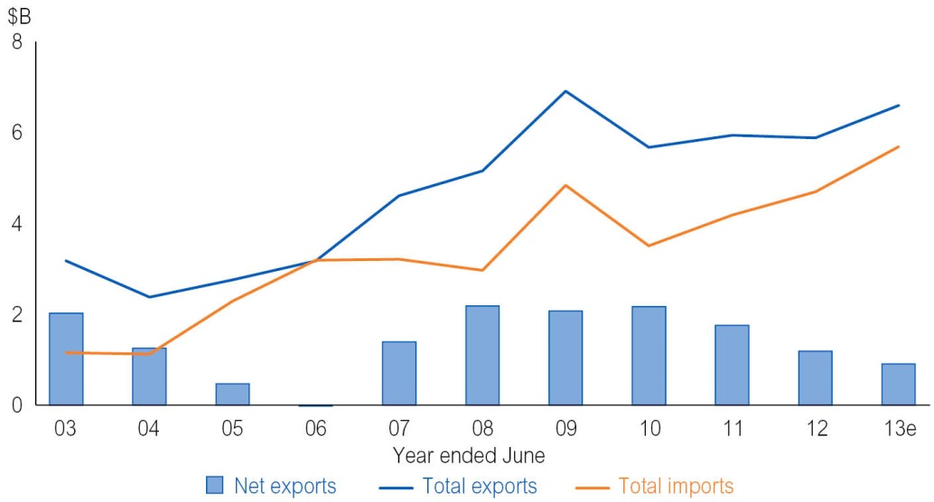
1 Current prices.
Source: ABS, International Trade in Goods and Services, Cat. No. 5368.0
The main Territory goods exports in 2012-13 were mineral fuels (largely LNG), crude materials (mainly mineral ores), and food and live animals (primarily live cattle). The main Territory goods imports are mineral fuels (largely feedstock gas for the production of LNG and petroleum products), and machinery and transport equipment.
National Economy
The national economy is important to the Territory, primarily through interstate trade and Commonwealth GST revenue. The Australian economy is forecast to strengthen over the budget and forward estimates period. However, the recovery in the non-resource sector is expected to be slower than anticipated and the decline in resource investment much sharper than previously anticipated. These factors have resulted in downward revisions by the International Monetary Fund (IMF) to Australia’s GDP forecasts. Despite the lower growth forecast, the Australian economy is still expected to outperform many other advanced economies over the forward estimates period.
Global Economy
The main international markets for Territory exports are Japan, China, Indonesia, the United States and Korea. The IMF expects the economic conditions in these countries to
remain favourable over the medium term (Table 4).

Table 4: GDP Growth for the Major Territory Goods Exports Destination (%)
Real GDP growth | 2012 | 2013e | 2014f | 2015f | 2016f | 2017f
Japan | 1.4 | 1.5 | 1.4 | 1.0 | 0.7 | 1.0
China | 7.7 | 7.7 | 7.5 | 7.3 | 7.0 | 6.8
Indonesia | 6.3 | 5.8 | 5.4 | 5.8 | 6.0 | 6.0
United States | 2.8 | 1.9 | 2.8 | 3.0 | 3.0 | 2.9
Korea | 2.0 | 2.8 | 3.7 | 3.8 | 3.8 | 3.8

e: estimate; f: forecast
Source: IMF
The IMF’s forecast of relatively weak economic growth in Japan may affect the number of Japanese tourists to the Territory, but it is not expected to have a significant impact on Territory goods exports to Japan, as LNG exports are sold on long-term contracts for electricity supply, and therefore are less influenced by economic conditions in Japan. While the IMF expects China’s economic growth to moderate in the medium term, due to policy measures aimed at achieving more sustainable levels of growth, it is still expected to remain relatively high.
Outlook
The outlook is for the Territory’s net trade surplus to widen over the medium term, largely driven by an expected increase in goods exports, coinciding with increased LNG exports once production commences at the Ichthys plant. However, in the short term, the Territory’s trade balance is likely to be affected by large imports of machinery and equipment for the Ichthys project. In the long term, the loss of alumina exports following the curtailment of operations at the Gove alumina refinery, partially offset by increased bauxite exports, will also affect the trade balance.
The Korea-Australia Free Trade Agreement (KAFTA) and Japan-Australia Economic Partnership Agreement, when in force, represent opportunities for Territory exporters to expand into the Korean and Japanese markets. Over time, these agreements are expected to benefit cattle and horticulture industries in the Territory through the progressive reduction in tariffs on Australian beef and horticultural exports. In addition, the elimination of the tariff on LNG exports from Australia to Korea, effective immediately when the KAFTA comes into force, presents an opportunity for the Territory to increase exports of LNG to Korea.

Population
The Territory has the smallest population and the third largest land mass of the states, making it the most sparsely populated jurisdiction in Australia. The Territory has a relatively young age profile with half of the population aged under 32 years. A further characteristic of the Territory’s population is its mobility, with high levels of interstate migration among the non-Indigenous population and substantial movement within the Territory among the Indigenous population.
A key feature of the Territory is its relatively large Indigenous population. At 30 June 2011, there were 68 850 Indigenous people residing in the Territory. This equates to 29.8 per cent of the Territory’s total population. The Indigenous share of the total population in other states ranges from 0.9 per cent in Victoria to 4.7 per cent in Tasmania. Indigenous people make up 3.0 per cent of Australia’s total population.
Population Growth
The Territory’s estimated resident population at 30 June 2013 was 240 759 people. This was an increase of 2.1 per cent from 30 June 2012, with growth driven by relatively strong net overseas migration and natural increase partly offset by migration from the Territory to other jurisdictions.
Net overseas migration added 3065 people to the Territory’s population and was the largest contributor to population growth in 2012-13 (Chart 4). Current high levels of net overseas migration are due to favourable employment conditions in the Territory and strong demand for skilled workers associated with major resource projects.
Chart 4: Components of Population Growth (moving annual total)
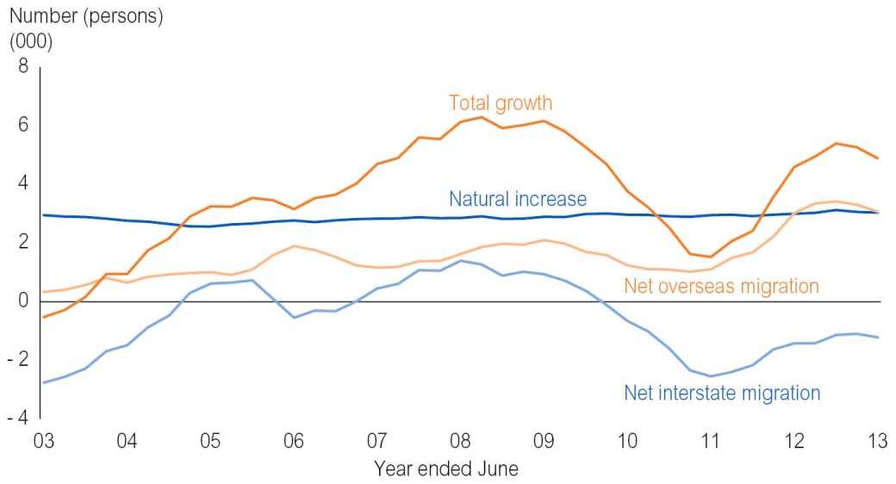
Source: ABS, Australian Demographic Statistics, Cat. No. 3101.0
Natural increase is the most stable contributor to population growth in the Territory. In 2012-13, natural increase added 3033 people to the Territory’s population, comprising 4062 registered births and 1029 registered deaths. Interstate migration is a volatile contributor to the Territory’s population growth. Historically, it tends to detract from, rather than contribute to, growth. This was the case in 2012-13 where net interstate migration detracted 1220 people from the Territory’s population.
Regional Population
Table 5 shows the estimated resident population (ERP) as at 30 June 2013, population share, and annual and five-year growth rates (2008 to 2013) for the regions and major towns of the Territory. Over half the Territory’s population resides in the Greater Darwin region (comprising Darwin city, Darwin suburbs, Palmerston and Litchfield) and the region recorded the highest growth rate (3 per cent) in the year to June 2013. East Arnhem recorded the lowest growth rate in 2012-13 at 0.5 per cent, largely reflecting losses in the township of Nhulunbuy.
Table 5: Regional Population and Major Townships Estimated Resident Population
 | ERP¹ | Proportion of  Total Population | Annual Population Change² | 5-Year Average Annual Population Change³
 | No. | % | % | %
Region⁴
Alice Springs | 41 637 | 17.3 | 0.7 | 0.6
Barkly | 6 736 | 2.8 | 1.0 | 1.0
Daly-Tiwi-West Arnhem | 18 755 | 7.8 | 1.6 | 2.5
East Arnhem | 16 357 | 6.8 | 0.5 | 1.0
Greater Darwin | 136 245 | 56.6 | 3.0 | 2.4
Katherine | 21 029 | 8.7 | 1.1 | 1.2
Major Townships
Alice Springs⁵ | 26 140 | 10.9 | 0.5 | 0.9
Darwin⁶ | 115 300 | 47.9 | 3.0 | 2.2
Katherine | 10 957 | 4.6 | 1.5 | 1.5
Nhulunbuy | 4 436 | 1.8 | - 1.7 | - 0.9
Tennant Creek | 3 619 | 1.5 | 0.9 | 0.8

1 ERP at 30 June 2013.
2 Annual change in ERP between 30 June 2012 and 30 June 2013.
3 Average annual change in ERP between 30 June 2008 and 30 June 2013.
4 ABS Statistical Area 3 (SA3) and SA4 (Greater Darwin).
5 Comprising SA2s of Charles, East Side, Flynn, Larapinta and Mount Johns.
6 Comprising SA3s of Darwin city, Darwin suburbs and Palmerston.
Source: ABS, Regional Population Growth, Australia, Cat. No. 3218.0
Outlook
Population growth of 2.0 per cent is expected in 2013 before moderating to 1.6 per cent in 2014 as population outflows related to the curtailed operations at the Gove alumina refinery partly offset inflows associated with the demand for labour by major projects (Table 6). Population growth in 2015 is forecast to strengthen as the effect from the reduced refinery activity passes and workforce requirements for the construction phase of the Ichthys project peak. Growth is then forecast to moderate in the outer years as the Ichthys project moves to the less labour-intensive production phase.
Table 6: Population Growth (%)
Calendar Year | 2012 | 2013e | 2014f | 2015f | 2016f | 2017f
Northern Territory | 2.3 | 2.0 | 1.6 | 2.6 | 1.0 | 1.0

e: estimate; f: forecast
Source: Department of Treasury and Finance

Labour Market
The Territory’s labour market is characterised by low unemployment, high labour force participation and a young mobile workforce. This reflects the tendency of many people, particularly those in younger age groups, to come to the Territory for employment opportunities.
Current labour market conditions in the Territory are strong, as highlighted by robust employment growth, and it has one of the lowest unemployment rates in Australia.
Employment
The Australian Bureau of Statistics (ABS) estimates that, on average, there were about 125 700 residents employed in the Territory during 2012-13. Growth in resident employment strengthened from 1.2 per cent in 2011-12 to 2.6 per cent in 2012-13, equating to an additional 3100 persons employed in the Territory. ABS labour force data shows that employment growth has continued to strengthen in the first three quarters of 2013-14 (Chart 5).
Chart 5: Territory Year-on-Year Employment Growth
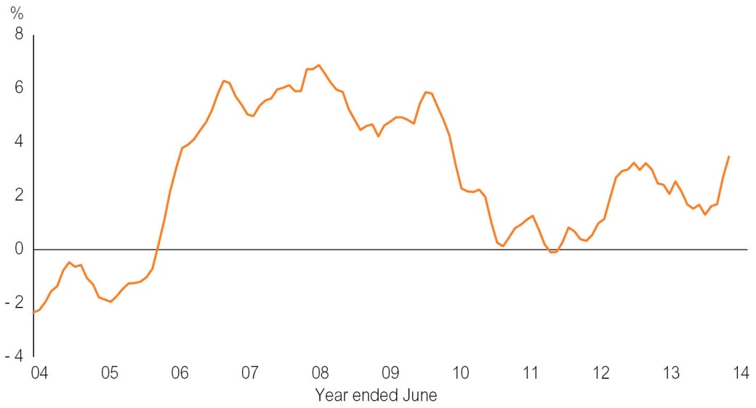
Source: ABS, Labour Force, Australia, Cat. No. 6202.0
The main industries that contributed to employment growth in the Territory in 2012-13 were health and social assistance, construction, mining and manufacturing. This was partly offset by a decline in the number of persons employed in agriculture, forestry and fishing, financial and insurance services, and retail trade industries.
The Territory consistently has the highest labour force participation rate of any jurisdiction in Australia, as well as one of the lowest unemployment rates. As such, the Territory has little capacity to provide extra workers from within the local labour market as major projects commence. Consequently, the use of fly-in fly-out (FIFO) workers and/or overseas migrants is critical to meet the labour force demand for major projects.
The most recent data available on the number of FIFO workers in the Territory is from the 2011 Census, which reported that the size of Territory’s non-resident workforce was 5200 people. In addition to FIFOs, overseas workers on temporary and permanent visas are a vital means of meeting skilled labour demands in the Territory. In 2012-13, there were 913 Temporary Work (skilled) Visa (subclass 457) and 839 permanent skilled visas granted in the Territory.
Unemployment
Although the Territory recorded strong employment growth in 2012-13, its average annual unemployment rate rose from 4.4 per cent in 2011-12 to 4.7 per cent in 2012-13. This was largely due to the increase in the number of persons employed in the Territory being outpaced by the increase in the number of persons participating in the labour force. Despite this, the Territory’s unemployment rate remained the third lowest of the jurisdictions in 2012-13, and well below the national annual average unemployment rate of 5.4 per cent (Chart 6).
Chart 6: Average Annual Unemployment Rate
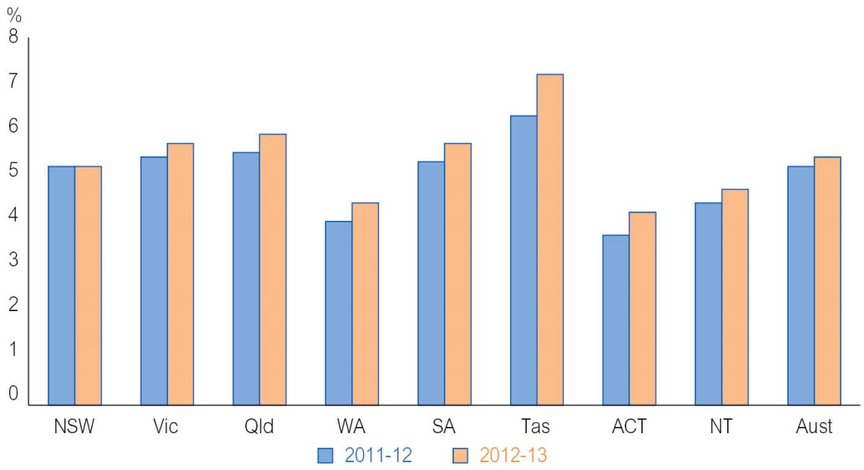
Source: ABS, Labour Force, Australia, Cat. No. 6202.0
Outlook
Employment growth in the Territory is expected to strengthen to 3.7 per cent in 2013-14 and to 3.8 per cent in 2014-15, during the construction peak of the Ichthys project. Over this time the acceleration of construction activity is expected to have flow-on benefits for industries such as retail trade, accommodation and food services, and rental, hiring and real estate services. As employment increases, the Territory’s unemployment rate is expected to decline to 4.4 per cent in 2013-14 and to 4.0 per cent in 2013-14 (Table 7).
From 2015-16, labour market conditions are expected to soften as the Ichthys project transitions to the less labour-intensive production phase. As a result, employment growth is expected to moderate and the unemployment rate is forecast to rise in the outer years.
Table 7: Labour Market (%)
Northern Territory | 2012-13 | 2013-14e | 2014-15f | 2015-16f | 2016-17f | 2017-18f
Employment growth¹ | 2.6 | 3.7 | 3.8 | 2.1 | 0.7 | 0.7
Unemployment rate² | 4.7 | 4.4 | 4.0 | 4.2 | 4.7 | 4.7

e: estimate; f: forecast
1 Year-on-year change.
2 Year average.
Source: ABS, Labour Force, Australia, Cat. No. 6202.0; Department of Treasury and Finance

Prices and Wages
Consumer Price Index
In 2013, the Darwin consumer price index (CPI) increased by 3.9 per cent. This was the highest increase of all capital cities, which ranged from 1.8 per cent in Hobart to 2.6 per cent in Perth. Average CPI across the eight capital cities in Australia increased by 2.4 per cent in 2013.
The primary drivers of growth in the Darwin CPI were increases in costs in the housing (including utility prices), transport, recreation and culture, alcohol and tobacco, and health categories (Chart 7).
Chart 7: Year-on-Year Percentage Point Contribution to Change in CPI, 2013
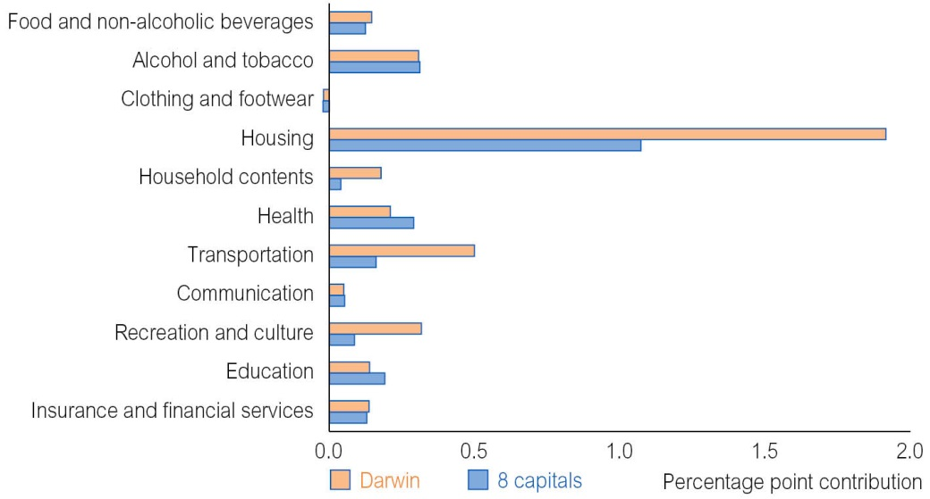
Source: ABS, Consumer Price Index, Australia, Cat. No. 6401.0
The Darwin CPI is forecast to moderate in the budget and forward years as the impacts of the 2013 increases in utility prices and motor vehicle registration fees, as well as the price effect from the carbon tax, are incorporated in the base (Table 8). Utility prices are expected to have a lower impact on the Darwin CPI over the next two years, reflecting the smaller increase in utility tariffs in 2014 and 2015. The impact of rents and home purchases on the Darwin CPI is expected to moderate substantially, reflecting the supply of new dwelling stock and further housing developments in the Territory’s major centres.
Table 8: CPI Forecasts, Year-on-Year Change (%)
 | 2013 | 2014e | 2015f | 2016f | 2017f
Darwin CPI | 3.9 | 3.0 | 2.8 | 2.5 | 2.5

e: estimate; f: forecast
Source: ABS, Consumer Price Index, Australia, Cat. No. 6401.0; Department of Treasury and Finance
House Prices and Rents
In the December quarter 2013, the Real Estate Institute of Australia (REIA) reported that Darwin (including Palmerston) had the third highest median house price in Australia at $610 000 and the third highest median unit price (equal with Perth) at $455 000 of all capital cities (Chart 8). REIA reports that the median house price in other capital cities ranged from $370 000 in Hobart to $763 169 in Sydney, while the median unit price ranged between $280 000 in Hobart and $541 992 in Sydney.

Chart 8: Median House and Unit Prices, Capital Cities, December Quarter 2013
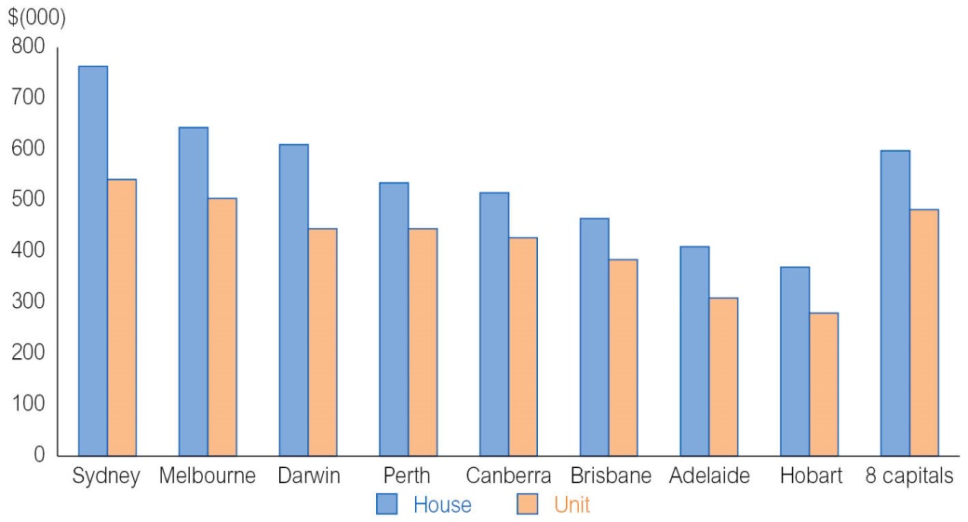
Source: REIA
The median house price varies between Territory major centres. The Real Estate Institute of the Northern Territory reports that the median house price was $445 000 in Alice Springs, $380 000 in Katherine and $290 000 in Tennant Creek in the December quarter 2013.
In the rental market, REIA reports that as at December quarter 2013, Darwin had the highest median weekly rent for a three-bedroom house at $636 and the second highest median weekly rent for a two-bedroom unit at $486. In other capital cities, the median weekly rent for a three-bedroom house ranged from $325 in Adelaide to $470 in Perth, while the median weekly rent for a two-bedroom unit ranged from $270 in Hobart to $490 in Sydney.
Wages
In 2013, the Territory wage price index (WPI) moderated to 2.9 per cent, down from 3.4 per cent in 2012. This was mainly driven by slowing growth in the public WPI, likely reflecting the timing of new enterprise agreements in the Territory Government public sector.
Growth in the Territory’s WPI is expected to strengthen in 2014 to 3.5 per cent and to 3.7 per cent in 2015 before moderating to 3.0 per cent in 2016 and 2017 (Table 9). This reflects the increase in economic activity during the construction of the Ichthys project followed by a reduction in the demand for labour as the construction activity winds down.
Table 9: WPI Forecasts, Year-on-Year Change (%)
 | 2013 | 2014e | 2015f | 2016f | 2017f
Northern Territory | 2.9 | 3.5 | 3.7 | 3.0 | 3.0

e: estimate; f: forecast
Source: ABS, Wage Price Index, Australia, Cat. No. 6345.0; Department of Treasury and Finance

Industry Analysis
Mining
In 2012-13, the mining industry’s contribution to the Territory’s GSP was 14.3 per cent, much greater than its contribution to the Australian economy (8.0 per cent). Despite mining being one of the largest industries in the Territory, the capital-intensive nature and non-resident status of a significant proportion of the labour force means the industry comprised only 3.9 per cent of Territory workforce in 2012-13.
In real terms, mineral and energy production in the Territory increased in value from $5.5 billion in 2011-12 to an estimated $5.9 billion in 2012-13. The increase was driven by higher manganese, uranium and offshore gas production. Combined, gas and liquids, manganese and uranium represented about 65 per cent of the total value of mineral and energy production in the Territory in 2012-13 (Chart 9).
Chart 9: Value of Mineral and Energy Production in the Territory, 2012-13¹
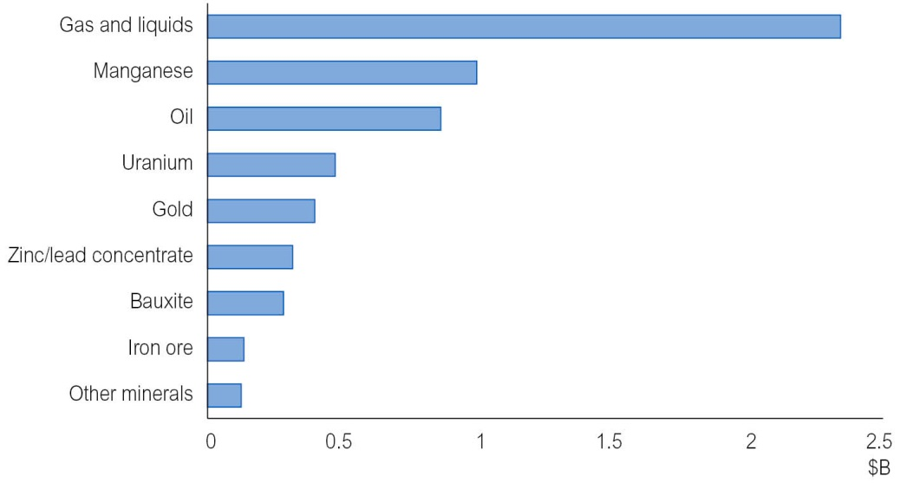
1 Inflation adjusted.
Source: Department of Treasury and Finance; Department of Mines and Energy
The IMF is forecasting global economic growth to strengthen in the forward years. This is expected to underpin demand for mineral and energy resources, which will support mining production in the Territory over this period.
Recent capital investments at Groote Eylandt Mining Company (GEMCO) and the McArthur River Mine will enable higher production over coming years, contributing to growth in the mineral sector in the Territory. Increased iron ore production resulting from new mining in the Roper region will also contribute to growth. While output may rise, the actual value of production may be volatile due to movements in iron ore prices.
A number of prospective developments may support an increase in mining and energy production in the future. These include Sherwin Iron’s Roper River iron ore project, Australian Abrasive Mineral’s garnet sand deposit, Aard Metals’ reprocessing of five tailings dams, new gold mines by ABM Resources, the Evans Shoal gas field by ENI, an appraisal drilling program led by ConocoPhillips at the Caldita-Barossa gas field, and Central Petroleum’s development of the Dingo gas field.
Construction
In 2012-13, the construction industry accounted for 17.7 per cent of the Territory’s GSP, up from 13.7 per cent in the previous year. The construction industry surpassed mining as the single largest industry in the Territory in terms of value in current terms.
In addition to the significant contribution to Territory GSP, the construction industry employed about 13 500 residents during 2012-13. This accounted for 10.7 per cent of the Territory’s workforce and made the construction industry one of the Territory’s largest employers.
The growth in construction activity was primarily driven by record levels of engineering construction activity related to several major projects, including the Ichthys project, expansion at major Territory mine sites and the development of the Montara and nearby oilfields (Chart 10). Construction of the Darwin Correctional Precinct and record levels of private residential construction also supported growth in the construction industry in 2012-13.
Chart 10: Construction Work Done¹ (moving annual total)
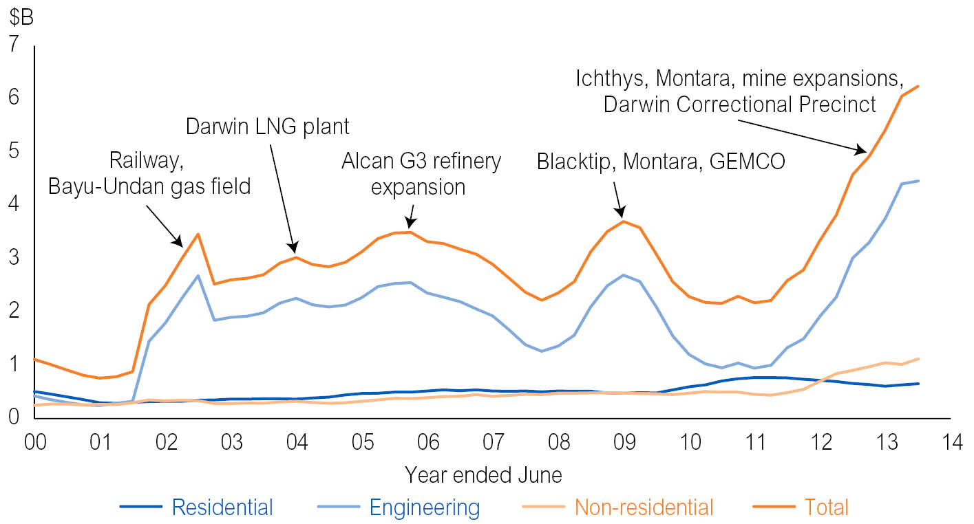
1 Inflation adjusted.
Source: ABS, Construction Work Done, Cat. No. 8755.0
The outlook for the construction industry over the medium term is strong. Growth is expected to be supported by construction activity on the Ichthys project, which is forecast to peak in 2014-15. Residential construction activity is also expected to contribute to growth with private residential construction activity to continue to perform strongly, supported by demand for dwellings, substantial land release and the Territory Government’s Real Housing for Growth plan. The plan has a target of 2000 new homes to be constructed across the Territory by 2016-17.
The First Home Owners Grant (FHOG) scheme has also been amended to target the purchase or construction of new homes. For contracts entered into for the purchase or construction of new homes on or after 13 May 2014, the FHOG increases to $26 000 and the value cap of $600 000 is removed. In addition, the FHOG for established homes will be removed from 1 January 2015. The changes to the FHOG scheme are expected to support private dwelling investment in the Territory.
Agriculture, Forestry and Fishing
In 2012-13, the agriculture, forestry and fishing industry accounted for 2.2 per cent of the Territory’s GSP and employed about 3100 people. The ABS estimates that there were about 1000 agriculture, forestry and fishing businesses actively operating in the Territory at June 2012. The majority of these businesses (about 70 per cent) were sole traders/owner operators.
The agriculture industry in the Territory comprises live cattle (55 per cent), horticulture (40 per cent) and other livestock (5 per cent).
The live cattle industry in the Territory comprises live cattle exported overseas and interstate (Chart 11). Indonesia is the Territory’s major overseas destination for live cattle, accounting for about 78 per cent of total live Territory cattle overseas exports in 2012-13. Other overseas export destinations for live Territory cattle in 2012-13 were the Philippines (10 per cent), Vietnam (6 per cent), Malaysia (4 per cent) and Brunei (2 per cent). The major interstate export destinations for live Territory cattle in 2012-13 were Queensland (63 per cent) and South Australia (21 per cent).
Chart 11: Annual Number of Live Territory Cattle Movements
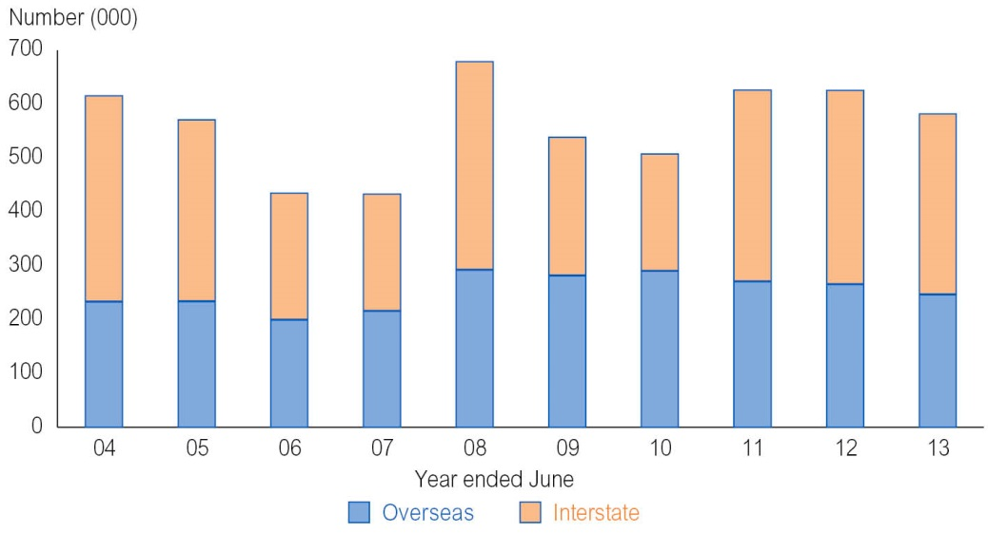
Source: Department of Primary Industry and Fisheries
In the horticulture sector, the main fruits produced in the Territory are mangoes, melons and bananas. The major types of vegetables produced are okra, bitter melon, snake beans, pumpkin and cucumber.
Fish production in the Territory largely comprises snapper, barramundi and shark, while crustacean production is dominated by prawns and mud crabs. Aquaculture in the Territory is largely related to pearls and barramundi fingerlings.
Forestry is a developing industry in the Territory. In February 2014, the Tiwi Plantation Corporation and Japanese company Mitsui and Co. signed a memorandum of understanding to develop markets for the sale of acacia woodchips from Melville Island. The memorandum of understanding is for an initial five-year period and could result in 200 000 to 400 000 metric tonnes of Tiwi woodchips exported to Japan, China and India each year.
The outlook is for the value of the agriculture, forestry and fishing production to trend upwards over the medium term, led by a recovery in the live cattle industry and increase in forestry production. Despite its relatively small contribution to the Territory’s GSP, the agriculture, forestry and fishing industry is vital in terms of generating economic activity and employment in regional areas.
Tourism
Tourism Research Australia (TRA) estimates that the tourism industry contributed 4.5 per cent to the Territory’s GSP. This was the highest of all states, which ranged from 1.7 per cent in Western Australia to 4.3 per cent in Tasmania.
The number of international visitors to the Territory has declined from a peak of more than 400 000 visitors during 2001 to an estimated 260 000 in 2013. The decrease was largely due to a fall in the number of visitors from the Territory’s major tourist source markets of the United Kingdom, the United States, Germany and Japan (Chart 12). Partly offsetting the decrease was growth in the number of visitors from Asia (excluding Japan) over the past decade, in particular, visitors from China, Taiwan, Hong Kong and Korea.

Chart 12: Number of International Visitors (moving annual total)
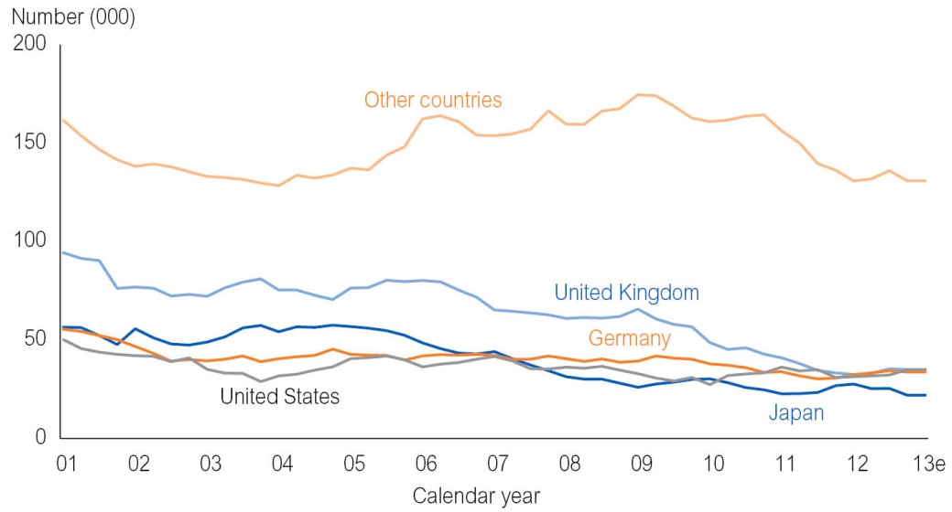
Source: TRA, International Visitors in Australia; Department of Treasury and Finance
In 2013, TRA estimates that there were about 897 000 domestic overnight trips to the Territory, a decrease of 13.0 per cent from 2012. The estimated number of domestic overnight visitors to the Territory across the three main purposes (holiday or leisure, business, or visiting friends and relatives) in 2013 is well below the ten-year average.
The outlook is for international and domestic visitor numbers to the Territory to stabilise in the short term and improve over the medium term. A key factor in the more positive outlook for the tourism industry is the forecast improvement in economic conditions in the Territory’s key tourist source markets.
In addition, the tourism industry is expected to be supported by increased domestic and international airline capacity to and from the Territory. The recent entry of Philippine Airlines, combined with the recommencement of services by Malaysia Airlines and Tiger Airways, join existing domestic and international carriers Qantas, Jetstar, Virgin, SilkAir and Airnorth to increase airline capacity in the Territory significantly.
Darwin International Airport is currently undergoing a major upgrade, which will significantly increase passenger handling capacity at the airport.

Defence
Defence makes a significant contribution to the Territory in terms of providing security to Northern Australia as well as making a stable and long-term contribution to the Territory economy.
In 2012-13, the Department of Defence reports that there were 6512 defence force personnel employed in the Territory. This comprises 5198 personnel in the permanent forces, 960 in the reserve forces and 354 in the Australian public service.
In current terms, in 2012-13, the ABS estimates that defence expenditure in the Territory was $1.42 billion or 7.0 per cent of the Territory’s GSP. This was the highest proportion of all jurisdictions, which ranged between 0.9 per cent in Western Australia to 5.1 per cent in the Australian Capital Territory. Nationally, defence expenditure accounted for 1.7 per cent of Australia’s GDP.
Defence is expected to continue to be an important part of the Territory economy, contributing significantly to the Territory’s population, employment and GSP.
Retail and Wholesale Trade
The retail and wholesale trade industry accounted for 4.8 per cent of the Territory’s GSP in 2012-13. Despite its relatively small contribution to the economy, the retail and wholesale industry is a key employer in the Territory. The industry employed about 13 600 Territory residents, which equates to 10.8 per cent of the total workforce.
Retail activity in the Territory and nationally continues to be constrained in the aftermath of the global financial crisis (GFC), with consumers exhibiting cautious consumption patterns and increased propensity to save and pay down debt. While global and Australian economic conditions have improved since the GFC, this has yet to be reflected through more liberal consumer spending.
In 2012-13, retail trade in the Territory increased by 1.0 per cent, well below the ten-year historical average of 4.5 per cent. Growth was primarily driven by higher levels of spending on non-discretionary items such as food and clothing as well as pharmaceuticals. On the other hand, lower spending on discretionary items such as household goods, and cafés, restaurants and takeaway food services, detracted from growth in Territory retail trade in 2012-13 (Table 10).
Table 10: Retail Trade by Industry Groups, 2012-13
 | Value | Year-on-Year Change | 10-Year Annual Average Growth
 | $M | % | %
Food | 1 242 | 6.5 | 3.1
Household goods | 504 | - 4.1 | 9.4
Clothing, footwear and personal accessories | 152 | 5.3 | 3.8
Cafés, restaurants and takeaway food services | 497 | - 6.9 | 5.6
Other retailing¹ | 463 | 1.0 | 4.8
Total | 2 858 | 1.0 | 4.5

1 Other retailing comprises: department stores; newspaper and book retailing; pharmaceutical, cosmetic and toiletry goods retailing; other industry recreation goods retailing; and other retailing (not elsewhere classified).
Source: ABS unpublished data

The outlook is for retail activity to improve, supported by generally favourable macro-economic conditions including historically low interest rates and forecast solid population and employment growth. Wages growth in the Territory is expected to strengthen over the next two years, which may lead to an improvement in consumer sentiment and household spending.
Manufacturing
In 2012-13, the manufacturing industry accounted for 4.2 per cent of the Territory’s GSP and employed about 3900 persons or 3.1 per cent of the Territory’s workforce. The manufacturing industry in the Territory is heavily reliant on mining-related processing, namely the production of LNG from the Darwin LNG plant and production of alumina from the Gove alumina refinery.
The outlook for the manufacturing industry is negative in the short term. This mainly reflects the decision by Rio Tinto to curtail operations at the Gove alumina refinery from 2014. This is expected to be partly offset by an increase in food processing from the new abattoir currently under construction at Livingstone, 50 kilometres south of Darwin. The facility will be operated by the Australian Agricultural Company Limited and is expected to process more than 1000 head of cattle a day at full capacity and create about 350 operational jobs.
In the medium term, the manufacturing sector is expected to recover and grow rapidly following the commencement of LNG production at the Ichthys plant, which is anticipated for 2016-17.

Government and Community Services
The government and community services industry comprises public administration and safety, education and training, and health care and social assistance.
In 2012-13, the government and community services industry accounted for 18.8 per cent of the Territory’s GSP and employed about 44 400 residents or 35.4 per cent of the Territory workforce. The proportion of Territory residents employed in the government and community services industry has declined as growth in employment in this industry has been outpaced by growth across all industries over this period.
The outlook is for the government and community services industry’s share of GSP to decline over the forward estimates period, reflecting the continuing fiscal consolidation across all levels of government.
Other Services
In 2012-13, the other services industry accounted for 24.1 per cent of the Territory’s GSP and 33.6 per cent of the total Territory workforce. The largest contributors to employment in the Territory in the other services industry are accommodation and food services; transport, postal and warehousing; and professional, scientific and technical services.
The strengthening population and employment growth in the Territory is expected to support service industries in general, however some industries are likely to benefit more than others. The Ichthys project and the associated large number of non-resident workers relocating to the Territory is expected to underpin strong growth in certain industries including transport and warehousing, accommodation and food services, and professional, scientific and technical services. Continued demand for rental accommodation and strength in Territory property markets is also expected to support growth in the rental, hiring and real estate services industry.

