Budget Strategy and Outlook
2014-15
Budget Paper No. 2

Contents
Under Treasurer’s Certification 5
Overview 7
Updated Fiscal Outlook 10
Fiscal Strategy 27
Budget Initiatives 32
Intergovernmental Financial Relations Issues 41
Territory Taxes and Royalties 54
The Territory Economy 68
Uniform Presentation Framework 75
Classification of Entities in the Northern Territory 94
Glossary 96

Under Treasurer’s Certification
In accordance with provisions of the Fiscal Integrity and Transparency Act, I certify that the financial projections included in the May 2014 Budget documentation are based on Government decisions that I was aware of or that were made available to me by the Treasurer before 8 May 2014. The projections presented are in accordance with the Uniform Presentation Framework.

Jodie Ryan
Under Treasurer
9 May 2014

Chapter 1
Overview
Budget Paper No. 2 presents whole of government financial information and related issues, and consolidates information from other Budget papers. It also meets the requirements of the Fiscal Integrity and Transparency Act and complies with the Uniform Presentation Framework, as agreed by all Australian jurisdictions.
Fiscal Outlook
The 2014-15 Budget demonstrates the Government’s continued focus on returning the Budget to a balanced position by 2017-18. The Budget has been framed against a background of strong economic growth in the Territory, resulting in improved own-source revenues, and a need for ongoing fiscal restraint.
The 2014-15 Budget presents a significantly improved fiscal position from that projected in the 2013-14 Budget. This improved fiscal outlook has been achieved through a combination of the following factors:
- increased Territory revenue;
- additional efficiency measures through improved service delivery; and
- an improving financial performance of the Power and Water Corporation.
These factors have resulted in the general government net operating balance projected to be in surplus by 2014-15, two years ahead of the fiscal strategy target. In addition, a small non financial public sector fiscal balance deficit of $39 million is projected in 2017-18, the target year to return the budget to surplus.
Net debt is expected to increase marginally over the forward estimates and by 2017-18 will be $4.2 billion. In addition, the net debt to revenue ratio is set to peak in 2014-15 at 67 per cent, reducing to 65 per cent by 2017-18. When compared to the August 2012 Pre-Election Fiscal Outlook, the improvement in both fiscal indicators, between the last years of the forward estimates, represents a $1.3 billion net debt reduction and a 33 percentage points reduction to the net debt to revenue ratio.
It was announced on 8 May 2014 that the handover of the new Darwin Correctional Precinct to the Territory would not be achieved by 30 June 2014 and may be delayed by a month. Should this eventuate, the Territory would not be liable to make availability payments until the facility is handed over and may receive compensation for any losses incurred as a result of the delay.
As such, the recognition of the $521 million facility in the Territory’s financial statements has been deferred from 2013-14 until 2014-15, with a corresponding adjustment to the fiscal balance between years and net debt in 2013-14. There is no effect on the forward estimates as a result of the delay.
For 2014-15 the fiscal deficit is now projected to be $723 million, $372 million higher than that estimated in the 2013-14 Budget. This is predominantly due to the change in timing of recognition of the $521 million Darwin Correctional Precinct; and a projected carryover of expenditure from 2013-14, largely related to the revised timing of expenditure associated with tied Commonwealth funding, offset by increased revenues, including a one-off improvement in the Territory’s goods and services tax (GST) relative share.
From 2015-16, the fiscal balance deficit improves across all forward years when compared to the 2013-14 Budget. The improved projections in forward years are due to a combination of increasing revenues relating to increased payroll tax, stamp duty and mining royalties, additional efficiency measures and an improvement in the financial performance of the Power and Water Corporation.
Table 1.1 highlights the key fiscal aggregates for the general government sector and the non financial public sector.
Table 1.1: Key Fiscal Indicators/Aggregates
 | 2013-14 | 2014-15 | 2015-16 | 2016-17 | 2017-18
 | Estimate | Budget | Forward Estimate
 | $M | $M | $M | $M | $M
General government sector
Net operating balance | - 31 | 63 | 99 | 69 | 1
Non financial public sector
Fiscal balance | - 394 | - 723 | - 92 | - 53 | - 39
Net debt | 3 406 | 4 066 | 4 117 | 4 139 | 4 159
Net debt to revenue (%) | 58 | 67 | 66 | 65 | 65

Source: Department of Treasury and Finance
Economic Outlook
The economic environment in the Territory remains favourable and the outlook is positive, with the Territory economy expected to outperform most other jurisdictions.
The Territory economy performed solidly over the past two years and the forecast is for this trend to continue over the budget and forward estimates period. The Territory economy is estimated to grow by 5.0 per cent in 2013-14, with growth to strengthen to 6.0 per cent in 2014-15. Growth over this period is expected to be underpinned by an acceleration of onshore construction activity related to the INPEX Ichthys liquefied natural gas project.
These forecasts incorporate the effect of the curtailment of operations at the Gove alumina refinery, which will detract from economic growth in the Territory through lower consumption growth. This reflects the loss of employment and population in the region and decreased alumina exports, partially offset by reduced fuel oil and caustic soda imports, and increased bauxite exports.
In the forward years, the Territory economy is expected to undergo a significant transition. From 2015-16, private investment is expected to decline and net exports are expected to emerge as the primary driver of economic growth as the Ichthys project transitions from the construction to the production phase.
Current labour market conditions in the Territory are strong, as highlighted by robust employment growth and one of the lowest unemployment rates in Australia. Territory employment growth is expected to strengthen over the next two years to 3.8 per cent in 2014-15, supported by continued elevated levels of construction activity, which is expected to flow through to other industries in the Territory.
Consistent with economic activity, Territory population growth is estimated to increase by 1.6 per cent in 2014 before strengthening to 2.6 per cent in 2015. Net overseas migration is expected to continue to make a strong contribution to the Territory’s overall population growth over the medium term.
In the forward years, Territory employment and population growth are expected to moderate as the Ichthys project transitions from the construction phase to the less labour-intensive production phase.
In 2013, the Darwin consumer price index (CPI) increased by 3.9 per cent. The main contributors to growth in the Darwin CPI in 2013 were increases in costs of housing, transportation, recreation and culture, alcohol and tobacco, and health. Price pressures are expected to ease over the forward estimates, as the impact of the increases in utility prices and motor vehicle registration, as well as the impact of the carbon tax, are incorporated in the base. Growth in the Darwin CPI is expected to moderate to 3.0 per cent in 2014 and remain relatively constant over the forward years.
Table 1.2: Key Economic Forecasts (%)
 | 2012-13 | 2013-14e | 2014-15f | 2015-16f | 2016-17f | 2017-18f
Gross state product¹ | 5.6 | 5.0 | 6.0 | 3.0 | 4.0 | 3.5
Population² | 2.3 | 2.0 | 1.6 | 2.6 | 1.0 | 1.0
Employment³ | 2.6 | 3.7 | 3.8 | 2.1 | 0.7 | 0.7
Consumer price index⁴ | 2.0 | 3.9 | 3.0 | 2.8 | 2.5 | 2.5

e: estimate; f: forecast
1 Year ended June, year-on-year change, inflation adjusted.
2 As at December, annual change.
3 Year-on-year percentage change.
4 As at December, year-on-year percentage change.
Source: ABS; Department of Treasury and Finance

Chapter 2
Updated Fiscal Outlook
Overview
This chapter addresses the requirement under section 10(1)(a) of the Fiscal Integrity and Transparency Act (FITA) that each fiscal outlook report contains updated financial projections for the budget year and the following three financial years for the Northern Territory general government sector and the non financial public sector.
Although the full set of financial projections is provided in Chapter 8, this chapter provides:
- a comparison of the projections with the estimates provided in the May 2013-14 Budget and the 2013-14 Mid-Year Report;
- a discussion of the forward estimates; and
- a statement of risks and a discussion of the Territory’s contingent liabilities.
Since the Northern Territory general election in August 2012, the Northern Territory Government has been going through a period of fiscal consolidation aimed at returning the Northern Territory’s budget to a balanced position by 2017-18.
In the lead up to the 2013-14 Budget the focus was on savings and revenue measures aimed at meeting the cost of the Government’s election commitments along with a range of identified unfunded legacy items. While this focus resulted in an improved outlook for 2013-14 and the forward estimates to 2016-17, the measures did not go far enough to achieve a fiscal balance by 2017-18. In addition, the Government had identified a range of new priorities during the year that required funding.
Against this backdrop, during 2013-14, the Government embarked upon the Improving Public Services Review.
The primary purpose of the review was to assess agency programs and functions to determine if the function remained a priority of Government and if it was achieving expected outcomes. As part of the process, agencies were asked to consider alternative options to achieve either similar, or improved, outcomes. From the review, further efficiencies have been found both within individual agencies and across government, with more work expected to continue during 2014-15 to build on the efforts undertaken to date. Some of the major outcomes from the review include:
- delivering the following services previously undertaken by government business divisions (GBDs) differently:
- tourism development previously undertaken through Territory Discoveries;
- government printing services formerly delivered by the Government Printing Office (GPO); and
- infrastructure project management previously undertaken by Construction Division (CD);
The activities of Territory Discoveries and GPO will be transitioning to external service providers by the end of the financial year while the resources and activities of CD will be consolidated into the Department of Infrastructure effective from 1 July 2014;
- commencement of a public tender process to outsource the provision of urban and school bus services currently undertaken by the Darwin Bus Service; and
- establishing the Board of the Museums and Art Galleries of the Northern Territory as an independent statutory body, with the new structure having the potential to increase the capacity to attract philanthropic and private sector donations or contributions.
In addition to the focus on expenditure restraint, there have also been substantial increases in own-source revenue during 2013-14. These increases are the result of the growth in the Territory economy, as demonstrated by the 5.6 per cent growth experienced in 2012-13 and the 5 per cent expected for 2013-14, with the estimated revenue for all tax categories higher than that projected in the 2013-14 Budget. Payroll tax has increased by $42.1 million through the year, conveyance stamp duty by $17.9 million and royalty revenue by $41.5 million. These revenue increases are expected to flow through to 2014-15 and the forward estimates.
In addition to own-source revenue, there has been a significant one-off increase to GST revenue in 2014-15. The increase is the result of the Territory’s higher relative share of the GST. In its 2014 Update, the Commonwealth Grants Commission (CGC) recommended that the Territory’s relativity increase from 5.31414 in 2013-14 to 5.66061 in 2014-15. The recommended relativity was approved by the Federal Treasurer in March 2014 and is the highest relativity the Territory has seen since the commencement of the GST. However, Western Australia’s relativity is also at its lowest point since 2000, therefore it is expected that the Territory’s high relativity will not be sustained, particularly as Western Australia’s mining royalties reduce over time. Due to this, and the 2015 Methodology Review being undertaken by the CGC, where the results will not be known until early 2015, the Territory’s relativity is projected to decline over the forward estimates.
The effect of the curtailment of operations at the Gove alumina refinery, combined with the expected reduction in the relativity has resulted in the GST revenue increase in 2014-15 being for one year only, with the forward estimates of GST revenue expected to be generally consistent with those projected in the 2013-14 Budget.
There is also an expected increase in tied Commonwealth funding due largely to the revised arrangements for education funding, however the agreement is only in place until 2016-17 at this stage. There are also a number of recommendations in the Commonwealth’s Commission of Audit report released on 1 May 2014 that, if accepted, will result in less revenue from the Commonwealth for specific services. If the services are to be continued, there will be a substantial impact on the Territory’s ability to meet its fiscal objectives.
The focus on fiscal restraint, coupled with an increase in own-source revenue has meant that the projected Budget and Forward Estimate outcomes are significantly improved compared to those presented in the 2013-14 Budget. Although a small deficit is currently projected for 2017-18, expectations are that a fiscal balance should be achieved if the current focus on fiscal restraint continues and Commonwealth revenue does not substantially decline.
Table 2.1 highlights the significant improvements in the operating statement key fiscal indicators and compares the updated projections with those published at the time of the 2013-14 Budget (May 2013) and the 2013-14 Mid-Year Report (December 2013).

Table 2.1: Key Fiscal Indicators – Operating Statement
 | 2013-14 | 2014-15 | 2015-16 | 2016-17 | 2017-18
 | Estimate | Budget | Forward Estimate
 | $M | $M | $M | $M | $M
General government sector
Net operating balance
2013-14 Budget | - 230 | - 171 | - 62 | - 47 | n.a.
2013-14 Mid-Year Report | - 201 | - 208 | - 94 | - 92 | n.a.
2014-15 Budget | -31 | 63 | 99 | 69 | 1
Variation from 2013-14 Budget | 199 | 234 | 161 | 116 | n.a.
Non financial public sector
Fiscal balance
2013-14 Budget | - 1 185 | - 351 | - 236 | - 176 | n.a.
2013-14 Mid-Year Report | - 1 181 | - 349 | - 235 | - 175 | n.a.
2014-15 Budget | - 394 | - 723 | - 92 | - 53 | - 39
Variation from 2013-14 Budget | 791 | - 372 | 144 | 123 | n.a.

n.a.: not available at the time of publishing
Source: Department of Treasury and Finance
General Government Sector Net Operating Balance
As shown in Table 2.1, the general government sector operating balance is projected to improve in all years, when compared to the May 2013 Budget and the 2013-14 Mid-Year Report. As discussed above, the improvement is largely the result of increases in own-source revenue and continued fiscal restraint. The greater improvement in 2013-14 is due to the carryover of expenditure into 2014-15, which has been more than offset by the one-off increase in GST revenue and ongoing increases in Territory revenue.
The net operating balance is expected to return to surplus in 2014-15, two years ahead of the fiscal strategy target, with small surpluses projected across the forward estimates.
Non Financial Public Sector Fiscal Balance
The general government sector excludes the Power and Water Corporation (PWC) and due to the fact that PWC is not yet self-supporting, the fiscal balance measure is assessed at the non financial public sector. The improvement in the fiscal balance follows the same trend as the improvement in the general government operating balance, except for the improving financial position of the PWC and the revised timing of the handover of the Darwin Correctional Precinct.
As shown in Table 2.1, the fiscal balance deficit is now projected to peak at $723 million in 2014-15, before trending to improvement with a small deficit of $39 million estimated in 2017-18. The key offsetting revenue and expense-related variations that have contributed to the movements in the fiscal balance are described in more detail below.
Policy and Non-Policy Changes Since May 2013 Budget
Table 2.2 sets out changes that have affected the non financial public sector fiscal balance for 2013-14 and 2014-15 since the May 2013 Budget was delivered.

Table 2.2: Variations to the Non Financial Public Sector’s Fiscal Balance since May 2013
 | 2013-14  Accrual | 2014-15  Accrual
 | $M | $M
2013-14 BUDGET | - 1 185.0 | - 350.9
Revenue – policy
Revenue – increase in bookmakers turnover tax |  | 2.8
Revenue Measures across agencies |  | 6.9
Total revenue – Policy |  | 9.7
REVENUE
Revenue – non policy
Stamp duty | 17.9 | 18.4
Payroll tax | 42.1 | 34.8
Other taxes | 8.2 | 8.4
GST revenue | 3.0 | 157.0
Timing of new/expanded Commonwealth revenue | 116.4 | 192.1
Mining royalties | 41.5 | 50.8
Agency own-source revenue | 14.3 | 12.0
Power and Water Corporation revised revenue estimates | 36.0 | 21.9
Other revenue | 40.1 | 4.5
Total revenue – non policy | 319.5 | 499.9
TOTAL REVENUE | 319.5 | 509.6
OPERATING EXPENSES
Expenses – policy
Policy initiatives | 31.6 | 57.2
Efficiency improvements |  | - 55.8
Total expenses – policy | 31.6 | 1.4
Expenses – non policy
Commonwealth revenue-related payments | 87.7 | 135.3
Transfer of payments between years and to capital | - 88.3 | 67.1
Power and Water Corporation revised revenue estimates | 9.1 | - 9.1
Interest expense | 1.3 | - 17.6
Depreciation | 133.1 | 86.4
Other | 9.1 | 9.6
Total expenses – non policy | 151.9 | 271.6
TOTAL OPERATING EXPENSES | 183.5 | 273.0
Net capital payments
Commonwealth revenue-related payments | 45.1 | 25.1
Transfer of payments between years and to expenses | - 65.8 | 63.6
Policy initiatives | 1.1 | 63.9
Sales | 11.1 | - 2.8
Depreciation | - 133.0 | - 86.3
Power and Water Corporation revised capital payments | - 2.2 | 25.9
Other | 10.4 | - 2.4
Total capital payments | - 133.3 | 87.0
TOTAL EXPENSES | 50.2 | 360.0
Finance lease – Darwin Correctional Precinct | 521.3 | - 521.3
TOTAL VARIATION | 790.6 | - 371.7
2014-15 BUDGET | - 394.4 | - 722.6

Source: Department of Treasury and Finance
In total, the policy and non-policy changes present a net improvement of $790.6 million in 2013-14 and a worsening of $371.7 million in 2014-15. The main change relates to the timing in the handover of the Darwin Correctional Precinct, which has resulted in a $521 million improvement in 2013-14 with a corresponding worsening in 2014-15. The remaining key policy and non-policy changes are discussed in further detail below.
Revenue
The revenue-related policy changes since the 2013 Budget affect 2014-15 and total $9.7 million. The two changes are:
- an ongoing increase in the bookmaker turnover tax of $2.8 million due to an increase in the tax threshold from $262 500 to $555 000; and
- increases in agency revenue of $6.9 million largely due to a change in debt recovery arrangements, expected to result in one-off additional revenue of $4.8 million. The balance reflects minimal ongoing increases in existing charges across a range of functional areas.
The non-policy revenue-related variations since the May 2013 Budget total $319.5 million in 2013-14 and $499.9 million in 2014-15. The main changes are:
- an increase in payroll tax of $42.1 million in 2013-14 due to growth in both employment and wages. Although the growth is expected to flow through to 2014-15, the curtailment of operations at the Gove alumina refinery has an offsetting effect resulting in a lower increase of $34.8 million in 2014-15;
- increased stamp duty of $17.9 million in 2013-14, largely due to increased conveyance duty receipts due to a higher number of residential transactions, a small increase in the average value of those transactions and some high-value commercial transactions. It is expected that this increase is ongoing and will flow through to 2014-15, with an increase of $18.4 million projected;
- GST revenue is expected to be slightly up ($3 million) in 2013-14, however there is a large one-off increase of $157 million in 2014-15 as a result of the increase in the Territory’s relative share of the GST, as recommended by the CGC. As discussed earlier, this increase does not flow through to the forward estimates;
- tied funding from the Commonwealth has increased by $116.4 million in 2013-14 and $192.1 million 2014-15. The key variations include:
- extra funding to the Department of Education of $50 million in 2013-14 and $95 million in 2014-15 under the Schools First agreement, and additional funding of $12 million in 2013-14 for Trade Training Centres and Early Childhood Development;
- additional roads funding in 2013-14 of $8 million for the Umbakumba road project and $6 million for the Heavy Vehicle Safety program, offset by a reduction of $11.5 million in 2013-14 and an increase of $13 million in 2014-15 due to revised timing of funding to align with the Commonwealth’s updated projections;
- increased public order and safety funding of $19.6 million in 2014-15 for immigration detention policing and $4 million in 2013-14 and 2014-15 for tackling alcohol abuse;
- increased health funding of $8.8 million in 2013-14 for the Age Care and Disability Specific Purpose Payment (SPP) to match the Commonwealth’s updated projections, and $8 million in 2013-14 and $4 million in 2014-15 for a range of health-related programs; and
- additional housing funding of $4 million for homelessness in 2013-14 under the National Partnership Agreement on Homelessness.
- the increase in mining royalties of $41.5 in 2013-14 is due largely to the combined effect of the moderation of the Australian dollar and increased commodity prices and production levels. The increase of $50.8 million in 2014-15 is based on miners’ forecasts and assumptions that the Australian dollar will not materially strengthen and reasonable commodity prices will be achieved;
- increased agency own-source revenue due to increased usage of government services, mainly in the areas of health and housing;
- revised revenue estimates by PWC of $36 million in 2013-14 and $21.9 million in 2014-15, based on actual revenue received during 2013-14; and
- one-off increases in other revenue in 2013-14 of $40.1 million and $4.5 million in 2014-15.
Expenses
Non financial public sector expenses are projected to increase by $183.5 million in 2013-14 and $273 million in 2014-15.
In regards to policy-related expense variations, for 2013-14 the new initiatives total $31.6 million, largely the result of additional funding for the Department of Education, the container deposit scheme, rugby league matches, regional councils, legal settlements and continuation of the Tiwi Island ferry services. In 2014-15 the new and expanded initiatives and the efficiency improvement measures are largely offsetting.
New and expanded initiatives for 2014-15 total $57.2 million and include:
- $7.5 million to Tourism NT for international marketing to boost tourism in the Territory and $0.5 million for the regional and remote tourism product development grant program;
- $5 million additional for the expanded Sports Voucher scheme;
- $1.5 million per annum for three years for the Remote Indigenous Home Purchase Strategy;
- $10 million for additional repairs and maintenance funding for the Department of Health;
- $2.9 million to establish and operate the Northern Australia Development Office;
- $5 million ongoing additional funding to support the financial sustainability of regional councils;
- $5.95 million per annum for four years to create opportunities for resource exploration and to assess the Territory’s shale gas potential and resources;
- $3.6 million ongoing for the new mental health and behavioural facility and expanded primary health care at the new Darwin Correctional Precinct; and
- $3.4 million to establish a Northern Territory Civil and Administrative Appeal Tribunal.
Efficiency improvements total $55.8 million in 2014-15 and are largely the result of the Improving Public Services Review where a range of efficiencies and service delivery alternatives were identified across the majority of agencies. The main efficiency gains were found in the health and welfare portfolio ($21 million, or 1 per cent of total expenditure), public order and safety ($21.5 million, 3 per cent of total expenditure) and whole of government savings ($7.5 million).
Further information on the policy initiatives in the Budget can be found in Chapter 4 of this Budget Paper.
The non policy expense variations total $151.9 million in 2013-14 and $271.6 million in 2014-15, with the largest contributors to this being:
- additional expenditure related to the increase in Commonwealth revenues described above, with $87.7 million in 2013-14 and $135.3 million in 2014-15;
- the transfer of expenses between years and to capital resulting in a reduction of $88.3 million in 2013-14 and an increase of $67.1 million in 2014-15; and
- an increase in depreciation of $133.1 million in 2013-14 and $86.4 million in 2014-15 as a result of housing constructed under the National Partnership Agreement on Remote Indigenous Housing being added to the asset base and revised estimates of PWC’s assets.
There have also been some variations to net capital spending that, when depreciation is removed, result in an increase of $173.3 million in 2014-15 due to:
- the transfer of payments between years and from expenses, and associated Commonwealth payments of $88.7 million;
- increased Territory infrastructure funding of $50 million;
- additional expenditure of $13.3 million for Indigenous essential services for priority projects in Maningrida, Angurugu, Galuwin’ku, Yirrkala and Numbulwar; and
- additional capital spending by PWC of $25.9 million.
Further information on the Territory’s infrastructure program can be found in Budget Paper No. 4.
2014-15 Budget and 2015-16 to 2017-18 Forward Estimates
Basis of Forward Estimates
In accordance with the FITA, five years of estimates are maintained and used by Government, both as a planning and an operational tool. This provides the framework within which agencies plan and also provides the basis for the Government’s fiscal strategy.
Agency forward estimates vary in line with the application of parameters (inflators and deflators) to the Budget year on a no-policy-change basis. New policy decisions and funding decisions linked to demand or cost growth also add to each agency’s budget and forward estimates. The main parameters used to adjust estimates are:
- wages – inflator;
- consumer price index (CPI) – inflator; and
- efficiency dividend – deflator.
The wage inflator applied for employee costs in 2014-15 and over the forward estimates period is 3 per cent. A CPI factor of 2.5 per cent is applied to operational costs from 2014-15 ongoing, other than property management managed by the Department of Corporate and Information Services, which receives a higher parameter. An additional parameter of 4 per cent is applied to wage and non-wage expenditure for the Top End and Central Australia Health Services in recognition that hospital costs are generally higher than CPI.
An efficiency dividend is applied to operational and employee costs premised on agencies improving processes and delivering services more efficiently, as is the case with private sector enterprises. For key service delivery agencies with fixed staffing costs (police, health, education and correctional services), one quarter of the dividend is applied. An efficiency dividend of 1 per cent has been applied in 2014-15 and the forward estimate period. Efficiency dividends are not applied to grants and some contractual obligations.
For Territory-funded grants and subsidies, a composite factor is applied based on 75 per cent of the wages factor and 25 per cent of the CPI factor.
Operating Revenue
Table 2.3: Non Financial Public Sector – Revenue
 | 2013-14 | 2014-15 | 2015-16 | 2016-17 | 2017-18
 | Estimate | Budget | Forward Estimate
 | $M | $M | $M | $M | $M
Revenue
Taxation revenue | 544 | 559 | 575 | 592 | 615
GST revenue | 2 808 | 3 129 | 3 185 | 3 313 | 3 446
Current grants | 813 | 802 | 851 | 841 | 754
Capital grants | 300 | 240 | 211 | 226 | 116
Sales of goods and services | 944 | 1 001 | 1 057 | 1 073 | 1 073
Interest income | 57 | 55 | 55 | 56 | 58
Dividend and income tax equivalent income | 49 | 59 | 62 | 63 | 64
Mining royalties income | 155 | 164 | 164 | 164 | 164
Other | 153 | 87 | 85 | 86 | 86
Total revenue | 5 823 | 6 096 | 6 245 | 6 414 | 6 376
Year-on-year percentage increase (%) | 8 | 5 | 2 | 3 | -1

Source: Department of Treasury and Finance
Table 2.3 shows that total operating revenue is projected to increase on average by 2.4 per cent per annum from 2013-14 to 2017-18.
Taxation revenue is the most significant component of the Territory’s own-source revenue and is predicted to increase in all years compared with May 2013 Budget projections. The Territory’s taxation revenue for 2013-14 is expected to total $544 million. In 2014-15, taxation revenue is expected to increase by 2.7 per cent to $559 million, with an average increase of 3.3 per cent over the forward estimates. The growth is reflective of expected economic conditions in the Territory, offset by the effect of the curtailment of operations at the Gove alumina refinery.
Compared to the 2013 Budget, the estimate of the Territory’s GST revenue in 2014-15 has increased by $157 million. Of this increase, $191 million is directly attributed to the Territory’s revised GST relativity, which is partially offset by a reduction in estimates of both the Territory’s share of the national population and national GST collections. GST is expected to grow at an average of 3.4 per cent over the forward estimates, reflecting the expected decline in the Territory’s relativity.
Further details on GST can be found in Chapter 5 of this Budget Paper.
During each budget year there are significant changes in Commonwealth funding estimates as agreements are finalised. These adjustments tend not to affect the fiscal outcome as increases in revenue are generally matched by a corresponding increase in expenditure. However, timing differences in the receipt of tied revenue and associated expenditure introduce a degree of volatility affecting the budgeted and actual outcomes.
Current and capital grants are currently projected to decrease by 5.5 per cent over the forward estimates as a result of agreements with the Commonwealth being for fixed periods. Until these are renegotiated, they are not included in the forward estimates. The significant reduction in grants in 2017-18 is largely due to the Schools First agreement ceasing in 2016-17.
Revenue from the sales of goods and services has increased in all years when compared to the 2013 Budget and is expected to increase by 2.4 per cent from 2014-15 and over the forward estimate period.
The remainder of own-source revenue is mainly attributable to mining royalties, and although projected to remain relatively flat over the forward years, it is off a higher base from that projected in the 2013 Budget.
Operating Expenses
Table 2.4 sets out the revised projections for total expenditures for 2013-14 and the forward years.
Table 2.4: Non Financial Public Sector – Expenditure
 | 2013-14 | 2014-15¹ | 2015-16 | 2016-17 | 2017-18
 | Estimate | Budget | Forward Estimate
 | $M | $M | $M | $M | $M
Expenses
Employee expenses | 2 087 | 2 107 | 2 162 | 2 228 | 2 242
Superannuation expenses | 328 | 351 | 374 | 389 | 371
Depreciation and amortisation | 546 | 521 | 511 | 507 | 501
Other operating expenses | 1 704 | 1 773 | 1 806 | 1 888 | 1 882
Interest expenses | 293 | 350 | 358 | 362 | 370
Current grants | 768 | 741 | 741 | 769 | 786
Capital grants | 59 | 65 | 46 | 34 | 36
Subsidies and personal benefit payments | 111 | 118 | 116 | 119 | 123
Total expenses | 5 896 | 6 026 | 6 114 | 6 296 | 6 311
Year-on-year percentage increase (%) | 8 | 2 | 1 | 3 | 0
Net capital | 852 | 1 328 | 714 | 655 | 580
Total expenditure | 6 748 | 7 354 | 6 828 | 6 951 | 6 891
Year-on-year percentage increase (%) | 7 | 9 | - 7 | 2 | - 1
1 Net capital includes accounting for the total cost of the Darwin Correctional Precinct, now expected to be completed in early 2014-15.
Source: Department of Treasury and Finance
Total operating expenses are expected to grow from 2013-14 at an average of 1.8 per cent per annum over the forward estimates. This is lower than the revenue growth of 2.4 per cent over the same period, which is consistent with the target of eliminating the fiscal deficit by 2017-18. Consistent with the revenue estimates, the minimal growth in 2017-18 reflects the conclusion of the Schools First agreement in 2016-17.
Over the forward estimate period, employee expenses are estimated to increase on average from the budget year by 2.1 per cent per annum, largely as a result of the wages growth parameter, offset by the efficiency dividend.
Underlying growth from the budget year in other operating expenses is 2.1 per cent per annum. Interest expenses are increasing over the forward estimate period as debt increases, although at a lower rate than previously projected.
Included in expenditure estimates is an amount attributed to the contingency allowance in all forward estimate years. The inclusion of a contingency allowance is consistent with the practices in other states to meet unforeseen expenditure and support limited new and expanded initiatives. In order to achieve projected budget outcomes, additional expenditure above these amounts will need to be met through reprioritisation of existing expenditure or additional efficiency gains, with any additional revenue to be used to reduce debt.
The fluctuation in current and capital grants expense across the forward estimate period is in line with the timing of tied Commonwealth funding agreements, in particular, the Stronger Futures package and the National Partnership on Remote Indigenous Housing.
Net capital payments are projected to decline from the budget year over the forward estimate period, predominantly as a result of revised capital investment by PWC, and reduction in infrastructure investment by government as private sector investment increases. The reduction is further influenced by the reduction in Commonwealth-funded infrastructure programs such as the Remote Indigenous Housing program, which was funded at the front end of the program.
Key Fiscal Indicators – Balance Sheet
Table 2.5: Non Financial Public Sector – Net Debt and Net Debt to Revenue Ratio
 | 2013-14 | 2014-15 | 2015-16 | 2016-17 | 2017-18
 | Estimate | Budget | Forward Estimate
 | $M | $M | $M | $M | $M
Net debt
2013-14 Budget | 4 417 | 4 730 | 4 944 | 5 113 | n.a.
2013-14 Mid-Year Report | 4 260 | 4 568 | 4 781 | 4 946 | n.a.
2014-15 Budget | 3 406 | 4 066 | 4 117 | 4 139 | 4 159
Variation from 2013-14 Budget | - 1 011 | - 664 | - 827 | - 974 | n.a.
Net debt to revenue (%)
2013-14 Budget | 80 | 85 | 85 | 86 | n.a.
2013-14 Mid-Year Report | 76 | 81 | 81 | 82 | n.a.
2014-15 Budget | 58 | 67 | 66 | 65 | 65
Variation from 2013-14 Budget | - 22 | - 18 | -19 | - 21 | n.a.
n.a.: not available at the time of publishing the 2013-14 Budget and 2013-14 Mid-Year Report
Source: Department of Treasury and Finance
As shown in Table 2.5, compared to the 2013 Budget net debt has significantly decreased, and by 2017-18 is projected to be $4.2 billion. This represents a reduction of $1.3 billion from that projected for the final year of the forward estimates at the time of the Pre-Election Fiscal Outlook published in August 2012.
The improvement is reflective of the additional own-source revenue and the improving position of PWC. The significant improvement in 2013-14 is also reflective of the change in timing of recognition of the Darwin Correctional Precinct now not expected to be completed until early 2014-15.
As a result of the reduction in net debt, the net debt to revenue ratio is projected to decline over the forward estimates from 67 per cent in 2014-15 to 65 per cent by 2017-18. This represents a reduction of 33 percentage points from that projected at the time of the Pre-Election Fiscal Outlook published in August 2012.
Risks to the Updated Financial Projections
As required under section 10(1)(e) of FITA each fiscal outlook report is required to contain ‘a statement of the risks, quantified as far as practicable, that could materially affect the updated financial projections, including any contingent liabilities and any Government negotiations that have yet to be finalised’.
This chapter outlines the potential effect of risks to the Budget due to changes in revenue and expense estimates and the likelihood of contingent liabilities becoming actual liabilities. Any changes in risks or liabilities that are apparent since the 2013-14 Mid-Year Report are also identified.
Revenue
GST Revenue
Volatility in GST revenue represents the largest revenue risk for the Territory, with GST revenue accounting for over 50 per cent of the Territory’s total revenue. As such, changes in GST revenue estimates can significantly affect the Territory’s budget outcome and capacity to deliver government services.
The Territory’s GST entitlement is dependent on three parameters: national GST collections, the Territory’s share of the national population, and GST relativities as recommended by the CGC. There are many variables that influence each of these parameters, adding to the complexity of forecasting GST revenue to the Territory over the budget and forward estimates period.
National GST Collections
The Territory’s estimates of national GST collections in 2014-15 and over the forward estimates period are informed by the Commonwealth’s most recent published advice (the 2013 Mid-Year Economic and Fiscal Outlook) and national economic indicators. Compared with the 2013-14 Mid-Year Report, growth in national GST collections is forecast to be slightly higher over the forward estimates period, however coming off a lower base in 2013-14.
The Territory’s GST revenue is directly affected by variations in national GST collections. A ±1 percentage point change in the GST pool growth rate is estimated to have a ±$30 million impact on the Territory’s GST revenue in 2014-15. If variations of ±1 percentage point occurred in each of the budget and forward estimates years, the cumulative impact on Territory GST revenue is about ±$318 million.
Territory’s Share of National Population
The estimates of the Territory’s population growth for the budget and forward estimates largely reflect the impact of major projects. The Territory’s annual population growth is expected to moderate in 2014-15 due to population outflows related to the curtailment of operations at the Gove alumina refinery before strengthening in 2015-16 as workforce requirements for the construction phase of the Ichthys project peak. In 2016-17 and 2017-18, growth is forecast to moderate as the Ichthys project moves to the production phase and the focus of economic activity shifts to new projects and other activities.
Overall, the Territory’s population is expected to grow at a slower rate than nationally between 2013-14 and 2017-18, with the Territory’s share of the national population estimated to decrease over the forward estimates period.
Estimates of the Territory’s population growth relative to the national average influence the Territory’s share of the national population, and therefore impact on forecasts of the Territory’s GST revenue. The effect of a ±1 percentage point variation in the Territory’s forecast population growth is estimated at ±$29 million in 2014-15, all other things being equal. The cumulative impact of a ±1 percentage point variation in the estimate of the Territory’s population growth rate over the budget and forward estimates period is about ±$311 million.
GST Relativities
The CGC is responsible for determining GST relativities, which are updated each year. However, the CGC does not forecast relativities for forward years. The CGC has recommended the relativities that will be used to distribute GST revenue between the states in 2014-15.
The Territory’s relativity is forecast to be lower over the forward estimates period, as the current relativity is considered unsustainable given that it is at an unprecedented high, while Western Australia’s is at an unprecedented low. The Territory’s forecasts are based on expected changes in the CGC’s assessment of states’ revenue-raising capacities over the forward estimates period.
The approximate impact of a 1 per cent variation in the Territory’s GST relativity is ±$29 million, with a cumulative impact over the forward estimates period of ±$123 million.
The above analysis examines the effect of variations in estimates of each parameter in isolation. However, these parameters often interact and, as a result, variations in each parameter could have a compounding or offsetting effect on GST revenue estimates.
Commonwealth Grants Commission 2015 Methodology Review
Every five years the CGC undertakes a major review of the methodology it uses to recommend the distribution of GST revenue between the states. The CGC’s Final Report on GST Revenue Sharing Relativities – 2015 Review (2015 Review) will affect states’ GST revenue shares from 2015-16 onwards. Given the Territory’s reliance on GST revenue, the review represents a significant financial risk to the Territory, as it could result in a reduction in the Territory’s share of GST revenue. The effect of any changes to the methodology will not be known until the release of the 2015 Review in February 2015. The 2015 Review is discussed in further detail in Chapter 5 of this Budget Paper.
Other Commonwealth Grants and Subsidies
Commonwealth funding is provided under either the Intergovernmental Agreement on Federal Financial Relations (IGA) through SPPs, National Health Reform (NHR) payments, Students First – A Fairer Funding Agreement for Schools payments and National Partnership (NP) payments, or through Commonwealth Own Purpose Expenses (COPE) provided directly to agencies. The IGA affords flexibility of expenditure across the relevant sector for SPPs (provided for the skills and workforce, disability and housing sectors in 2014-15) without input controls, co-investment and maintenance of effort requirements. These payments are not time limited and are indexed on a sector-specific basis. These arrangements provide a degree of certainty for the Territory’s budgeting, although adequacy of indexation in terms of capturing cost growth remains an ongoing risk. From 2014-15 NHR payments will, at a minimum, be equivalent to the amount that would have been paid under the previous Healthcare SPP. From 2014-15, NHR payments will predominantly be based on either hospital activity, or ‘block funding’ for smaller hospitals in recognition of their circumstances. A risk remains that the Territory’s circumstances will not be adequately recognised in the funding arrangements, therefore potentially affecting the adequacy of Commonwealth funding.
NP agreements continue to include many risks to states including co-investment, input controls, application of national costs, burdensome reporting and administrative arrangements, and potential withdrawal of seed funding. Expiry of NP agreements, which by their nature are time limited, also potentially pose a risk to the Territory’s Budget, particularly where funding has raised service delivery expectations.
The Territory has 21 NP agreements expiring during 2013-14, for which total funding of $39.6 million is expected to be received in 2013-14. A further eight NP agreements are due to expire by the end of 2014-15, with expected total funding of $30.4 million during this period. Should the funding under these agreements not be renewed or rolled into an existing SPP, the Territory would need to either reduce service delivery levels or provide additional funding.
In addition, timing of Commonwealth decisions regarding the treatment of expiring NP agreements and their funding is also critical to ensure continuity in delivery or to allow for alternative approaches to be considered should funding not be available.
With the potential budget pressure issues prevailing at the Commonwealth level, there is a further risk of reduced funding levels to all state and territory tied and untied funding if these payments are re-directed to work towards achieving revised priorities of the Commonwealth.
Own-Source Revenue
The amount of revenue received from Territory taxes and royalties is dependent on the performance of the Territory economy and other external factors. Forecasting such revenue involves judgements and assumptions made about the performance of the various economic factors and indicators that directly affect Territory taxes and royalties, such as growth in wages, employment, average hours worked, commodity prices, market activity and exchange rates.
It is difficult to accurately predict revenue collections into the future, particularly for the later years of the forward estimates. The most difficult source of revenue to forecast is mining royalty revenue because it is influenced by a number of factors, but predominantly mineral price, production levels and exchange rate conditions.
Mining revenue forecasts rely mainly on advice from mining companies of their expected liability for the financial year. Unpredicted market changes in mineral prices, production or exchange rates will have a material affect on this forecast.
Forecasting conveyance stamp duty is also difficult because it is linked to activity in the property market. For example, there was strong growth in residential property market activity prior to 2010-11, followed by a slowing in transaction volumes in 2011, with significant recovery of transaction volumes in 2012 and 2013. In 2014, the recovery in activity includes an increase in average transaction values. The extent and timing of any market changes or growth or decline in property prices or transaction levels is difficult to predict and can have a significant affect on conveyance duty collections. In addition, the Territory has a relatively small conveyance duty base, which includes valuable commercial properties including pastoral properties and mining projects. These factors introduce significant variability in collections as a result of the impact of the duty collected from large commercial transactions.
In total, a variation of ±1 per cent to the parameters used to forecast Territory taxes and royalties would affect revenue by about $7 million for 2014-15.
Expenses and Payments
The forward estimates for expenses are based on known policy decisions, with adjustments for non-policy changes.
The most significant risk to these estimates is the range of agency savings initiatives that have been factored in the 2014-15 Budget and forward estimates. The risk to the budget outcome will be influenced to the extent that the outcomes from these measures are not achieved.
In addition, future enterprise bargaining agreements represent a risk to the Budget to the extent that the outcome of negotiations is over and above amounts currently factored into the forward estimates. However the majority of agreements have recently been finalised, deferring this risk to the later years of the forward estimates.
In accordance with FITA, the 2014-15 Budget includes forward estimates up to 2017-18. There is the potential for the fiscal aggregates beyond the forward estimates period to be affected by existing commitments. These could either take the form of recurrent costs that are not expected to crystallise until later in the forward estimates period, recurrent initiatives that roll out over time and have therefore not yet reached their peak of funding, or capital infrastructure for which the associated recurrent costs are not fully incorporated into forward years as their completion falls either close to or outside of the forward estimates period.
Commission of Audit
The Commission of Audit (COA) Report was commissioned by the Federal Government on coming to power in September 2013. The report was publicly released on 1 May 2014 and contains a range of recommendations that could affect revenue and service delivery in the Territory.
Regarding the effect on the Territory, the most significant recommendation made was to change the distribution of the GST revenue from one based on horizontal fiscal equalisation to one based on equal per capita. Such a change would see the Territory’s revenue reduce by $2.5 billion. Although the recommendation is for the smaller states to be funded from another funding source, it would result in more than 50 per cent of the Territory’s funding subject to the Commonwealth’s discretion.
The other risk to the Territory Budget is that funding for existing services is withdrawn, leaving the Territory to either meet the funding gap or cease the service.
The Commonwealth has indicated it may not accept all recommendations of the COA and some that are accepted may take some years to implement. It would be expected that the implications of the COA will be clarified during 2014-15.
Power and Water Corporation
Increases in electricity, water and sewerage tariffs combined with reduced operating and capital costs of PWC, which form the basis of PWC’s 2014-15 Statement of Corporate Intent, have been factored into the 2014-15 Budget and forward estimates. The extent to which PWC is unable to successfully implement these improvement measures represents an ongoing risk to the budget.
Contingent Liabilities
A contingent liability is a liability that the Government may be called on to meet at some future date if a specified event should occur. Contingent liabilities of the Territory may arise out of a range of circumstances, the most common being indemnities and guarantees contained in agreements executed by the Territory. Contingent liabilities may also arise as a result of undertakings made by the Territory or as a result of legislation containing a guarantee or indemnity.
Contingent liabilities have the potential to materially affect the Budget due to the likelihood of an actual liability arising. As such, where possible, the potential extent of the actual liability should be quantified.
Material contingent liabilities of the Territory are defined as guarantees and indemnities with potential exposure greater than $5 million and are disclosed in annual financial statements of the Territory in accordance with Australian Accounting Standards requirements. Quantifiable and unquantifiable material contingent liabilities of the Territory are outlined below and remain relatively unchanged since the December 2013-14 Mid-Year Report and the 2012-13 Treasurer’s Annual Financial Report (TAFR).
As at the date of this report, no transaction or event of a material nature has occurred that would crystallise the contingent liabilities reported in this section.
Quantifiable Contingent Liabilities
Details of estimated amounts of material contingent liabilities as at 30 June 2013, resulting from guarantees or indemnities granted by the Territory, as published in the 2012-13 TAFR are presented as follows:
Table 2.6: Material Quantifiable Contingent Liabilities
 | Estimated Quantifiable Contingent Liability as at 30 June 2013
 | $M NPV
Pine Creek/McArthur River electricity purchase agreements | 18¹
Public Trustee Common Fund | 25
NPV: net present value
1 Future values discounted at a nominal 3.8 per cent discount rate.
Source: Department of Treasury and Finance
Electricity and Gas Supply to Pine Creek and McArthur River
PWC has entered into agreements for the provision of gas and wholesale supply of electricity for the Pine Creek region and the McArthur River mine. The agreement for the supply of gas contains three indemnities relating to PWC supplying nonconforming gas.
Although the corporation’s total contingent liability is unquantifiable, a major portion of the value of the contingent liability is quantifiable: the cost of overhauling turbine machinery, owned by the electricity producers, damaged by the provision of nonconforming gas. The Territory’s maximum exposure is equivalent to the net present value of lease and operating charges under the purchase agreements.
Under PWC’s current operating practices, the contingent events relating to each of the above indemnities are within the corporation’s control and are expected to be avoidable.
Public Trustee
The Public Trustee Common Fund is reported to total $25 million as at 30 June 2013 and is government guaranteed.
Statutory Contingent Liabilities
Under section 97 of the Public Trustee Act, the Treasurer indemnifies the Common Fund against any deficiencies in money available to meet claims on it. The Common Fund is a repository for all moneys received by the Public Trustee on behalf of estates, trusts or persons, and earns interest. Money to the credit of the Common Fund is invested according to the directions issued by an Investment Board.
Although a material statutory contingent liability exists, the prospect of this contingent liability being called upon is considered low.
Unquantifiable Contingent Liabilities
Unquantifiable contingent liabilities exist, which could pose a risk to the Government’s financial projections.
Transport
The Territory has contingent liabilities in this category that relate to indemnities and guarantees that have been provided in support of the Adelaide to Darwin railway project.
The AustralAsia Railway Corporation (AARC) and the Territory and South Australian governments have entered into a concession arrangement for the Adelaide to Darwin railway on a build, own, operate and transfer-back basis.
Unquantifiable contingent liabilities of the Territory in relation to the Adelaide to Darwin railway project relate to the following:
- joint guarantee of the obligations of AARC; and
- indemnities granted in relation to title over the railway corridor (title is secure but the indemnity continues).
The Darwin Port Corporation (DPC) has leased facilities at the Darwin Port to the concession holder, interfacing the port and the railway. There are contingent liabilities that arise out of any loss or claim incurred or suffered as a result of the corporation’s failure to comply with its environmental obligation contained in the lease. The lease contains similar indemnities given by the lessee with respect to contamination caused by the lessee and a failure to comply with its environmental obligations.
AARC and the governments have comprehensive risk management procedures in place for all events that would give rise to liabilities.
The Territory Government has entered into agreements for the relocation of fuel terminals from near the Darwin central business district to the East Arm industrial estate. The agreements provide for certain unquantifiable contingent liabilities to be provided to the developer of the new fuel terminal and an oil company. Government has put in place comprehensive risk management processes to address potential exposure.
DPC has entered into an agreement that indemnifies the other party against any claim, loss, damage, liability, cost and expense that may be incurred or sustained by Shell arising out of any breach of DPC’s obligation under the agreement, or in connection with any failure or defect in the integrity of the bunker lines.
The Territory has provided an indemnity to DPC in relation to certain remedial works at East Arm Port. The indemnity covers third-party claims that may be made against DPC, as well as rectification of damage to the wharf or other DPC property caused by the carrying out of the remedial works. Comprehensive risk management procedures are in place to minimise risk exposure to the Territory.
Health and Community Services
The Territory has granted a series of health-related indemnities for various purposes including indemnities to specialist medical practitioners employed or undertaking work in public hospitals, indemnities provided to medical professionals requested to give expert advice on inquiries before the Medical Board and indemnities to midwives.
Although the risks associated with health indemnities are potentially high, the beneficiaries of the indemnities are highly trained and qualified professionals. The indemnities generally cannot be called upon where there is wilful or gross misconduct on the part of the beneficiary.
There are no reportable contingent liabilities in this category.
Government Administration
Where the Territory has invited the participation of private sector persons and government officers on boards of government owned or funded companies, the Territory may grant indemnities to the board members to cover them for any losses that may result from good faith actions.
These indemnities are generally consistent with cover available through Directors and Officers Insurance and the policy of issuing an indemnity rather than purchasing commercial insurance is in line with the Government’s self-insurance arrangements.
In relation to corporations established in accordance with the Government Owned Corporation Act, an indemnity given by the Territory to board members is limited to actions arising from compliance with a direction issued by the shareholding minister or the portfolio minister pursuant to the Government Owned Corporation Act.
The resulting contingent liabilities are considered low risk as board members are professionals, selected based on their expertise and knowledge. Further, the indemnities are restricted to good faith actions only. These contingent liabilities are unquantifiable.
Indemnities are also granted to the Commonwealth and other entities involved in funding or sponsoring activities and programs initiated or undertaken by the Territory. Under the indemnities, the Territory generally accepts liability for damage or losses occurring as a result of the activities or programs and acknowledges that, while the Commonwealth or another party has contributed financially or provided in-kind support, the Territory is ultimately liable for the consequences of the activity or program.
Although the resulting contingent liability may, depending on the activity undertaken, not always be low risk, the Territory’s financial exposure is no greater than would have been the case without funding or sponsorship assistance. These contingent liabilities are unquantifiable.
Where the Territory is engaged in legal proceedings and disputes, due to the wide variety and nature of these cases and the uncertainty of any potential liability, no value can be attributed to these cases. In addition, the attribution of value to those cases also has the potential to prejudice the outcome of the proceedings and disputes.
The Government has indemnified private sector insurers who provide workers compensation insurance in the Territory. The indemnity covers insurers for losses that arise as a result of acts of terrorism.
Except for the terrorism indemnity, which is unquantifiable, there are no reportable contingent liabilities in this category.
Secure Facilities
The Territory has contingent liabilities in this category that relate to indemnities and guarantees that have been provided in support of the new secure facilities project that will be conducted under a public private partnership agreement.
The Territory has indemnified the proponent for losses arising from uninsurable risks. Except for this indemnity, which is unquantifiable, there are no other reportable contingent liabilities in this category.
Finance
The Territory’s financial management framework is underpinned by centralised banking arrangements. The sole provider of banking-related services has been granted indemnities under the whole of government banking contract. These indemnities are considered not to involve significant risk.
There are no reportable contingent liabilities in this category.
Property and Business Services
Agreements for leases or licences of property, plant or equipment generally contain standard indemnity provisions, similar to those commonly found in commercial leases, covering the lessor or licensor for any losses suffered as a result of the lease or licence arrangement. The contingent liabilities resulting from the indemnities are unquantifiable.
The granting of a concession to Darwin Cove Convention Centre Pty Ltd, gives rise to contingent liabilities associated with:
- discriminatory changes in law;
- environmental clean-up costs;
- incentive payments to the operator if performance targets established for the centre are exceeded; and
- negotiated payments to the operator in the early years of the centre’s operation.
For the categories listed above, neither the probability nor the amount that the Territory might be called upon to pay at some future date can be determined reliably. As a result, these items are regarded as contingent liabilities, where the existence of an actual liability in the future will be confirmed only by the occurrence of uncertain future events that lie outside the control of the Territory.
A contingent asset also arises as a consequence of the concession arrangement. The Territory Availability Payment (TAP) is recognised as a liability on the general government sector and whole of government balance sheets. However, the Territory has the right to recover up to 75 per cent of that liability if the operator should not achieve certain performance criteria. Because neither the probability of such a recovery nor the amount that might be recovered can be determined reliably, the part of the TAP that might be subject to abatement is classified as a contingent asset.

Chapter 3
Fiscal Strategy
Overview
The Territory’s fiscal strategy underpins budget planning and accountability, outlines the Government’s short and medium-term fiscal objectives in the context of prevailing economic conditions and provides the basis against which policy decisions can be assessed. Under the Fiscal Integrity and Transparency Act (FITA), the fiscal strategy statement must be based on principles of sound fiscal management to:
- formulate and apply spending and taxation policies, considering the effect of these policies on employment, economic prosperity and the development of the Territory economy;
- formulate and apply spending and taxation policies to give rise to a reasonable degree of stability and predictability;
- ensure funding for current services is available through current generation; and
- prudently manage financial risks faced by the Territory (considering economic circumstances), including the maintenance of Territory debt at sustainable levels.
The Government’s fiscal strategy remains consistent with that developed as part of the May 2013 Budget, with the principal aim of returning the budget to surplus by 2017-18 through the elimination of the fiscal balance deficit at the non financial public sector.
Upon achievement of this goal, the Government will be in a position to set targets to effectively reduce the accumulated net debt burden over the medium term.
Assessment of Updated Fiscal Outlook Against the Fiscal Strategy
This section addresses the requirement of FITA that each fiscal outlook report contains an explanation of the factors and considerations that contribute to any material differences between the updated financial projections and expected outcomes for the key fiscal indicators as specified in the Government’s fiscal strategy statement. This enables an assessment of the Government’s adherence to its fiscal objectives and targets.
Key Fiscal Indicators
The key indicators against which the Government’s adherence to its fiscal policy can be measured and assessed are:
- the non financial public sector’s fiscal balance;
- the general government sector’s net operating balance;
- the rate of return earned on capital employed by government owned corporations;
- the Territory’s taxation effort compared with other jurisdictions; and
- the non financial public sector’s net debt to total revenue ratio.
Key fiscal target: by 2017-18 the fiscal imbalance in the Territory’s non financial public sector is to be eliminated
The May 2014 Budget contains the first published projection of the 2017-18 fiscal balance for the non financial public sector.

Table 3.1: Non Financial Public Sector – Fiscal Balance
 | 2013-14 | 2014-15 | 2015-16 | 2016-17 | 2017-18
 | Estimate | Budget | Forward Estimate
 | $M | $M | $M | $M | $M
Fiscal balance
2013-14 Budget | - 1 185 | - 351 | - 236 | - 176 | n.a.
2013-14 Mid-Year Report | - 1 181 | - 349 | - 235 | - 175 | n.a.
2014-15 Budget | - 394 | - 723 | - 92 | - 53 | - 39
Variation from 2013-14 Budget | 791 | - 372 | 144 | 123 | n.a.
n.a.: not available
Source: Department of Treasury and Finance
As highlighted in Table 3.1, the fiscal balance deficit is reducing from 2014-15. By 2017-18, the final year of the forward estimates and the year targeted for removal of the fiscal deficit position, a small deficit of $39 million is projected.
When compared to projections in the May 2013 Budget, the fiscal balance has improved by on average in excess of $170 million per annum over the budget cycle. In addition, when the change in timing between 2013-14 and 2014-15 for the handover of the $521 million Darwin Correctional Precinct is removed the fiscal balance has improved in all years.
The significant improvement is the result of additional revenue and the improving position of PWC. Given there remains a small fiscal balance deficit in 2017-18, achieving balance by 2017-18 will require a continued focus on sound financial management.
Associated fiscal outcome: by 2016-17, the Territory’s general government sector is achieving a net operating surplus
The net operating balance is measured by the general government sector’s total annual revenues less its total annual operating expenses (including annual depreciation, a non-cash expense). A net operating deficit indicates that total annual operating expenses exceed total annual revenues.
Table 3.2: General Government Sector – Net Operating Balance
 | 2013-14 | 2014-15 | 2015-16 | 2016-17 | 2017-18
 | Estimate | Budget | Forward Estimate
 | $M | $M | $M | $M | $M
Net operating balance
2013-14 Budget | - 230 | - 171 | - 62 | - 47 | n.a.
2013-14 Mid-Year Report | - 201 | - 208 | - 94 | - 92 | - 79
2014-15 Budget | - 31 | 63 | 99 | 69 | 1
Variation from 2013-14 Budget | 199 | 234 | 161 | 116 | n.a.
n.a.: not available
Source: Department of Treasury and Finance
Based on estimates in the 2014-15 Budget, the Government is on target to achieving this element of the strategy two years ahead of the fiscal strategy target. Table 3.2 shows the operating balance over the forward estimates period, with a modest surplus in all years from 2014-15.
When compared to projections in the May 2013 Budget and the December 2013 Mid-Year Report, the operating balance has significantly improved in all years. The improvement since May 2013 largely represents the same factors influencing the fiscal balance, with the exception of the change in scope and timing of Commonwealth funds received for capital purposes, the offsetting effect of higher depreciation charges and the change in timing of handover of the Darwin Correctional Precinct from 2013-14 to 2014-15.
Associated fiscal outcome: by 2016-17, taxation effort in the Territory’s general government sector is more on par with the average effort of the states
This measure is a lagging indicator as the Commonwealth Grants Commission (CGC) updates the information annually in February based on the actual outcome of the previous year. Significant increases in tax collections and mining royalties, reflecting strengthening economic conditions in the Territory and new taxation policies adopted by the Government, have resulted in an improvement in the Territory’s revenue-raising effort.
As shown in Chart 3.1, the Territory’s taxation effort has improved from 78 per cent in 2011-12, as presented in the May 2013 Budget, to 84 per cent in 2012-13, the latest year assessed by the CGC.
Chart 3.1: Revenue Raising Effort – General Government Sector
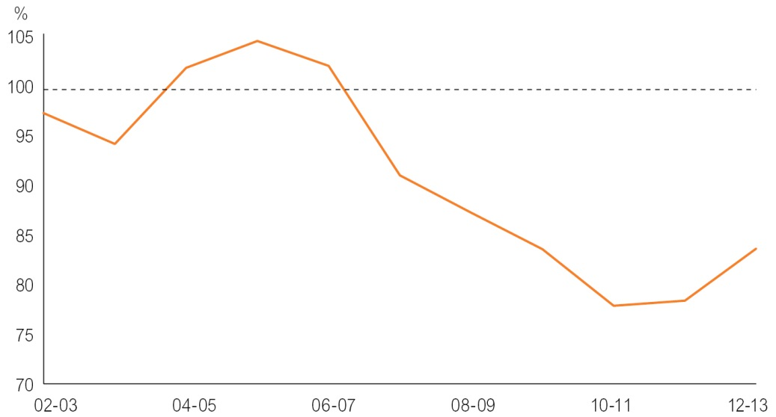
Source: 2002-03 to 2006-07 from CGC 2009 update, 2007-08 from CGC 2012 update, 2008-09 from CGC 2013 update, 2009-10 to 2012-13 from CGC 2014 update
Associated fiscal outcome: by 2016-17, the Territory’s government owned corporation is moving towards commercial rates of return on capital employed
As highlighted in Chart 3.2, the Power and Water Corporation (PWC) is trending towards achieving a commercial rate of return (estimated to be 6 per cent return on capital employed) over the forward estimate period. The 2014-15 estimate of 3.6 per cent represents a modest improvement of 0.44 per cent compared to the 3.15 per cent published in the 2013-14 Budget, while the rate of return in 2017-18 is projected to be 5.4 per cent, approaching a more commercial rate of return.
The improved position is primarily due to higher revenues, combined with more efficient operating and capital costs resulting in lower borrowing requirements. The Government’s utility reform agenda, which includes regulatory reform of the sector along with structural separation of PWC, will assist in achieving more commercial rates of return through increased competition and operating efficiencies.

Chart 3.2: Pre-Tax Annual Rate of Return – Power and Water Corporation
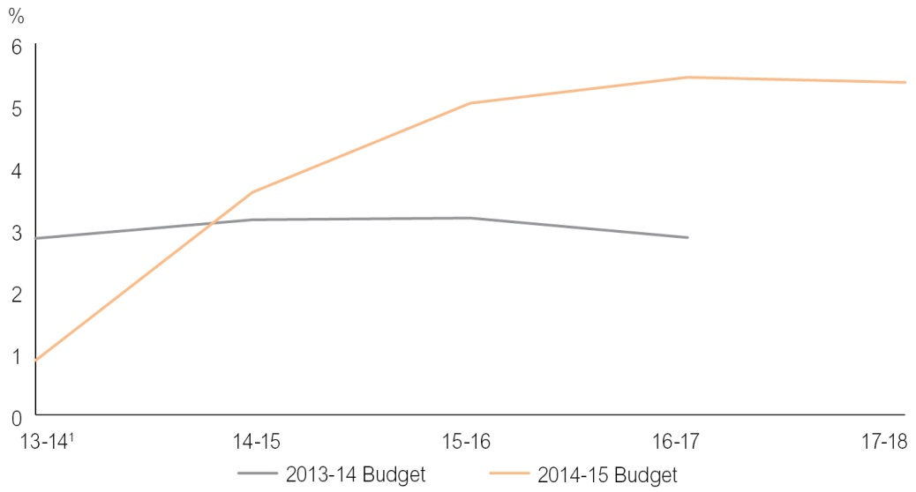
1 2013-14 differs from PWC due to change in accounting treatment, which has been removed for comparative purposes.
Source: Department of Treasury and Finance
Associated fiscal outcome: by 2020, the Territory’s non financial public sector net debt as a percentage of revenue is returning towards 60 per cent
As Chart 3.3 shows, the net debt to revenue ratio for the non financial public sector is projected to be 67 per cent in 2014-15, a 18 percentage point improvement on the 85 per cent presented in the May 2013 Budget, and decreasing across the budget cycle to 65 per cent in 2017-18.
The 2017-18 estimate represents a 21 percentage point reduction when compared to the May 2013 Budget projection for 2016-17, the latest forward estimate year published at that time, and a 33 percentage point improvement on the 98 per cent published for 2015-16 in the Pre-Election Fiscal Outlook in August 2012.
This significant improvement is a direct result of the improved fiscal balance position and is evidence of achievement of the target of returning net debt to revenue towards 60 per cent by 2020.
Chart 3.3: Non Financial Public Sector – Net Debt to Revenue
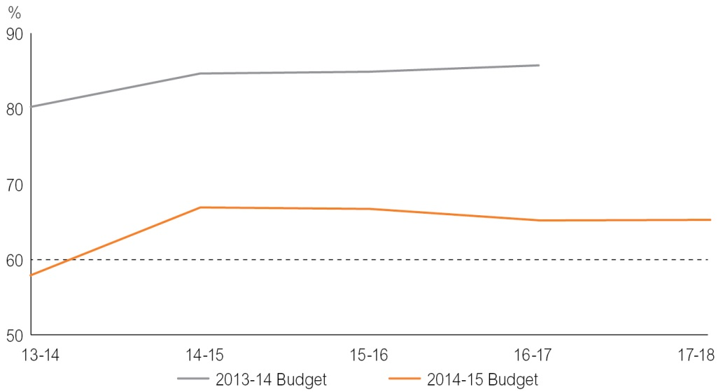
Source: Department of Treasury and Finance
Conclusion
The improved financial projections contained within the 2014-15 Budget highlight that the fiscal objectives and targets underpinning the Government’s fiscal strategy are achievable as evidenced by:
- the general government net operating balance projected to be in surplus by 2014-15, two years ahead of schedule;
- the small non financial public sector fiscal balance deficit of $39 million in 2017-18, the target year to return the budget to surplus;
- the Territory’s tax effort of 84 per cent, improving by 6 percentage points, in 2012-13 and moving towards the average of the states;
- PWC’s rate of return on capital employed is projected to be 5.4 per cent by 2017-18, compared to the targeted 6 per cent; and
- net debt to revenue is projected to decrease to 65 per cent by 2017-18, trending closer to the target of returning to 60 per cent by 2020.

Chapter 4
Budget Initiatives
Overview
This chapter summarises the Government’s new initiatives for expenditure and savings included in the 2014-15 Budget.
New initiatives identify the funding allocated to implement election commitments and new policy decisions.
The 2014-15 Budget includes approved savings targets for all agencies. For the purpose of this document, the savings measures have been grouped under the following categories:
- administrative efficiencies relate to initiatives delivering savings through more efficient use of existing administrative resources, rationalisation of administration tasks to focus on core functions and reduced expenditure on discretionary spending such as travel;
- program efficiencies and rationalisation relate to initiatives delivering savings through more efficient use of existing program resources and program rationalisation to focus on improved service delivery of priority programs and functions; and
- whole of government savings relate to initiatives that derive savings across all government agencies.

 | 2013-14  Estimate | 2014-15  Budget
 | $000 | $000
Auditor-General’s Office
New initiatives | 400 | 500
Increased capacity to conduct audits | 400 | 500
Total | 400 | 500
Northern Territory Electoral Commission
Agency savings | - 33 | - 53
Administrative efficiencies | - 33 | - 50
Whole of government savings |  | - 3
Total | - 33 | - 53
Department of the Chief Minister
New initiatives | 5 650 | 10 902
Increase to the Community Support Grants program | 442 | 442
Funding to support the ANZAC Centenary and Centenary of Service | 150 | 283
Funding for new and expanded agency responsibilities particularly Economic Development Policy and Planning, and the Office of Major Infrastructure Investment | 2 702 | 2 312
Harbour and Foreshore Development Project | 700 | 2 000
Establish the Northern Australia Development Office | 1 396 | 2 950
Inquiry into hydraulic fracturing in the Territory | 260 | 890
Territory Government support for economic development in the East Arnhem region |  | 2 000
Increased support to the Council on the Ageing Northern Territory |  | 25
Agency savings | 0 | - 879
Program efficiencies and rationalisation |  | - 746
Whole of government savings |  | - 133
Total | 5 650 | 10 023
Department of the Legislative Assembly
Agency savings | 0 | - 124
Administrative efficiencies |  | - 100
Whole of government savings |  | - 24
Total | 0 | - 124
Northern Territory Police, Fire and Emergency Services
New initiatives |  | 1 373
Upgrade the Northern Territory Fire Alarm System Transmission fire alarm monitoring system |  | 907
Establish a Water Police program to provide marine ranger training |  | 466
Agency savings |  | - 17 745
Administrative efficiencies |  | - 5 523
Program efficiencies and rationalisation |  | - 12 058
Whole of government savings |  | - 164
Total |  | - 16 372
Department of Treasury and Finance
New initiatives | 700 | 300
Support for the reform of the Northern Territory Utilities sector | 700 | 300
Agency savings |  | - 5 439
Administrative efficiencies |  | - 420
Program efficiencies and rationalisation |  | - 5 000
Whole of government savings |  | - 19
Total | 700 | - 5 139
Department of Business
New initiatives | 0 | 1 555
Support for Tiwi Islands economic development |  | 255
Establish a Red Tape Abolition Squad |  | 450
Additional funding to support the Racing Commission |  | 350
Funding to progress procurement reforms |  | 500
Agency savings | 0 | - 2 773
Administrative efficiencies |  | - 1 600
Program efficiencies and rationalisation |  | - 1 125
Whole of government savings |  | - 48
Total | 0 | - 1 218
Department of Local Government and Regions
New initiatives | 1 500 | 6 500
De-merging of Victoria Daly Regional Council | 1 500 | 1 500
Funding to support the financial sustainability of regional councils |  | 5 000
Agency savings | 0 | - 55
Administrative efficiencies |  | - 30
Whole of government savings |  | - 25
Total | 1 500 | 6 445
Department of Corporate and Information Services
New initiatives | 0 | 2 400
Asset management solution |  | 2 400
Agency savings | - 4 | - 807
Program efficiencies and rationalisation |  | - 780
Whole of government savings | - 4 | - 27
Total | - 4 | 1 593
Department of the Attorney-General and Justice
New initiatives | 72 | 3 160
Funding to establish the Northern Territory Civil and Administrative Tribunal | 72 | 2 860
Increase capacity for the Office of the Commissioner for Public Interest Disclosures |  | 300
Agency savings | 0 | - 3 277
Program efficiencies and rationalisation |  | - 3 150
Whole of government savings |  | - 127
Total | 72 | - 117
Office of the Commissioner for Public Employment
Agency savings | 0 | - 254
Administrative efficiencies |  | - 250
Whole of government savings |  | - 4
Total | 0 | - 254
Department of Children and Families
Agency savings | 0 | - 7 544
Administrative efficiencies |  | - 6 000
Program efficiencies and rationalisation |  | - 1 534
Whole of government savings |  | - 10
Total | 0 | - 7 544
Department of Correctional Services
New initiatives | 0 | 2 300
Funding to operate the Secure Mental Health facility at the Darwin Correctional Precinct |  | 2 300
Agency savings | 0 | - 5 636
Administration efficiencies |  | - 360
Program efficiencies and rationalisation |  | - 5 208
Whole of government savings |  | - 68
Total | 0 | - 3 336
Department of Health
New initiatives | 330 | 11 711
Increase support for palliative care in Alice Springs |  | 391
Increased repairs and maintenance funding |  | 10 000
Expanded prison health service at Darwin Correctional Precinct | 330 | 1 320
Agency savings | - 10 000 | - 13 545
Administration efficiencies |  | - 1 750
Program efficiencies and rationalisation | - 10 000 | - 11 679
Whole of government savings |  | - 116
Total | - 9 670 | - 1 834
Department of Education
New initiatives | 14 500 | 6 700
Funding to support the transition to global school budgeting |  | 5 000
Increase to the early childhood services subsidy |  | 1 700
Additional funding to support in-school staffing levels | 14 500
Agency savings | 0 | - 16 255
Administrative efficiencies |  | - 11 200
Program efficiencies and rationalisation |  | - 4 770
Whole of government savings |  | - 285
Total | 14 500 | - 9 555
Department of Lands, Planning and the Environment
New initiatives | 2 015 | 2 215
Additional resources to support increased capacity and meet demand growth | 2 015 | 2 015
Maintain infrastructure and public-use areas at the Darwin Waterfront |  | 200
Agency savings | 0 | - 1 051
Administrative efficiencies |  | - 775
Program efficiencies and rationalisation |  | - 250
Whole of government savings |  | - 26
Total | 2 015 | 1 164
Department of Primary Industry and Fisheries
New initiatives | 2 450 | 2 906
Fishing licence buybacks | 2 340
Farm Finance Program – promotion and communications | 110 | 140
Establish the Food Industry Development Group |  | 513
Funding to support Indigenous development opportunities and provide permit-free fishing access to inter-tidal waters overlaying Aboriginal land |  | 2 253
Agency savings | 0 | - 91
Program efficiencies and rationalisation |  | - 55
Whole of government savings |  | - 36
Total | 2 450 | 2 815
Department of Mines and Energy
New initiatives | 0 | 5 950
Funding for the Creating Opportunities for Resource Exploration initiatives |  | 3 950
Funding to assess the Territory’s shale gas potential and resources |  | 2 000
Agency savings | 0 | - 14
Whole of government savings |  | - 14
Total | 0 | 5 936
Department of Land Resource Management
New initiatives | 0 | 2 400
Increased funding to accelerate land and water suitability for agricultural development |  | 2 400
Agency savings | 0 | - 1 131
Administrative efficiencies |  | - 685
Program efficiencies and rationalisation |  | - 405
Whole of government savings |  | - 41
Total | 0 | 1 269
Department of Housing
New initiatives | 0 | 1 500
Remote Indigenous Home Purchase Strategy |  | 1 500
Agency savings | 0 | - 1 128
Program efficiencies and rationalisation |  | - 971
Whole of government savings |  | - 157
Total | 0 | 372
Tourism NT
New initiatives | 0 | 8 000
Increased funding to support tourism marketing activities |  | 7 500
Funding for a regional tourism product development grant program |  | 500
Agency savings | - 399 | - 3 376
Administrative efficiencies |  | - 800
Program efficiencies and rationalisation | - 396 | - 2 542
Whole of government savings | - 3 | - 34
Total | - 399 | 4 624
Department of Sport, Recreation and Racing
New initiatives | 1 000 | 7 213
Support for Parramatta Eels to play National Rugby League matches in the Territory | 1 000 | 1 000
Expanded Sports Voucher Scheme |  | 5 000
Australian Football League matches in the Territory |  | 1 000
Additional support for Thoroughbred Racing Northern Territory |  | 213
Agency savings | 0 | - 1 111
Program efficiencies and rationalisation |  | - 1 100
Whole of government savings |  | - 11
Total | 1 000 | 6 102
Department of Arts and Museums
Agency savings | 0 | - 1 314
Program efficiencies and rationalisation |  | - 1 300
Whole of government savings |  | - 14
Total | 0 | - 1 314
Department of Transport
New initiatives | 2 107 | 6 525
Extension of the Tiwi Islands ferry services | 924 | 804
Extension of the remote bus trial | 400 | 400
Mandorah Ferry service additional funding | 783 | 940
Additional funding to investigate and design key Darwin City Master Plan concepts |  | 1 000
Melville Bay medium to large vessel pontoon development |  | 500
Increased funding for infrastructure planning studies |  | 1 000
Additional repairs and maintenance funding |  | 1 881
Agency savings | 0 | - 1 251
Administrative efficiencies |  | - 712
Program efficiencies and rationalisation |  | - 500
Whole of government savings |  | - 39
Total | 2 107 | 5 274
Department of Infrastructure
Agency savings | 0 | - 451
Administrative efficiencies |  | - 400
Whole of government savings |  | - 51
Total | 0 | - 451
Department of Community Services
New initiatives | 0 | 800
Funding to implement the First Circles Emerging Leaders consultation model |  | 800
Agency savings | 0 | - 269
Administrative Efficiencies |  | - 150
Program efficiencies and rationalisation |  | - 82
Whole of government savings |  | - 37
Total | 0 | 531
Parks and Wildlife Commission of the Northern Territory
Agency savings | 0 | - 712
Administrative efficiencies |  | - 700
Whole of government savings |  | - 12
Total | 0 | - 712
Aboriginal Areas Protection Authority
Agency savings | 0 | - 104
Administration efficiencies |  | - 100
Whole of government savings |  | - 4
Total | 0 | - 104

Chapter 5
Intergovernmental Financial Relations Issues
Overview
In 2014-15 the Territory is estimated to receive $4171 million in Commonwealth funding, representing about 68 per cent of the Territory’s total non financial public sector revenue. This comprises $3134 million in untied payments, largely goods and services tax (GST) revenue, and $1037 million in tied payments.
GST revenue is the largest single fiscal transfer from the Commonwealth, representing about 51 per cent of the Territory’s total revenue. In 2014-15, the Territory is expected to receive $3129 million in GST revenue, a $321 million increase from the estimate of $2808 million for 2013-14.
The increase in the Territory’s GST revenue is predominantly due to an increase in the Territory’s GST per capita relativity over this period. In its Report on GST Revenue Sharing Relativities – 2014 Update, the Commonwealth Grants Commission (CGC) recommended an increase in the Territory’s GST relativity from 5.31414 in 2013-14 to 5.66061 in 2014-15, increasing the Territory’s share of the GST pool from 5.5 per cent to 5.9 per cent.
The increase in the Territory’s relativity was mainly driven by an increase in national average per capita spending on Indigenous-related services, particularly health services and Indigenous community development, increasing the Territory’s assessed GST revenue needs due to the Indigenous share of the total population being so much greater in the Territory than elsewhere.
Although the Territory’s relativity has reached an historical high, it is not expected to remain at this level. Structural changes in the Australian economy are expected to have a significant impact on states’ assessed fiscal capacities over the forward estimates period, particularly due to changes in the mining and housing sectors. Further, the CGC is currently undertaking a review of the methodology for distributing GST revenue among the states. The outcomes of the CGC’s 2015 Methodology Review, will affect the GST distribution from 2015-16 onwards. The 2015 Review represents a significant financial risk to the Territory.
Tied Commonwealth revenue is estimated to contribute $1037 million or 17 per cent of the Territory’s total revenue in 2014-15. While an overarching objective of the Intergovernmental Agreement on Federal Financial Relations (IGA) was less Commonwealth prescription on tied Commonwealth funding, this has not been fully realised, particularly with the development of a number of prescriptive national reform agreements in recent years. However, in December 2013, the Council of Australian Governments (COAG) made a decision to direct effort into rationalising the number of existing National Partnership (NP) agreements, across several sectors, and to reduce their reporting burden, to maintain the integrity of the IGA.
Federal Financial Relations
Australia’s system of federal financial relations is characterised by a high level of vertical fiscal imbalance compared with other federations, necessitating significant revenue transfers from the Commonwealth to the states. These transfers attempt to provide the states with fiscal support, in recognition that states’ expenditure obligations far outweigh their capacities to raise revenue, while for the Commonwealth, the opposite is true.
Chart 5.1 highlights the level of vertical fiscal imbalance in Australia. In 2012-13, states were responsible for around 44 per cent of total Commonwealth and state government expenditure in Australia, but only raised around 25 per cent of total revenue. Conversely, the Commonwealth raised around 75 per cent of total Commonwealth and state revenue, but its expenditure obligations only accounted for around 56 per cent of total expenditure. As such, the Commonwealth makes transfers to the states to support the provision of states’ expenditure obligations, such as health care, education, public safety and transport.
Chart 5.1: – Comparison of Commonwealth and States’ Total Expenditure and Revenues, 2012-13
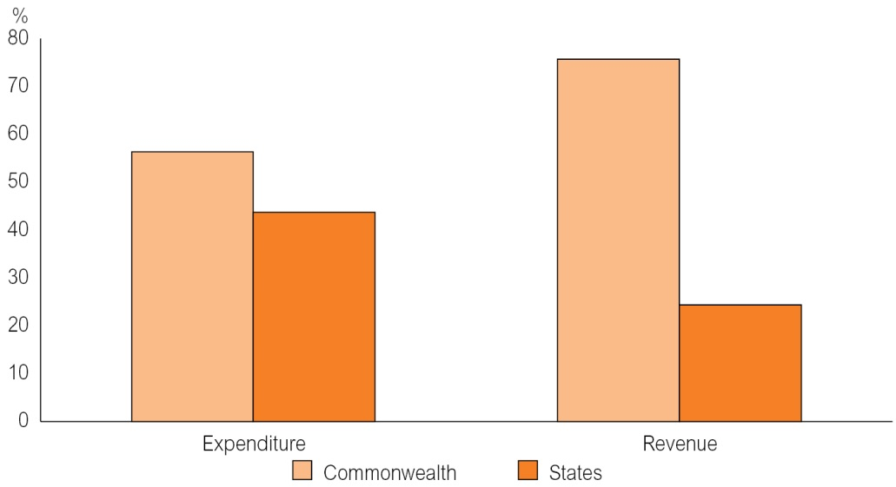
Source: Commonwealth 2012-13 Final Budget Outcome; CGC 2014 Update
Further to the high level of vertical fiscal imbalance, the Australian federation is also characterised by significant differences in the fiscal capacities of the states, or horizontal fiscal imbalance, which is a factor of differences in states’ demographic, geographic and economic circumstances. Consequently, the Commonwealth provides differing levels of funding to each state, on both an aggregate and per capita basis.
Table 5.1 shows the level of Commonwealth funding proportional to each state’s total general government revenue in 2012-13.
Table 5.1: Commonwealth Funding as a Percentage of States’ Total General Government Revenue
 | NSW | Vic | Qld | WA | SA | Tas | ACT | NT | Average
Revenue from the Commonwealth, $ per capita | 3 778 | 3 727 | 4 197 | 3 425 | 4 536 | 5 409 | 4 279 | 15 161 | 4 029
Commonwealth proportion of total state revenue, % | 46 | 44 | 46 | 33 | 49 | 59 | 39 | 75 | 49
Source: Commonwealth 2012-13 Final Budget Outcome; State/Territory 2012-13 Annual Financial Reports
Commonwealth funding to the states includes both general revenue assistance (untied funding), which is mainly GST revenue, and tied funding, predominantly Specific Purpose Payments (SPPs) and NP payments. Table 5.2 shows that in 2014-15, total Commonwealth payments to the Territory are estimated to be $4171 million, of which 21 per cent comprises tied SPPs, NP payments and National Health Reform (NHR) funding, with a further 75 per cent comprising GST revenue and grants in lieu of uranium royalties.
Compared with 2013-14, revenue from the Commonwealth is expected to increase by $250 million or 6 per cent in 2014-15. The increase is largely due to the increase in GST revenue receipts, which is discussed later in this chapter.

Table 5.2: Components of Territory Revenue¹
 | 2012-13 Actual | 2013-14 Estimate | 2014-15 Budget
 | $M | $M | $M
General revenue assistance
GST revenue² | 2 793 | 2 808 | 3 129
Grants in lieu of uranium royalties | 6 | 5 | 5
Tied revenue
Specific Purpose Payments³ | 239 | 242 | 297
National Partnership payments | 411 | 517 | 444
National Health Reform funding | 107 | 132 | 150
Other Commonwealth payments⁴ | 224 | 217 | 146
Total Commonwealth revenue | 3 780 | 3 921 | 4 171
Territory own-source revenue | 1 632 | 1 902 | 1 926
Total revenue | 5 412 | 5 823 | 6 097
1 Includes non financial public sector.
2 Includes balancing adjustments for over/under payments of GST in the previous financial year.
3 Includes payments ‘through’ the Territory for non-government schools.
4 For consistency of reporting with the Commonwealth, funding under the Natural Disaster Relief and Recovery Arrangements is reported as tied funding.
Source: Department of Treasury and Finance
Intergovernmental Agreement on Federal Financial Relations
The IGA, agreed by all states and the Commonwealth in 2008, provides a framework for national collaboration on policy development and service delivery, and to facilitate the implementation of nationally important economic and social reforms.
The aim of the IGA is to improve the effectiveness of government services through:
- fair and sustainable federal financial arrangements;
- clearly defined roles and responsibilities between the Commonwealth and states;
- enhanced public accountability through simpler, standardised and more transparent performance reporting;
- performance reporting that focuses on the achievement of outcomes and outputs;
- reduced administration and compliance overheads;
- elimination of financial and other input controls imposed on states, for service delivery, in Commonwealth funding agreements; and
- the equalisation of fiscal capacities between states.
These arrangements are formalised through:
- National Agreements (NAs) for significant state services (health care, school education, skills and workforce development, disability, affordable housing and Indigenous reform);
- NP agreements for nationally significant reforms and/or projects; and
- the provision of GST revenue to the states, with all proceeds from the GST provided on an untied basis and distributed among the states in accordance with the principle of horizontal fiscal equalisation (HFE).
GST Revenue
GST revenue is the largest revenue transfer from the Commonwealth, representing about 75 per cent of payments to the states. A state’s GST revenue entitlement is dependent on three factors: national GST collections, the state’s GST per capita relativity, and the state’s share of the national population.
Each state’s GST entitlement is calculated by multiplying the state’s population by its GST per capita relativity to derive its weighted population, which is then applied to national GST collections.
Table 5.3 shows the parameters used to estimate the Territory’s GST revenue in the 2014-15 Budget.
Table 5.3: Territory GST Revenue Parameter Estimates
 | 2012-13 | 2013-14 | 2014-15 | 2015-16 | 2016-17 | 2017-18
 | Actual | Estimate | Budget | Forward Estimate
GST collections ($M) | 48 061 | 50 480 | 53 226 | 56 207 | 59 186 | 62 323
Territory GST relativity | 5.52818 | 5.31414¹ | 5.66061¹ | 5.40736 | 5.36267 | 5.31798
Territory share of national population (%) | 1.0342 | 1.0357 | 1.0343 | 1.0430 | 1.0378 | 1.0326
Territory GST revenue ($M)² | 2 793 | 2 808 | 3 129 | 3 185 | 3 313 | 3 446
1 Actual relativities, as determined by CGC 2013 and 2014 updates.
2 Includes balancing adjustment for the over/underpayment of GST revenue to the Territory.
Source: Department of Treasury and Finance
In 2013-14, the Territory is expected to receive $2808 million in GST revenue, representing a 0.5 per cent increase from 2012-13. The increase in the Territory’s GST revenue in 2013-14 is due to increased GST pool growth from 4.4 per cent to 5.0 per cent between 2012-13 and 2013-14, and a balancing adjustment for the underpayment of GST revenue in 2012-13, largely offset by a decrease in the Territory’s GST relativity. The Territory’s GST revenue is estimated to increase by 11.4 per cent to $3129 million in 2014-15.
The estimate of the Territory’s GST revenue in 2014-15 is $157 million higher than estimated at the time of the 2013-14 Budget. This is primarily due to an upward revision to the Territory’s GST relativity, as shown in Table 5.4.
Table 5.4: Factors Contributing to the Revision in the Territory’s GST Revenue Estimate
 | 2013-14 | 2014-15
GST revenue | $M | $M
As at 2013-14 Budget | 2 805 | 2 972
As at 2014-15 Budget | 2 808 | 3 129
Difference | 3 | 157
Change caused by new:
National GST collections | - 7 | 7
Relativities¹ | 0 | 191
Population | - 11 | - 40
Interactions² | 21 | - 1
Total | 3 | 157
1 The estimated impact of the change in relativity as sourced from CGC 2014 Update.
2 Impact of rounding and the interaction between the updated parameters in the calculation of states’ GST shares.
Source: Department of Treasury and Finance
National GST Collections
Over the budget and forward estimates period, growth in the GST pool is expected to continue to remain below the growth rates recorded in years prior to the global financial crisis (GFC). Chart 5.2 shows that prior to the GFC, the GST pool grew on average by 8.2 per cent per annum, falling to an average of 2.6 per cent between 2007-08 and 2012-13.
Chart 5.2: Annual Growth in National GST Collections
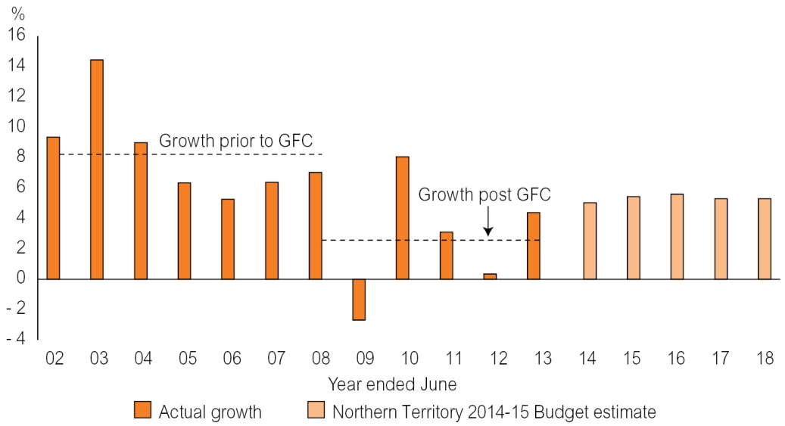
Source: Department of Treasury and Finance
The Territory’s GST revenue estimates are based on projected collections growth of 5.0 per cent in 2013-14 and 5.4 per cent in 2014-15, before moderating to 5.3 per cent in 2017-18 (Chart 5.2). The constrained growth in GST since the GFC has been driven by cautious consumer behaviour, characterised by higher levels of household savings and lower spending on discretionary goods and services that are subject to GST.
Chart 5.3 shows that private consumption as a proportion of gross domestic product (GDP) is expected to increase in 2013-14 and remain stable over the forward estimates period due to increased household spending, supported by relatively low interest rates. However, GST, as a proportion of private consumption, and GDP, are not expected to recover to pre-GFC levels over this period as expenditure on discretionary items, which tend to attract GST, remains subdued. As a result, estimates of the GST pool in 2013-14 onwards remain significantly lower than anticipated prior to the GFC.
Chart 5.3: Index of GST and Private Consumption as a Proportion of GDP
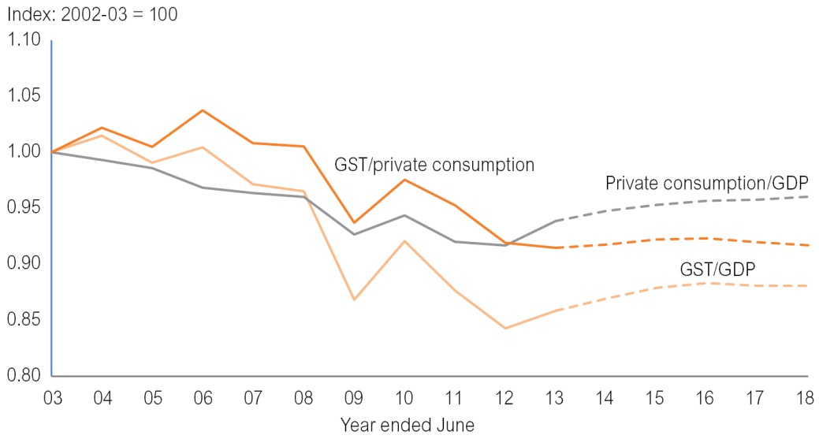
Source: ABS; Deloitte Access Economics; Department of Treasury and Finance
GST Relativities
The GST relativity component of the GST revenue distribution formula determines whether a state will receive more or less than its population share of the GST revenue pool. The relativities represent the culmination of the CGC’s work as the independent body responsible for recommending to the Commonwealth Treasurer each year the distribution of GST revenue between the states, in accordance with the principle of HFE, which is defined as:
State governments should receive funding from the pool of goods and services tax revenue such that, after allowing for material factors affecting revenues and expenditures, each would have the fiscal capacity to provide services and the associated infrastructure at the same standard, if each made the same effort to raise revenue from its own sources and operated at the same level of efficiency. (CGC 2014 Update)
HFE ensures that each state has the fiscal capacity to provide its citizens with comparable access to government services, no matter where they live. In order to assess states’ fiscal capacities, the CGC determines an ‘average’ state policy, by examining what states do across all areas of state responsibility, and takes into account unavoidable differences between states that affect their capacities to deliver an average level of services, such as population characteristics, geographic size and remoteness, structure of economies and natural resource endowments.
The Territory requires significantly more than its population share of the GST pool to fund national average levels of services due to its lower than average capacity to raise own-source revenue and the significantly higher costs of providing services compared with elsewhere. The major drivers of the Territory’s above-average service delivery costs are its small population dispersed over a broad geographic area, a significant proportion of which reside in remote areas, large share of Indigenous population, long distance from major supply centres in southern states and inability to achieve economies of scale in service delivery.
It is important to note that states’ shares of GST revenue change over time, as factors affecting state revenues and expenses change. For example, a states’ health expenditure needs will increase over time if it has an increasing share of the national elderly population, or a state’s share of GST revenue will decrease over time, if its capacity to raise revenue increases relative to other states’ (all other things remaining equal).
Chart 5.4 shows changes in the contributions of the ‘donor states’ to the redistribution of GST revenue to the other states. It shows that between 2004-05 and 2006-07, Western Australia became a ‘recipient’ state, receiving more than its population share of GST revenue, and that until 2008-09, Queensland was also a recipient state and is also expected to be in 2014-15 and 2015-16. It also shows that New South Wales is receiving an increasing share of the GST pool over time, moving closer to an equal per capita share, as its revenue capacity relative to other states decreases, and its expenditure needs increase.

Chart 5.4: ‘Donor’ States’ Share of the Redistribution of GST Revenue to Other States
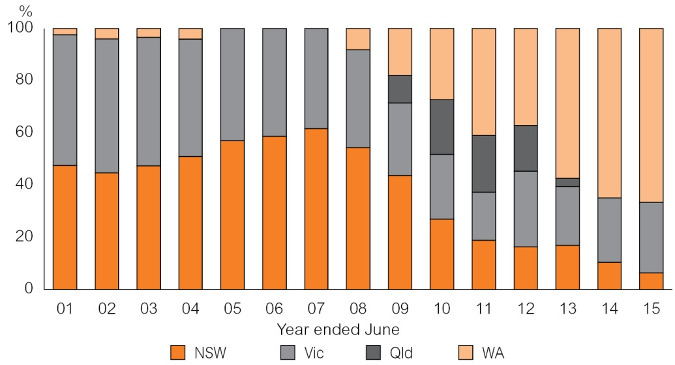
Source: Commonwealth Grants Commission
Commonwealth Grants Commission Report on GST Revenue Sharing Relativities 2014 Update
In March 2014, the CGC released its Report on GST Revenue Sharing Relativities – 2014 Update, which recommended an increase in the Territory’s GST relativity from 5.31414 in 2013-14 to 5.66061 in 2014-15, as shown in Table 5.5. The effect of the increase in the Territory’s GST relativity is an increase in its share of the GST pool from 5.5 per cent in 2013-14 to 5.9 per cent in 2014-15.
Table 5.5: Illustrative Change in GST Revenue Between 2013-14 and 2014-15
 | NSW | VIC | Qld | WA | SA | TAS | ACT | NT
2013 Update | 0.96576 | 0.90398 | 1.05624 | 0.44581 | 1.26167 | 1.61454 | 1.22083 | 5.31414
2014 Update | 0.97500 | 0.88282 | 1.07876 | 0.37627 | 1.28803 | 1.63485 | 1.23600 | 5.66061
Impact ($M) | 145 | - 286 | 234 | - 411 | 97 | 22 | 13 | 187
Impact ($pc) | 20 | - 50 | 51 | - 166 | 58 | 43 | 34 | 789
Source: CGC 2014 Update
Table 5.5 shows that the GST revenue impact of the increase in the Territory’s GST relativity in the 2014 Update is estimated to be an additional $187 million to the Territory in 2014-15, compared with the Territory’s 2013 Update relativity. The change is based on the latest estimates of populations and the GST pool published in the Commonwealth’s Mid-Year Economic and Fiscal Outlook 2013-14.
The CGC calculates states’ assessed GST revenue needs based on national averages. In the 2014 Update, changes in national average expenditure were the major drivers of the increase in the Territory’s relativity for 2014-15. Of particular note was the increase in national expenditure on Indigenous persons, predominantly for health and community development, which led to an increase in the Territory’s assessed GST revenue needs due to the Indigenous share of the total population being so much greater in the Territory than elsewhere.
Other factors contributing to the increase were the below-average growth of Medicare and privately funded health services in the Territory compared with other states, resulting in an increase in the Territory’s public health services expenditure need, and an increase in national roads spending, leading to an increase in the Territory’s assessed roads maintenance expenses.
While the Territory’s relativity reached an unprecedented high in the 2014 Update, there is a risk that possible changes to the CGC’s GST distribution methodology, following the outcomes of its 2015 Review, could lead to a significant reduction in the Territory’s relativity in the future.
Further, it is likely that states’ GST relativities will converge towards one over the forward estimates period as a result of structural change in states’ economies. In particular, falling mineral export prices and volumes are expected to lead to a reduction in Western Australia’s mining royalty revenues and a subsequent increase in its GST relativity, while the recovery of New South Wales and Victorian property markets is expected to increase stamp duty revenues, leading to an expected reduction in these states’ GST relativities.
Commonwealth Grants Commission – 2015 Methodology Review
Every five years, the CGC undertakes a review of the methodology used to assess states’ GST revenue needs. The Commonwealth released the Terms of Reference (TOR) for the 2015 Methodology Review (2015 Review) in June 2013, directing the CGC to conduct an inquiry into the methodological approach to determining GST relativities for 2015-16 onwards.
The CGC is using the 2010 methodology as a basis for its 2015 Review, allowing a shorter review period, and reducing the scope for significant changes to the current methodology. However, the 2015 Review presents a significant financial risk for the Territory, with the GST representing more than half of the Territory’s total revenue.
Importantly, the TOR direct the CGC to take into account the IGA, ensuring that the CGC continues to base its methodology on the principle of HFE. This is vital for the Territory, because it will ensure that the GST distribution methodology continues to provide each state with the fiscal capacity to provide the national average level of services.
The TOR also direct the CGC to develop methods to appropriately capture the changing characteristics of the Indigenous population following the outcomes of the 2011 Census, which saw a significant increase in the number of persons identifying as Indigenous in other states.
The 2011 Census resulted in a reduction in the Territory’s share of the national Indigenous population from 12.4 per cent to 10.3 per cent in 2011 and a subsequent reduction in the Territory’s assessed GST revenue needs, while all other states’ shares of the national Indigenous population increased.
Notwithstanding the increase in self-identification in other states compared with previous censuses, the Territory has strongly argued that changes need to be made to the CGC’s methodology to appropriately capture the relative level of Indigenous disadvantage between states. The impact on the Territory’s assessed GST revenue is counterintuitive, all else remaining the same, given that the Territory’s Indigenous population as a percentage of the Territory’s total population did not change significantly following the 2011 Census, nor did the level of Indigenous disadvantage in the Territory.
The Territory’s submissions also focused on ensuring that the additional costs associated with providing services to Indigenous Australians and in remote locations continue to be adequately assessed, and funding to the Territory for Indigenous-specific programs such as the National Partnership on Stronger Futures in the Northern Territory and the National Partnership on Remote Indigenous Housing, continue to be considered outside of the scope of equalisation such that they do not affect states’ shares of GST revenue, in recognition that they are intended to address unmet needs for additional Indigenous-related services and remote infrastructure.
States will have the opportunity to provide further submissions in response to the 2015 Review Draft Report, to be released in June 2014, which will provide the CGC’s proposed assessment approach in detail, before the Final Report is released in February 2015.
Population
The estimates of the Territory’s population growth for 2012-13 and 2013-14 remain unchanged from the 2013-14 Budget. However, in 2014-15, the Territory’s annual population growth is expected to moderate due to population outflows related to the curtailment of operations at the Gove alumina refinery. The Territory’s population is then forecast to strengthen in 2015-16 as the effect from the refinery curtailment flows through and workforce requirements for the construction phase of the INPEX Ichthys project peak. In 2016-17 and 2017-18, growth is forecast to moderate as the Ichthys project moves to the production phase and the focus of economic activity shifts to new projects and other activities.
The Territory’s population is expected to grow at a slower rate than nationally between 2013-14 and 2017-18, with the Territory’s share of the national population estimated to decrease from 1.0357 per cent in 2013-14 to 1.0326 per cent in 2017-18.
GST Administration – Low Value Threshold on Imports
All state Treasurers have indicated support for the development of a business case in order to consider the impacts of reducing the low-value threshold for GST on imports as a means of increasing the GST revenue base. Currently, the GST is applied to imports valued at more than $1000. A reduction in the threshold is expected to have a positive impact on the GST pool and will ensure that domestic and international firms are competing on a more level playing field with respect to the application of the GST. The intention of the proposed reform is to maintain the integrity of the GST base, given the increasing volume of low-cost imports into Australia, particularly from online sales.
A Heads of Treasuries working group has been established to review the business case for the reform, which will be progressed through the Council on Federal Financial Relations (CFFR).
Specific Purpose Payments
SPPs are provided by the Commonwealth to support states to achieve the outputs and outcomes in the NAs that deal with major service areas agreed by COAG. In 2014-15 it is currently anticipated that there will be three SPPs associated with an NA (disability, affordable housing, and skills and workforce development). Like the SPP for health care in 2012-13, the schools SPP transitioned on 31 December 2013, becoming the new ‘Students First – A Fairer Funding Agreement for Schools’, commencing on 1 January 2014.
Under the IGA, SPP funding is ongoing and indexed annually. Following a transition period, funding will be distributed between states on a population-share basis, and is untied within the relevant sector. The Disability SPP will be fully transitioned to population share in 2013-14, with the remaining SPPs being fully transitioned in 2014-15. Historically, the Territory received a higher than population share of some SPPs and therefore the transition results in the Territory receiving a reduced share of the SPP. This is illustrated by the reduction in the Territory’s National Affordable Housing SPP in 2014-15. However, it is anticipated this lower SPP funding will be offset by an increase in GST revenue.
In 2014-15, the Territory expects to receive $39.1 million in SPPs for skills and workforce development, affordable housing and disability. Table 5.6 provides estimates of SPPs to be received by the Territory in 2013-14 and 2014-15.
Table 5.6: Specific Purpose Payments
 | 2013-14 Estimate | 2014-15 Budget
 | $M | $M
National Schools² | 79.2
Students First funding² | 128.0 | 258.0
Pay Equity for the Social and Community Services Sector | 0.5 | 0.7
National Skills and Workforce Development | 14.6 | 14.8
National Affordable Housing | 19.4 | 13.2
National Disability¹ |  | 10.4
Total² | 241.7 | 297.1
1 The budget neutral adjustment to the Disability SPP to ensure neutrality of the realigned Commonwealth and state responsibilities for aged care and disability services, agreed under the NHR agreement, is $-17.9 million in 2013-14 and $-16.8 million in 2014-15.
2 Includes SPPs for non-government schools.
Source: Department of Treasury and Finance
National Partnership Payments
The IGA established NP agreements to implement projects of national importance
and/or significant reforms. NP agreements have been agreed for initiatives in a broad range of state services. Some NP agreements require implementation plans to outline state-specific arrangements.
NP payments are now the major source of tied Commonwealth funding, with the Territory estimated to receive NP revenue of $517 million in 2013-14 and $444 million in 2014-15. Table 5.7 provides estimates of NP revenue by each agency responsible for delivering the service in the Territory.
The Territory currently has around 50 NP agreements and Project Agreements, with another 12 under negotiation, including some that represent the continuation of previous funding. There are also around 40 implementation plans either agreed or under development. In December 2013, COAG agreed to reduce intergovernmental red tape by rationalising funding agreements and reducing their reporting burden. It was decided that, if this approach was successful, it would be applied to more agreements in the 2014-15 financial year.
Table 5.7: National Partnership Payments
Agency | 2013-14 Estimate | 2014-15 Budget
 | $M | $M
Department of the Chief Minister | 4.8 | 4.2
Northern Territory Police, Fire and Emergency Services | 43.2 | 30.2
Department of Business | 6.7 | 8.2
Department of Local Government and Regions | 0.2
Department of Children and Families | 17.9 | 15.8
Department of Correctional Services | 0.3
Department of Health | 120.7 | 54.2
Department of Education | 74.1 | 41.3
Department of Mines and Energy | 3.4 | 3.9
Department of Land Resource Management | 0.6 | 0.5
Department of Housing | 141.9 | 135.3
Department of Arts and Museums | 0.3 | 1.2
Department of Transport | 78.3 | 123.8
Department of Community Services | 24.6 | 25.4
Total | 517.0 | 444.0
Source: Department of Treasury and Finance
NP revenue included in the Territory’s Budget represents funding under agreements that have been signed by the Territory and the Commonwealth. As additional agreements are finalised through the year, the Territory’s NP revenue for 2014-15 and forward estimates will be adjusted accordingly. Timing of revenue over the life of an agreement is dependent on the achievement of agreed milestones and/or performance benchmarks and the nature of the initiative. It may not be uniform across the years.
The decrease in NP revenue from 2013-14 to 2014-15 is attributed to various initiatives reducing, including capital funding for police stations under Stronger Futures in the Northern Territory, and the cessation of the NP Indigenous early childhood development – children and family centres, and trade training centres in schools. In addition, funding for the Remote Indigenous Housing NP is declining by $14.9 million from 2013-14 to 2014-15 as a result of bringing forward funding from outer years to 2013-14, to fast track new housing construction and other related works. There has also been expiry of some time-limited NP agreements.
Stronger Futures in the Northern Territory
The Stronger Futures in the Northern Territory NP agreement was signed by the Commonwealth and Territory governments in August 2012. It is a ten-year funding package that commenced in 2012-13, totalling $3.49 billion, aiming to improve Indigenous outcomes through the program areas of health; schooling; community safety and justice; tackling alcohol abuse; child, youth, family and community wellbeing; housing; municipal and essential services; Alice Springs transformation; remote engagement and coordination; and jobs.
It is likely that negotiations will commence with the Commonwealth in 2014 to vary a number of Implementation Plans under the agreement, with the objective to clarify or amend performance benchmarks, reduce reporting burden and increase flexibility regarding the purpose to which the Stronger Futures investment is directed.
Expiring National Partnership Agreements
The Territory has 19 NP agreements expiring during 2013-14, for which total funding of $41.3 million is expected to be received in 2013-14. The majority of these agreements had a substantial service delivery component in the health and education sectors, while four of these expiring NP agreements are either one-off capital or short-term programs, which have now been completed. A further seven NP agreements are due to expire by the end of 2014-15, with the majority of these having a high service delivery component and expected total funding of $22.2 million during this period.
Under the IGA, the CFFR, comprising all state, territory and Commonwealth treasurers, may make recommendations as to the treatment of funding under expiring NP agreements. Little is known about the continuation of the majority of expiring NP agreements, and the final decision on available funding remains a Commonwealth budgetary matter. The effect of expiring NP agreements on the Territory’s budget remains a risk and will continue to be closely monitored.
If Commonwealth funding is ceased, then additional demands may be placed on state finances, which may or may not accord with state priorities. While the expiry of NP agreements that focus on discrete initiatives (such as infrastructure) can be relatively easily managed by states, it is more problematic where the NP agreement creates expectations of ongoing service delivery.
Reward Payments
A small number of NP agreements include reward payments for achievement of performance benchmarks. Payments are released following an assessment by the COAG Reform Council (CRC) and subsequent determination by the relevant Commonwealth Minister on the basis of the CRC’s assessment.
In 2013-14, the CRC assessed jurisdictions’ performance under the NP agreements on Essential Vaccines, Improving Teacher Quality, Youth Attainment and Transitions, and Seamless National Economy. The Territory anticipates receiving reward funding for the majority of these NPs. Details of reward payments expected and received in 2013-14 are provided in Budget Paper No. 3. In 2014-15, the Territory’s performance will be assessed by the CRC for reward payments under the NP Agreement on Essential Vaccines only as several NP agreements with reward funding expire during 2013-14.
Performance Reporting
A key principle of the IGA is enhanced accountability to both governments and the public through simpler, standardised and more transparent performance reporting. Performance measures are required to be outcome and/or output focused in both NAs and NPs, and reported in a timely manner. As well as considering the performance of states for NP agreements with reward payments outlined above, the CRC annually assesses and publicly reports on the performance of states under each NA. Before this occurs, the Steering Committee for the Report on Government Service Provision initially examines evidence of government performance regarding agreed NA performance measures and benchmarks, outputs and outcomes for data quality and appropriateness.
Performance reports have been issued by the CRC for the baseline, first, second and third years of all NAs. Fourth year performance reports under the National Healthcare Agreement and the National Indigenous Reform Agreement are expected to be released towards the end of 2013-14. The remaining fourth year NA performance reports are expected to be released in 2014-15.
The reports issued to date indicate an overall incremental improvement in Territory performance, reflecting the enhancement of service delivery arising from the significant investments made in recent years. A particular data quality concern of the Territory is the use of data sourced from national surveys, which do not fully sample the diversity of the Territory’s population and thus do not fully reflect the Territory’s circumstances. This issue is commonly acknowledged in relevant CRC publications.
White Papers – Federal Financial Reform and Taxation Reform
In the 2013 federal election, the Coalition committed to commissioning white papers on taxation reform and reform of the federation within two years of taking office, with the intent of developing a reform agenda for the next election.
The Commonwealth is pursuing reform of the federation as a means of increasing economic growth and productivity while also removing inefficiencies, including duplication of responsibilities. The Commonwealth has indicated that the scope of the Federation White Paper may include consideration of the allocation of roles and responsibilities between different levels of government, vertical fiscal imbalance and governance arrangements.
The white paper on tax reform will be a means for the Commonwealth to explore potential ways to make the Australian tax system more efficient and simpler, to increase workforce participation incentives and enhance productivity.
National Health Reform Agreement
The NHR agreement provides a framework for reforms of public hospital funding and governance across Australia, and was signed by COAG in August 2011. The reform has been implemented progressively, with state and Commonwealth funding contributions transitioning to the new arrangements since July 2012.
In accordance with the NHR agreement, the Territory’s Department of Health has been transformed from a single organisation into three entities, comprising the Department of Health, Top End Health Service, and Central Australia Health Service. This decentralisation of health services provides clear delineation between governance, policy development and regulatory functions and the delivery of health care services.
New funding arrangements for hospitals under the NHR agreement will be fully implemented from 1 July 2014, resulting in public hospitals being funded based on levels of activity. The activity-based funding (ABF) arrangements aim to improve patient access to services and increase public hospital efficiencies by funding hospitals for agreed services rather than on an historical basis.
Pricing under the NHR agreement is determined by the Independent Hospitals Pricing Authority (IHPA), however the agreed price for services within a hospital system may differ to the efficient price determined by the IHPA. The Territory’s contribution to ABF is determined by the difference between the agreed price and the Commonwealth’s contribution towards the efficient price.
Funding for those public patient services that are not conducive to, or appropriately funded through, the ABF framework will continue to be provided on a block-funding basis.
The payment arrangements are incorporated in the 2014-15 Budget Papers. In 2014-15, the Territory anticipates that it will receive $150 million in NHR agreement payments.
National Disability Insurance Scheme
The National Disability Insurance Scheme (NDIS) was a key recommendation from the Productivity Commission’s report into a national long-term disability care and support scheme. The NDIS will reform the way the Commonwealth and states fund and deliver disability services in Australia.
The NDIS is aimed at providing lifelong care and support for people with a significant disability, including greater choice and control over the supports received and a focus on early intervention.
In December 2012, COAG signed an Intergovernmental Agreement for the NDIS launch. The agreement sets out the objectives, roles and responsibilities of all parties during the first stage of the NDIS and provides a framework for progressing to a full scheme.
All jurisdictions, with the exception of Queensland, have agreed to participate in trial sites. These trial sites are designed to inform governments about how and when to proceed to a full scheme NDIS.
An in-principle agreement has been reached for a three-year trial in the Barkly region from July 2014. A formal bilateral agreement is expected to be signed by the Territory and Commonwealth before the commencement of the trial.
Students First – A Fairer Funding Agreement
The former Federal Government had developed the National Education Reform Agreement (NERA) with the aim of changing the funding arrangements for all schools across Australia, through providing funding for all government and non-government schools on a per student basis, with loadings to recognise the additional resources required to provide education services to disadvantaged students. However, not all states agreed to the terms of the NERA and at the time of the 2013 federal election, the Northern Territory, Queensland and Western Australia had not signed.
These three states have since signed separate bilateral education reform agreements with the Commonwealth. Unlike the NERA, the bilateral agreements do not require states to provide any additional funding as a prerequisite for additional Commonwealth funding, nor do they include the reporting requirements of the NERA.
As all states have now signed up to some form of education reform agreement, the Commonwealth provides education funding to states through the Students First – A Fairer Funding Agreement program, which commenced on 1 January 2014. In 2014-15, the Territory is expected to receive $258 million in Commonwealth funding under Students First, of which $133.8 million relates to government schools.
Indigenous Expenditure Report
The Indigenous Expenditure Report (IER) is a biennial publication produced by the Steering Committee for the Review of Government Service Provision.
The IER provides nationally comparable information on Commonwealth and state government expenditure for services provided to Indigenous people. The objective of the IER is to facilitate, over time, an understanding of the link between expenditure and outcomes for Indigenous people and to provide additional information to support the development of policies aimed at closing the gap in outcomes between the Indigenous and non-Indigenous populations.
The 2012 IER was released in September 2012 and pertains to general government expenditure on services related to Indigenous people in 2010-11. The key findings from the 2012 IER for the Territory were:
- in 2010-11, the Territory spent $2.5 billion on services related to Indigenous people. This equates to 55.9 per cent of the Territory’s total general government expenditure. In comparison, Indigenous people represent 30 per cent of the Territory’s population;
- on a per capita basis, Territory expenditure on services related to Indigenous people was 2.9 times higher than that related to non-Indigenous people; and
- the per capita expenditure on services related to Indigenous people in the Territory was $35 852. This was the highest of all states and 19.2 per cent higher than Western Australia, the second highest jurisdiction.
The third edition of the IER is expected to be released in the third quarter of 2014 and will report on Commonwealth and state government expenditure on services related to Indigenous people in 2012-13.
Chapter 6
Territory Taxes and Royalties
Overview
Nationally, own-source revenue represents around one half of states’ total revenue, with the remaining revenue sourced from Commonwealth grants. Although the Territory is more reliant on Commonwealth grants than other jurisdictions, the Territory’s own-source revenue forms an important component of total revenue. Own-source revenue provides states with the fiscal autonomy and flexibility to tailor infrastructure investment and services to meet the needs of their respective jurisdiction.
Territory own-source revenue predominantly comprises taxes and mining revenue but also includes fees and charges, rent and tenancy income, interest and dividend revenue, and profit and loss on disposal of assets.
This chapter provides details of the Territory’s own-source revenue categories of taxes and royalties, information on revenue collection forecasts and a comparison of the Territory’s taxation revenue with other jurisdictions. It also includes a statement of the Territory’s forecast tax expenditure as a result of concessions and exemptions for 2014-15 through to 2017-18, as required by the Fiscal Integrity and Transparency Act.
Full details of all the Territory’s own-source revenues are set out in Budget Paper No 3.
Analysis of Territory Taxes and Royalties
The projected revenue for 2014-15 from taxes and royalties for the general government sector totals $732.7 million. The main contributors are taxes on employers (payroll tax) at $244.7 million or 33.4 per cent, mining royalties at $164.1 million or 22.4 per cent and taxes on property (stamp duties on capital transactions) at $141.9 million or 19.4 per cent.
Chart 6.1 shows the Territory’s estimated main own-source revenues for 2014-15 according to the classification used in the Uniform Presentation Framework adopted for the Territory’s reporting requirements.
Chart 6.1: Main Own-Source Revenue Categories, 2014-15
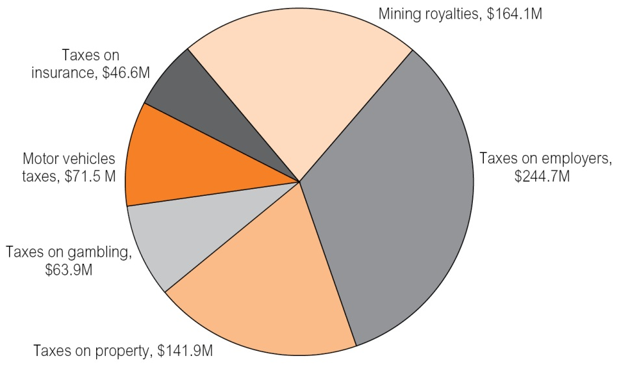
Note: Excludes payroll tax from general government entities.
Source: Department of Treasury and Finance
The estimated revenue in 2013-14 from taxes and royalties totals $708.2 million, compared to the forecast total of $598.6 million from the 2013 Budget. The increase of $109.7 million from the original forecast is due to increases across all taxes and royalties reflecting improved economic conditions in the Territory. The most significant increases are in payroll tax (taxes on employers) and mining royalties as a result of growth in the employment market and both prices and volume growth for minerals.
Moderate growth across all main own-source revenues is expected for 2014-15.
Table 6.1: Main Own-Source Revenue Categories
 | 2013-14  Budget | 2013-14  Estimate | 2014-15  Budget
 | $000 | $000 | $000
Mining royalties | 113 332 | 154 799 | 164 127
Taxes on employers | 200 093 | 242 183 | 244 669
Taxes on property | 130 264 | 138 498 | 141 930
Taxes on gambling | 53 203 | 59 574 | 63 863
Motor vehicle taxes | 63 989 | 68 735 | 71 502
Taxes on insurance | 37 688 | 44 422 | 46 643
Total | 598 569 | 708 211 | 732 734
Source: Department of Treasury and Finance
Mining and Petroleum Revenue
Mining revenue is obtained from royalties levied on the recovery of mineral commodities from mining tenements in the Territory. Similarly, petroleum revenue accrues from royalties imposed on the production of petroleum in the Territory. Mineral and petroleum royalties are a charge for resource usage, payable to the Territory as the owner of the site or the mineral or petroleum rights over the site.
The Territory’s mining royalty revenues are generally based on a profit-based regime specified under the Mineral Royalty Act. Unlike the Territory’s profit-based scheme, the other states predominantly use output-based royalty schemes that impose a royalty rate on the value of production (ad valorem) or on the tonnage extracted. By contrast, the Territory’s profit-based regime uses the net value of a mine’s production to calculate royalty. This is the operating revenue derived from mining activities in excess of $50 000 after deducting allowable project costs, prior year carried forward losses, the cost of capital employed in the mine and the cost of capital and exploration expenditure on the mine site.
Mineral royalties are collected in the Territory from mining and quarrying for gold, silver, bauxite, manganese, lead, zinc, sand, gravel, laterite, vermiculite and lime. The Territory is unable to impose royalties in respect of uranium mined in the Territory as, unlike the states, the Commonwealth retains the ownership of uranium. Nonetheless, the Territory receives a grant in lieu of uranium royalty from the Commonwealth. The only uranium mine in the Territory is the Ranger Project, which has an ad valorem royalty scheme settled by the Commonwealth. The Territory receives grant payments reflecting the royalty regime that applied at the time the Ranger Project arrangements were settled. However, Commonwealth legislation provides that royalty on any future uranium mines in the Territory will be based on the Territory’s Mineral Royalty Act. The royalties will continue to be paid to the Territory as a grant in lieu of royalty.
A key feature of the Territory’s Mineral Royalty Act is that both prices and mining costs, including mine set-up costs carried forward to profitable years, are taken into account in royalty calculations. If commodity prices, production costs or the value of the Australian dollar rise or fall, royalty liabilities vary accordingly. This variability produces stronger growth in royalty revenues in times of high mineral prices than under ad valorem royalties.
In 2013-14, it is expected that the Territory will receive $154.8 million in mining revenue, $41.5 million more than forecast in the 2013 Budget, due largely to the combined effect of the moderation of the Australian dollar and increased commodity prices and production in respect of the minerals mined by the Territory’s largest royalty payers.
Mining revenue forecasts are reliant on advice from mining companies of estimated liability and related company estimates of commodity price movements, production levels and the value of the Australian dollar. The forecast for royalty revenue in 2014-15 is $164.1 million and is based on forecasts from royalty payers that profitability will continue based on the assumptions that the Australian dollar does not materially strengthen and reasonable relevant commodity prices will be achieved.
Taxation Revenue
The Territory’s taxation revenue for 2013-14 is expected to total $553.4 million. In 2014-15, taxation revenue is expected to increase by 2.7 per cent to $568.6 million.
The components of the Territory’s taxation revenue are payroll tax, stamp duty on conveyances, taxes on gambling, taxes on insurance, and motor vehicle fees and taxes. Table 6.2 shows the original Budget and revised Estimate of the Territory’s taxation revenue for 2013-14 and forecast for 2014-15.
Table 6.2: Northern Territory Taxation Revenue
 | 2013-14  Budget | 2013-14  Estimate | 2014-15  Budget
 | $000 | $000 | $000
Taxes on employers
Payroll tax¹ | 200 093 | 242 183 | 244 669
Taxes on property
Conveyance duty | 129 778 | 136 486 | 139 898
Other duty | 487 | 2 012 | 2 032
Taxes on the provision of goods and services
Taxes on gambling | 53 202 | 59 574 | 63 863
Taxes on insurance | 37 688 | 44 422 | 46 643
Taxes on use of goods and performance of activities
Motor vehicle taxes | 63 989 | 68 735 | 71 502
Total | 485 237 | 553 412 | 568 607
1 Comprising payroll tax from public financial corporations, public non financial corporations and the private sector.
Source: Department of Treasury and Finance
Payroll Tax
Payroll tax is payable in the Territory when the total annual Australian wages of an employer (or group of employers) exceeds the Territory’s annual threshold amount, which is $1.5 million. The threshold reduces proportionately if an employer pays wages in another state or territory. The threshold amount is a deduction from taxable wages, which operates so businesses with total Australian wages of up to $1.5 million do not pay any payroll tax. The deduction reduces by $1 for every $4 in wages paid by an employer above the $1.5 million threshold. This means that an employer who pays wages of $7.5 million or more does not receive a deduction.
Payroll tax is calculated at the rate of 5.5 per cent based on taxable wages (less the deduction) paid by an employer for services rendered by employees in the Territory.
In 2013-14, payroll tax revenue is expected to be $242.2 million, an increase of $42.1 million from the estimate of $200 million in the 2013 Budget. This reflects employment and wages growth in the Territory during 2013-14, particularly among the larger employers making up the Territory’s payroll tax base.
In 2014-15, payroll tax receipts are expected to remain steady off the higher base at $244.7 million, reflecting employment growth and growth in average weekly earnings, but offset by a reduction in employment caused by the curtailment of processing at the Gove alumina refinery. Over the forward estimates period, payroll tax revenue is expected to increase at a long-term growth rate of 5 per cent.
Stamp Duty
Conveyance Duty
The Territory’s conveyance duty is derived from direct and indirect conveyances of dutiable property in the Territory. Such property comprises real estate and transfers of businesses.
Conveyance duty in the Territory is calculated by a formula that determines a rate applicable to the value of dutiable property conveyed. This is different from the other states, which levy stamp duty on the basis of marginal rates. A comparison of the Territory’s stamp duty regime with the other states is provided later in this chapter.
In 2013-14, the Territory is expected to collect $136.5 million in stamp duty on conveyances, compared with $129.8 million estimated in the 2013 Budget. The increase in conveyance duty collections is due mainly to a higher than predicted number of residential transactions, some increase in the average value of those transactions, together with some high value commercial transactions.
In 2014-15, conveyance duty is estimated to increase by $3.4 million to $139.9 million, reflecting expectations that residential and commercial property stamp duty revenue will increase slightly. Forward estimates for stamp duty are based on a growth rate of 2.5 per cent per annum.
Stamp Duty on Insurance
Insurance duty is imposed on general and life insurance policies, with general insurance contributing to the majority of the revenue collected from this revenue source. Stamp duty on general insurance is calculated at a rate of 10 per cent of the premium paid on all general insurance products that relate to property or risk in the Territory. Where the policy also relates to a risk or property outside the Territory, the premium is apportioned. Stamp duty on life insurance is levied on life insurance policies for people residing in the Territory and is calculated at a rate of 10 cents per $100 or part thereof of the sum insured.
Revenue from insurance duty is forecast to be $44.4 million in 2013-14. Based on historical growth rates, insurance duty is forecast to grow by 5 per cent to $46.6 million in 2014-15.
Motor Vehicle Taxes
Motor vehicle taxes comprise stamp duty on the transfer and initial registration of motor vehicles and motor vehicle registration fees.
Generally, stamp duty is levied on the purchase price of the vehicle at a rate of $3 per $100 or part thereof. Revenue from this source in 2013-14 is estimated to be $24.5 million. In 2014-15, it is expected to increase to $25.1 million, which includes the long-term growth rate that has been applied to the forward estimates of 2.5 per cent per annum.
Motor vehicle registrations comprise heavy vehicle and light vehicle registrations. Heavy vehicle registration fees are determined by the Standing Council on Transport and Infrastructure. Light vehicle registration fees are determined by each state. In the Territory, the light vehicle fee is calculated by reference to a differential rate scale based on the engine capacity of the vehicle. In 2013-14, the Territory is forecast to receive $44.2 million in motor vehicle registration fees, increasing to $46.4 million in 2014-15. This increase reflects long-term growth rates plus the expected consumer price index adjustments to light vehicle registration fees, as these fees are expressed in revenue units that are indexed annually.
Gambling Taxes
Gambling taxes constitute a significant, although reducing, proportion of state revenues. In 2014-15, gambling tax revenue is forecast to be $63.9 million, or the fifth largest contributor to own-source revenue. The components of gambling taxes in the Territory are community gaming machine tax, lotteries tax, wagering tax, bookmaker turnover tax, casino/internet tax and the community benefit levy.
In 2013-14, the Territory is estimated to receive $59.6 million in gambling taxes, which is an improvement of $6.4 million on the 2013 Budget forecast.
Table 6.3 shows the estimated revenue from each of the Territory’s gambling taxes.
Table 6.3: Estimated Revenue from Gambling Taxes
Tax/Duty | 2013-14  Budget | 2013-14  Estimate | 2014-15  Budget
 | $000 | $000 | $000
Wagering taxes | 3 855 | 3 793 | 3 888
Casino/internet tax | 11 192 | 11 038 | 11 314
Bookmakers – racing and sports betting | 2 781 | 2 796 | 5 648
Community gaming machines | 17 851 | 17 491 | 18 366
Lotteries | 15 309 | 21 886 | 22 433
Community benefit levy | 2 214 | 2 570 | 2 214
Total | 53 202 | 59 574 | 63 863
Source: Department of Treasury and Finance; Department of the Attorney General and Justice
In 2014-15, bookmaker turnover tax is expected to increase by $2.8 million to $5.6 million, reflecting the increase in the tax threshold from $262 500 to $555 000 and the increase in the value of revenue units from $1.08 to $1.11 from 1 July 2014.
Lotteries tax for 2014-15 is expected to increase, reflecting the growth rates of 2.5 per cent used in the forward estimates. Similarly, casino and community gaming machine taxes are expected to record moderate growth.
Wagering taxes are expected to remain stagnant, reflecting the market change of consumers switching from betting with totalisators to utilising fixed-odds betting services provided by TABs and corporate bookmakers.
Interstate Tax Comparison
The composition of state taxes is broadly similar between the states, however there are differences in the application of particular taxes. These differences primarily relate to rates, exemptions and thresholds. The ability of states to modify their rates and tax base promotes competition between states and provides the autonomy and capacity to structure their tax system to accommodate their specific fiscal, economic and social circumstances.
Various approaches to measuring tax competitiveness can be adopted. Two common approaches are the Commonwealth Grants Commission (CGC) measures of taxation effort and capacity, and the representative taxpayer model.

Commonwealth Grants Commission
Revenue Effort
CGC assesses each state’s revenue-raising effort on an annual basis. Revenue effort is the ratio of the actual amount of revenue a state raises to the amount of tax revenue the CGC assesses could be raised if the state applied the average tax rates to its tax base.
Average revenue effort is assumed to be 100 per cent. A state with an above average revenue effort will score more than 100 per cent, while a below-average effort scores less than 100 per cent.
Table 6.4 provides a comparison of the CGC’s assessment of own-source revenue-raising effort in 2012-13 (the latest year that an assessment is available). The total own-source revenue figure includes taxation, mining revenue, contributions by trading enterprises and public safety user charges. The table shows that the Territory’s own-source revenue-raising effort is the lowest of the states and is significantly below the national average of 100 per cent, with the taxation effort of the Territory also being the lowest of all the states.
Table 6.4: 2012-13 Revenue Effort by Jurisdiction
 | NSW | Vic | Qld | WA | SA | Tas | ACT | NT
 | % | % | % | % | % | % | % | %
Total taxation | 107 | 101 | 89 | 95 | 110 | 92 | 99 | 84
Total own-source revenue | 99 | 103 | 102 | 90 | 108 | 88 | 144 | 87
Source: Commonwealth Grants Commission 2014 Update
The Territory’s low total taxation and own-source revenue effort largely reflects the position adopted by the Territory to not impose a land tax. However, consistent with the Government’s strategy of moving the Territory’s revenue effort to the average of the states, some charges and tax arrangements were varied during 2012-13. The partial year effect of these changes is reflected in the above and has resulted in the tax effort increasing by six percentage points from 78 per cent in 2011-12. It would be expected that the Territory’s effort in 2013-14 will be closer to the average of the states, given there would be a full year effect for most of the changes.
Revenue Capacity
States are constrained from growing their own-source revenues by either replacing current taxes with a new growth tax or by expanding existing tax bases. This is evident as nationally, state own-source revenue comprises only about 50 per cent of total state revenue. However, the Territory’s own-source revenue is much lower, comprising about 23 per cent of total revenue.
The revenue limitations imposed on the states are the result of the Australian Constitution and Commonwealth-state financial relations. For instance, states are unable to raise excise and customs duties and the Commonwealth has long assumed the collection of income tax.
In addition, state taxation policy provides a balance between raising sufficient revenue to deliver government services, minimising the tax burden on the community, fostering business development and creating a tax environment that is competitive with other jurisdictions.
Although all states face similar constraints in raising own-source revenue, the Territory’s capacity to raise revenue is further weakened by its relatively small revenue base. This is illustrated in Table 6.5, which shows the CGC’s assessed revenue-raising capacity for the major taxes and mining revenue. Revenue capacity is the ratio of the per capita amount a state could raise if it applied the national average policy to its tax base, compared to the per capita average revenue raised on the national tax base. This measure removes differences in state policies.

Table 6.5: Assessed Revenue-Raising Capacity, 2012-13
 | NSW | Vic | Qld | WA | SA | Tas | ACT | NT
 | % | % | % | % | % | % | % | %
Payroll tax | 101 | 94 | 96 | 143 | 78 | 60 | 95 | 93
Land tax | 100 | 108 | 97 | 131 | 64 | 48 | 58 | 70
Conveyance duty | 111 | 95 | 89 | 137 | 61 | 50 | 96 | 81
Insurance duty | 108 | 93 | 99 | 97 | 105 | 80 | 96 | 88
Motor vehicle duty | 88 | 101 | 106 | 124 | 99 | 103 | 85 | 96
Total taxation | 101 | 98 | 97 | 128 | 82 | 71 | 91 | 90
Mining revenue | 46 | 3 | 115 | 522 | 43 | 23 | 0 | 124
Source: Commonwealth Grants Commission 2014 Update
For all the major state taxes, the Territory is assessed as having a relatively low capacity to raise revenue, in all categories, especially land tax and conveyance duty, significantly below the national average of 100 per cent. This reflects the Territory’s different circumstances such as a relatively small number of very high value commercial and residential properties, although average land prices in the Territory are higher than the national average.
The Territory is compensated for its relatively small own-source revenue base by the CGC’s equalisation process through a higher share of goods and services tax (GST) revenue.
Representative Taxpayer Model
Comparisons can also be made of states’ tax schemes by comparing the amount of tax payable by a representative household or firm. This approach takes into account the different circumstances of each state by applying each state’s tax rate to a representative or average standard.
Payroll Tax
Table 6.6 compares the payroll tax rates and thresholds for each jurisdiction. The table shows that the Territory’s payroll tax annual threshold is the second highest in Australia and its payroll tax rate is equal to the national average.
Table 6.6: State and Territory Payroll Tax Rates and Annual Thresholds
 | NSW | Vic | Qld¹ | WA | SA | Tas | ACT | NT² | Average
Threshold ($M) | 0.75 | 0.55 | 1.1 | 0.75 | 0.6 | 1.25 | 1.75 | 1.5 | 1.03
Rate (%) | 5.45 | 4.9 | 4.75 | 5.5 | 4.95 | 6.1 | 6.85 | 5.5 | 5.5
1 Queensland’s threshold reduces as an employer’s wages increase, so that no exemption is provided for employers with wages over $5.5 million.
2 The Territory’s threshold reduces as an employer’s wages increase, so that no exemption is provided for employers with wages over $7.5 million.
Source: State legislation and information available at 31 March 2014
Table 6.7 provides the effective payroll tax rate at various wage levels for each jurisdiction after considering individual state thresholds and the payroll tax rates. For businesses with wages of $3 million and below, the Territory has a competitive payroll tax scheme as it has an effective tax rate below the national average. For very large businesses with wage costs of $20 million or more, the Territory has a more favourable effective payroll tax rate than the Australian Capital Territory and Tasmania, and is reasonably comparable to Western Australia and New South Wales.

Table 6.7: Effective State and Territory Payroll Tax Rates at Various Wages Levels
 | NSW | Vic | Qld | WA | SA | Tas | ACT | NT | Average
$M | % | % | % | % | % | % | % | % | %
1 | 1.36 | 2.21 | 0.00 | 1.38 | 1.98 | 0.00 | 0.00 | 0.00 | 0.87
2 | 3.41 | 3.55 | 2.67 | 3.44 | 3.47 | 2.29 | 0.86 | 1.72 | 2.67
3 | 4.09 | 4.00 | 3.76 | 4.13 | 3.96 | 3.56 | 2.85 | 3.44 | 3.72
4 | 4.43 | 4.23 | 4.30 | 4.47 | 4.21 | 4.19 | 3.85 | 4.30 | 4.25
5 | 4.63 | 4.36 | 4.63 | 4.68 | 4.36 | 4.58 | 4.45 | 4.81 | 4.56
10 | 5.04 | 4.63 | 4.75 | 5.09 | 4.65 | 5.34 | 5.65 | 5.50 | 5.08
20 | 5.25 | 4.77 | 4.75 | 5.29 | 4.80 | 5.72 | 6.25 | 5.50 | 5.29
Source: State legislation and information available at 31 March 2014
Stamp Duty on Conveyances
Non-first homebuyers receive a rebate of $7000 on the purchase of a new home to be used as a principal place of residence, which is equivalent to a stamp duty concession on around the first $231 500 of the value of the residence.
In addition, seniors and Northern Territory Pensioner and Carer Concession cardholders receive a concession of $8500 on the purchase of a principal place of residence for property values up to $750 000. This is equivalent to a stamp duty concession on the first $252 970 of the value of the residence.
It is difficult to compare stamp duty on houses in each state, given the significant variation in median house prices. Chart 6.2 shows that Darwin has the third highest median house price behind Melbourne and Sydney.
Chart 6.2: Median House Prices
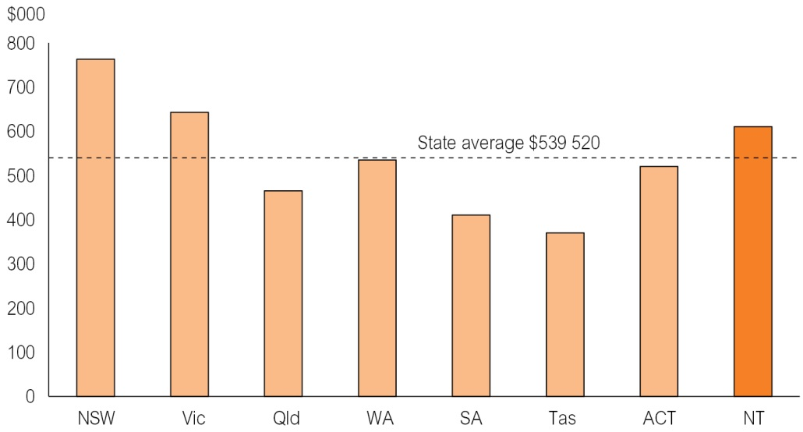
Note: Median house prices as at December 2013.
Source: Real Estate Institute of Australia
However, one method is to compare the stamp duty that would be payable in each state for similarly priced housing. Chart 6.3 provides an interjurisdictional comparison of the amount of stamp duty levied on new principal places of residence valued at the median house price in the Territory ($610 000). It indicates that stamp duty in the Territory on the reference property is slightly lower than the national average.

Chart 6.3: Stamp Duty Payable on Purchase of Territory Median-Priced New House
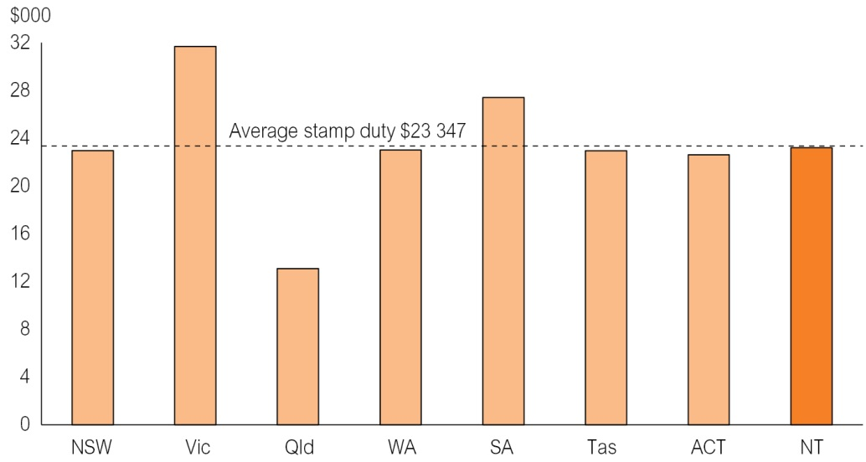
Note: Median house prices as at December 2013.
Source: Real Estate Institute of Australia; state legislation and information available at 31 March 2014
Insurance Duty
As shown in Chart 6.4, the Territory is an average taxing jurisdiction for insurance. By comparison, the total tax load on insurance in New South Wales, Tasmania and Victoria is significantly above the national average when fire services levies are taken into account.
All states impose taxes on general insurance premiums at rates between 7.5 per cent and 11 per cent, with New South Wales, Queensland and Tasmania having special rates on particular classes of general insurance business. All states apart from Western Australia also impose taxes on life insurance policies at different rates. In addition, New South Wales and Tasmania collect a portion of their fire services levies through a charge on insurers. While Tasmania raises a levy on insurance, similar to Queensland, South Australia and Western Australia, a large proportion of the levy is sourced from a charge on property owners through local councils. The Territory does not impose any emergency or fire services levies on the general public, although, like the states, it does charge for commercial fire alarm monitoring.
Chart 6.4: Average State Tax Rate on General Insurance Premiums
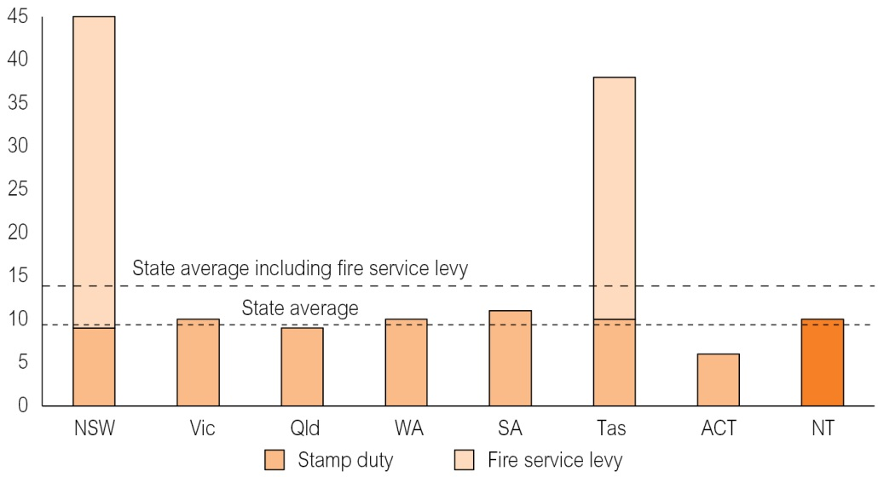
Source: State legislation and information available at 31 March 2014
Stamp Duty on Motor Vehicles
Chart 6.5 compares the stamp duty applicable for a new motor vehicle valued at $34 990. The chart shows that the stamp duty payable in the Territory is below the national average and the equal second lowest in Australia.

Chart 6.5: Stamp Duty on Purchase of $34 990 Motor Vehicle
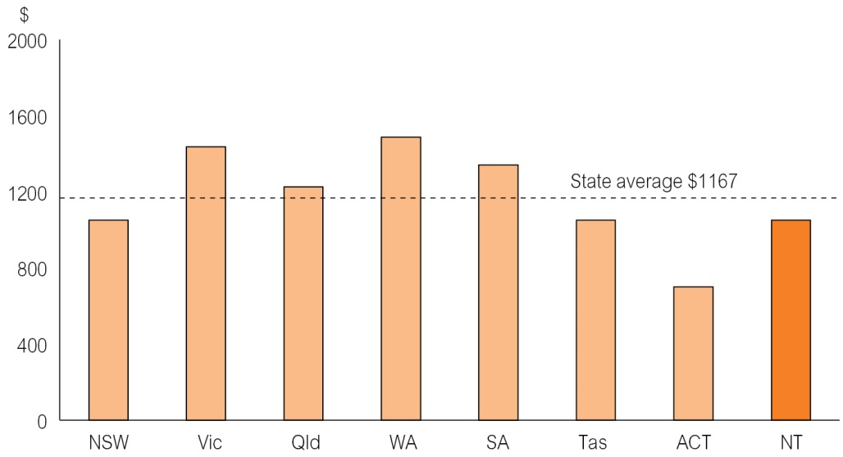
Source: State legislation and information available at 31 March 2014
Motor Vehicle Registration
Motor vehicle registration fees comprise registration, compulsory third-party insurance and other fees, and therefore vary significantly between jurisdictions. Chart 6.6 compares the costs of registering a medium-sized passenger vehicle in each jurisdiction. At $693.45, the Territory has the third-lowest total registration cost in Australia.
Chart 6.6: Annual Registration Fees and Charges for a Medium-Sized Passenger Vehicle
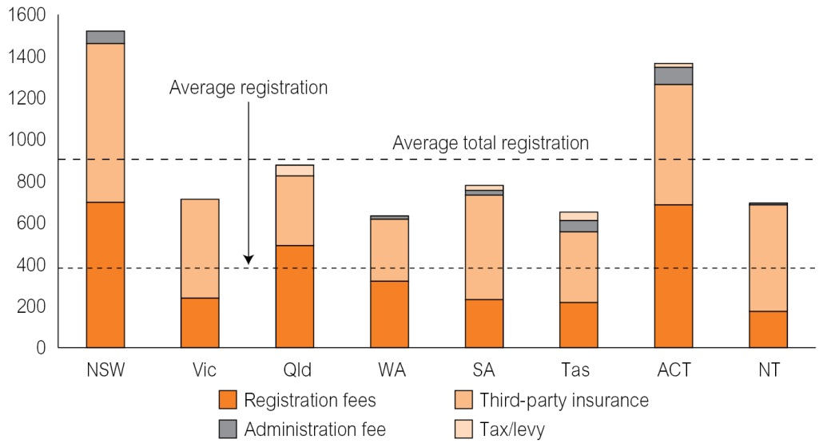
Note: Based on six-cylinder, 2014 Holden Commodore Evoke.
Source: State legislation and information available at 31 March 2014
The higher than average compulsory third-party premiums in the Territory reflect the inherently higher costs associated with third-party insurance due to the small size of the Territory and relatively high road accident casualties. Motor Accident Compensation scheme premiums aim to ensure that likely compensation claims for the upcoming year can be met and that the scheme maintains a prudent solvency margin.
However, total registration costs in the Territory are the third lowest in Australia and significantly below the national average due to the low registration fees and the fact that the Territory does not, unlike some jurisdictions, also add ancillary taxes and levies. These additional levies imposed in other jurisdictions include fire and emergency service levies, motor taxes, traffic improvement levies and road safety contributions.
Land Revenue
This category includes taxes on the ownership of land, where the tax is based on the assessed unimproved value of the land. It also includes any metropolitan land planning, development and fire and emergency services levies that are included in the land tax base of some states.
Land tax is an important source of income for states, estimated to generate more than $6.5 billion in revenue in 2013-14. Land tax is levied on the landowner’s total holdings of commercial land and investment residential property, although generally an exclusion is provided for land used for primary production. Land tax rates are generally progressive and most jurisdictions have tax-free thresholds.
The Territory does not impose a land tax. However, in its 2014 Update, the CGC assessed that the Territory could raise about $45.5 million if it adopted the average state policies on land tax.
Tax Expenditure Statement
Tax concessions are often provided to benefit a specified activity or class of taxpayer. They are expenditures in the sense that their impact on the budget is similar to direct outlays and can be used to achieve similar goals to grant programs.
Tax expenditure can be provided in a variety of ways, including by way of exemption, deduction, rebate or a concessionary tax rate.
The tax expenditure statement details revenue estimated to be forgone by the Government or financial benefits obtained by taxpayers as a result of tax exemptions or concessions provided by the Government. Identifying this expenditure assists in providing a more accurate picture of the Government’s contributions by way of taxation concessions to assist various groups or industries.
The tax expenditure identified in this statement relates to the more important and material concessions available in the Territory. In accordance with the Fiscal Integrity and Transparency Act, the tax expenditure statement provides an estimate of expenditure in 2013-14, and forecast information for 2014-15 and following three financial years.
Methodology
Tax expenditure has been estimated by applying the benchmark rate of taxation to the forecast volume of activities or assets exempted by a particular concession. Only future events that are certain or highly likely to impact on assumed tax bases or tax rates have been taken into consideration in estimating future tax expenditure. Otherwise, existing taxation arrangements have been assumed to apply for future years.
Measuring tax expenditure requires the identification of:
- a benchmark tax base;
- concessionary taxed components of the benchmark tax base, such as specific activity or class of taxpayer; and
- a benchmark tax rate to apply to the concessionary taxed components of the tax base.
The establishment of a benchmark tax base provides a basis against which each tax concession can be evaluated. The aim of the benchmark is to determine which concessions are tax expenditure rather than structural elements of the tax.
By definition, tax expenditure comprises those tax concessions not included as part of the benchmark tax base.
Payroll Tax
The benchmark tax base for payroll tax is assumed to be all wages (as defined under the payroll tax legislation) paid in the Territory. The benchmark tax rate is 5.5 per cent.

Table 6.8: Payroll Tax Expenditure
 | 2013-14 | 2014-15 | 2015-16 | 2016-17 | 2017-18
Tax expenditure ($M) | 106.4 | 111.2 | 116.1 | 119.2 | 122.5
Source: Department of Treasury and Finance
As data is not generally collected from employers that do not have a payroll tax liability, tax expenditure in relation to many payroll tax concessions is difficult to estimate. Accordingly, the reported estimated tax expenditure outlined in Table 6.8 has been derived by adding recorded tax concessions to a figure derived by comparing ATO data about wages paid by employers in the Territory to data reported by employers registered for payroll tax in the Territory. The difference provides a reasonable estimate of wages paid by non-registered employers that are not subject to Territory payroll tax because of the small business exclusion (detailed below).
The reported estimated tax expenditure in relation to payroll tax mainly comprises the following exemptions.
Small Business Exclusion
Employers with wages below $1.5 million are not required to pay tax, a saving of up to $82 500. Employers with payrolls exceeding $1.5 million receive a deduction of up to $1.5 million, which reduces by $1 for every $4 in wages paid by the employer where the wages paid by the employer exceeds $1.5 million. This means employers with wages of $7.5 million or more will not receive a deduction and will pay tax on the total wages paid by the employer.
Charities and Other Exempt Bodies
Non-profit organisations having a sole or dominant purpose that is charitable, benevolent, philanthropic or patriotic, are exempt from payroll tax to the extent that wages are paid for an employee’s services that relate directly to the purpose for which the organisation was established. In addition, employment agencies providing temporary staff to exempt organisations are able to claim payroll tax exemption for these wages.
Apprentices, Graduates and Others
Businesses receive payroll tax exemptions for apprentices, graduates of approved tertiary institutions and employees receiving wages funded under the Community Development Employment Projects program.
Stamp Duty on Conveyances
The benchmark tax base is assumed to be sales of all dutiable property, including chattels that are part of a transaction that conveys other dutiable property. The benchmark tax scale is the currently applicable stamp duty scale.
Table 6.9: Stamp Duty on Conveyances Expenditure
 | 2013-14 | 2014-15 | 2015-16 | 2016-17 | 2017-18
Tax expenditure ($M) | 5.6 | 6.4 | 6.5 | 6.7 | 6.8
Source: Department of Treasury and Finance
Tax expenditure estimates in Table 6.9 are based on an historical revenue base indexed by normal growth parameters and mainly comprise the following concessions:
Corporate Reconstructions Exemption
Corporate groups formed by commonly owned corporations are able to reorganise the ownership of assets without incurring a stamp duty liability. The estimated tax expenditure is the actual stamp duty foregone for approved reconstruction exemptions.
Principal Place of Residence Rebate
Homebuyers who purchase a new home are entitled to a rebate of $7000 when purchasing a principal place of residence. Tax expenditure is estimated by actual collections in relation to the rebate.
Seniors, Pensioner and Carers Concession
A concession of $8500 is provided for seniors (aged 60 years and over) and Northern Territory Pensioner and Carers Concession cardholders when purchasing a principal place of residence up to the value of $750 000. Tax expenditure is estimated by actual collections in relation to the rebate.
Other Conveyance Duty Exemptions
Several other conveyance stamp duty exemptions are provided that together result in significant revenue being foregone by the Territory, the largest of these being exemptions for:
- property transferred to charitable organisations having a sole or dominant purpose that is charitable, benevolent, philanthropic or patriotic;
- the transfer of a company’s property, on its winding up, to a shareholder of the company entitled to the property on a distribution in-kind;
- an exemption under the Commonwealth Family Law Act for instruments made pursuant to a court order that alter the interests of the parties to a marriage or de facto partnership; and
- the conveyance of property between partners of a de facto relationship on the breakdown of the relationship.
The estimated tax expenditure for these concessions is based on actual historical data collected in relation to the various exemptions that have been granted and how these relate to overall conveyance stamp duty collections.
Stamp Duty on General Insurance Policies
The benchmark tax base is all classes of general insurance policies. This does not include life insurance policies, which are treated differently for stamp duty purposes. The benchmark tax rate is 10 per cent of the premium.
Table 6.10: Stamp Duty on General Insurance
 | 2013-14 | 2014-15 | 2015-16 | 2016-17 | 2017-18
Tax expenditure ($M) | 24.3 | 25.4 | 25.5 | 26.1 | 26.8
Source: Department of Treasury and Finance
The Territory provides stamp duty concessions on certain insurance products to reduce the costs of such insurance, namely workers compensation insurance and private health insurance. Tax expenditure outlined in Table 6.10 has been estimated using total work health insurance policy premiums paid during past years compared to total payroll data of employers in the Territory and data on private health insurance premiums obtained from the Private Health Insurance Administration Council.
Motor Vehicle Registration Fees
Motor vehicle registration concessions are available to Northern Territory Pensioner and Carer Concession or Northern Territory Seniors cardholders. Table 6.11 shows the motor vehicle registration fees expenditure. Actual registration fee data has been used to estimate this item of tax expenditure.
Table 6.11: Motor Vehicle Registration Fees Expenditure
 | 2013-14 | 2014-15 | 2015-16 | 2016-17 | 2017-18
Tax expenditure ($M) | 2.3 | 2.3 | 2.3 | 2.3 | 2.3
Source: Department of Treasury and Finance

Mineral Royalties
The benchmark tax base is assumed to be all profitable mining operations in the Territory and the benchmark tax rate is 20 per cent.
Table 6.12: Mineral Royalties Expenditure
 | 2013-14 | 2014-15 | 2015-16 | 2016-17 | 2017-18
Tax expenditure ($M) | 0.2 | 0.2 | 0.2 | 0.2 | 0.2
Source: Department of Treasury and Finance
The first $50 000 of profit is not subject to royalty and royalty payers are able to reduce the amount of royalty they pay in the Territory for eligible exploration expenditure (EEE) incurred in their mining operations in the Territory. However, the amount by which royalty may be reduced through the use of EEE is limited to a maximum of 25 per cent of the amount that would otherwise be payable.
The estimated cost of this concession as outlined in Table 6.12 is based on projected future mineral royalty collections, assuming that royalty payers will seek to maximise their royalty deduction by using EEE.

Chapter 7
The Territory Economy
Overview
The structure of the Territory economy is markedly different to other Australian economies. This reflects the Territory’s different population characteristics and its large land mass with an abundance of natural endowments.
The largest industries in the Territory, in terms of contribution to gross state product (GSP), are construction, mining, and government and community services (which comprises industries with outputs predominantly supplied by the public sector). These industries account for about half of the Territory’s GSP compared with about one third of Australia’s gross domestic product (GDP) (Chart 7.1).
Chart 7.1: Industry Proportion of GSP and GDP, 2012-13¹
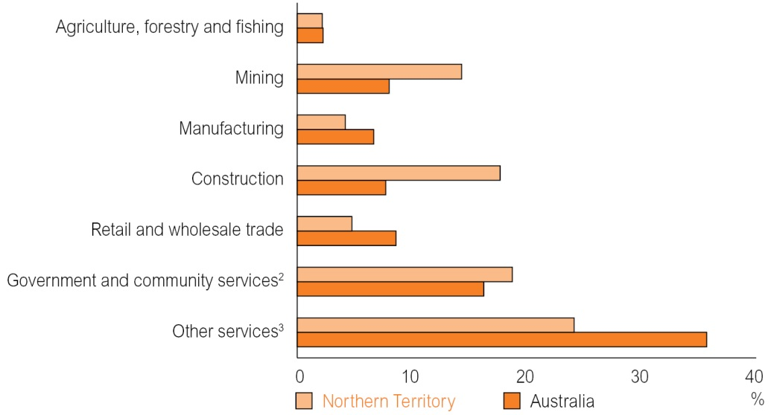
1 Current prices.
2 Government and community services comprises public administration and safety, education and training, and health care and social assistance industries.
3 The other services sector comprises: accommodation and food services; transport, postal and warehousing; information and media telecommunications; financial insurance services; rental, hiring and real estate services; professional, scientific and technical services; administrative and support services; electricity, gas, water and waste services; and arts and recreation services.
Source: ABS, Australian National Accounts: State Accounts, Cat. No. 5220.0
The Territory economy is expected to perform strongly over the budget and forward estimates period. Continued elevated levels of construction activity related to the Ichthys project are expected to support robust employment and population growth. As the Ichthys project transitions to the less labour-intensive production phase, it is expected to lead to a softening of labour market conditions and moderation in population growth in the forward years. Following a strong increase in the Darwin consumer price index (CPI) in 2013, price pressures are expected to ease over the budget and forward estimates period.
Table 7.1 shows the forecasts for key economic indicators for the Territory over the budget and forward estimates period.

Table 7.1: Key Economic Forecasts (%)
 | 2012-13 | 2013-14e | 2014-15f | 2015-16f | 2016-17f | 2017-18f
Gross state product¹ | 5.6 | 5.0 | 6.0 | 3.0 | 4.0 | 3.5
Population² | 2.3 | 2.0 | 1.6 | 2.6 | 1.0 | 1.0
Employment³ | 2.6 | 3.7 | 3.8 | 2.1 | 0.7 | 0.7
Consumer price index⁴ | 2.0 | 3.9 | 3.0 | 2.8 | 2.5 | 2.5

e: estimate; f: forecast
1 Year ended June, year-on-year change, inflation adjusted.
2 As at December, annual change.
3 Year-on-year percentage change.
4 As at December, year-on-year percentage change.
Source: ABS; Department of Treasury and Finance
The following provides a high-level analysis of the above indicators. For further information on these as well as information on specific industries, see the Northern Territory Economy book.
Economic Growth
Over the past two years, growth in the Territory economy has outpaced growth in the Australian economy and this trend is expected to continue over the forward estimates period.
The Territory economy grew by 5.6 per cent in 2012-13, the highest growth rate of all jurisdictions and more than double the national average of 2.6 per cent. Economic growth in 2012-13 was driven by record levels of private investment, as well as strengthening household consumption and an increase in net exports.
The Territory economy is expected to grow strongly over the budget and forward estimates period. Growth over the next two years is expected to be primarily supported by construction activity related to the Ichthys project, which is expected to have a positive flow-through impact on other industries.
However, the Territory’s economic growth estimates are lower than they would otherwise have been following Rio Tinto’s decision to curtail operations at the Gove alumina refinery. The curtailment is expected to detract from economic growth through lower levels of consumption and reduced Territory net exports, partly offset through an expected increase in bauxite exports and a decrease in imports of fuel oil and caustic soda.
From 2015-16, the Territory economy is forecast to undergo a significant transition, with economic growth expected to be underpinned by a substantial increase in net exports as the Ichthys project moves towards the production phase.
Household Consumption
Household consumption was a strong contributor to economic growth in 2012-13, largely due to an increase in net expenditure interstate. However, the strength in net expenditure interstate masks the general weakness in other household expenditure.
Removing net expenditure interstate, underlying household consumption in the Territory grew by 1.7 per cent, well below the trend rate of 4.0 per cent, and extends the run of relatively weak growth in underlying household consumption since 2009-10.
Weak growth in underlying household consumption reflects changes in household behaviour that has seen consumers become more cautious with their spending, leading to higher levels of savings and lower levels of spending on discretionary goods and services.
Over the next three years, household consumption is expected to grow at a solid rate, although below trend levels, supported by favourable economic conditions including low interest rates and robust employment and population growth. Household consumption growth is expected to moderate in 2016-17 and 2017-18, coinciding with the softening of labour market conditions.
Private Investment
Private investment has been a key driver of growth in the Territory’s GSP over the past two years. In 2012-13, private investment increased by 62.2 per cent to $10.7 billion.
The recent surge in private investment primarily reflects the commencement of the Ichthys project as well as construction activity on a number of major resource projects including expansions at the Groote Eylandt Mining Company (GEMCO) and McArthur River mines, and the development of the Montara project (Chart 7.2). In addition, high levels of non-residential and private residential building activity also contributed to growth in private investment.
Chart 7.2: Private Investment¹ (moving annual total)
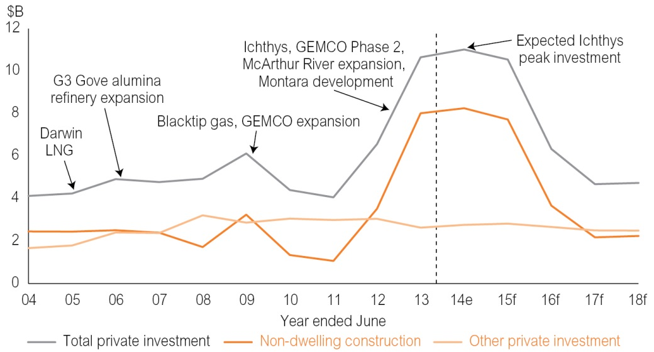
e: estimate; f: forecast; LNG: liquefied natural gas
1 Inflation adjusted.
Source: Department of Treasury and Finance; ABS, Australian National Accounts: State Accounts, Cat. No. 5220.0
The outlook is for private investment in the Territory to remain at historically elevated levels over the next two years before declining sharply from 2015-16 onwards as construction activity on the Ichthys project winds down. Private investment is expected to return to long-term trend levels in the forward years.
Public Final Demand
Public final demand comprises consumption and investment by the Commonwealth, Territory and local governments, including defence. Public final demand detracted from economic growth in 2012-13, reflecting decreases of 23.5 per cent in public investment and 0.7 per cent in public consumption.
Between 2009-10 and 2011-12, public investment in the Territory was at elevated levels. The annual average level of capital expenditure over this period was nearly double the ten-year average prior to 2009-10. Public investment in the Territory is expected to decline over the forward estimates period and return to historical levels, consistent with the Territory Government’s target of reaching a fiscal balance by 2017-18, as well as the fiscal consolidation occurring at the Commonwealth level.
Public consumption is expected to remain relatively flat over the budget and forward estimates period. Combined with the reduction in public investment, the public final demand share of Territory GSP is expected to decline significantly.
Net Exports
Net exports made a small contribution to growth in 2012-13, with an increase in exports partly offset by higher levels of imports.
In the medium term, net exports are expected to be highly volatile. Increased production following the completion of the Montara project and expansions at the GEMCO and McArthur River mines will be offset by a decrease in alumina exports following the curtailment of operations at the Gove alumina refinery and an increase in imports due to the arrival of high-value machinery and equipment related to the Ichthys project.
From 2016-17, net exports are expected to grow significantly as the Ichthys project transitions to the production phase.
External Economic Environment
The Territory has a small, open economy that can be influenced by external economic conditions.
The performance of the Australian economy impacts on the level of interstate trade and population migration between the Territory and other jurisdictions, as well as the amount of Commonwealth revenue received by the Territory.
The Australian economy is currently undergoing significant transition. As resource investment declines, the Australian economy is expected to transition from resources to the non-resource drivers of growth, such as services, housing construction and consumption.
Nationally, conditions are conducive for a pick up in the non-resource sectors, reflecting a forecast recovery in the global economy, relatively low interest rates, increasing household wealth, contained inflation and a relatively low unemployment rate. The Australian dollar has depreciated in value over the past two years, but it remains relatively high. Consequently, it is expected to continue to weigh heavily on a number of industries such as tourism and manufacturing.
In its World Economic Outlook April 2014, the International Monetary Fund (IMF) revised down the economic growth forecasts for Australia, citing the decline in resource investment. Despite the downward revision, the Australian economy is still expected to outperform many other advanced economies over the forward estimates period.
Global economic conditions influence the level of private investment in the Territory, demand for Territory-produced goods and services and overseas population migration to the Territory. The IMF forecasts global growth to strengthen over the forward years, led by a recovery in advanced economies. The favourable outlook should support demand for Territory goods and services.
The economic performance of the Territory’s main trading partners is forecast to remain solid over the forward estimates period with the exception of Japan, which is the Territory’s largest export destination (Table 7.2). The IMF forecasts Japan’s economic growth to recover from the levels recorded following the global financial crisis, however it is expected to remain subdued relative to other advanced countries. The forecast weakness in the Japanese economy is not, however, expected to have a significant impact on Territory goods exports to Japan because they largely comprise liquefied natural gas, which is traded under long-term contracts.
Table 7.2: GDP Growth (%)
 | 2007 to 2012¹ | 2013e | 2014e | 2015f | 2016f | 2017f
World | 3.3 | 3.0 | 3.6 | 3.9 | 4.0 | 3.9
Australia | 2.9 | 2.4 | 2.6 | 2.7 | 2.9 | 3.0
Japan | 0.2 | 1.5 | 1.4 | 1.0 | 0.7 | 1.0
China | 10.1 | 7.7 | 7.5 | 7.3 | 7.0 | 6.8
Indonesia | 6.0 | 5.8 | 5.4 | 5.8 | 6.0 | 6.0
United States | 1.0 | 1.9 | 2.8 | 3.0 | 3.0 | 2.9
Korea | 3.3 | 2.8 | 3.7 | 3.8 | 3.8 | 3.8
e: estimate; f: forecast
1 Five-year average.
Source: IMF
Population
The Territory accounts for about 1 per cent of the total Australian population, with its small population dispersed over a large land mass. The Territory’s population is young and mobile, with high levels of interstate migration among the non-Indigenous population and substantial movement within the Territory among the Indigenous population. In addition, about 30 per cent of the Territory’s population is Indigenous compared with 3 per cent nationally.
The Territory recorded a 2.1 per cent growth in population in 2012-13. Growth from strong net overseas migration and natural increase was partly offset by migration from the Territory to other jurisdictions.
Net overseas migration added 3065 people to the Territory’s population and was the largest contributor to population growth in 2012-13 (Chart 7.3). The high level of positive net overseas migration is due to favourable employment conditions in the Territory and the strong demand for skilled workers associated with major resource projects.
Chart 7.3: Components of Population Growth (moving annual total)
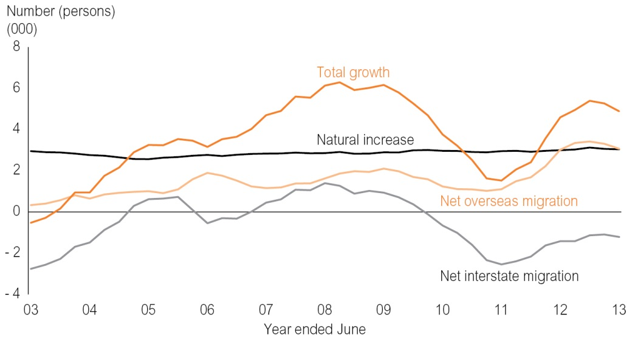
Source: ABS, Australian Demographic Statistics, Cat. No. 3101.0
The recent trend of strong positive net overseas migration to the Territory is expected to continue over the next two years. Despite this, the Territory’s population growth is forecast to moderate to 1.6 per cent in 2014, primarily due to an expected population outflow following the curtailment of operations at the Gove alumina refinery.
Population growth in 2015 is forecast to strengthen to 2.6 per cent, as the population effects from the curtailment of operations at the Gove alumina refinery pass and the workforce requirements for the construction phase of the Ichthys project peak. Population growth is forecast to moderate in the forward years, coinciding with an expected softening in labour market conditions.
Labour Market
The Territory’s labour market is characterised by low unemployment, high labour force participation and a young mobile workforce, reflecting the tendency of people to move to the Territory for employment opportunities. The largest employment industries in the Territory are government and community services, retail trade and construction.
Labour market conditions in the Territory are positive, with robust employment growth and one of the lowest unemployment rates in the nation.
Employment growth in the Territory strengthened from 1.2 per cent in 2011-12 to 2.6 per cent in 2012-13 (Chart 7.4). The Territory’s relatively strong employment growth over this period has been supported by construction, mining and manufacturing industries that have directly benefited from the record levels of investment in resource projects in recent years and some services sectors such as health care and social assistance.
In contrast, employment conditions in other industries remain challenging, with employment levels in some industries declining in 2012-13, including agriculture, forestry and fishing, financial and insurance services, and retail trade.
Chart 7.4: Territory Year-on-Year Employment Growth
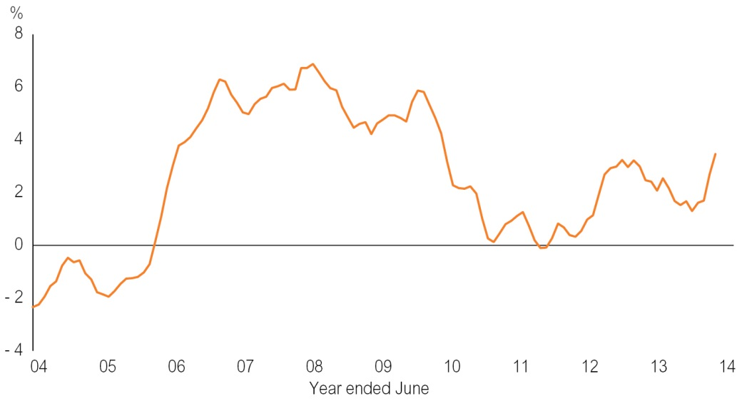
Source: ABS, Labour Force, Australia, Cat. No. 6202.0
Over the next two years, employment growth is expected to strengthen, underpinned by an acceleration of construction activity associated with the Ichthys project, which is expected to flow through to industries such as retail trade, accommodation and food services, and rental, hiring and real estate services.
As employment growth strengthens, the unemployment rate is expected to decline to 4.4 per cent in 2013-14 and moderate further to 4.0 per cent in 2014-15.
The Territory’s labour market conditions are expected to soften from 2015-16 onwards as the investment phase of the Ichthys project passes its peak and the project transitions to the less labour-intensive production phase. Employment growth is forecast to moderate and the unemployment rate is expected to rise in the forward years. Despite the forecast increase, the Territory’s unemployment rate is expected to remain one of the lowest in Australia.
Prices and Wages
The Darwin CPI increased by 3.9 per cent in 2013 reflecting increases in the costs of housing, transportation, recreation and culture, alcohol and tobacco, and health.
Increases in the costs of housing, namely utilities, rents and home purchases, accounted for nearly half of the increase in the Darwin CPI in 2013. However, the impact of housing costs on the Darwin CPI is expected to moderate substantially due to lower increases in utility tariffs in 2014 and 2015. In addition, an increase in the supply of dwelling stock and further housing developments in the Territory is expected to ease pressure on house purchase and rent prices.
Growth in the Darwin CPI is expected to moderate to 3.0 per cent in 2014 and 2.8 per cent in 2015 before easing further to 2.5 per cent in the following years. The moderation in growth in the Darwin CPI reflects the expected lower increases in housing costs and the forecast slowdown in economic activity and population growth in the Territory in later years of the forward estimates period.
Territory wages, as measured by the wage price index, grew by 2.9 per cent in 2013, below the ten-year average levels of 3.8 per cent. Growth in public sector wages (2.5 per cent) was below the increase in private sector wages (3.1 per cent) in 2013.
Territory wage growth is expected to be around trend levels over the next two years, coinciding with strengthening labour market conditions. In the forward years, wage pressures are expected to ease following the slow-down of economic activity in the Territory and the forecast softening of labour market conditions.

Chapter 8
Uniform Presentation Framework
Under the Uniform Presentation Framework (UPF), the Commonwealth, state and territory governments have agreed to publish information in a standard format in their budget papers. The UPF is based on accounting standard AASB 1049 Whole of Government and General Government Sector Financial Reporting, which harmonises Government Finance Statistics and generally accepted accounting principles with the objective of improving the clarity and transparency of government financial statements.
The harmonised standard means that government financial reports are now presented on the same basis by all jurisdictions, resulting in greater transparency and consistency.
The Fiscal Integrity and Transparency Act requires that fiscal outlook reports be prepared in accordance with external reporting standards, including the Australian Accounting Standards or the UPF.
The tables in this chapter meet the Territory’s reporting obligations under both the Fiscal Integrity and Transparency Act and the UPF. They include, for each sector of government, a:
- Comprehensive Operating Statement;
- Balance Sheet; and
- Cash Flow Statement.
Also included are supplementary tables for the general government sector presenting:
- taxes;
- grant revenue and expenses;
- dividend and income tax equivalent income;
- general government operating expenses by function; and
- a revised 2014-15 Loan Council Allocation.
The financial statements for the general government, public non financial corporation and non financial public sectors include the revised 2013-14 Estimate, 2014-15 Budget and 2015-16 to 2017-18 Forward Estimates. The statements for the public financial corporation sector and total public sector present the 2013-14 Estimate only, with the remaining supplementary tables presenting both the 2013-14 Estimate and the 2014-15 Budget.

Table 8.1
General Government Sector Comprehensive Operating Statement
 |  | 2013-14 | 2014-15 | 2015-16 | 2016-17 | 2017-18
 |  | Estimate | Budget | Forward Estimates
 |  | $000 | $000 | $000 | $000 | $000
 | REVENUE
 | Taxation revenue | 553 412 | 568 607 | 583 937 | 601 250 | 624 510
 | Current grants | 3 619 085 | 3 929 810 | 4 036 317 | 4 153 984 | 4 199 095
 | Capital grants | 284 380 | 239 678 | 209 685 | 226 049 | 115 692
 | Sales of goods and services | 257 701 | 261 750 | 275 728 | 274 827 | 272 099
 | Interest income | 57 030 | 54 826 | 54 829 | 55 857 | 57 647
 | Dividend and income tax equivalent income | 65 125 | 103 224 | 132 824 | 136 649 | 128 536
 | Other | 247 229 | 212 054 | 209 117 | 208 730 | 207 644
 | TOTAL REVENUE | 5 083 962 | 5 369 949 | 5 502 437 | 5 657 346 | 5 605 223
less | EXPENSES
 | Employee benefits expense | 1 982 609 | 1 993 375 | 2 042 955 | 2 097 699 | 2 105 972
 | Superannuation expenses
 | Superannuation interest cost | 129 076 | 120 270 | 142 840 | 164 260 | 165 045
 | Other superannuation expenses | 187 803 | 218 472 | 219 070 | 212 180 | 193 016
 | Depreciation and amortisation | 287 938 | 316 222 | 321 676 | 327 378 | 327 532
 | Other operating expenses | 1 237 431 | 1 325 471 | 1 354 372 | 1 439 849 | 1 437 649
 | Interest expenses | 206 552 | 261 507 | 268 777 | 272 691 | 278 628
 | Other property expenses
 | Current grants | 822 583 | 797 126 | 798 324 | 827 428 | 844 783
 | Capital grants | 79 191 | 81 722 | 63 946 | 52 135 | 53 963
 | Subsidies and personal benefit payments | 181 961 | 192 841 | 191 353 | 194 615 | 197 265
 | TOTAL EXPENSES | 5 115 144 | 5 307 006 | 5 403 313 | 5 588 235 | 5 603 853
equals | NET OPERATING BALANCE | - 31 182 | 62 943 | 99 124 | 69 111 | 1 370
plus | Other economic flows – included in operating result | 47 551 | 20 999 | 22 530 | 23 659 | 24 585
equals | OPERATING RESULT | 16 369 | 83 942 | 121 654 | 92 770 | 25 955
plus | Other economic flows – other comprehensive income | - 16 550 | 547 432 | 375 156 | 208 936 | 224 899
equals | COMPREHENSIVE RESULT – total change in net worth before transactions with owners in their capacity as owners | - 181 | 631 374 | 496 810 | 301 706 | 250 854
 | NET OPERATING BALANCE | - 31 182 | 62 943 | 99 124 | 69 111 | 1 370
less | Net acquisition of non financial assets
 | Purchases of non financial assets | 655 762 | 637 342 | 557 036 | 542 545 | 421 732
 | Sales of non financial assets | - 59 712 | - 74 779 | - 54 917 | - 73 024 | - 71 562
 | less Depreciation | 287 938 | 316 222 | 321 676 | 327 378 | 327 532
 | plus Change in inventories | - 154
 | plus Other movements in non financial assets | - 12 186 | 483 757
 | equals Total net acquisition of non financial assets | 295 772 | 730 098 | 180 443 | 142 143 | 22 638
equals | FISCAL BALANCE | - 326 954 | - 667 155 | - 81 319 | - 73 032 | - 21 268

Table 8.2
General Government Sector Balance Sheet
 | 2013-14 | 2014-15 | 2015-16 | 2016-17 | 2017-18
 | Estimate | Budget | Forward Estimates
 | $000 | $000 | $000 | $000 | $000
ASSETS
Financial assets
Cash and deposits | 461 509 | 186 960 | 230 757 | 174 838 | 136 010
Advances paid | 222 602 | 220 602 | 209 602 | 202 602 | 198 474
Investments, loans and placements | 1 295 422 | 1 245 840 | 1 287 887 | 1 328 459 | 1 418 591
Receivables | 147 442 | 184 899 | 190 347 | 196 787 | 196 984
Equity
Investments in other public sector entities | 2 835 614 | 2 939 875 | 3 125 079 | 3 330 063 | 3 551 010
Investments – other | 100 | 100 | 100 | 100 | 100
Other financial assets
Total financial assets | 4 962 689 | 4 778 276 | 5 043 772 | 5 232 849 | 5 501 169
Non financial assets
Inventories | 10 560 | 10 560 | 10 560 | 10 560 | 10 560
Property, plant and equipment | 11 027 242 | 11 770 253 | 11 963 714 | 12 118 985 | 12 154 861
Investment property | 88 685 | 84 578 | 81 171 | 78 014 | 74 857
Other non financial assets | 123 034 | 123 021 | 123 008 | 122 995 | 122 982
Total non financial assets | 11 249 521 | 11 988 412 | 12 178 453 | 12 330 554 | 12 363 260
TOTAL ASSETS | 16 212 210 | 16 766 688 | 17 222 225 | 17 563 403 | 17 864 429
LIABILITIES
Deposits held | 594 828 | 185 031 | 188 329 | 196 124 | 202 288
Advances received | 354 456 | 360 096 | 320 148 | 309 565 | 301 579
Borrowing | 3 076 753 | 3 770 950 | 3 916 360 | 3 935 912 | 3 981 785
Superannuation | 3 434 762 | 3 040 806 | 2 879 753 | 2 893 534 | 2 897 645
Other employee benefits | 571 787 | 579 787 | 585 787 | 589 787 | 590 787
Payables | 139 045 | 153 480 | 153 499 | 153 627 | 154 637
Other liabilities | 172 006 | 176 591 | 181 592 | 186 391 | 186 391
TOTAL LIABILITIES | 8 343 637 | 8 266 741 | 8 225 468 | 8 264 940 | 8 315 112
NET ASSETS/(LIABILITIES) | 7 868 573 | 8 499 947 | 8 996 757 | 9 298 463 | 9 549 317
Contributed equity
Accumulated surplus/(deficit) | 705 051 | 1 218 993 | 1 526 647 | 1 619 417 | 1 645 372
Reserves | 7 163 522 | 7 280 954 | 7 470 110 | 7 679 046 | 7 903 945
NET WORTH | 7 868 573 | 8 499 947 | 8 996 757 | 9 298 463 | 9 549 317
NET FINANCIAL WORTH¹ | - 3 380 948 | - 3 488 465 | - 3 181 696 | - 3 032 091 | - 2 813 943
NET FINANCIAL LIABILITIES² | 6 216 562 | 6 428 340 | 6 306 775 | 6 362 154 | 6 364 953
NET DEBT³ | 2 046 504 | 2 662 675 | 2 696 591 | 2 735 702 | 2 732 577

1 Net financial worth equals total financial assets minus total liabilities.
2 Net financial liabilities equals the sum of total liabilities less total financial assets excluding investments in other public sector entities.
3 Net debt equals the sum of deposits held, advances received and borrowing, minus the sum of cash and deposits, advances paid and investments, loans and placements.

Table 8.3
General Government Sector Cash Flow Statement
 | 2013-14 | 2014-15 | 2015-16 | 2016-17 | 2017-18
 | Estimate | Budget | Forward Estimates
 | $000 | $000 | $000 | $000 | $000
Cash receipts from operating activities
Taxes received | 553 281 | 568 332 | 583 787 | 601 250 | 624 510
Receipts from sales of goods and services | 230 370 | 306 811 | 320 790 | 319 887 | 317 160
Grants and subsidies received | 3 903 465 | 4 169 488 | 4 246 002 | 4 380 033 | 4 314 787
Interest receipts | 57 030 | 54 826 | 54 829 | 55 857 | 57 647
Dividends and income tax equivalents | 51 974 | 66 042 | 127 526 | 130 209 | 128 339
Other receipts | 503 656 | 428 204 | 425 545 | 425 353 | 424 267
Total operating receipts | 5 299 776 | 5 593 703 | 5 758 479 | 5 912 589 | 5 866 710
Cash payments for operating activities
Payments for employees | - 2 247 893 | - 2 284 642 | - 2 370 565 | - 2 453 005 | - 2 455 569
Payment for goods and services | - 1 440 504 | - 1 584 387 | - 1 614 326 | - 1 699 901 | - 1 701 748
Grants and subsidies paid | - 1 071 169 | - 1 033 761 | - 1 053 428 | - 1 074 178 | - 1 096 011
Interest paid | - 206 612 | - 248 604 | - 268 852 | - 272 759 | - 278 567
Other payments | - 2 827
Total operating payments | - 4 969 005 | - 5 151 394 | - 5 307 171 | - 5 499 843 | - 5 531 895
NET CASH FLOWS FROM OPERATING ACTIVITIES | 330 771 | 442 309 | 451 308 | 412 746 | 334 815
Cash flows from investments in non financial assets
Sales of non financial assets | 52 940 | 74 779 | 54 917 | 73 024 | 71 562
Purchases of non financial assets | - 655 762 | - 637 342 | - 557 036 | - 542 545 | - 421 732
Net cash flows from investments in non financial assets | - 602 822 | - 562 563 | - 502 119 | - 469 521 | - 350 170
NET CASH FROM OPERATING ACTIVITIES AND INVESTMENTS IN NON FINANCIAL ASSETS | - 272 051 | - 120 254 | - 50 811 | - 56 775 | - 15 355
Net cash flows from investments in financial assets for policy purposes¹ | 11 786 | 15 171 | 14 952 | 10 952 | 8 080
Net cash flows from investments in financial assets for liquidity purposes | 28 083 | 61 799 | - 29 104 | - 26 860 | - 75 604
NET CASH FLOWS FROM INVESTING ACTIVITIES | - 562 953 | - 485 593 | - 516 271 | - 485 429 | - 417 694
Net cash flows from financing activities
Advances received (net) | - 23 816 | 5 640 | - 39 948 | - 10 583 | - 7 986
Borrowing (net) | 376 544 | 172 892 | 145 410 | 19 552 | 45 873
Deposits received (net) | - 70 125 | - 409 797 | 3 298 | 7 795 | 6 164
Other financing (net) | - 2 494
NET CASH FLOWS FROM FINANCING ACTIVITIES | 280 109 | - 231 265 | 108 760 | 16 764 | 44 051
NET INCREASE/DECREASE IN CASH HELD | 47 927 | - 274 549 | 43 797 | - 55 919 | - 38 828
Net cash flows from operating activities | 330 771 | 442 309 | 451 308 | 412 746 | 334 815
Net cash flows from investments in non financial assets | - 602 822 | - 562 563 | - 502 119 | - 469 521 | - 350 170
CASH SURPLUS (+)/DEFICIT (-) | - 272 051 | - 120 254 | - 50 811 | - 56 775 | - 15 355
Future infrastructure and superannuation contributions/earnings² | - 11 052 | - 23 046 | - 24 429 | - 25 895 | - 27 448
UNDERLYING SURPLUS (+)/DEFICIT (-) | - 283 103 | - 143 300 | - 75 240 | - 82 670 | - 42 803
Additional information to the Cash Flow Statement
CASH SURPLUS (+)/DEFICIT (-) | - 272 051 | - 120 254 | - 50 811 | - 56 775 | - 15 355
Acquisitions under finance leases and similar arrangements |  | - 521 305
ABS GFS SURPLUS (+)/DEFICIT (-) including finance leases and similar arrangements | - 272 051 | - 641 559 | - 50 811 | - 56 775 | - 15 355

1 Includes equity acquisitions, disposals and privatisations (net).
2 Contributions for future infrastructure and superannuation requirements.
Table 8.4
Public Non Financial Corporation Sector Comprehensive Operating Statement
 |  | 2013-14 | 2014-15 | 2015-16 | 2016-17 | 2017-18
 |  | Estimate | Budget | Forward Estimates
 |  | $000 | $000 | $000 | $000 | $000
 | REVENUE
 | Current grants | 144 406 | 146 611 | 149 327 | 152 596 | 153 096
 | Capital grants | 35 660 | 17 452 | 18 974 | 18 069 | 18 569
 | Sales of goods and services | 718 768 | 771 083 | 813 157 | 830 253 | 833 352
 | Interest income | 2 509 | 1 800 | 2 230 | 2 250 | 2 280
 | Other | 63 002 | 42 486 | 43 434 | 44 342 | 45 273
 | TOTAL REVENUE | 964 345 | 979 432 | 1 027 122 | 1 047 510 | 1 052 570
less | EXPENSES
 | Employee benefits expense | 104 371 | 113 581 | 119 150 | 130 457 | 135 747
 | Superannuation expenses | 13 755 | 14 583 | 15 115 | 15 572 | 15 772
 | Depreciation and amortisation | 258 231 | 204 500 | 189 694 | 179 752 | 173 089
 | Other operating expenses | 506 862 | 489 467 | 491 984 | 489 283 | 487 073
 | Interest expenses | 88 833 | 90 581 | 91 485 | 91 947 | 93 977
 | Other property expenses | 6 230 | 26 431 | 36 033 | 30 484 | 19 907
 | Current grants | 50
 | Capital grants
 | Subsidies and personal benefit payments | 17 572 | 15 191 | 16 713 | 18 086 | 19 570
 | TOTAL EXPENSES | 995 904 | 954 334 | 960 174 | 955 581 | 945 135
equals | NET OPERATING BALANCE | - 31 559 | 25 098 | 66 948 | 91 929 | 107 435
plus | Other economic flows – included in operating result | - 1 131 | - 2 998 | - 2 472 | - 2 381 | - 2 364
equals | OPERATING RESULT | - 32 690 | 22 100 | 64 476 | 89 548 | 105 071
plus | Other economic flows – other comprehensive income | - 157 334 | 110 202 | 107 341 | 105 107 | 107 279
equals | COMPREHENSIVE RESULT – total change in net worth before transactions with owners in their capacity as owners | - 190 024 | 132 302 | 171 817 | 194 655 | 212 350
 | NET OPERATING BALANCE | - 31 559 | 25 098 | 66 948 | 91 929 | 107 435
less | Net acquisition of non financial assets
 | Purchases of non financial assets | 255 978 | 244 922 | 212 007 | 185 602 | 229 473
 | Sales of non financial assets | - 6 | - 6 | - 126 | - 126 | - 126
 | less Depreciation | 258 231 | 204 500 | 189 694 | 179 752 | 173 089
 | plus Change in inventories | 7 205 | 6 277 | 4 147 | 6 609 | 6 984
 | plus Other movements in non financial assets | 21 150 | 16 230 | 16 636 | 17 052 | 17 478
 | equals Total net acquisition of non financial assets | 26 096 | 62 923 | 42 970 | 29 385 | 80 720
equals | FISCAL BALANCE | - 57 655 | - 37 825 | 23 978 | 62 544 | 26 715

Table 8.5
Public Non Financial Corporation Sector Balance Sheet
 | 2013-14 | 2014-15 | 2015-16 | 2016-17 | 2017-18
 | Estimate | Budget | Forward Estimates
 | $000 | $000 | $000 | $000 | $000
ASSETS
Financial assets
Cash and deposits | 116 349 | 80 796 | 84 282 | 92 892 | 98 744
Advances paid
Investments, loans and placements
Receivables | 115 032 | 116 373 | 127 006 | 130 233 | 131 847
Equity | 3 | 3 | 3 | 3 | 3
Other financial assets
Total financial assets | 231 384 | 197 172 | 211 291 | 223 128 | 230 594
Non financial assets
Inventories | 116 970 | 123 247 | 127 394 | 134 003 | 140 987
Property, plant and equipment | 3 415 682 | 3 565 554 | 3 686 474 | 3 794 083 | 3 952 756
Investment property | 53 775 | 60 175 | 63 375 | 66 575 | 70 275
Other non financial assets | 182 985 | 190 234 | 213 043 | 230 880 | 250 363
Total non financial assets | 3 769 412 | 3 939 210 | 4 090 286 | 4 225 541 | 4 414 381
TOTAL ASSETS | 4 000 796 | 4 136 382 | 4 301 577 | 4 448 669 | 4 644 975
LIABILITIES
Deposits held | 9 315 | 9 315 | 9 315 | 9 315 | 9 315
Advances received
Borrowing | 1 466 826 | 1 474 975 | 1 495 847 | 1 487 157 | 1 516 018
Superannuation
Other employee benefits | 49 247 | 49 204 | 50 994 | 53 063 | 55 226
Payables | 65 855 | 59 002 | 62 081 | 60 385 | 61 493
Other liabilities | 55 053 | 87 883 | 94 458 | 101 863 | 102 070
TOTAL LIABILITIES | 1 646 296 | 1 680 379 | 1 712 695 | 1 711 783 | 1 744 122
NET ASSETS/(LIABILITIES) | 2 354 500 | 2 456 003 | 2 588 882 | 2 736 886 | 2 900 853
Contributed equity | 668 832 | 655 661 | 651 709 | 647 757 | 643 805
Accumulated surplus/(deficit) | 676 453 | 680 925 | 710 415 | 757 264 | 817 904
Reserves | 1 009 215 | 1 119 417 | 1 226 758 | 1 331 865 | 1 439 144
TOTAL EQUITY | 2 354 500 | 2 456 003 | 2 588 882 | 2 736 886 | 2 900 853
NET FINANCIAL WORTH¹ | - 1 414 912 | - 1 483 207 | - 1 501 404 | - 1 488 655 | - 1 513 528
NET DEBT² | 1 359 792 | 1 403 494 | 1 420 880 | 1 403 580 | 1 426 589

1 Net financial worth equals total financial assets minus total liabilities.
2 Net debt equals the sum of deposits held, advances received and borrowing, minus the sum of cash and deposits, advances paid and investments, loans and placements.

Table 8.6
Public Non Financial Corporation Sector Cash Flow Statement
 | 2013-14 | 2014-15 | 2015-16 | 2016-17 | 2017-18
 | Estimate | Budget | Forward Estimates
 | $000 | $000 | $000 | $000 | $000
Cash receipts from operating activities
Receipts from sales of goods and services | 765 437 | 771 263 | 806 309 | 830 562 | 834 295
Grants and subsidies received | 180 066 | 164 063 | 168 301 | 170 665 | 171 665
Interest receipts | 2 436 | 1 797 | 2 230 | 2 250 | 2 280
Other receipts | 35 067 | 21 786 | 20 601 | 21 302 | 22 804
Total operating receipts | 983 006 | 958 909 | 997 441 | 1 024 779 | 1 031 044
Cash payments for operating activities
Income tax equivalents paid | 570 | - 6 625 | - 47 545 | - 31 422 | - 22 114
Payments for employees | - 128 059 | - 136 762 | - 141 459 | - 153 117 | - 158 536
Payment for goods and services | - 538 001 | - 485 795 | - 484 108 | - 488 324 | - 482 758
Grants and subsidies paid | - 17 622 | - 15 191 | - 16 713 | - 18 086 | - 19 570
Interest paid | - 88 631 | - 90 420 | - 91 409 | - 92 117 | - 95 076
Other payments | - 629 |  | - 132
Total operating payments | - 772 372 | - 734 793 | - 781 366 | - 783 066 | - 778 054
NET CASH FLOWS FROM OPERATING ACTIVITIES | 210 634 | 224 116 | 216 075 | 241 713 | 252 990
Cash flows from investments in non financial assets
Sales of non financial assets | 6 | 6 | 126 | 126 | 126
Purchases of non financial assets | - 255 978 | - 244 922 | - 212 007 | - 185 602 | - 229 473
Net cash flows from investments in non financial assets | - 255 972 | - 244 916 | - 211 881 | - 185 476 | - 229 347
NET CASH FROM OPERATING ACTIVITIES AND INVESTMENTS IN NON FINANCIAL ASSETS | - 45 338 | - 20 800 | 4 194 | 56 237 | 23 643
Net cash flows from investments in financial assets for policy purposes¹
Net cash flows from investments in financial assets for liquidity purposes
NET CASH FLOWS FROM INVESTING ACTIVITIES | - 255 972 | - 244 916 | - 211 881 | - 185 476 | - 229 347
Net cash flows from financing activities
Advances received (net)
Borrowing (net) | 73 908 | 8 149 | 20 872 | - 8 690 | 28 861
Deposits received (net) | - 787
Dividends paid | - 1 601 | - 9 731 | - 17 628 | - 34 985 | - 42 700
Other financing (net) | - 10 450 | - 13 171 | - 3 952 | - 3 952 | - 3 952
NET CASH FLOWS FROM FINANCING ACTIVITIES | 61 070 | - 14 753 | - 708 | - 47 627 | - 17 791
NET INCREASE/DECREASE IN CASH HELD | 15 732 | - 35 553 | 3 486 | 8 610 | 5 852
Net cash flows from operating activities | 210 634 | 224 116 | 216 075 | 241 713 | 252 990
Net cash flows from investments in non financial assets | - 255 972 | - 244 916 | - 211 881 | - 185 476 | - 229 347
Dividends paid | - 1 601 | - 9 731 | - 17 628 | - 34 985 | - 42 700
CASH SURPLUS (+)/DEFICIT (-) | - 46 939 | - 30 531 | - 13 434 | 21 252 | - 19 057
Additional information to the Cash Flow Statement
CASH SURPLUS (+)/DEFICIT (-) | - 46 939 | - 30 531 | - 13 434 | 21 252 | - 19 057
Acquisitions under finance leases and similar arrangements
ABS GFS SURPLUS (+)/DEFICIT (-) including finance leases and similar arrangements | - 46 939 | - 30 531 | - 13 434 | 21 252 | - 19 057

1 Includes equity acquisitions, disposals and privatisations (net).

Table 8.7
Non Financial Public Sector Comprehensive Operating Statement
 |  | 2013-14 | 2014-15 | 2015-16 | 2016-17 | 2017-18
 |  | Estimate | Budget | Forward Estimates
 |  | $000 | $000 | $000 | $000 | $000
 | REVENUE
 | Taxation revenue | 544 474 | 559 465 | 574 795 | 592 108 | 615 368
 | Current grants | 3 621 038 | 3 930 575 | 4 036 462 | 4 153 984 | 4 199 595
 | Capital grants | 299 741 | 239 932 | 211 031 | 226 049 | 116 192
 | Sales of goods and services | 944 331 | 1 000 602 | 1 056 595 | 1 072 527 | 1 072 683
 | Interest income | 57 030 | 54 826 | 54 829 | 55 857 | 57 677
 | Dividend and income tax equivalent income | 49 164 | 59 165 | 61 805 | 63 466 | 64 198
 | Other | 307 356 | 251 604 | 249 606 | 250 118 | 249 954
 | TOTAL REVENUE | 5 823 134 | 6 096 169 | 6 245 123 | 6 414 109 | 6 375 667
less | EXPENSES
 | Employee benefits expense | 2 086 980 | 2 106 956 | 2 162 105 | 2 228 156 | 2 241 719
 | Superannuation expenses
 | Superannuation interest cost | 129 076 | 120 270 | 142 840 | 164 260 | 165 045
 | Other superannuation expenses | 198 972 | 230 417 | 231 547 | 225 114 | 206 150
 | Depreciation and amortisation | 546 169 | 520 722 | 511 370 | 507 130 | 500 621
 | Other operating expenses | 1 702 928 | 1 773 267 | 1 804 617 | 1 887 121 | 1 882 487
 | Interest expenses | 292 876 | 350 288 | 358 032 | 362 388 | 370 355
 | Other property expenses
 | Current grants | 768 276 | 741 199 | 740 933 | 768 534 | 785 889
 | Capital grants | 58 892 | 64 524 | 46 318 | 34 066 | 35 894
 | Subsidies and personal benefit payments | 111 437 | 118 113 | 116 275 | 118 999 | 123 133
 | TOTAL EXPENSES | 5 895 606 | 6 025 756 | 6 114 037 | 6 295 768 | 6 311 293
equals | NET OPERATING BALANCE | - 72 472 | 70 413 | 131 086 | 118 341 | 64 374
plus | Other economic flows – included in operating result | 46 420 | 18 001 | 20 058 | 21 278 | 22 221
equals | OPERATING RESULT | - 26 052 | 88 414 | 151 144 | 139 619 | 86 595
plus | Other economic flows – other comprehensive income | 25 871 | 542 960 | 345 666 | 162 087 | 164 259
equals | COMPREHENSIVE RESULT – total change in net worth before transactions with owners in their capacity as owners | - 181 | 631 374 | 496 810 | 301 706 | 250 854
 | NET OPERATING BALANCE | - 72 472 | 70 413 | 131 086 | 118 341 | 64 374
less | Net acquisition of non financial assets
 | Purchases of non financial assets | 911 740 | 882 264 | 769 043 | 728 147 | 651 205
 | Sales of non financial assets | - 59 718 | - 74 785 | - 55 043 | - 73 150 | - 71 688
 | less Depreciation | 546 169 | 520 722 | 511 370 | 507 130 | 500 621
 | plus Change in inventories | 7 051 | 6 277 | 4 147 | 6 609 | 6 984
 | plus Other movements in non financial assets | 8 964 | 499 987 | 16 636 | 17 052 | 17 478
 | equals Total net acquisition of non financial assets | 321 868 | 793 021 | 223 413 | 171 528 | 103 358
equals | FISCAL BALANCE | - 394 340 | - 722 608 | - 92 327 | - 53 187 | - 38 984

Table 8.8
Non Financial Public Sector Balance Sheet
 | 2013-14 | 2014-15 | 2015-16 | 2016-17 | 2017-18
 | Estimate | Budget | Forward Estimates
 | $000 | $000 | $000 | $000 | $000
ASSETS
Financial assets
Cash and deposits | 470 490 | 195 941 | 239 738 | 183 819 | 144 991
Advances paid | 222 602 | 220 602 | 209 602 | 202 602 | 198 474
Investments, loans and placements | 1 295 422 | 1 245 840 | 1 287 887 | 1 328 459 | 1 418 591
Receivables | 234 258 | 244 676 | 254 802 | 257 713 | 260 059
Equity
Investments in other public sector entities | 481 114 | 483 872 | 536 197 | 593 177 | 650 157
Investments – other | 103 | 103 | 103 | 103 | 103
Other financial assets
Total financial assets | 2 703 989 | 2 391 034 | 2 528 329 | 2 565 873 | 2 672 375
Non financial assets
Inventories | 127 530 | 133 807 | 137 954 | 144 563 | 151 547
Property, plant and equipment | 14 442 924 | 15 335 807 | 15 650 188 | 15 913 068 | 16 107 617
Investment property | 142 460 | 144 753 | 144 546 | 144 589 | 145 132
Other non financial assets | 306 019 | 313 255 | 336 051 | 353 875 | 373 345
Total non financial assets | 15 018 933 | 15 927 622 | 16 268 739 | 16 556 095 | 16 777 641
TOTAL ASSETS | 17 722 922 | 18 318 656 | 18 797 068 | 19 121 968 | 19 450 016
LIABILITIES
Deposits held | 496 775 | 122 531 | 122 343 | 121 528 | 121 840
Advances received | 354 456 | 360 096 | 320 148 | 309 565 | 301 579
Borrowing | 4 543 579 | 5 245 925 | 5 412 207 | 5 423 069 | 5 497 803
Superannuation | 3 434 762 | 3 040 806 | 2 879 753 | 2 893 534 | 2 897 645
Other employee benefits | 621 034 | 628 991 | 636 781 | 642 850 | 646 013
Payables | 193 921 | 201 340 | 204 448 | 202 884 | 205 023
Other liabilities | 209 822 | 219 020 | 224 631 | 230 075 | 230 796
TOTAL LIABILITIES | 9 854 349 | 9 818 709 | 9 800 311 | 9 823 505 | 9 900 699
NET ASSETS/(LIABILITIES) | 7 868 573 | 8 499 947 | 8 996 757 | 9 298 463 | 9 549 317
Contributed equity
Accumulated surplus/(deficit) | 1 381 504 | 1 899 918 | 2 237 062 | 2 376 681 | 2 463 276
Reserves | 6 487 069 | 6 600 029 | 6 759 695 | 6 921 782 | 7 086 041
NET WORTH | 7 868 573 | 8 499 947 | 8 996 757 | 9 298 463 | 9 549 317
NET FINANCIAL WORTH¹ | - 7 150 360 | - 7 427 675 | - 7 271 982 | - 7 257 632 | - 7 228 324
NET FINANCIAL LIABILITIES² | 7 631 474 | 7 911 547 | 7 808 179 | 7 850 809 | 7 878 481
NET DEBT³ | 3 406 296 | 4 066 169 | 4 117 471 | 4 139 282 | 4 159 166

1 Net financial worth equals total financial assets minus total liabilities.
2 Net financial liabilities equals the sum of total liabilities less total financial assets excluding investments in other public sector entities.
3 Net debt equals the sum of deposits held, advances received and borrowing, minus the sum of cash and deposits, advances paid and investments, loans and placements.
Table 8.9
Non Financial Public Sector Cash Flow Statement
 | 2013-14 | 2014-15 | 2015-16 | 2016-17 | 2017-18
 | Estimate | Budget | Forward Estimates
 | $000 | $000 | $000 | $000 | $000
Cash receipts from operating activities
Taxes received | 544 474 | 559 465 | 574 795 | 592 108 | 615 368
Receipts from sales of goods and services | 963 574 | 1 045 843 | 1 094 808 | 1 117 897 | 1 118 687
Grants and subsidies received | 3 920 779 | 4 170 507 | 4 247 493 | 4 380 033 | 4 315 787
Interest receipts | 57 030 | 54 829 | 54 832 | 55 857 | 57 677
Dividends and income tax equivalents | 51 114 | 50 082 | 62 309 | 63 782 | 63 466
Other receipts | 538 434 | 449 692 | 445 839 | 446 339 | 446 746
Total operating receipts | 6 075 405 | 6 330 418 | 6 480 076 | 6 656 016 | 6 617 731
Cash payments for operating activities
Payments for employees | - 2 367 292 | - 2 412 776 | - 2 503 000 | - 2 596 965 | - 2 604 925
Payment for goods and services | - 1 946 007 | - 2 037 810 | - 2 065 824 | - 2 155 352 | - 2 151 392
Grants and subsidies paid | - 926 039 | - 885 908 | - 903 331 | - 921 599 | - 944 916
Interest paid | - 292 807 | - 337 230 | - 358 034 | - 362 626 | - 371 393
Other payments | - 3 456 |  | - 132
Total operating payments | - 5 535 601 | - 5 673 724 | - 5 830 321 | - 6 036 542 | - 6 072 626
NET CASH FLOWS FROM OPERATING ACTIVITIES | 539 804 | 656 694 | 649 755 | 619 474 | 545 105
Cash flows from investments in non financial assets
Sales of non financial assets | 52 946 | 74 785 | 55 043 | 73 150 | 71 688
Purchases of non financial assets | - 911 740 | - 882 264 | - 769 043 | - 728 147 | - 651 205
Net cash flows from investments in non financial assets | - 858 794 | - 807 479 | - 714 000 | - 654 997 | - 579 517
NET CASH FROM OPERATING ACTIVITIES AND INVESTMENTS IN NON FINANCIAL ASSETS | - 318 990 | - 150 785 | - 64 245 | - 35 523 | - 34 412
Net cash flows from investments in financial assets for policy purposes¹ | 1 336 | 2 000 | 11 000 | 7 000 | 4 128
Net cash flows from investments in financial assets for liquidity purposes | 28 083 | 61 799 | - 29 104 | - 26 860 | - 75 604
NET CASH FLOWS FROM INVESTING ACTIVITIES | - 829 375 | - 743 680 | - 732 104 | - 674 857 | - 650 993
Net cash flows from financing activities
Advances received (net) | - 23 816 | 5 640 | - 39 948 | - 10 583 | - 7 986
Borrowing (net) | 450 452 | 181 041 | 166 282 | 10 862 | 74 734
Deposits received (net) | - 86 644 | - 374 244 | - 188 | - 815 | 312
Other financing (net) | - 2 494
NET CASH FLOWS FROM FINANCING ACTIVITIES | 337 498 | - 187 563 | 126 146 | - 536 | 67 060
NET INCREASE/DECREASE IN CASH HELD | 47 927 | - 274 549 | 43 797 | - 55 919 | - 38 828
Net cash flows from operating activities | 539 804 | 656 694 | 649 755 | 619 474 | 545 105
Net cash flows from investments in non financial assets | - 858 794 | - 807 479 | - 714 000 | - 654 997 | - 579 517
CASH SURPLUS (+)/DEFICIT (-) | - 318 990 | - 150 785 | - 64 245 | - 35 523 | - 34 412
Future infrastructure and superannuation contributions/earnings² | - 11 052 | - 23 046 | - 24 429 | - 25 895 | - 27 448
UNDERLYING SURPLUS (+)/DEFICIT (-) | - 330 042 | - 173 831 | - 88 674 | - 61 418 | - 61 860
Additional information to the Cash Flow Statement
CASH SURPLUS (+)/DEFICIT (-) | - 318 990 | - 150 785 | - 64 245 | - 35 523 | - 34 412
Acquisitions under finance leases and similar arrangements |  | - 521 305
ABS GFS SURPLUS (+)/DEFICIT (-) including finance leases and similar arrangements | - 318 990 | - 672 090 | - 64 245 | - 35 523 | - 34 412

1 Includes equity acquisitions, disposals and privatisations (net).
2 Contributions for future infrastructure and superannuation requirements.
Table 8.10
Public Financial Corporation Sector Comprehensive Operating Statement
2013-14
Estimate
 |  | $000
 | REVENUE
 | Current grants
 | Capital grants
 | Sales of goods and services | 206 406
 | Interest income | 350 413
 | Other | 1 981
 | TOTAL REVENUE | 558 800
less | EXPENSES
 | Employee benefits expense | 37 776
 | Superannuation expenses | 1 839
 | Depreciation and amortisation | 3 300
 | Other operating expenses | 113 015
 | Interest expenses | 277 897
 | Other property expenses | 18 867
 | Current grants | 4 536
 | Capital grants
 | Subsidies and personal benefit payments
 | TOTAL EXPENSES | 457 230
equals | NET OPERATING BALANCE | 101 570
plus | Other economic flows – included in operating result | 14 919
equals | OPERATING RESULT | 116 489
plus | Other economic flows – other comprehensive income | 34
equals | COMPREHENSIVE RESULT – total change in net worth before transactions  with owners in their capacity as owners | 116 523
 | NET OPERATING BALANCE | 101 570
less | Net acquisition of non financial assets
 | Purchases of non financial assets | 12 366
 | Sales of non financial assets | - 7 362
 | less Depreciation | 3 300
 | plus Change in inventories
 | plus Other movements in non financial assets
 | equals Total net acquisition of non financial assets | 1 704
equals | FISCAL BALANCE | 99 866

Table 8.11
Public Financial Corporation Sector Balance Sheet
2013-14
Estimate
 | $000
ASSETS
Financial assets
Cash and deposits | 565 409
Advances paid | 85 025
Investments, loans and placements | 5 986 434
Receivables | 140 665
Equity
Other financial assets
Total financial assets | 6 777 533
Non financial assets
Inventories
Property, plant and equipment | 44 222
Investment property
Other non financial assets | 6 182
Total non financial assets | 50 404
TOTAL ASSETS | 6 827 937
LIABILITIES
Deposits held | 607 296
Advances received | 240 793
Borrowing | 4 841 124
Superannuation
Other employee benefits | 4 744
Payables | 91 250
Other liabilities | 561 616
TOTAL LIABILITIES | 6 346 823
NET ASSETS/(LIABILITIES) | 481 114
Contributed equity | 58 054
Accumulated surplus/(deficit) | 389 875
Other reserves | 33 185
TOTAL EQUITY | 481 114
NET FINANCIAL WORTH¹ | 430 710
NET DEBT² | - 947 655

1 Net financial worth equals total financial assets minus total liabilities.
2 Net debt equals the sum of deposits held, advances received and borrowing, minus the sum of cash and deposits, advances paid and investments, loans and placements.

Table 8.12
Public Financial Corporation Sector Cash Flow Statement
2013-14
Estimate
 | $000
Cash receipts from operating activities
Receipts from sales of goods and services | 227 411
Grants and subsidies received
Interest receipts | 350 186
Other receipts | 5 667
Total operating receipts | 583 264
Cash payments for operating activities
Income tax equivalents paid | - 16 951
Payments for employees | - 41 969
Payment for goods and services | - 123 895
Grants and subsidies paid | - 4 536
Interest paid | - 275 384
Other payments | - 2 357
Total operating payments | - 465 092
NET CASH FLOWS FROM OPERATING ACTIVITIES | 118 172
Cash flows from investments in non financial assets
Sales of non financial assets | 7 362
Purchases of non financial assets | - 12 366
Net cash flows from investments in non financial assets | - 5 004
NET CASH FROM OPERATING ACTIVITIES AND INVESTMENTS IN NON FINANCIAL ASSETS | 113 168
Net cash flows from investments in financial assets for policy purposes¹
Net cash flows from investments in financial assets for liquidity purposes | - 542 919
NET CASH FLOWS FROM INVESTING ACTIVITIES | - 547 923
Net cash flows from financing activities
Advances received (net) | - 6 200
Borrowing (net) | 264 624
Deposits received (net) | 130 160
Dividends paid | - 34 163
Other financing (net)
NET CASH FLOWS FROM FINANCING ACTIVITIES | 354 421
NET INCREASE/DECREASE IN CASH HELD | - 75 330
Net cash flows from operating activities | 118 172
Net cash flows from investments in non financial assets | - 5 004
Distributions paid | - 34 163
CASH SURPLUS (+)/DEFICIT (-) | 79 005
Additional information to the Cash Flow Statement
CASH SURPLUS (+)/DEFICIT (-) | 79 005
Acquisitions under finance leases and similar arrangements
ABS GFS SURPLUS (+)/DEFICIT (-) including finance leases and similar arrangements | 79 005

1 Includes equity acquisitions, disposals and privatisations (net).

Table 8.13
Total Public Sector Comprehensive Operating Statement
2013-14
Estimate
 |  | $000
 | REVENUE
 | Taxation revenue | 542 701
 | Current grants | 3 620 538
 | Capital grants | 299 741
 | Sales of goods and services | 1 144 739
 | Interest income | 120 203
 | Dividend and income tax equivalent income
 | Other | 306 307
 | TOTAL REVENUE | 6 034 229
less | EXPENSES
 | Employee benefits expense | 2 124 756
 | Superannuation expenses
 | Superannuation interest cost | 129 076
 | Other superannuation expenses | 200 761
 | Depreciation and amortisation | 549 469
 | Other operating expenses | 1 805 192
 | Interest expenses | 283 533
 | Other property expenses | 2 357
 | Current grants | 772 312
 | Capital grants | 58 892
 | Subsidies and personal benefit payments | 111 437
 | TOTAL EXPENSES | 6 037 785
equals | NET OPERATING BALANCE | - 3 556
plus | Other economic flows – included in operating result | 61 339
equals | OPERATING RESULT | 57 783
plus | Other economic flows – other comprehensive income | - 57 964
equals | COMPREHENSIVE RESULT – total change in net worth before transactions  with owners in their capacity as owners | - 181
 | NET OPERATING BALANCE | - 3 556
less | Net acquisition of non financial assets
 | Purchases of non financial assets | 924 106
 | Sales of non financial assets | - 67 080
 | less Depreciation | 549 469
 | plus Change in inventories | 7 051
 | plus Other movements in non financial assets | 8 964
 | equals Total net acquisition of non financial assets | 323 572
equals | FISCAL BALANCE | - 327 128

Table 8.14
Total Public Sector Balance Sheet
2013-14
Estimate
 | $000
ASSETS
Financial assets
Cash and deposits | 608 392
Advances paid | 218 083
Investments, loans and placements | 2 629 824
Receivables | 326 045
Equity
Investments in other public sector entities
Investments – other | 103
Other financial assets
Total financial assets | 3 782 447
Non financial assets
Inventories | 127 530
Property, plant and equipment | 14 487 146
Investment property | 142 460
Other non financial assets | 312 201
Total non financial assets | 15 069 337
TOTAL ASSETS | 18 851 784
LIABILITIES
Deposits held | 670 712
Advances received | 251 274
Borrowing | 4 992 954
Superannuation | 3 434 762
Other employee benefits | 625 778
Payables | 272 931
Other liabilities | 734 800
TOTAL LIABILITIES | 10 983 211
NET ASSETS/(LIABILITIES) | 7 868 573
Contributed equity
Accumulated surplus/(deficit) | 1 771 379
Reserves | 6 097 194
NET WORTH | 7 868 573
NET FINANCIAL WORTH¹ | - 7 200 764
NET DEBT² | 2 458 641

1 Net financial worth equals total financial assets minus total liabilities.
2 Net debt equals the sum of deposits held, advances received and borrowing, minus the sum of cash and deposits, advances paid and investments, loans and placements.

Table 8.15
Total Public Sector Cash Flow Statement
2013-14
Estimate
 | $000
Cash receipts from operating activities
Taxes received | 542 701
Receipts from sales of goods and services | 1 184 987
Grants and subsidies received | 3 920 279
Interest receipts | 120 045
Other receipts | 541 121
Total operating receipts | 6 309 133
Cash payments for operating activities
Payments for employees | - 2 407 488
Payment for goods and services | - 2 060 924
Grants and subsidies paid | - 930 075
Interest paid | - 281 020
Other payments | - 5 813
Total operating payments | - 5 685 320
NET CASH FLOWS FROM OPERATING ACTIVITIES | 623 813
Cash flows from investments in non financial assets
Sales of non financial assets | 60 308
Purchases of non financial assets | - 924 106
Net cash flows from investments in non financial assets | - 863 798
NET CASH FROM OPERATING ACTIVITIES AND INVESTMENTS IN NON FINANCIAL ASSETS | - 239 985
Net cash flows from investments in financial assets for policy purposes¹ | 1 336
Net cash flows from investments in financial assets for liquidity purposes | - 106 594
NET CASH FLOWS FROM INVESTING ACTIVITIES | - 969 056
Net cash flows from financing activities
Advances received (net) | 8 800
Borrowing (net) | 268 018
Deposits received (net) | 125 597
Other financing (net) | - 2 494
NET CASH FLOWS FROM FINANCING ACTIVITIES | 399 921
NET INCREASE/DECREASE IN CASH HELD | 54 678
Net cash flows from operating activities | 623 813
Net cash flows from investments in non financial assets | - 863 798
CASH SURPLUS (+)/DEFICIT (-) | - 239 985
Future infrastructure and superannuation contributions/earnings² | - 11 052
UNDERLYING SURPLUS (+)/DEFICIT (-) | - 251 037
Additional information to the Cash Flow Statement
CASH SURPLUS (+)/DEFICIT (-) | - 239 985
Acquisitions under finance leases and similar arrangements
ABS GFS SURPLUS (+)/DEFICIT (-) including finance leases and similar arrangements | - 239 985

1 Includes equity acquisitions, disposals and privatisations (net).
2 Contributions for future infrastructure and superannuation requirements.

Table 8.16
General Government Sector Taxes
 | 2013-14  Estimate | 2014-15  Budget
 | $M | $M
Taxes on employers’ payroll and labour force | 242 | 245
Payroll taxes | 242 | 245
Taxes on property | 138 | 142
Stamp duties on financial and capital transactions | 138 | 142
Taxes on the provision of goods and services | 104 | 111
Taxes on gambling | 60 | 64
Taxes on insurance | 44 | 47
Taxes on the use of goods and performance of activities | 69 | 71
Motor vehicle registration fees | 69 | 71
TOTAL TAXES | 553 | 569

Table 8.17
State and Territory General Government Sector Grant Revenue
 | 2013-14  Estimate | 2014-15  Budget
 | $M | $M
Current grant revenue
Current grants from the Commonwealth (including for on-passing)
National partnership payments | 289 | 235
Specific purpose payments | 206 | 271
General purpose grants | 3 124 | 3 424
Total current grant revenue | 3 619 | 3 930
Capital grant revenue
Capital grants from the Commonwealth (including for on-passing)
National partnership payments | 228 | 208
Specific purpose payments | 35 | 26
General purpose grants | 21 | 6
Total capital grant revenue | 284 | 240
TOTAL GRANT REVENUE | 3 903 | 4 170

Table 8.18
State and Territory General Government Sector Grant Expense
 | 2013-14  Estimate | 2014-15  Budget
 | $M | $M
Current grant expense including subsidies and personal benefit payments
Local government | 105 | 131
Private and not-for-profit sector (including for on-passing) | 688 | 626
Grants to other sectors of government | 54 | 56
Other | 158 | 177
Total current grant expense including subsidies and personal benefit payments | 1 005 | 990
Capital grant expense
Local government | 17 | 6
Private and not-for-profit sector (including for on-passing) | 34 | 20
Grants to other sectors of government | 20 | 17
Other | 8 | 39
Total capital grant expense | 79 | 82
TOTAL GRANT EXPENSE | 1 084 | 1 072

Table 8.19
General Government Sector Dividend and Income Tax Equivalent Income
 | 2013-14  Estimate | 2014-15  Budget
 | $M | $M
Dividend and income tax equivalent income from public non financial corporation sector | 16 | 44
Dividend and income tax equivalent income from public financial corporation sector | 49 | 59
TOTAL DIVIDEND AND INCOME TAX EQUIVALENT INCOME | 65 | 103

Table 8.20
General Government Sector Operating Expenses
 | 2013-14  Estimate | 2014-15  Budget
 | $M | $M
General public services | 138 | 147
Public order and safety | 672 | 691
Education | 991 | 1 043
Health | 1 312 | 1 321
Social security and welfare | 309 | 301
Housing and community amenities | 514 | 540
Recreation and culture | 208 | 212
Fuel and energy | 111 | 115
Agriculture, forestry, fishing and hunting | 74 | 74
Mining, manufacturing and construction | 29 | 35
Transport and communications | 260 | 273
Other economic affairs | 147 | 151
Other purposes | 350 | 404
TOTAL OPERATING EXPENSES | 5 115 | 5 307

Table 8.21
2014-15 Loan Council Allocation
 | Loan Council Allocation | Budget-time Estimate
 | $M | $M
General government sector cash deficit (+)/surplus (-) | 262 | 120
Public non financial corporations sector cash deficit (+)/surplus (-) | 57 | 31
Non financial public sector cash deficit (+)/surplus (-) | 319 | 151
less Acquisitions under finance leases and similar arrangements |  | - 521
equals ABS GFS cash deficit (+)/surplus (-) | 319 | 672
less Net cash flows from investments in financial assets for policy purposes | 17 | 2
plus Memorandum items
2014-15 LOAN COUNCIL NOMINATION | 302 | 670
Tolerance limit (2% of non financial public sector cash receipts from operating activities) | 127
Change in loan council allocation | 368

Note: This table sets out the Territory’s 2014-15 Loan Council Allocation (LCA) Budget update of $670 million as compared to that nominated and endorsed with the Loan Council of $302 million. Nominations for 2014-15 were provided by all jurisdictions on the basis of policies commenced up to and included in their Mid-Year Budget updates. The budget-time estimate reflects the change in timing of the $521 million Darwin Correctional Precinct being acquired under a finance lease previously expected to be handed over in 2013-14 but now not anticipated until early 2014-15. This is partly offset by increased Territory revenue, combined with an improvement in the financial performance of the Power and Water Corporation. The Territory’s 2014-15 LCA is outside the tolerance limit of 2 per cent of non financial public sector operating cash receipts of $127 million that applies between the LCA and budget-time nomination.

Appendix A
Classification of Entities in the Northern Territory
Total Public Sector
Non Financial Public Sector
General Government
Aboriginal Areas Protection Authority
Auditor-General’s Office
AustralAsia Railway Corporation¹
Batchelor Institute of Indigenous Tertiary Education¹
Central Australia Health Service²
Central Holding Authority
Darwin Waterfront Corporation¹
Data Centre Services²
Department of Arts and Museums
Department of the Attorney-General and Justice
Department of Business
Department of the Chief Minister
Department of Children and Families
Department of Corporate and Information Services
Department of Correctional Services
Department of Education
Department of Health
Department of Housing
Department of Infrastructure
Department of Land Resource Management
Department of Lands, Planning and the Environment
Department of the Legislative Assembly
Department of Local Government and Regions
Department of Mines and Energy
Department of Primary Industry and Fisheries
Department of Community Services
Department of Sport, Recreation and Racing
Department of Transport
Department of Treasury and Finance
Desert Knowledge Australia¹
Museums and Art Galleries Board of the Northern Territory¹
Nominal Insurer’s Fund¹
Northern Territory Electoral Commission
Northern Territory Legal Aid Commission¹
Northern Territory Major Events Company Pty Ltd¹
Northern Territory Police, Fire and Emergency Services
NT Build Statutory Corporation¹
NT Fleet²
NT Home Ownership²
Office of the Commissioner for Public Employment
Ombudsman’s Office
Parks and Wildlife Commission of the Northern Territory
Territory Wildlife Parks²
Top End Health Service²
Tourism NT
Public Non Financial Corporations
Darwin Bus Service²
Darwin Port Corporation²
Indigenous Essential Services Pty Ltd¹
Land Development Corporation²
Power and Water Corporation^{1,3}
Public Financial Corporations
Northern Territory Treasury Corporation²
Territory Insurance Office¹
1 Non budget sector entity.
2 Government business division.
3 Government owned corporation.

Appendix B
Glossary
Advances/Advances Paid
Loans acquired for policy rather than liquidity management purposes. Included are long-term and short-term loans, non-marketable debentures and long-term and short-term promissory agreements (bonds and bills) issued to public sector units for achieving government policy objectives.
Agency
A unit of government administration, or office or statutory corporation, nominated in an Administrative Arrangements Order for the purposes of the Financial Management Act and including, where the case requires, a part or division (by whatever name called) of an agency.
Australian Accounting Standards
Statements of accounting standards that can be applied in the preparation and presentation of financial statements.
Capital Grants
Transactions in which the ownership of an asset (other than cash and inventories) is transferred from one institutional unit to another, in which cash is transferred to enable the recipient to acquire another asset, or in which the funds realised by the disposal of another asset are transferred, for which no economic benefits of equal value are receivable or payable in return.
Cash Surplus/Deficit
Reported in the Cash Flow Statement that measures the net impact of cash flows during the period. It equals net cash flows from operating activities plus net cash flows from acquisition and disposal of non financial assets, less distributions paid less value of assets acquired under finance leases and similar arrangements.
Commonwealth Own-Purpose Expenses
Payments by the Commonwealth for goods and services and associated transfer payments for the conduct of its general government activities.
Comprehensive Result
The net result of all items of income and expense recognised for the period. It is the aggregate of the operating result and other movements in equity, other than transactions with owners as owners.
Consumer Price Index
A general indicator of the prices paid by household consumers for a specific basket of goods and services.
Contingent Liability
A potential financial obligation arising out of a condition, situation, guarantee or indemnity, the ultimate effect of which will be confirmed only on the occurrence or non-occurrence of one or more uncertain future events.
Current Grants
Amounts payable or receivable for current purposes for which no economic benefits of equal value are receivable or payable in return.
Finance Lease
Lease agreements that transfer substantially all the risks and benefits relating to ownership of an asset from the lessor (legal owner) to the lessee (party using the asset).
Financial Asset
Any asset that is:
- cash;
- an equity instrument of another entity;
- a contractual right:
- to receive cash or another financial asset from another entity; or
- to exchange financial assets or financial liabilities with another entity under conditions that are potentially favourable to the entity; or
- a contract that will or may be settled in the entity’s own equity instruments and is:
- a non-derivative for which the entity is or may be obliged to receive a variable number of the entity’s own equity instruments; or
- a derivative that will or may be settled other than by the exchange of a fixed amount of cash or another financial asset for a fixed number of the entity’s own equity instruments.
For this purpose, the entity’s own equity instruments do not include instruments that are themselves contracts for the future receipt or delivery of the entity’s own equity instruments.
Fiscal Balance
Fiscal balance, also referred to as net lending/borrowing, is an operating statement measure that differs from the net operating balance in that it includes spending on capital items but excludes depreciation. A net lending (or fiscal surplus) balance indicates that a government is saving more than enough to finance all its investment spending. A net borrowing (or fiscal deficit) position indicates that a government’s level of investment is greater than its level of savings.
Generally Accepted Accounting Principles
A term used to describe broadly the body of principles that governs the accounting for financial transactions underlying the preparation of a set of financial statements.
General Government Sector
Defined in Government Finance Statistics as an entity or group of entities that are mainly engaged in the production of goods and/or services outside the normal market mechanism. Goods and services are provided free of charge or at nominal charges well below costs of production.
Goods and Services Tax Revenue
On 1 July 2000, the Commonwealth introduced the goods and services tax (GST). Payments from the Commonwealth return the GST revenue to the states and territories, replacing the previous general purpose grants.
Government Business Division
A Territory-controlled trading entity that follows commercial practices and is required to comply with competitive neutrality principles.
Government Finance Statistics (GFS)
Refers to statistics that measure the financial transactions of governments and reflect the impact of those transactions on other sectors of the economy. Government Finance Statistics in Australia are developed by the Australian Bureau of Statistics in conjunction with all governments and are mainly based on international statistical standards, developed in consultation with member countries by the International Monetary Fund.

Government Owned Corporation
An entity whose objectives are to operate at least as efficiently as any corporate business and maximise sustainable return to government. The Government Owned Corporations Act adopts the shareholder model of corporate governance, and the Power and Water Corporation became the Territory’s first government owned corporation on 1 July 2002.
Government Purpose Classification
Classifies outlays or expenditure transactions by the purpose served, for example, health or education.
Grants
Transactions in which one unit provides goods, services, assets (or extinguishes a liability) or labour to another unit without receiving approximately equal value in return. Grants can either be of a current or capital nature (see current grants and capital grants).
Grants can be paid as general purpose grants, which refer to grants that are not subject to conditions regarding their use. Alternatively, they may be paid as specific purpose grants, which are paid for a particular purpose and/or have conditions attached regarding their use.
Grants for On-Passing
All grants paid to one institutional sector (for example, a state general government) to be passed on to another institutional sector (for example, local government or a non-profit institution).
Gross Domestic Product
The total value of goods and services produced in Australia over the period for final consumption. Intermediate goods, or those used in the production of other goods, are excluded. Gross domestic product can be calculated by summing total output, total income or total expenditure.
Gross State Product
Similar to gross domestic product, except that it measures the total value of goods and services produced in a jurisdiction. It is the sum of all income, namely wages, salaries and profits, plus indirect taxes less subsidies. It can also be calculated by measuring expenditure, where it is the sum of state final demand and international and interstate trade, changes in the level of stocks and a balancing item.
Guarantee
An undertaking to answer for the debt or obligations of another person or entity.
Indemnity
A written undertaking to compensate, protect or insure another person or entity against future financial loss, damage or liability.
Loan Council
The Australian Loan Council coordinates borrowing by Australian and state governments. Current arrangements seek to emphasise transparency of public sector finances, through financial market scrutiny of proposed borrowing to restrict borrowing to prudent levels.
Loan Council Allocation
The nomination to the Loan Council of the level of financing required.
Memorandum Items – Loan Council
Memorandum items are used to adjust the cash surplus/deficit to include in the Loan Council Allocation certain transactions that may have the characteristics of public sector borrowings but do not constitute formal borrowings.

National Partnership Agreement
An agreement defining the objectives, outputs and performance benchmarks related to the delivery of specified projects, to facilitate reforms or to reward those jurisdictions that deliver on national reforms or achieve service delivery improvements.
Net Acquisition/(Disposal) of Non Financial Assets from Transactions
Purchases (or acquisitions) of non financial assets less sales (or disposals) of non financial assets less depreciation plus changes in inventories and other movements in non financial assets.
Purchases and sales (or net acquisitions) of non financial assets generally include accrued expenses and payables for capital items. Purchases exclude non-produced assets and valuables that are included in other movements in non financial assets.
Net Actuarial Gains
Includes actuarial gains and losses on defined benefit superannuation plans.
Net Cash Flows from Investments in Financial Assets (Liquidity Management Purposes)
Cash receipts from liquidation or repayment of investments in financial assets for liquidity management purposes less cash payments for such investments. Investment for liquidity management purposes means making funds available to others with no policy intent and with the aim of earning a commercial rate of return.
Net Cash Flows from Investments in Financial Assets (Policy Purposes)
Cash receipts from the repayment and liquidation of investments in financial assets for policy purposes less cash payments for acquiring financial assets for policy purposes. Acquisition of financial assets for policy purposes is distinguished from investments in financial assets (liquidity management purposes) by the underlying government motivation for acquiring the assets. Acquisition of financial assets for policy purposes is motivated by government policies such as encouraging the development of certain industries or assisting citizens affected by natural disasters.
Net Debt
Net debt measures a government’s net stock of selected gross financial liabilities less financial assets.
Net debt equals the sum of deposits held, advances received, government securities, loans and other borrowing less the sum of cash and deposits, advances paid and investments, loans and placements.
Net Financial Liabilities
Total liabilities less financial assets, other than equity in public non financial corporations and public financial corporations. This measure is broader than net debt as it includes significant liabilities, other than borrowings (for example, accrued employee liabilities such as superannuation and long service leave entitlements). For the public non financial corporation and public financial corporation sectors, it is equal to negative net financial worth.
Net Financial Worth
A measure of a government’s net holdings of financial assets. It is calculated from the Uniform Presentation Framework Balance Sheet as financial assets minus liabilities. Net financial worth is a broader measure than net debt as it incorporates provisions (such as superannuation, but excludes depreciation and doubtful debts) as well as holdings of equity. Net financial worth includes all classes of financial assets and liabilities.
Net Operating Balance
The revenue from transactions minus expenses from transactions. It is a summary measure of the ongoing sustainability of operations and excludes gains and losses resulting from changes in price levels and other changes in the volume of assets. It is the component of the change in net worth that is due to transactions and can be attributed directly to government policies.
Net Worth
Provides a relatively comprehensive picture of a government’s overall financial position. It is calculated as total assets less total liabilities less shares and other contributed capital. It includes a government’s non financial assets such as land and other fixed assets, which may be sold and used to repay debt, as well as its financial assets and liabilities including debtors, creditors and superannuation liabilities. Net worth also shows asset acquisitions over time, giving an indication of the extent to which borrowings are used to finance asset purchases, rather than only current expenditure.
Non Financial Assets
Assets that are not financial assets, predominantly land and other fixed assets.
Non Financial Public Sector
The sector formed through a consolidation of the general government and public non financial corporation subsectors.
Other Economic Flows
Changes in the volume or value of an asset or liability that do not result from transactions (that is, revaluations and other changes in the volume of assets).
Other Superannuation Expense
Includes all superannuation expenses from transactions except superannuation interest cost. It generally includes current service cost, which is the increase in entitlements associated with the employment services provided by employees in the current period. Superannuation actuarial gains/losses are excluded as they are considered other economic flows.
Payables
Includes short-term and long-term trade debt and accounts payable, grants and interest payable.
Public Financial Corporations
Government-controlled entities that perform central bank functions, and/or have the authority to incur liabilities and acquire financial assets in the market on their own account.
Public Non Financial Corporations
Public enterprises primarily engaged in the production of goods or services of a non financial nature, for sale in the market place at prices that aim to recover most of the costs involved.
Receivables
Includes short-term and long-term trade credit and accounts receivable, grants, taxes and interest receivable.
Sale of Goods and Services
Revenue from the direct provision of goods and services and includes fees and charges for services rendered, sale of goods and services, fees from regulatory services and work done as an agent for private enterprises. It also includes rental income under operating leases and on produced assets such as buildings and entertainment, but excludes rental income from the use of non-produced assets such as land. User charges include sale of goods and services revenue.
Specific Purpose Payments
A Commonwealth financial contribution to support state delivery of services in a particular sector. Payments are made from the Commonwealth Treasury to state treasuries and are appropriated to the relevant Northern Territory agency.
State Final Demand
Final consumption expenditure plus gross fixed capital formation in each jurisdiction. It represents the total expenditure on consumption and investment in a jurisdiction.
Superannuation Interest Cost
The expense resulting from the increase in the liability due to the fact that, for all participants in the scheme, retirement (and death) is one year nearer, and so one fewer discount factors must be used to calculate the present value of the benefits for each future year. Interest cost is the increase during a period in the present value of a defined benefit obligation that arises because the benefits are one period closer to settlement, as per the relevant accounting standard. The cost is measured net of the return on plan assets of defined benefit schemes.
Tax Equivalents Regime
The mechanism to ensure that government business divisions and government owned corporations incur tax liabilities similar to privately owned organisations. Thus, greater parity exists between the cost structures of government-controlled trading entities and the private sector, aiding in the achievement of competitive neutrality.
Treasurer’s Advance
An appropriation purpose of that name as specified in an Appropriation Act, which provides a pool of funds specifically set aside in each budget to meet operational contingencies that arise during the year.
Uniform Presentation Framework (UPF)
A uniform reporting framework agreed by the Australian Loan Council in 2000, which is a revision of the agreement reached at the 1991 Premiers’ Conference. The UPF was further updated and reissued in April 2008 to incorporate accounting standard AASB 1049 Whole of Government and General Government Sector Financial Reporting. The UPF specifies that the Commonwealth, state and territory governments will present a minimum set of budget and financial outcome information on the Government Finance Statistics basis, according to an agreed format and specified Loan Council reporting arrangements.

